**Posting and Chatting System Use Case Diagram**

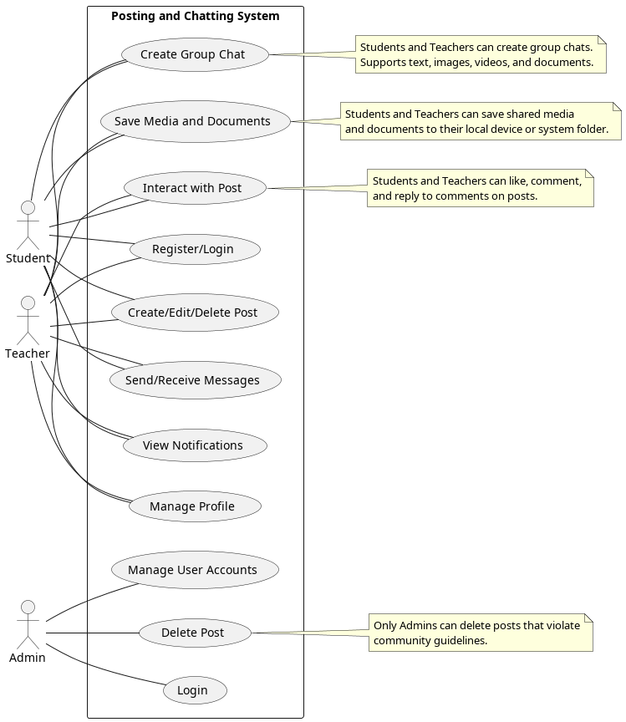

**Detailed Use Case Description**

**1. Student**

**Description:**  
Students are the primary users of the system. They can create posts, chat with others, and receive notifications. They can share and save text, images, videos, and documents in both posts and chats. Additionally, students can interact with posts by liking, commenting, and replying to comments.

**1.1 Create Group Chat**

**Description:**  
Students can create a group chat to communicate with multiple users at once. The chat supports text, images, videos, and documents.

**Preconditions:**

* The student must be logged into the system.
* The student must have at least one other user to add to the group.

**Postconditions:**

* A new group chat is created.
* Invited members can access the group chat.

**Flow of Events:**

1. The student navigates to the "Chat" section and selects the "Create Group Chat" option.
2. The student enters a name for the group chat and selects members to add.
3. The system validates the selected members and creates the group chat.
4. Members can now send and receive text, images, videos, and documents in the group chat.

**Error Handling:**

* If the system fails to create the group chat (e.g., due to a server error), an error message is displayed:  
  **"Failed to create group chat. Please try again later."**

**1.2 Register/Login**

**Description:**  
Students need to register with their university email (e.g., [<example@ucshpaan.edu.mm](mailto:<example@ucshpaan.edu.mm)>) and log in to access the platform.

**Preconditions:**

* For registration: The student must provide a valid university email and a strong password.
* For login: The student must have an existing account.

**Postconditions:**

* For registration: A new account is created, and the student can log in.
* For login: The student gains access to their account and system features.

**Flow of Events:**

1. The student navigates to the "Register" or "Login" page.
2. For registration:
   1. The student enters their university email, password, and other required details (e.g., name, profile picture).
   2. The system validates the email and password.
   3. The system creates a new account.
3. For login:
   1. The student enters their email and password.
   2. The system verifies the credentials and grants access to the account.

**Alternative Flow:**

* If the email is already registered, the system displays an error message:  
  **"This email is already registered. Please log in or use a different email."**
* If the login credentials are incorrect, the system displays an error message:  
  **"Invalid email or password. Please try again."**

**Error Handling:**

* If the login process fails due to a server error, the system displays:  
  **"Login failed. Please try again later."**

**1.3 Create/Edit/Delete Post**

**Description:**  
Students can create, modify, and remove posts to share content. Posts can include text, images, videos, and documents.

**Preconditions:**

* The student must be logged in.
* For editing or deleting: The student must be the author of the post.

**Postconditions:**

* For editing: The post is updated with the new content.
* For deletion: The post is permanently removed from the system.

**Flow of Events:**

1. The student navigates to the "Create Post" section.
2. The student enters the post content (e.g., text, images, videos, documents).
3. For editing:
   1. The student selects the "Edit" option on an existing post.
   2. The student modifies the content (e.g., updates text) and clicks "Save."
4. For deletion:
   1. The student selects the "Delete" option on an existing post.
   2. The system prompts for confirmation, and the post is deleted upon confirmation.

**Alternative Flow:**

* If the post content is empty, the system displays an error message:  
  **"Post content cannot be empty."**
* If a file (e.g., image, video, document) exceeds the allowed size, the system displays:  
  **"File size too large. Please upload a smaller file."**

**Error Handling:**

* If the system fails to save the post (e.g., due to a network error), an error message is displayed:  
  **"Failed to save post. Please try again later."**

**1.4 Send/Receive Messages**

**Description:**  
Students can send and receive direct messages from other users. Messages can include text, images, videos, and documents. Users can save shared media and files.

**Preconditions:**

* Both users must be registered in the system.
* The student must be logged in.

**Postconditions:**

* The message is delivered and stored in the chat history.
* The recipient is notified of the new message.
* The recipient can save shared images, videos, and documents.

**Flow of Events:**

1. The student selects a user from their contact list or searches for a user.
2. The student composes a message (e.g., text, images, videos, documents) and clicks "Send."
3. The system delivers the message to the recipient and stores it in the chat history.
4. The recipient receives a notification about the new message.
5. The recipient can save shared images, videos, and documents by clicking the "Save" button next to the file.

**Alternative Flow:**

* If a file (e.g., image, video, document) exceeds the allowed size, the system displays:  
  **"File size too large. Please upload a smaller file."**

**Error Handling:**

* If the message fails to send (e.g., due to a network error), the system displays:  
  **"Failed to send message. Please try again later."**

**1.5 View Notifications**

**Description:**  
Students receive notifications about messages, comments, and post likes.

**Preconditions:**

* The student must be logged in.
* There must be new notifications (e.g., unread messages, comments on posts).

**Postconditions:**

* The student views the notifications.
* Notifications are marked as read after being viewed.

**Flow of Events:**

1. The student clicks on the "Notifications" icon.
2. The system displays a list of recent notifications (e.g., new messages, comments, new post likes).
3. The student can click on a notification to view the related content.
4. The system marks the notification as read.

**Alternative Flow:**

* If there are no new notifications, the system displays:  
  **"No new notifications."**

**Error Handling:**

* If the system fails to load notifications, an error message is displayed:  
  **"Failed to load notifications. Please try again later."**

**1.6 Manage Profile**

**Description:**  
Students can update their profile information (e.g., name, profile picture).

**Preconditions:**

* The student must be logged in.

**Postconditions:**

* The updated profile information is saved in the system.
* Other users can see the updated profile.

**Flow of Events:**

1. The student navigates to the "Profile" section.
2. The student edits their profile information (e.g., name, profile picture).
3. The student clicks "Save" to update the profile.
4. The system validates and saves the changes.

**Alternative Flow:**

* If the profile picture exceeds the allowed file size, the system displays:  
  **"File size too large. Please upload a smaller image."**

**Error Handling:**

* If the system fails to save the profile changes, an error message is displayed:  
  **"Failed to save profile. Please try again later."**

**1.7 Save Media and Documents**

**Description:**  
Students can save images, videos, and documents shared in chats or posts to their local device or a designated folder in the system.

**Preconditions:**

* The student must be logged in.
* The media or document must be shared in a chat or post.

**Postconditions:**

* The media or document is saved to the student's local device or system folder.

**Flow of Events:**

1. The student views a shared image, video, or document in a chat or post.
2. The student clicks the "Save" button next to the file.
3. The system prompts the student to choose a location to save the file (e.g., local device or system folder).
4. The file is saved to the selected location.

**Alternative Flow:**

* If the file cannot be saved (e.g., due to insufficient storage), the system displays:  
  **"Failed to save file. Please check your storage and try again."**

**Error Handling:**

* If the system fails to save the file, an error message is displayed:  
  **"Failed to save file. Please try again later."**

**1.8 Interact with Post**

**Description:**  
Students can interact with posts by liking, commenting, and replying to comments.

**Preconditions:**

* The student must be logged in.
* The post or comment must exist in the system.

**Postconditions:**

* For liking: The post's like count is updated.
* For commenting: The comment is added to the post.
* For replying: The reply is added to the comment thread.

**Flow of Events:**

1. The student views a post.
2. The student can perform one of the following actions:
   1. **Like the post:**
      1. The student clicks the "Like" button on the post.
      2. The system increments the like count and records the student's like.
   2. **Comment on the post:**
      1. The student clicks the "Comment" button and enters their comment.
      2. The student clicks "Submit" to post the comment.
      3. The system adds the comment to the post and increments the comment count.
   3. **Reply to a comment:**
      1. The student selects a comment and clicks the "Reply" button.
      2. The student enters their reply and clicks "Submit."
      3. The system adds the reply to the comment thread and increments the reply count.

**Alternative Flow:**

* If the student has already liked the post, the system removes the like and decrements the like count.
* If the comment or reply is empty, the system displays an error message:  
  **"Comment/Reply cannot be empty."**

**Error Handling:**

* If the system fails to process the interaction (e.g., like, comment, reply), an error message is displayed:  
  **"Failed to interact with post. Please try again later."**

**2. Teacher**

**Description:**  
Teachers have the same privileges as students, including the ability to create posts, chat, and manage their profiles. They can also interact with posts by liking, commenting, and replying to comments. However, teachers cannot delete students' posts.

**3. Admin**

**Description:**  
The admin manages user accounts and maintains the system. Admins have the authority to delete posts that violate community guidelines.

**3.1 Delete Post**

**Description:**  
Admins can remove posts that violate community guidelines.

**Preconditions:**

* The admin must be logged in.
* The post must exist in the system.

**Postconditions:**

* The post is removed from the system.
* The author of the post is notified of the deletion.

**Flow of Events:**

1. The admin views a post and identifies it as violating community guidelines.
2. The admin selects the "Delete Post" option.
3. The system prompts for confirmation, and the post is deleted upon confirmation.
4. The system notifies the author of the post about the deletion.

**Alternative Flow:**

* If the admin cancels the deletion, the post remains in the system.

**Error Handling:**

* If the system fails to delete the post, an error message is displayed:  
  **"Failed to delete post. Please try again later."**