**Posting and Chatting System Use Case Diagram**

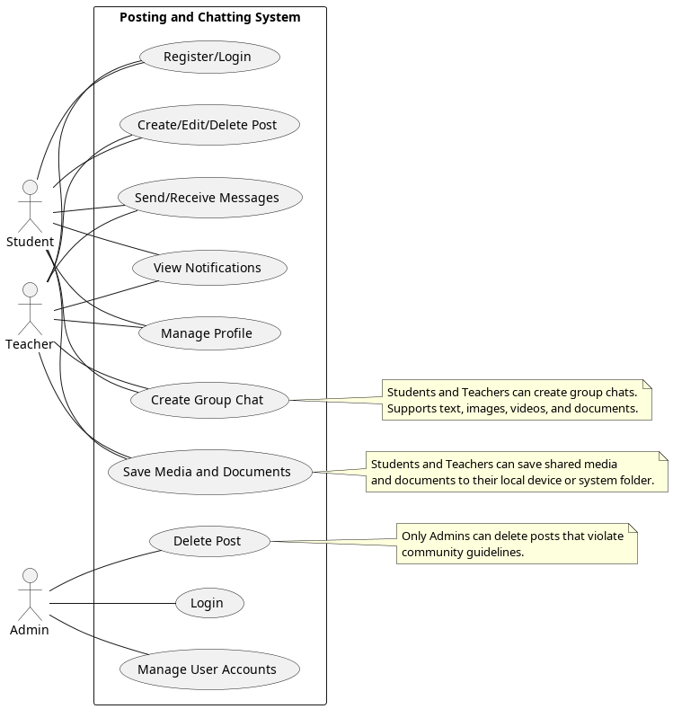

**Detailed Use Case Description for Posting and Chatting System**

This document provides a detailed explanation of the **Posting and Chatting System** use case diagram. The system is designed to facilitate communication, collaboration, and content sharing among **Students**, **Teachers**, and **Admins**. The system supports **text, images, videos, and documents** in both **posts** and **chats**, and users can save shared media and files.

**Actors and Use Cases**

**1. Student**

**Description:**  
Students are the primary users of the system who can create posts, chat with others, and receive notifications. They can share and save **text, images, videos, and documents** in both **posts** and **chats**.

**Use Cases for Student**

**1.1 Create Group Chat**

* **Description:** Students can create a group chat to communicate with multiple users at once. The chat supports **text, images, videos, and documents**.
* **Preconditions:**
* The student must be logged into the system.
* The student must have at least one other user to add to the group.
* **Postconditions:**
* A new group chat is created.
* Invited members and can access the group chat.
* **Flow of Events:**
* The student navigates to the "Chat" section and selects the "Create Group Chat" option.
* The student enters a name for the group chat and selects members to add.
* The system validates the selected members and creates the group chat.
* Members can now send and receive **text, images, videos, and documents** in the group chat.
* **Error Handling:**
* If the system fails to create the group chat (e.g., due to a server error), an error message is displayed: "Failed to create group chat. Please try again later."

**1.2 Register/Login**

* **Description:** Students need to register with their university email (e.g., [<example@ucshpaan.edu.mm](mailto:<example@ucshpaan.edu.mm)>) and log in to access the platform.
* **Preconditions:**
* For registration: The student must provide a valid university email and a strong password.
* For login: The student must have an existing account.
* **Postconditions:**
* For registration: A new account is created, and the student can log in.
* For login: The student gains access to their account and system features.
* **Flow of Events:**
* The student navigates to the "Register" or "Login" page.
* For registration:
  + - The student enters their university email, password, and other required details (e.g., name, profile picture).
    - The system validates the email and password.
    - The system creates a new account.
* For login:
  + - The student enters their email and password.
    - The system verifies the credentials and grants access to the account.
* **Alternative Flow:**
* If the email is already registered, the system displays an error message: "This email is already registered. Please log in or use a different email."
* If the login credentials are incorrect, the system displays an error message: "Invalid email or password. Please try again."
* **Error Handling:**
* If the login process fails due to a server error, the system displays: "Login failed. Please try again later."

**1.3 Create/Edit/Delete Post**

* **Description:** Students can create, modify, and remove posts to share content. Posts can include **text, images, videos, and documents**.
* **Preconditions:**
* The student must be logged in.
* For editing or deleting: The student must be the author of the post.
* **Postconditions:**
* For editing: The post is updated with the new content.
* For deletion: The post is permanently removed from the system.
* **Flow of Events:**
* The student navigates to the "Create Post" section.
* The student enters the post content (e.g., **text, images, videos, documents**).
* For editing:
  + - The student selects the "Edit" option on an existing post.
    - The student modifies the content (e.g., updates text) and clicks "Save."
* For deletion:
  + - The student selects the "Delete" option on an existing post.
    - The system prompts for confirmation, and the post is deleted upon confirmation.
* **Alternative Flow:**
* If the post content is empty, the system displays an error message: "Post content cannot be empty."
* If a file (e.g., image, video, document) exceeds the allowed size, the system displays: "File size too large. Please upload a smaller file."
* **Error Handling:**
* If the system fails to save the post (e.g., due to a network error), an error message is displayed: "Failed to save post. Please try again later."

**1.4 Send/Receive Messages**

* **Description:** Students can send and receive direct messages from other users. Messages can include **text, images, videos, and documents**. Users can save shared media and files.
* **Preconditions:**
* Both users must be registered in the system.
* The student must be logged in.
* **Postconditions:**
* The message is delivered and stored in the chat history.
* The recipient is notified of the new message.
* The recipient can save shared **images, videos, and documents**.
* **Flow of Events:**
* The student selects a user from their contact list or searches for a user.
* The student composes a message (e.g., **text, images, videos, documents**) and clicks "Send."
* The system delivers the message to the recipient and stores it in the chat history.
* The recipient receives a notification about the new message.
* The recipient can save shared **images, videos, and documents** by clicking the "Save" button next to the file.
* **Alternative Flow:**
* If a file (e.g., image, video, document) exceeds the allowed size, the system displays: "File size too large. Please upload a smaller file."
* **Error Handling:**
* If the message fails to send (e.g., due to a network error), the system displays: "Failed to send message. Please try again later."

**1.5 View Notifications**

* **Description:** Students receive notifications about messages, comments, and post likes.
* **Preconditions:**
* The student must be logged in.
* There must be new notifications (e.g., unread messages, comments on posts).
* **Postconditions:**
* The student views the notifications.
* Notifications are marked as read after being viewed.
* **Flow of Events:**
* The student clicks on the "Notifications" icon.
* The system displays a list of recent notifications (e.g., new messages, comments, new post likes).
* The student can click on a notification to view the related content.
* The system marks the notification as read.
* **Alternative Flow:**
* If there are no new notifications, the system displays: "No new notifications."
* **Error Handling:**
* If the system fails to load notifications, an error message is displayed: "Failed to load notifications. Please try again later."

**1.6 Manage Profile**

* **Description:** Students can update their profile information (e.g., name, profile picture).
* **Preconditions:**
* The student must be logged in.
* **Postconditions:**
* The updated profile information is saved in the system.
* Other users can see the updated profile.
* **Flow of Events:**
* The student navigates to the "Profile" section.
* The student edits their profile information (e.g., name,profile picture).
* The student clicks "Save" to update the profile.
* The system validates and saves the changes.
* **Alternative Flow:**
* If the profile picture exceeds the allowed file size, the system displays: "File size too large. Please upload a smaller image."
* **Error Handling:**
* If the system fails to save the profile changes, an error message is displayed: "Failed to save profile. Please try again later."

**1.7 Save Media and Documents**

* **Description:** Students can save **images, videos, and documents** shared in chats or posts to their local device or a designated folder in the system.
* **Preconditions:**
* The student must be logged in.
* The media or document must be shared in a chat or post.
* **Postconditions:**
* The media or document is saved to the student's local device or system folder.
* **Flow of Events:**
* The student views a shared **image, video, or document** in a chat or post.
* The student clicks the "Save" button next to the file.
* The system prompts the student to choose a location to save the file (e.g., local device or system folder).
* The file is saved to the selected location.
* **Alternative Flow:**
* If the file cannot be saved (e.g., due to insufficient storage), the system displays: "Failed to save file. Please check your storage and try again."
* **Error Handling:**
* If the system fails to save the file, an error message is displayed: "Failed to save file. Please try again later."

**2. Teacher**

**Description:**  
Teachers have the same privileges as students, including the ability to create posts, chat, and manage their profiles. However, **teachers cannot delete students' posts**. Teachers can also share and save **text, images, videos, and documents** in posts and chats.

**3. Admin**

**Description:**  
The admin manages user accounts and maintains the system. Admins have the authority to delete posts that violate community guidelines.

**Use Cases for Admin**

**3.1 Delete Post**

* **Description:** Admins can remove posts that violate community guidelines.
* **Preconditions:**
* The admin must be logged in.
* The post must exist in the system.
* **Postconditions:**
* The post is removed from the system.
* The author of the post is notified of the deletion.
* **Flow of Events:**
* The admin views a post and identifies it as violating community guidelines.
* The admin selects the "Delete Post" option.
* The system prompts for confirmation, and the post is deleted upon confirmation.
* The system notifies the author of the post about the deletion.
* **Alternative Flow:**
* If the admin cancels the deletion, the post remains in the system.
* **Error Handling:**
* If the system fails to delete the post, an error message is displayed: "Failed to delete post. Please try again later."