Question 1: (10 Points)

What is the difference between shell and bash?

* Shell is a translator between you and the computer. It will let you give commands and run programs. Bash is a specific type of shell, while the shell is a general concept for any command interpreter.

Question 2: (10 Points) To respond to this question, you need to use terminal/Bash and have a screenshot of your terminal/bash.

1. What is your home directory?

* 

1. What files/folders exist in it?

* 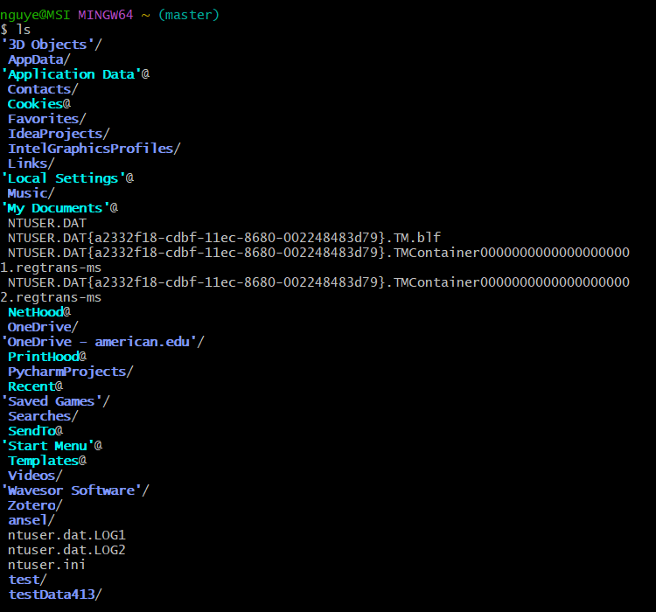

Question 3: (10 Points) To respond to this question, you need to use terminal/Bash and have a screenshot of your terminal/bash.

1. Where does the command `cd../../` take you? Run the command `pwd` and explain the output!

* 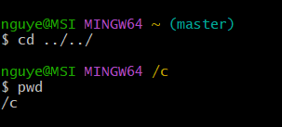
* This command will move you up two levels. Which takes you from /c/users/nguye back to /c. And the pwd will just show your current directory.

1. What does the command `cd` do? Run the command `pwd` and explain the output!

* 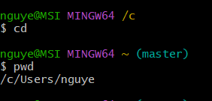
* Cd command will take you to your home directory, no matter where you currently are. Pwd will print the path of your home directory.

Question 4: (10 Points) To respond to this question, you need to use terminal/Bash and have a screenshot of your terminal/bash.

Read the manual page of ls. What does the `a` flag do? What does the `l` flag do?

* 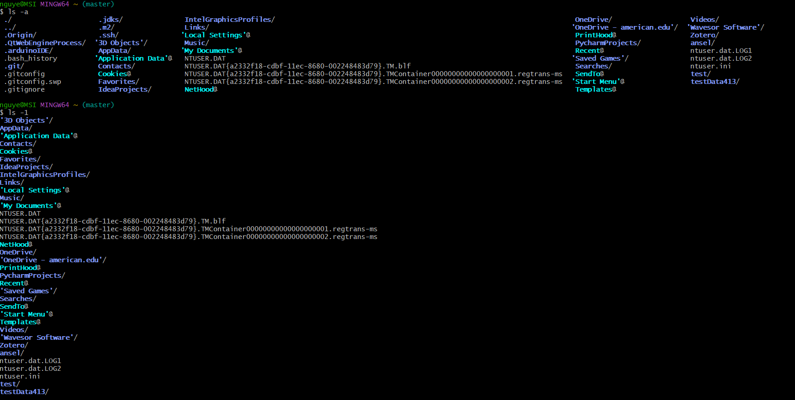
* Ls is just a command for list to list out the files and directories. -a flag in the ls command stands for all. It will show all files in the directory. Including hidden files which began with (.). Ls does not show hidden files but ls -a does.
* -1 flag stands for long listing format. It will show detailed information about each file.

Question 5: (A and B each have 5 points, and C has 10 points. The total is 20 points.) To respond to this question, you need to use terminal/Bash and have a screenshot of your terminal/bash.

1. Create a folder within your home directory, which was identified in Question 2, and name it 'temp_bash'.

* 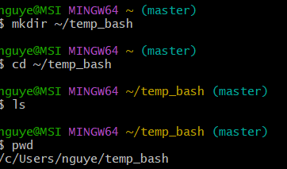

1. Create a new file using the command `touch` and name it `myfile.txt` inside the new folder `temp_bash` and run `ls` to show that the file is inside the folder.

* 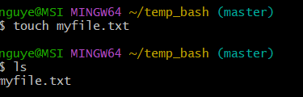

1. Run the `stat myfile.txt` command and explain the information retrieved from the output. Here is an example of what should be included in the output and a brief explanation for each part.

* `Blocks: 0 ` The number of blocks for the file.
* `IO Block: 65536` The size of each block.
* 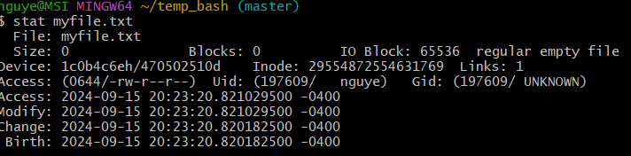
* File: myfile.txt: The name of the file you checked.
* Size: 0: The file size is 0 bytes because it's an empty file.
* Blocks: 0: No disk blocks are used for this file
* IO Block: 65536: The block size used by the filesystem is 65536 bytes.
* Device: 1c0b4c6eh/470502510d: The device identifier where the file is stored.
* Inode: 29554872554631769: The inode number is a unique identifier for the file within the filesystem.
* Links: 1: There is one hard link to this file.
* Access: (0644/-rw-r--r--): The file permissions. 0644 means the owner can read and write the file, while others can only read it.
* Uid: (197609/ nguye): The user ID (UID) of the file owner. nguye is the username associated with that UID.
* Gid: (197609/ UNKNOWN): The group ID (GID) of the file owner. UNKNOWN indicates that the group information could not be resolved.
* Access: 2024-09-15 20:23:20.821029500 -0400: The last access time of the file.
* Modify: 2024-09-15 20:23:20.821029500 -0400: The last modification time of the file.
* Change: 2024-09-15 20:23:20.820182500 -0400: The last status change time (e.g., when permissions or ownership were changed).
* Birth: 2024-09-15 20:23:20.820182500 -0400: The creation time of the file (if supported by the filesystem).

Question 6: (40 Points) To respond to this question, you need to use terminal/Bash and have a screenshot of your terminal/bash.

1. Use the command `>>` and add the following line This line is my first line. Now add the following line This line is my second line. Then, run cat myfile.txt to show that the line has been added.

* 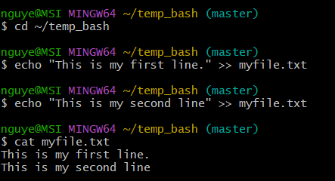

1. Copy the file myfile.txt to file copy_myfile.txt with the command `cp`

* 

1. Use the command `>` and add the following line This line is a new line to copy_myfile.txt. Then run cat copy_myfile.txt to show the line is added.

* 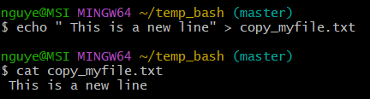

1. Explain the difference between `>` and `>>` based on the result of the Question 6.

* >> is adding data to the end of a file without changing existing data. > Replaces the entire content of a file with new data.