Lecture 10

**Targets-Partitions Logic-Concept**

-----------------------------------------

In CentOS 7 & 8 onward there r no runlevels,

* There are “targets” but runlevel are also visible, but actual work is done by targets
* $ cat /etc/redhat-release 🡪 to check the version of the CentOS
* 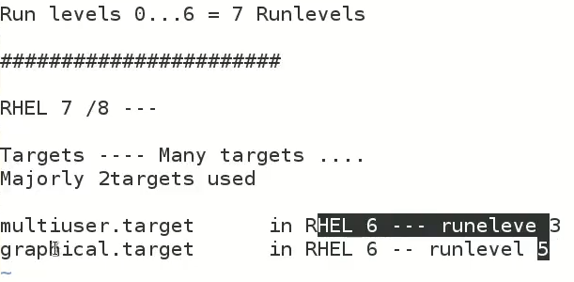
* In CentOS 7/8
* 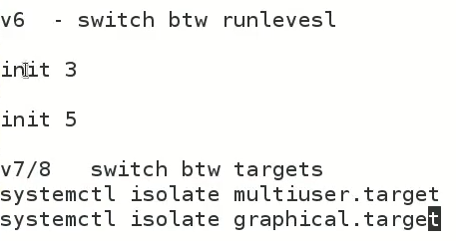
* $ systemctl isolate <specific_target_name.target>
  + e.g $ **systemctl isolate multiuser.target 🡪 justlike init 3**
* 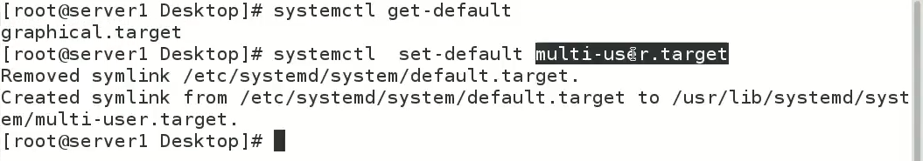
* In RHEL 7/8 how to break for changing root password
* Break “initramfm” and get the access of shell to change root password
* Steps are,
* Press e to interrupt splash screen
* 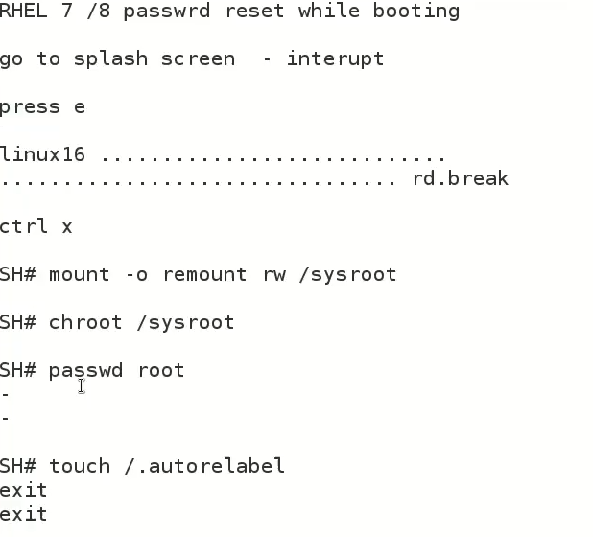

-Add “rd.break” at the end of line which starts with “Linux16…” –rd.nreak “RAM disk break”

-Ctrl+x to start the shell

-# mount -o remount,rw /sysroot

-# chroot /sysroot 🡪 it changes the shell

-# passwd root –> here we go, the root password is changed

-# touch /.autorelable

# exit

# exit

For me this process failed in spite of many tries to reset boot password, then I tried to rest root password using bootable USB which worked for me,

The step by process is as under,

To reset the root password of a CentOS 7 system using a bootable USB, you can follow these steps:

1. Boot the system using the bootable USB.
2. Press any key to enter the boot menu and select the option to boot into rescue mode.
3. Once the system is in rescue mode, it will automatically mount the file system.
4. Run the command **chroot /mnt/sysimage** to change the root to the mounted file system.
5. Run the command **passwd** to change the root password.
6. Type in the new password twice to set it.
7. Exit the chroot environment by running the command **exit**.
8. Run the command **reboot** to restart the system.
9. Log in as root using the new password.

Please note that this is a general guide, and may not work in all cases, but this is the most common way to reset the root password on a CentOS 7 system.

* The details of the whole process will be discussed in coming lectures InnSha Allah.
* **fdisk further discussion**
* sda or sdb is **“driver”**
* **empty hard disk is called “raw hard disk”**
* the disk shows less space which is written on its coveris is because of some firmware etc.
* 16Gb is for human understandings but fdisk calculates it is **“cylinders”** cylinders means “volume” in 16 Gbs 1958 Cylinders are available.
* # fdisk -l /dev/sda
* 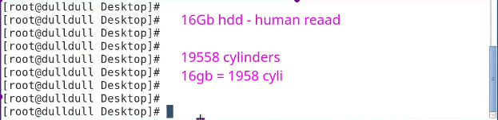
* 1 cylander is = 8Mb Approx. in case of 16Gb HD
* For Gb sized HDs (800Gb) cylinder size would be approx. 8 mb
* And if HD size is in Mbs (500Mb)then cylinder size would be 1 Mb
* # fdisk -l 🡪 list partitions
* # bc 🡪 builtin calculator in Linux
* HD Detection if not showin up with fdisk -l /dev/sd*
* Run elow mentioned 3 commands to detect HDD in running machine without restart
* 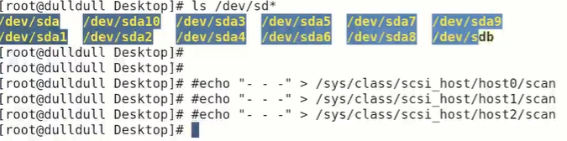
* **Remember “fdisk” utility is only to create, manage & delete partitions**
* Rest of the processes are done in other steps
* Primary partitions are limited in numbers depending upon size of HDD, the extended partition is the partition which can create many partitions in it
* The “extended” partition is to create more partitions in it, it is just a name , we can’t format it or utilize it as primary partitions, it is just to create more partitions in it.
* 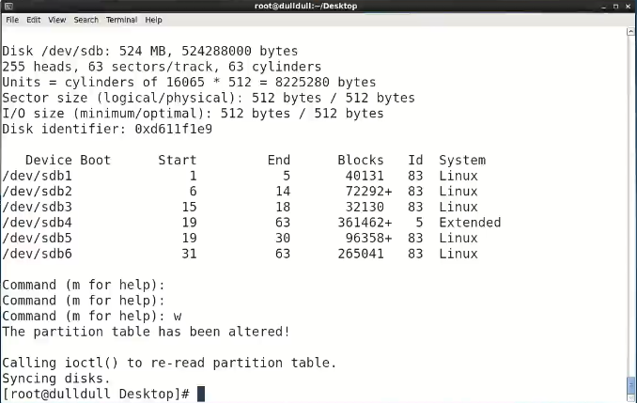
* Next steps,
* $ partx -a /dev/sdb 🡪 this command updates the tables
* $ ls /dev/sd* 🡪 to list created partitions
* $ mkfs.ext4 /dev/sdb1 🡪 change the numbers according to partitions to be formatted
* $ makdir /part1 🡪 to mount each partition in desired names (part1 or part2 etc)
* $ mount /dev/sdb1 /part1 – **Remember always give full “absolute path” of the mount point i.e pasrt1, or mount point not fount error will display.**
* $ mount /dev/sdb2 /part2 🡪 repeat for all partitions
* $ df -h 🡪 to check status of created partitions