Lecturer 11

Partitions Logic-Concept-FSTab

* Partition table stores all the information about partitions , in fdisk “w” stores all the info in partition table before pressing “q”,
* “$ partx -a /dev/sdb” or “$ partprobe /dev/sdb” (it worked for me) command retrieves info from partition table to tell the Kernel table about newly added partitions. It is the method to update Kernel table without reboot, if the machine is rebooted, the Kernel Table will retrieve this information from partition table automatically.
* Format explained below,
* 
* In partition, the indexing is to control the data, Index controls the data to be written in future, it is created by FS. FS creates index.
* FS means metadata -🡪 collection of Indexing Data
* FS includes:
* Inode, Inode table, blocks, superblocks, mounting information
* “mount” 🡪 to access the data from partition.
* To persistent the mount process,
* So that this partition is auto mounted whenever system starts,
* Automount that partition 🡪 We need add this in a file
* 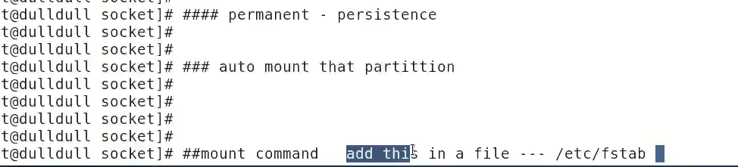
* # fstab
* 
* fstab file is referred while booting and it contains **mounting information**.
* File system table 🡪 fstab it is said to be 9th critical file in Linux
* 6 fields in fstab file
* 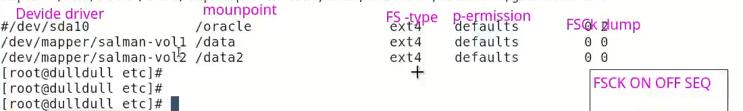
* To add this mountpoint in desired mount point
* $ vi /etc/fstab
* Here add the 6 fields details manually

|  |  |  |  |  |  |
| --- | --- | --- | --- | --- | --- |
| **Device Driver** | **Mountpoint** | **File System Type** | **Permissions** | **FSCK Dump** | **FSCK ON OFF Sequence** |
| /dev/sdb | /partition03 | ext4 | defaults | 0 | 2 |