Lecture 13

Archive – Compression

* $ touch file{1..2} à to create 10 files
* $ gzib * à to compress all the contents in a directory
* $ gunzip * à to un-compress all the contents in a directory
* Both uses LZO compression technology
* During compression the command takes some space for indexing so if you compress a “0”byte file its size increases. Indexing or writing headers in compressed file
* *gzip is best for small files à it’s bit fast but compression is low if compared to bzip2
* *bzip2 is best for large files à high compression , (compression depends upon format of a file), bit slow but high compression as compared to “gzip”
* $ bzip2 * à all files in a directory
* $ bunzip2 * à un-compress all the files in a directory
* **Archive & compression**
* “Archive” à to gather multiple files and compress it and save it in a single file. Archive doesn’t reduce size. It only gathers it
* **Tip:**
* **“zcat” to view and read the compressed file compressed gzip**
* **“bzcat” to read bzip2 compressed file**
* **“*”means to select everything from a specific directory**
* 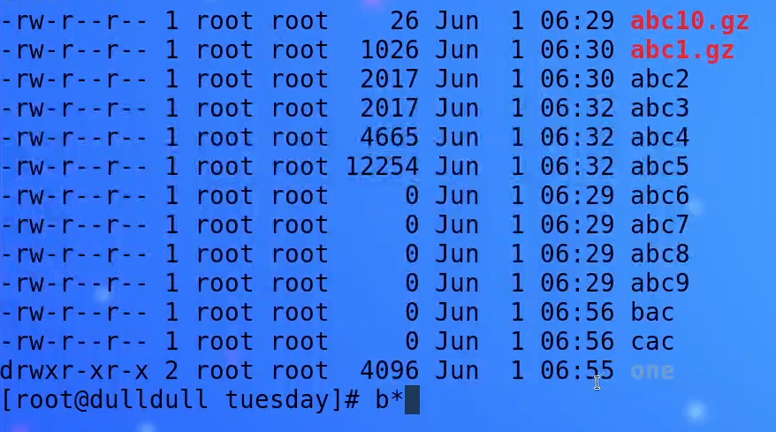
* Will select all the files starting with “b”
* How to archive & compress all the files in a directory
* 
* 
* Archive and zip a specific directories
* 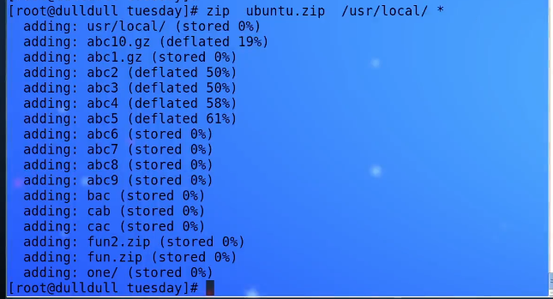
* **In above mentioned screenshot, “usr/local” directory and “*” means current directory both are archived and compressed in ubuntu.zip folder. “*” means everything in current directory. # zip ubuntu.zip /usr/local/ <space> \***
* *By this means backup is taken in Linux
* # zip backup.zip /etc/alsa/* à note it that there is not space given before “*”. It will create the backup of specified directory in present working directory
* $ zip /usr/games/mnt.zip /etc/alsa* 🡪 create compressed file in a specific location
* The extension doesn’t matter in below case, the command will run,
* 
* It may cause identification problem ,
* To solve this
* $ file abc.piz command checks ths original file type,
* 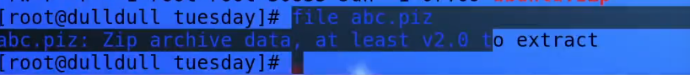
* “mv”or “rename” command renames the file with extension
* $ mv abc.piz abc.zip
* “mv” command is also used to cut & paste
* $ mv abc.zip /mnt/
* $ unzip abc.zip 🡪 to unzip a file
* **To look into a zip file**
* **$unzip -l <file_name>.zip**
* To unzip in a different directory
* 
* Tip: Interview Questions
* 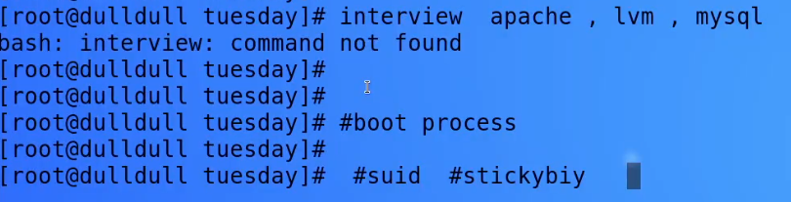

**Tape Archive (TAR)** 🡪 native tool of Linux

* It’s archive only tool and no compression.
* $ tar file.
* **Tip:-**
* **If you don’t know how to use a command, read its manual**
* $ man tar
* -flags are used in tar
* $ tar -cvf <filename>.tar *
* **“-cvf” details**
* “-v” verbose means it shows command out put on display.
* “-f” means file
* “-c” flag means to create a new archive
* **To move a file**
* **Tip:-**
* **Ctrl+shift+n (always do work in multiple tabs)**
* $ mv tar_file.tar /mnt
* **To untar / or uncompress or flate**
* **$ tar -xvf <file_name>.tar “-x” extract the contents of the fille**
* To see contents of tar
* $ tar -tvf <file_name> “-t” list the contents of the archive
* **To compress with tar**
* **$ tar -zcvf <file_name>.tar.gz 🡪 in case of gzip**
* **$ tar -jcvf <file_name>.tar.bz 🡪 in case of bzip2**
* **To extract**
* **$ tar -zxvf <filename>.tar.gz <location>**
* **$ tar -jxcvf <file_name>.tar.bz <location>**
* **Tip:-**
* **Cp <location_copy_from>* <location_copy_to> 🡪 copies all the files from one to another location but skips directories**
* **Add ”-rv” with “cp” command to include directories**
* **$ cp -rv <location_1><file_name> <location_2>**

**“rsync” is a very powerful tool , it can also take remore backup, it takes incremented backup to**

* Its an interview question