Lecture 16

Fdisk-Partitioning Cases-Standards-and Mounting

Fdisk further (final chapter)

* The extended partition is for the namesake ojnly and it always starts after 4th position, i.e /dev/sdb5 or /dsdec5 because 1 – 4 no are reserved for Primary partitions i.e /dev/sdb1 to /sdb4, from 1 to 4 drivers are only assigned to primary + extended
* The extended partition can be placed at no to i.e sdb 2 , in this cae sdb3 and sdb4 would be skipped and logical partitions will start from /sdb5 and so on.
* It means extended partition has no space. Its just for the name’s sake
* OS doesn’t know about primary or logical partitions; it only needs a partition.
* If extended partition is at /sdb2 and it doesn’t occupy whole remaining space, and there is unallocated space available, in this situation primary partition option will display and you can make a primary partition.
* **Partition table 🡪 there are 2 types of partition tables, and one HDD has only 1 partition table, these types are.**
  1. msdos/mbr
  2. GPT 🡪 128 primary partition can be created
* Mostly GPT partition table is in use now a days.
* msdos/mbr 🡪 Limitation: only 4 primary partitions can be created
* there is a tool “parted” to know which partition table is in use
* $ parted -l /dev/sdb
* 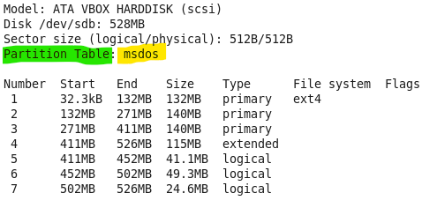
* Partition table can be converted to GPT or vice versa 🡪 **data loss is possible.**
* $ sync 🡪 
* This command is useful after quitting from fdisk
* $ partx -a /dev/sdb or partprobe /dev/sdb
* **Interview question:** what is difference between different file systems in Linux, eg, ext2, ext,3 ext4
* **mounting**
* /sdb must be mapped with a directory to access that storage from a specific partition
* $ mkdir <name>
* $ mount /dev/sdb <mount point name>
* Inode is loaded into the memory by “mount” command
* The partition becomes as a process.
* $ unmount <mount_point> 🡪 can unmount the specific partition
* If device is busy