Lecture 18

**Filesystem Check Repair-e2fsck-lsblk-pipe-less-more**

* **$ e2fsck /dev/sdb1** 🡪 repairs partitions against bad sectors, provided that the target partition must be “unmounted” first, with **$ unmount <mount_point>**
* To check mounted partition, “read only” option is available. To scan for bad blocks use **$ badblocks -v** (read-only) for mounted partition. “/” can’t be unmounted, yes we can unmount “/” in “rescue” mode.
* 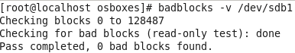
* **Tip:-** the “e2fsck” after unmounting the partition is called “manual repair”. And to avoide “yes” “no” during scanning pass the flag “-y” with “e2fsck”, “-c” flag is for report after scanning.
* works in 5 “passes”.
* 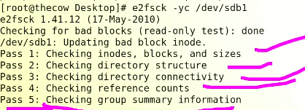
* **Reason for “check and clean”**
  + Inconsistent HDD
    - Unclean shutdown, improper shutdown 🡪 directly powering off the system
    - Power fluctuation (RAM & HDD couldn’t sync each other)
    - Wrong designed application (data is updating in RAM but not sync with HDD 🡪 developer’s mistake)
* To add this “scanning utility” at the system start up look into “fstab” 6th field,
* What is it (fstab)?
* Your Linux system's filesystem table, aka fstab, is a configuration table designed to ease the burden of mounting and unmounting file systems to a machine. It is a set of rules used to control how different filesystems are treated each time they are introduced to a system.
* **Device**: usually the given name or UUID of the mounted device (sda1/sda2/etc).
* **Mount Point**: designates the directory where the device is/will be mounted.
* **File System Type**: nothing trick here, shows the type of filesystem in use.
* **Options**: lists any active mount options. If using multiple options they must be separated by commas.
* **Backup Operation**: (the first digit) this is a binary system where 1 = dump utility backup of a partition. 0 = no backup. This is an outdated backup method and should NOT be used.
* **File System Check Order**: (second digit) Here we can see three possible outcomes.  0 means that fsck will not check the filesystem. Numbers higher than this represent the check order. The root filesystem should be set to 1 and other partitions set to 2.
* In following example,
* 
* 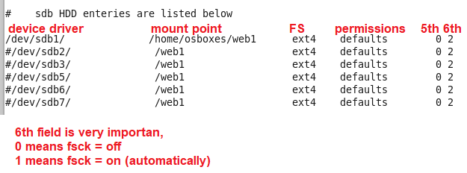
  + "The system ignores “/boot” and “/usr” because value is “0” , “0” means “off”
  + “/tmp” is to be checked first because value is “1”
  + “/var” is to bechecked at 2nd place because values is “2”
  + “/home” is to be checked ar 3rd place because values of FSCK 6th field in fstab is “3”
* **In industry, “/” or “root” goes first and it’s value is set to “1” and all remaining partitions set at “2” for scanning simultaneously.**
* It can be observe during “splash screen” by pressing “Esc”
* 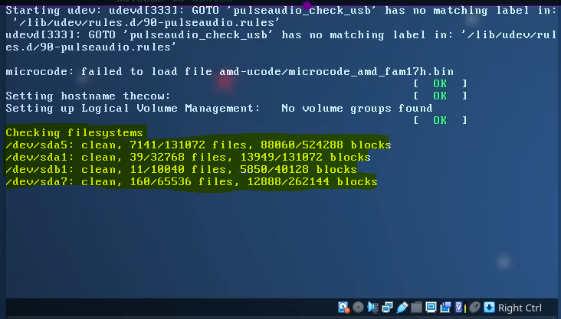
* The 5th field is not in use, FSCK dump, (its absolute now a days), it is depended on 6th field, it is suggested that if “6th ” filed is “on” than “5th”field should also “on”. It’s values are “0” or “1”
* UUID
* 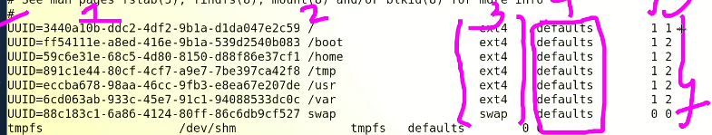
* **Universal Unique ID or partition ID (Device Driver)** can be at 1st place. It is recommended to place “UUID” instead of “device Driver”
* **$ blkid /dev/sdb1 🡪** to have “UUID ” of this specific partition.
* [**Stands for**](https://www.google.com/search?rlz=1C1CHBD_enPK1037PK1037&sxsrf=AJOqlzUsL3xUdDj5zj_L8VQGIF1GejutOw:1674099856370&q=blkid+stands+for&stick=H4sIAAAAAAAAAOPgE-LVT9c3NExJqajMMi8p0lLMTrbSzy6IzynXL83LrIhPzs_NTcxLsSouAZLF8Wn5RYtYBZJysjNTFCBCCkAhAEJHaLhHAAAA&sa=X&ved=2ahUKEwj9qIf629L8AhU7iv0HHW28AJYQ6BMoAHoECCUQAg)**:**Block identification.
* 
* To observe all UUIDs the command is
* **$ cd /dev/disk/by-uuid/**
* And to list complete mapping **$ ls -l**
* 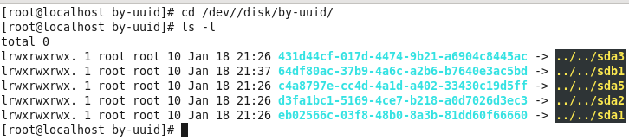
* **$ lsblk -f 🡪 to list all the details**
* 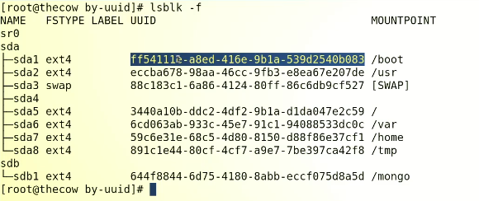

**How to send out put of a command to another command**

* Pipe “|” symbol is used for this purpose
* **$ wc -l – word count command**
* Empty command has no output
* **$ ls | wc -l 🡪**
* 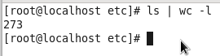
* **It means 273 files and directories are in “/etc” directory.**
* Here “ls” command sends it out put through “|” pipe to “wc -l” command.
* $ ls /etc/* 🡪 list all items in this directory.
* $ lsof | wc -l 🡪 optional command to get no of open files and programs
* $ ls /etc/* | less 🡪 “less” fits the output to page line by line (page fit) manner, single line scrolling.
* **Tip:- press “q” to quit the process**
* $ ls -l /etc/* | more 🡪 for page-by-page scrolling.