Lecture 06

Further exploration of Vim Editor

**$ cat /etc/passwd > /opt/containers**

* this command copies all contents of “passwd” fil into “containers” file

Now open it in vim,

In vim to add line numbers the command is,

**<esc> : set nu**

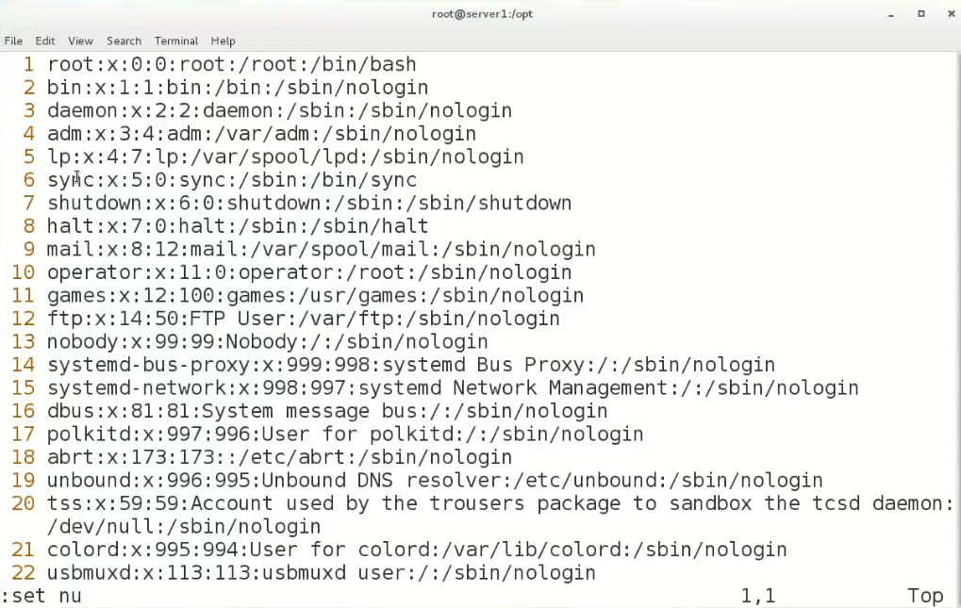

To revert it

**<Esc> : set nonu**

To a specific line

**<Esc>: <line_no> e.g “”<Esc>:14”**

To search anything

**<Esc>/<search_query>**

*press “n” for next search and for reverse search press “SHIFT+n”

Split

**<Esc>:vsplit**

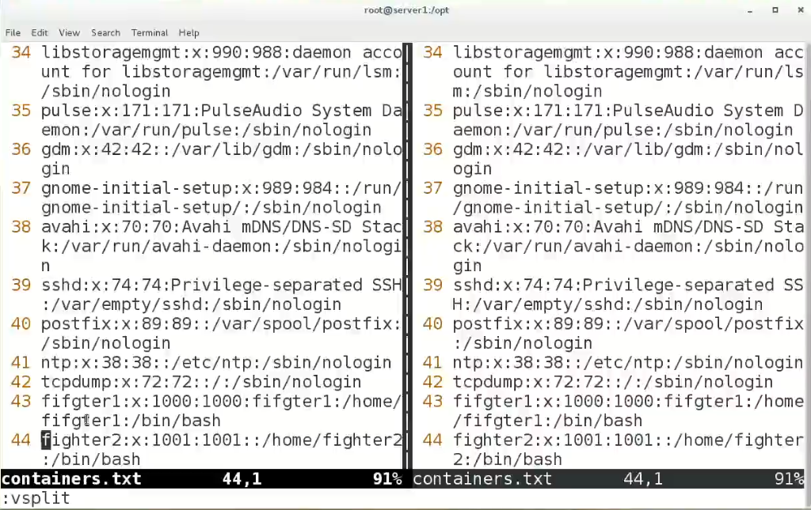

*it opens the same file 2 times in tow separate windows

And repeat **<Esc>:vsplit**

to opening more split windows and son on

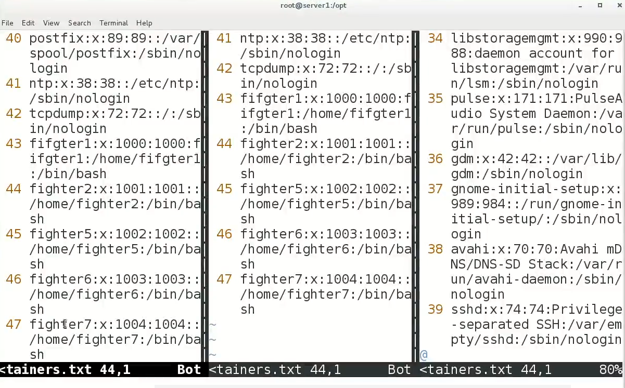

To have horizontal split

Just use this command,

**<Esc>:split**

To open more files in same window use

**<Esc>:split /etc/hosts**

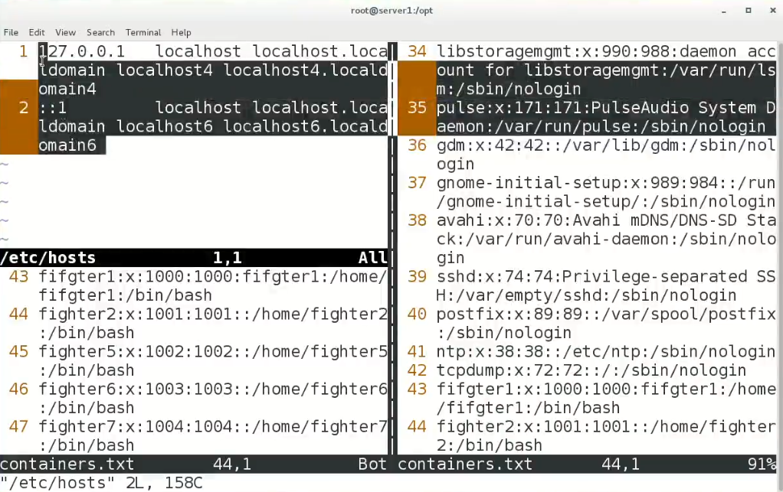

*switch windows with “CTRL+ww”

To close each windows <Esc>:q for every window.

-to password protect a file **<Esc>:x<ENTER>** and provide encryption key and password respectively.

To remove passwd of a file

<Esc>:x <ENTER>

And during Encryption key prompt press <ENTER> <ENTER>

And we r goo to go password is removed

And if the password is forgotten than using hacking or password cracking tool like john the ripper may help.

-

**Ownership & permissions (further)**

Read and write permissions

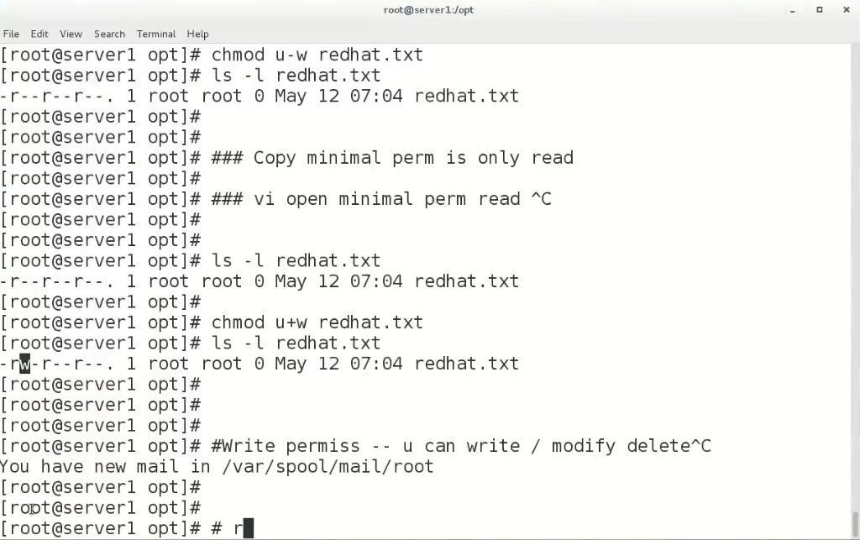

Execute permission “x”

This permission assign permissions to run a file like, binary files, bash scripts etc. normal files doesn’t require executable permission.

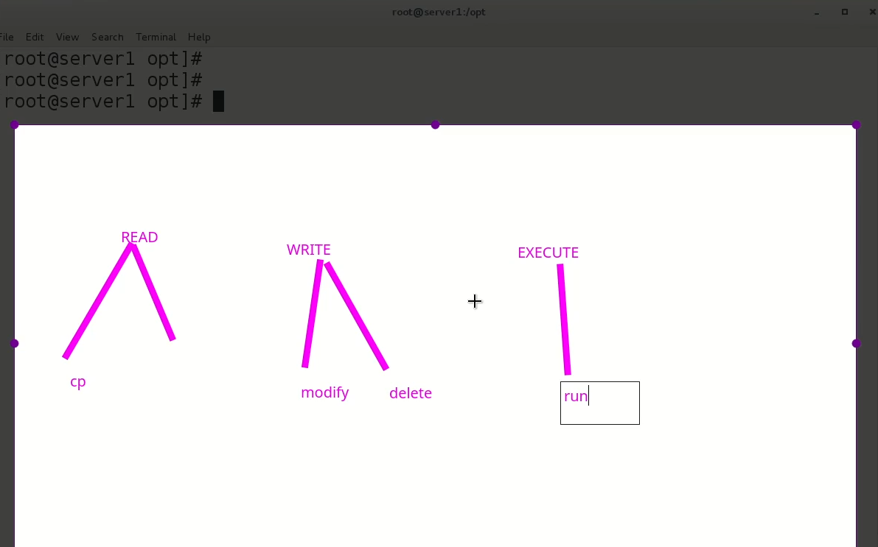

**Directory permissions**

* **r** permission means to read contents of the directory
* **w** permission means subdirectories can be made inside it
* **e** permission mean directory can be accesses and opened by “cd” command or double click etc.

Remember !!! “root” can do anything but if there is a situation that root too restricted to delete a file than there is a command called **“chattr”.**

**$ chattr +I <filename> 🡪 root is restricted to delete this specific file**

**$ chattr -I <filename> 🡪 chatter effects are removed**

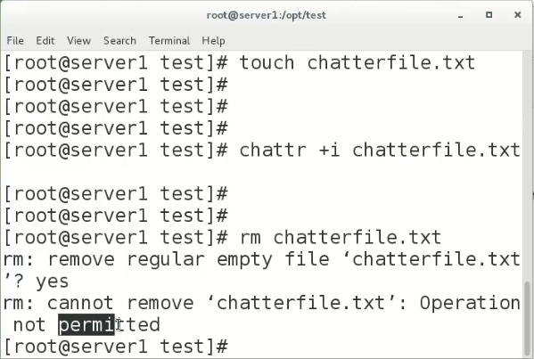

In below mentioned screenshot the purpose and functionality of chatter command is explained,

The attribute “i” means immutable

To know attributes of a file uses

$ lsattr <file_name>

Notice !!!

This “chattr +i” command or attribute should not be applied on system files because it will lock those files and the working of system may find complexities.

This attribute of immutability should be applied to other important files.

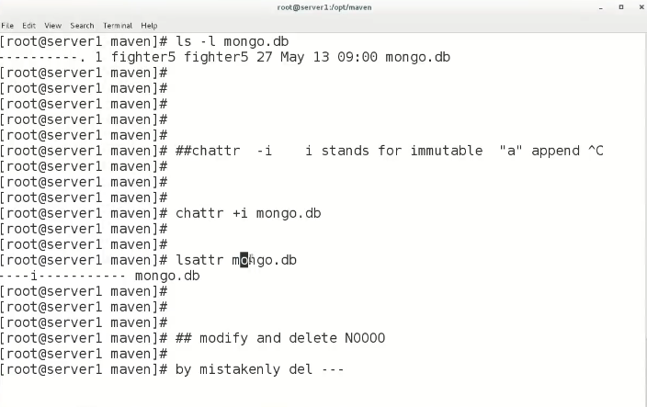

-

**Using “chmod” command and “ugo+rwx etc”to change permissions and ownerships is called “symbolic way”**

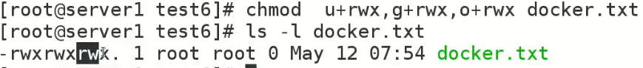

**There is another way to the same which is called “octal way”, it involves numbers with “chmod” command, for example,**

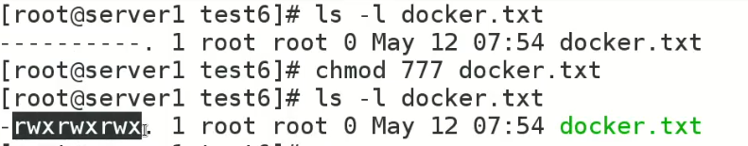

**\*in octal way “7” is maximum**

**“777”**

**Here,**

**1st 7 is for user**

**2nd 7 is for group**

**3rd 7 is for others**

**r=4**

**w=2**

**x=1**

