Lecture 08

Partitions

Types of Hard Disks

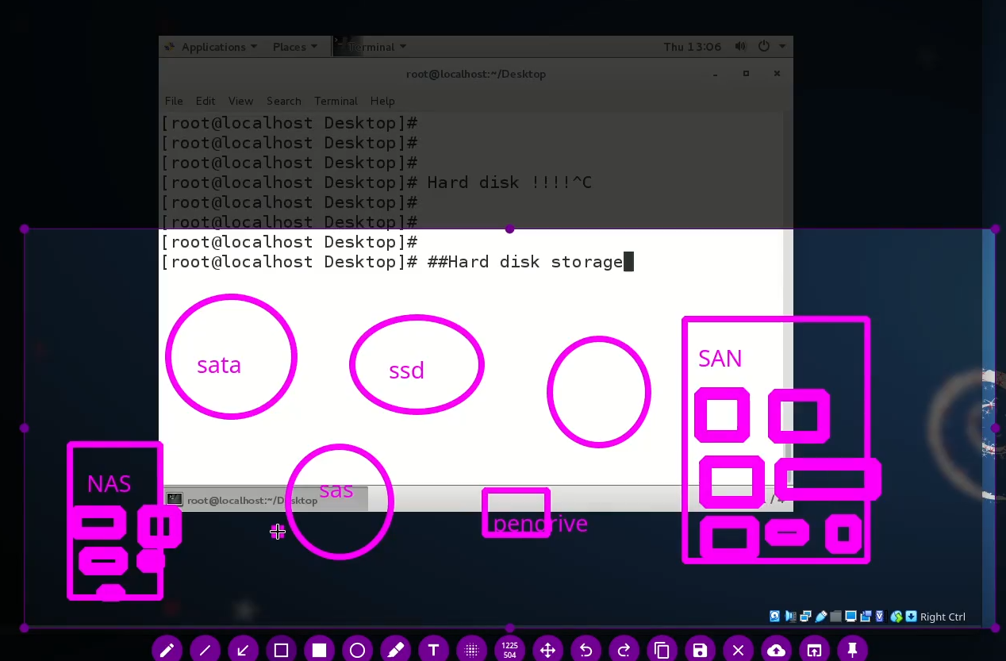

* SATA
* SSD
* Pen Drive
* NAS (Collection of HDs)
* SAN (Collection of HDs) Storage Area Network

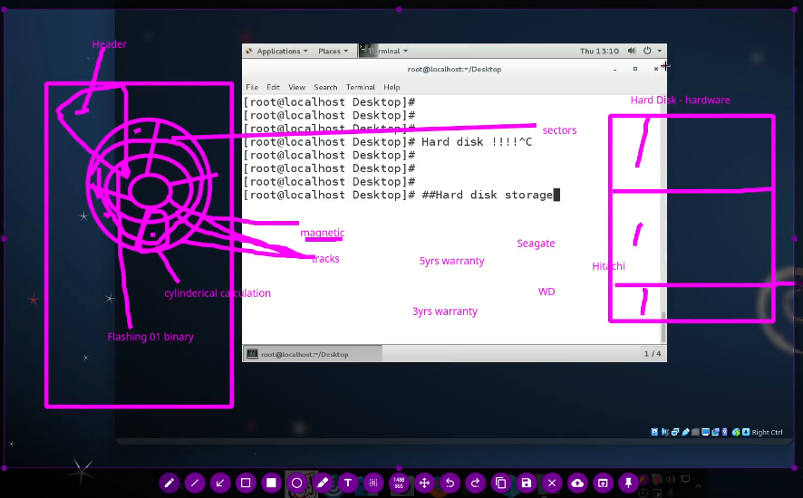

Device Drivers

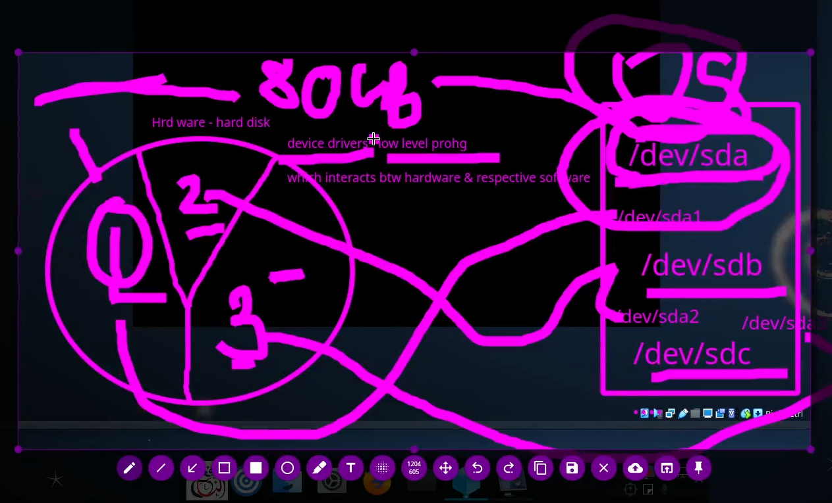

HD is a hardware , we need Device Drivers to interact with hardware, in Linux Device Drivers are as ,

Dev/sda

Dev/sdb

Dev/sdc

Every partition is associated with respective driver which assigns as follow,

/dev/sda1

/dev/sda2

/dev/sda3

Or

/dev/sdb1

/dev/sdb2

Or

/dev/sdc1

/dev/sdc2

An so on …

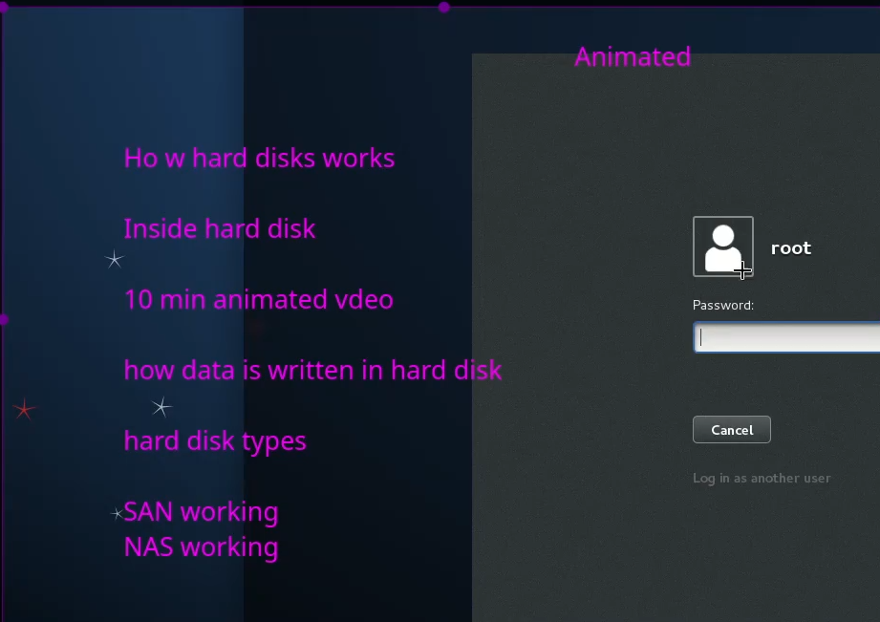

Partition tools in Linux

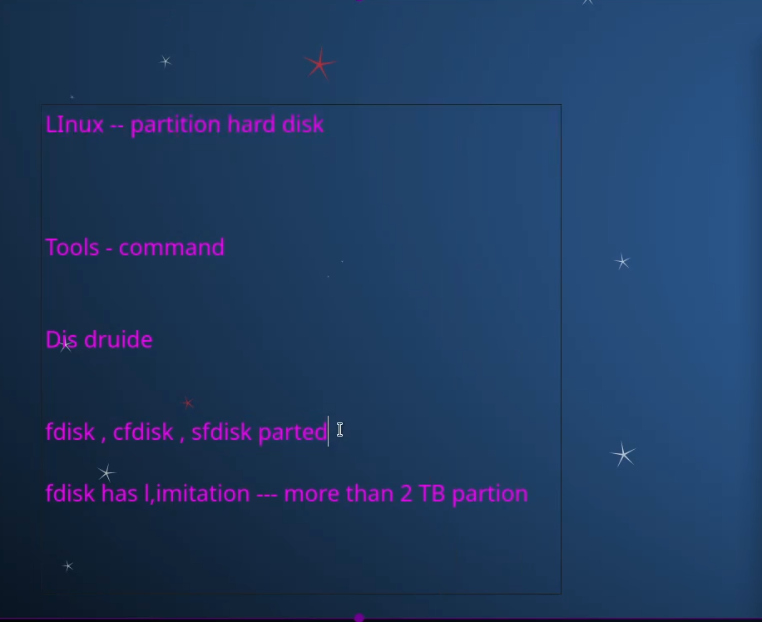

-

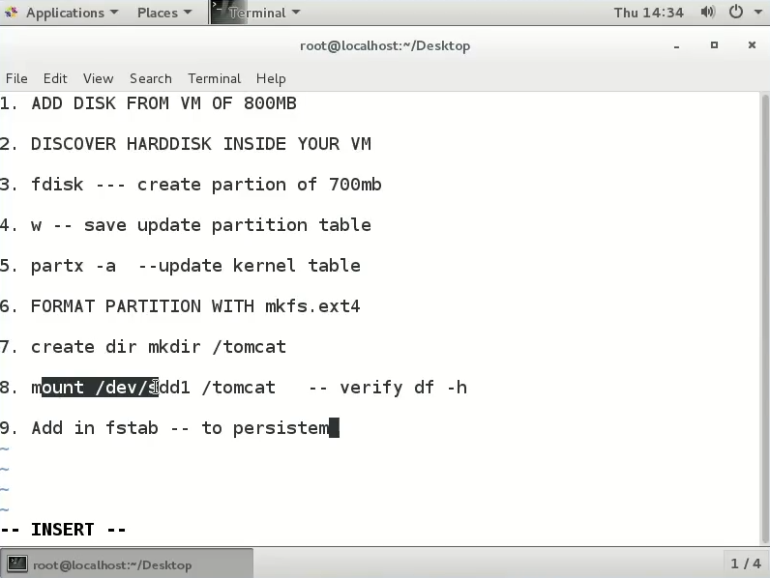

To check the attached Hard Disks and partitions

$ fdisk -l

To check newly added HD

$ ls /dev/sd <ENTER>

To check size of the HD

$ fdisk -l /dev/sdd

**$ echo “- - -” > /sys/class/scsi_host/host0/scan**

**\*if newly added HD is not detecting run above mentioned command to detect it**

$ fdisk /dev/sdd

-it takes into the new HD and run fdisk utility on the particular disk.

After all the step of adding required partitions

$ partx -a /dev/sdd <ENTER>

*partx command updates Kernel table

Now format the partitions i.e create file system

$ mksf.ext4 /dev/sdd1

Now mounting the partitions

Our requirement is to make “tomcat” as label of partition

$ mkdir /tomcat

$ mount <device_driver> <mount_point/directory_name>

$ mount /dev/sdd1 /tomcat