1. Unusual port

We evaluated the system and there is no unusual port listening on the server specially for port 1389

  
2.

Checked for process which anything looks suspicious on the target

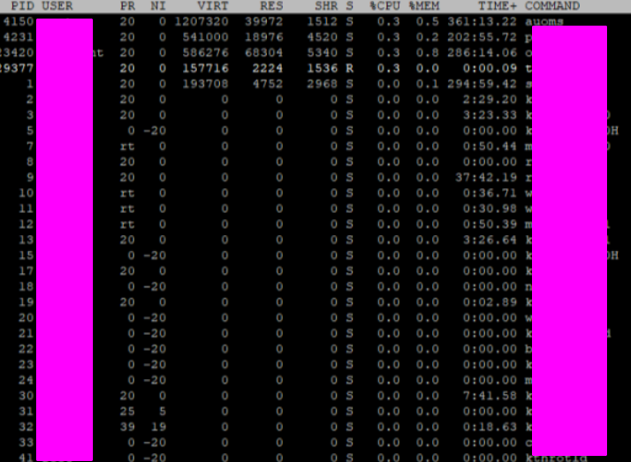  
  
  
3. checked for unusual files which attacker might do to create backdoor.

4. Checked for potential changes an attacker might have made to add new user accounts to the system

  
  
5. checked for unusual network entry

