- Student Management System Report Project
- Project Overview
- The Student Management System (SMS) is a sophisticated web platform designed to streamline academic administration. The system manages the entire student lifecycle, from initial registration to department allocation and final result generation. By integrating PHP for backend processing and a relational MySQL database, it provides a robust environment for managing large volumes of academic data through an intuitive, modern interface.
- User Authentication System
- Access to the administrative panel is protected by a secure login and registration system. The "Create Account" module allows new administrators to register, while the "Welcome Back" login interface validates credentials against the database. This ensures that sensitive student records and academic marks are only accessible to authorized users.
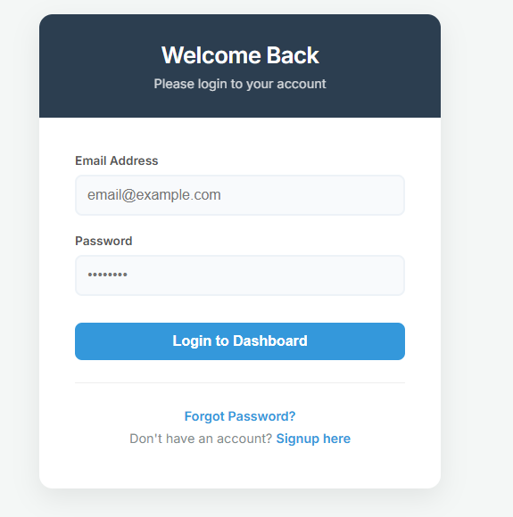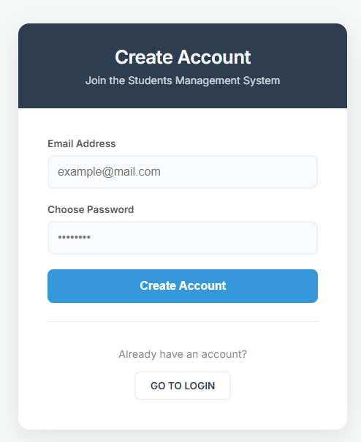
- Main Administrative Dashboard
- The dashboard serves as the central control room for the SMS. It features a "System Overview" with dynamic counters that display the current number of students, departments, and active programs. The dashboard provides "Quick Actions" for registering new students and viewing results, ensuring that common tasks are accessible with a single click.
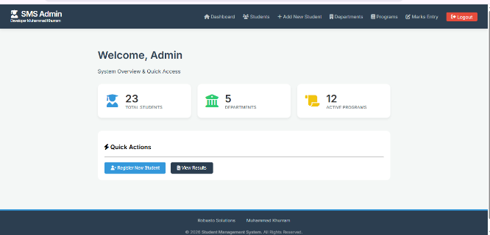
- Database Schema and Tables
- The system is powered by a comprehensive database named students_db. It utilizes ten core tables to maintain data integrity and relationships:
- users: Manages administrator login credentials and account settings.
- web_students: Stores the primary profile and personal data of enrolled students.
- st_departments: Contains the list of academic departments and their respective heads.
- st_programs: Defines the various study programs (e.g., BSCS, ADS) offered by the institution.
- st_sessions: Records academic sessions (e.g., Fall-2023, Spring-2024).
- st_semesters: Tracks the specific semesters within each program.
- st_courses: Maintains a master list of all available subjects and courses.
- st_student_courses: Maps specific students to the courses they are enrolled in for the current term.
- st_marks: Stores the individual scores for Mid-term, Final, and Sessional assessments.
- st_results: Contains finalized academic records and calculated grades for transcripts.
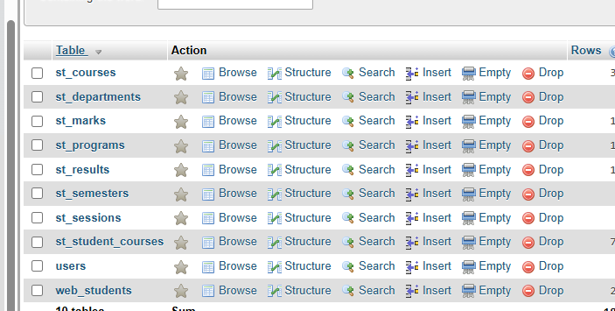
- Student Registration and Management
- The Registration module captures comprehensive student data, including unique Registration Numbers, personal details, and academic placements. The "Student Updation" form allows for real-time editing of existing records, including the ability to update profile pictures or change contact information, ensuring that the database remains current.
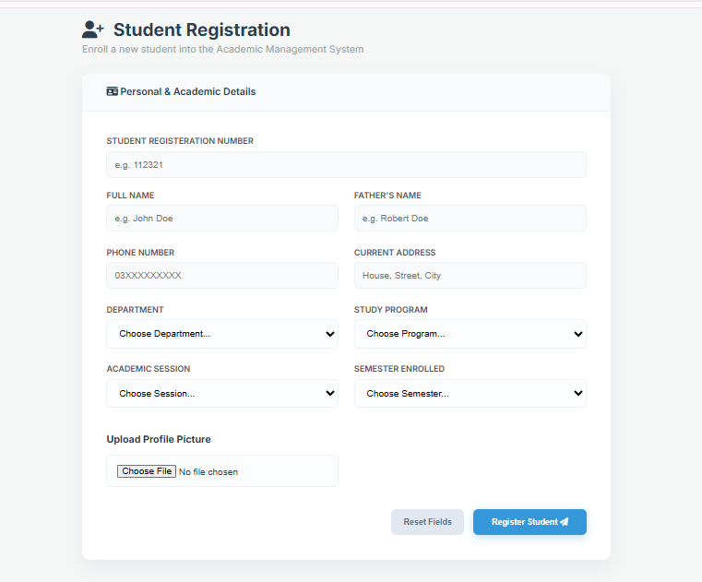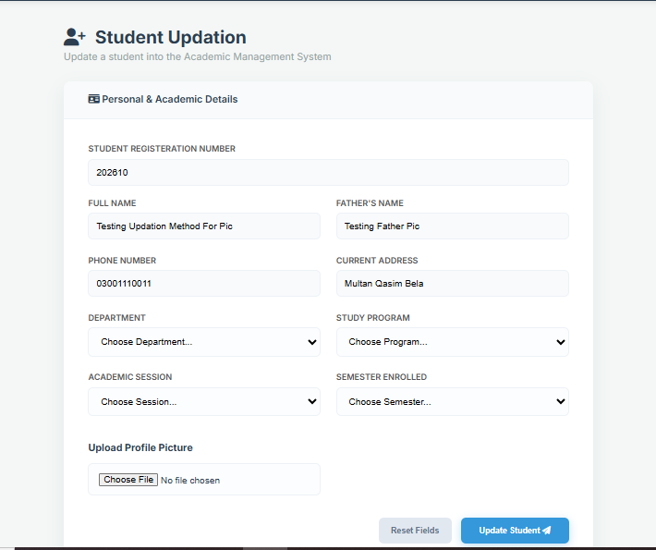
- Academic Organization (Departments and Programs)
- The application provides detailed views for managing the academic hierarchy. The Department Overview displays the status of various faculties, while the Programs Overview tracks student enrollment across different degrees. Each view includes options to edit or delete records, allowing for flexible management of the university's academic structure.
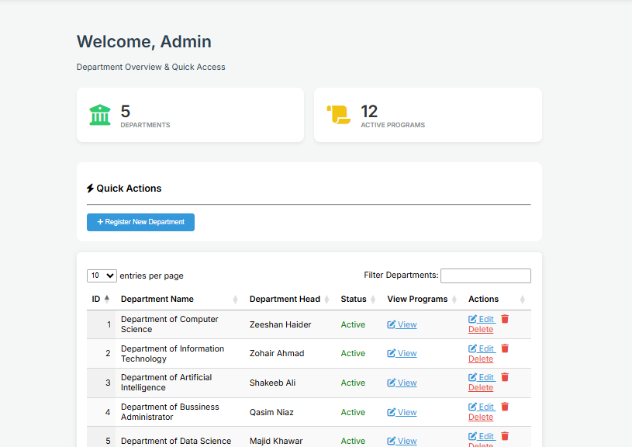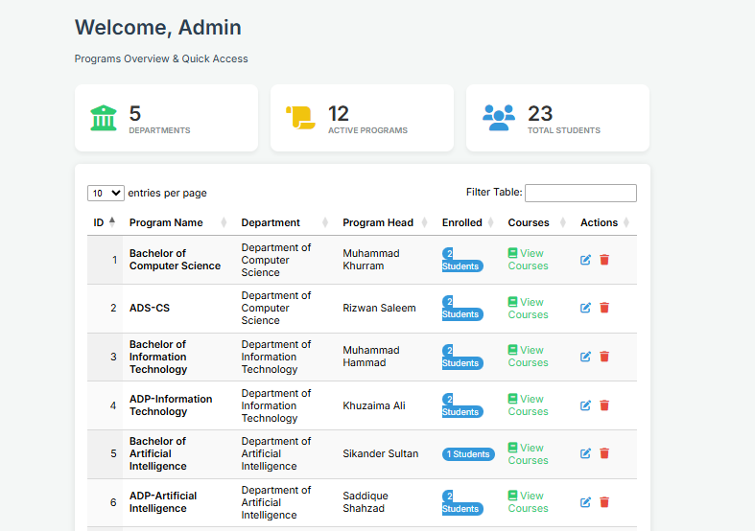
- Marks Entry and Results System
- This module automates the grading process. By searching for a student’s Roll Number, the system retrieves the specific courses linked to them via the st_student_courses table. Administrators enter marks for Mid (30), Final (50), and Sessional (20) components. Once submitted, the system processes these values to generate finalized academic results stored in the st_results table.
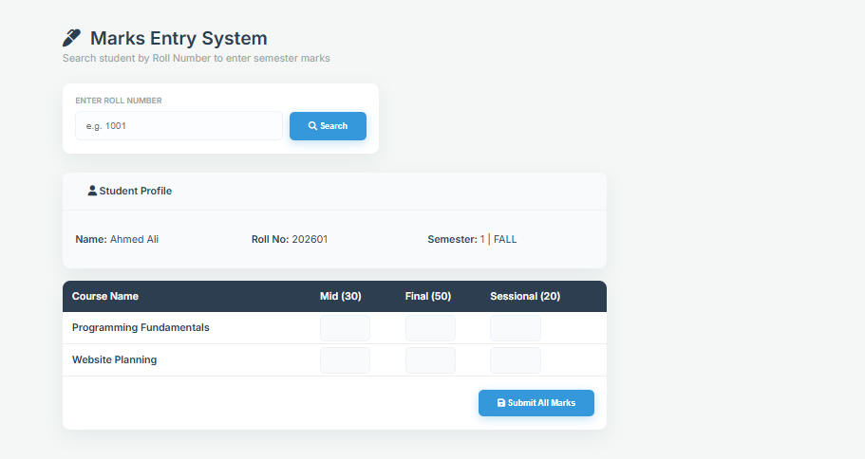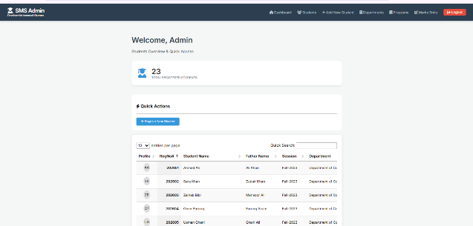
- Technical Architecture
- The system is built using a modular approach:
- Backend: PHP scripts handle logic, session management, and database CRUD operations.
- Frontend: HTML and CSS provide a clean, professional aesthetic with responsive layouts.
- Data Management: SQL queries are optimized to fetch related data across multiple tables (JOINs) to provide a unified view for the administrator.
- Conclusion
- The Student Management System successfully integrates all aspects of academic record-keeping into a single digital platform. By using a structured database and a user-friendly interface, it eliminates the need for manual paperwork, improves data accuracy, and provides administrators with a powerful tool for academic oversight and student success tracking.

