**The University of Azad Jammu and Kashmir, Muzaffarabad**



|  |  |
| --- | --- |
| **Submitted to:** | **Engr. Sidra Rafique** |
| **Course Title:** | **Operating System** |
| **Course Code:** | **SE-3205** |
| **Session:** | **2022-26** |
| **Semester:** | **6th** |
| **Roll No:** | **2022-SE-01** |
| **Submitted from:** | **Khurram Farman** |
| **Lab Task No** | **2** |
|  |  |

**Bachelors of Science in Software Engineering (2022-26)**

**Department of Software Engineering**

Contents

Topic: Command Prompt Commands 3

Command Prompt: 3

Commands: 3

➢ Wmic logicaldisk get name. 3

➢ Dir 3

➢ Disk Name: (e.g. D :) 4

➢ Cls 4

➢ Title 4

➢ Vol 5

➢ Whoami 5

➢ Help 5

➢ Ipconfig/all 6

➢ Ping 6

➢ Tracert: 7

➢ Netstat: 7

➢ Arp: 7

# Topic: Command Prompt Commands

## Command Prompt:

The **Command Prompt**, often referred to as CMD, is a command-line interface tool available in Microsoft Windows. It enables users to interact directly with the operating system by typing specific commands, allowing greater control over file management, system settings, and troubleshooting tasks. Unlike the graphical user interface (GUI), Command Prompt offers a more efficient way to perform advanced operations such as navigating directories, running scripts, and diagnosing network issues. It serves as a powerful tool for both everyday users and IT professionals, making it an essential component of the Windows operating system.

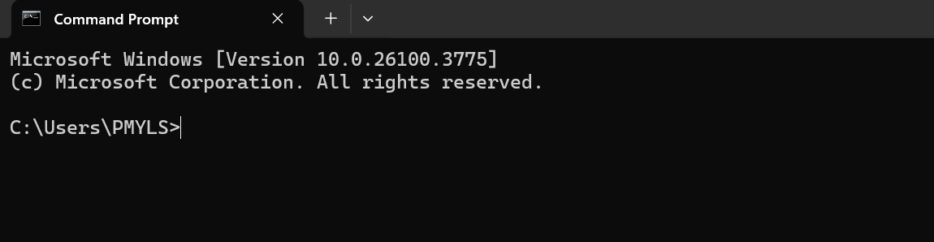

Figure : Command Prompt

## Commands:

### Wmic logicaldisk get name.

The command wmic logicaldisk get name is used to display all the logical drives present on a Windows system. It provides a quick overview of the drive letters (like C: D: etc.) assigned to different storage devices or partitions connected to the computer.

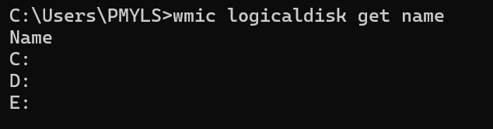

Figure : System Disks

## Dir

The dir command in Command Prompt is used to display a list of files and folders within the current directory.

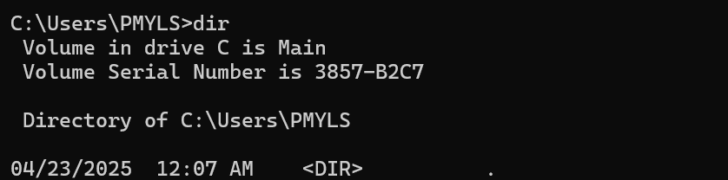

Figure : dir

## Disk Name: (e.g. D :)

Typing a **disk name followed by a colon** (e.g., D :) in Command Prompt is used to switch to that specific drive.

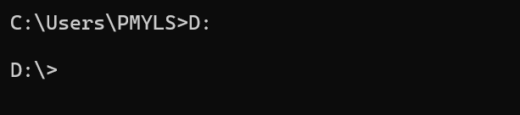

Figure : Disk Name:

## Cls

The cls command is used to clear all the text and commands currently displayed in the Command Prompt window.

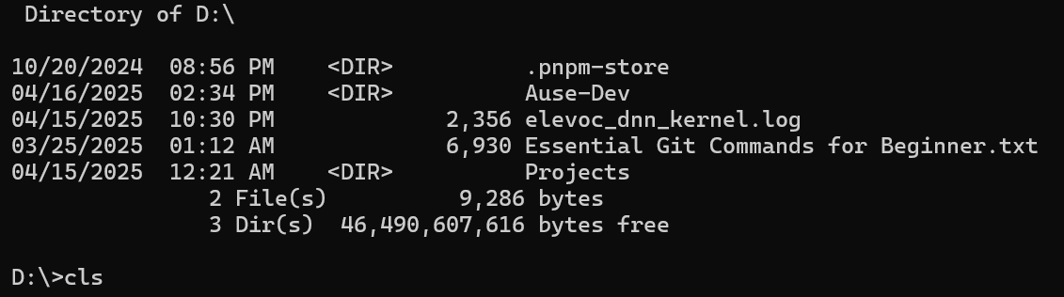

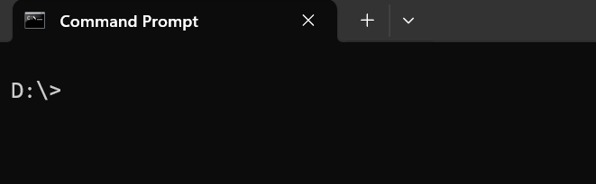

Figure : cls

## Title

To change the title of the command prompt:

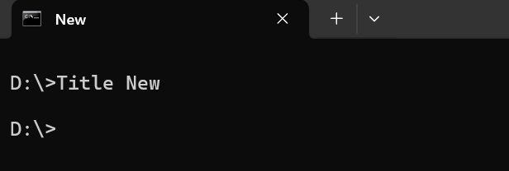

Figure : Title

## Vol

The vol command displays the volume label and serial number of the specified disk drive. It helps users identify the drive’s unique information, especially useful for verifying disk identity.

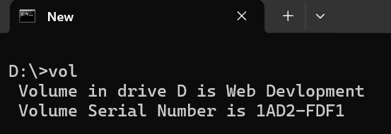

Figure : vol

## Whoami

The whoami command displays the current user’s username that is logged into the system. It is useful for confirming which user account is running the Command Prompt session.

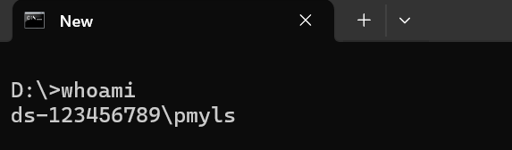

Figure : Whoami

## Help

The help command provides a list of available Command Prompt commands along with a brief description of each. It is useful for beginners to understand what commands are available and how they are used.

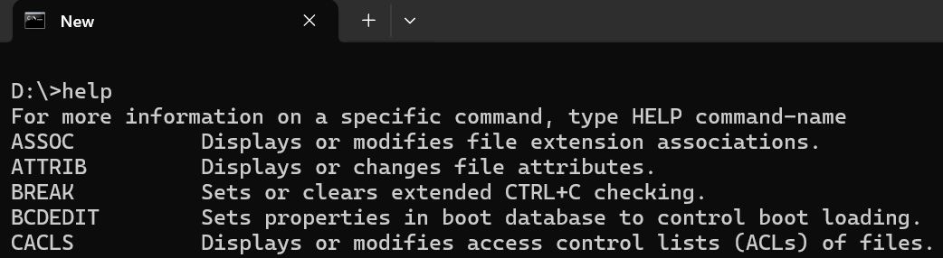

Figure : help

## Ipconfig/all

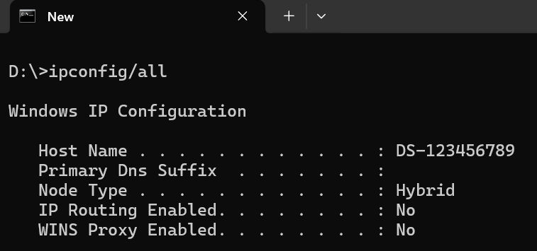

Figure : ipconfig

## Ping

Checks connectivity between you and a target host.

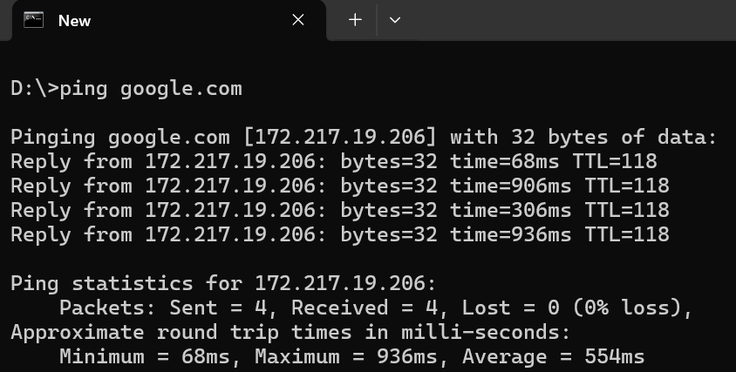

Figure : ping

## Tracert:

Traces the route packets take to a destination.

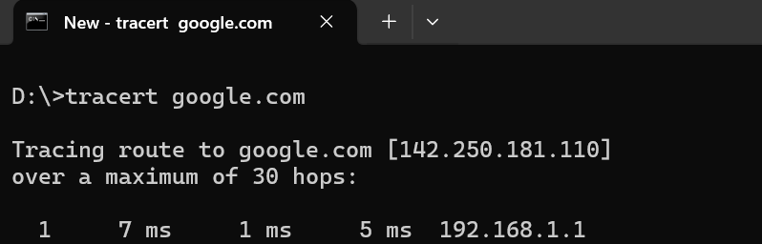

Figure : tracert

## Netstat:

Shows active connections and listening ports.

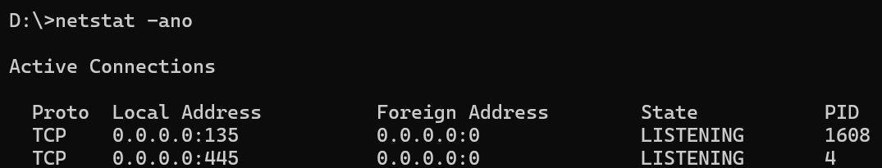

Figure : netstat

## Arp:

Displays the ARP table (IP ↔ MAC address mappings).

