**The University of Azad Jammu and Kashmir, Muzaffarabad**



|  |  |
| --- | --- |
| **Submitted to:** | **Engr. Sidra Rafique** |
| **Course Title:** | **Operating System** |
| **Course Code:** | **SE-3205** |
| **Session:** | **2022-26** |
| **Semester:** | **6th** |
| **Roll No:** | **2022-SE-01** |
| **Submitted from:** | **Khurram Farman** |
| **Lab Task No** | **4** |
|  |  |

**Bachelors of Science in Software Engineering (2022-26)**

**Department of Software Engineering**

Contents

Installation of VMware: 3

Step-by-Step Installation Process: 3

1. Download VMware Workstation: 3

2. Run the Installer: 3

3. Accept the License Agreement: 4

4. Choose Installation Folder: 4

5. Customize Shortcuts: 5

6. Begin Installation: 5

7. Complete the Installation: 6

8. Launch VMware Workstation: 6

# Installation of VMware:

## Step-by-Step Installation Process:

### ****Download VMware Workstation****:

* Visit the official VMware website.
* Hover over the "Downloads" tab and select "Workstation Pro" or "Workstation Player" depending on your needs.
* Click on "**Free Trials & Demos**" and then "Workstation Pro" to download the installer.

### ****Run the Installer****:

* Once the download is complete, locate the installer file in your ‘**downloads’** folder and double-click it to start the installation process

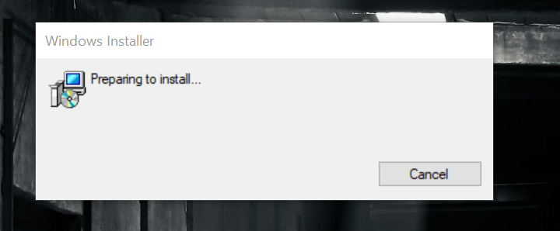

* Choose next to get start with the wizard.

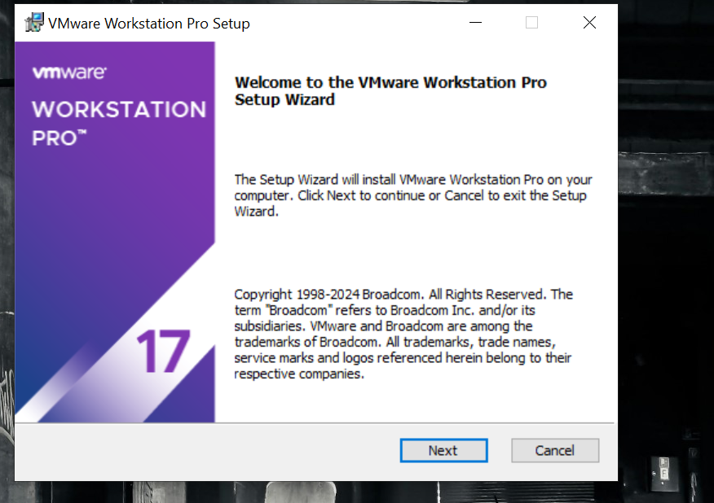

### ****Accept the License Agreement****:

* 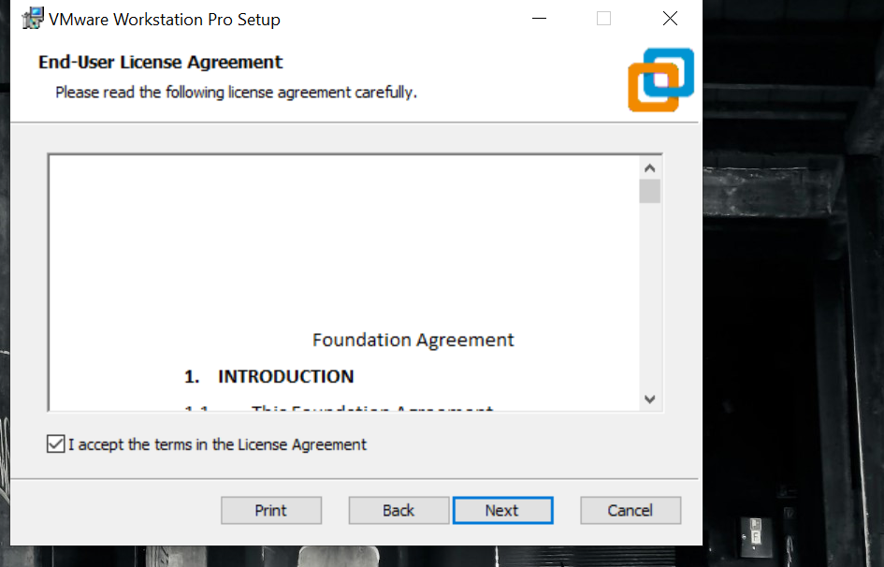The installer will prompt you to accept the license agreement. Read and accept it to proceed.

### ****Choose Installation Folder****:

* Select the directory where you want VMware Workstation to be installed. You can use the default location or choose a custom path.

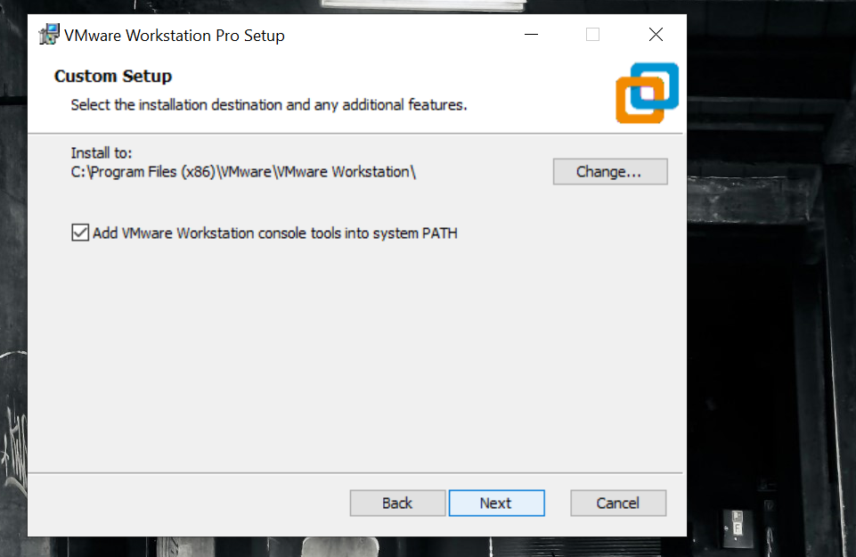

### ****Customize Shortcuts****:

* Decide if you want shortcuts to be created on the desktop or in the start menu.

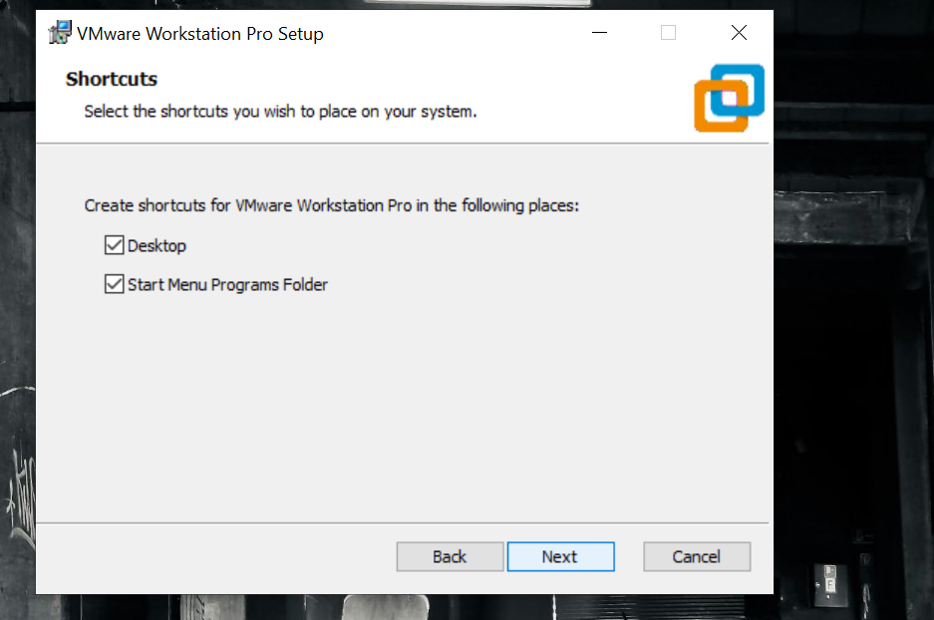

### ****Begin Installation****:

* Click on the "Install" button to start the installation process.

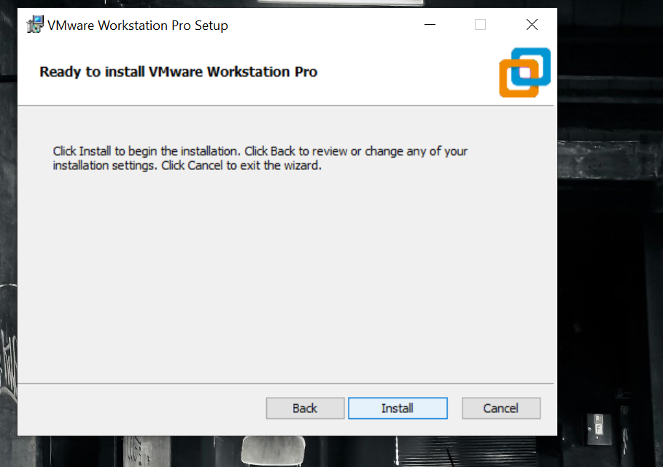

### ****Complete the Installation****:

* The installer will complete the installation and prompt you to restart your computer.

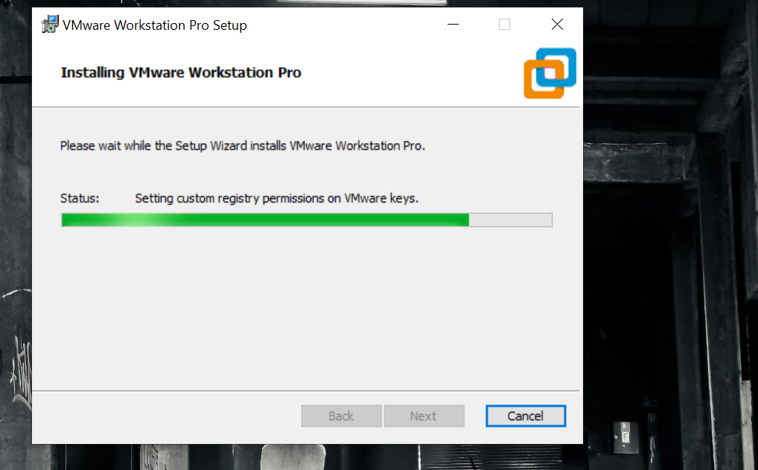

### ****Launch VMware Workstation****:

* After restarting, open VMware Workstation from the start menu or desktop shortcut to begin using it.

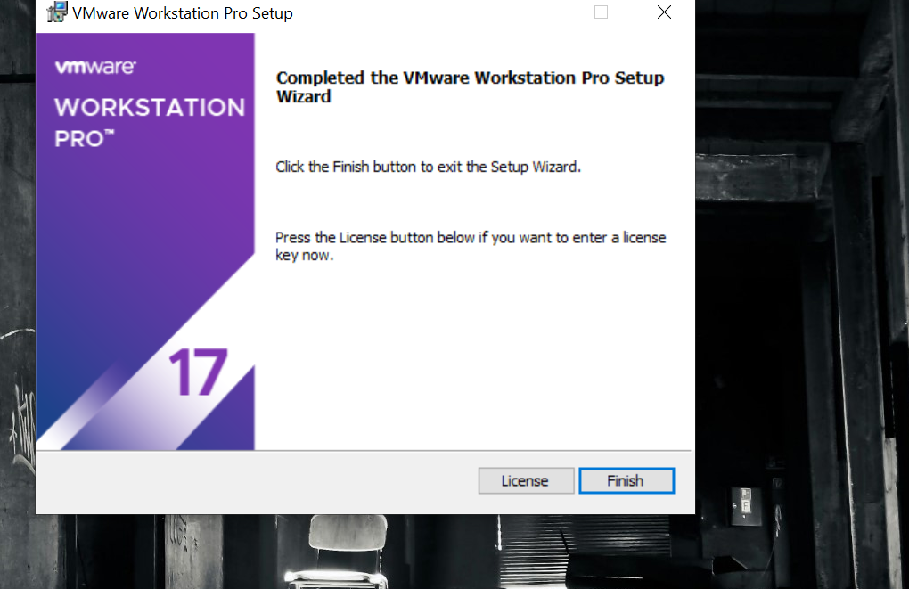

* Now you are ready to get started.

