**The University of Azad Jammu and Kashmir, Muzaffarabad**



|  |  |
| --- | --- |
| **Submitted to:** | **Engr. Sidra Rafique** |
| **Course Title:** | **Operating System** |
| **Course Code:** | **SE-3205** |
| **Session:** | **2022-26** |
| **Semester:** | **6th** |
| **Roll No:** | **2022-SE-01** |
| **Submitted from:** | **Khurram Farman** |
| **Lab Task No** | **5** |
|  |  |

**Bachelors of Science in Software Engineering (2022-26)**

**Department of Software Engineering**

# Installation of VMware:

## Debian in VMware

Debian in VMware refers to installing the Debian operating system, a popular Linux distribution, on a virtual machine created with VMware. This allows users to run Debian as a guest OS alongside other operating systems without dual-booting. It's commonly used for development, testing, or learning purposes in a virtualized environment.

## Step by Step Installation of Debian Linux in VMware

1. To create a new virtual machine in VMware, open the software, click Create a New Virtual Machine, select Custom (advanced) in the wizard, and click Next to proceed.

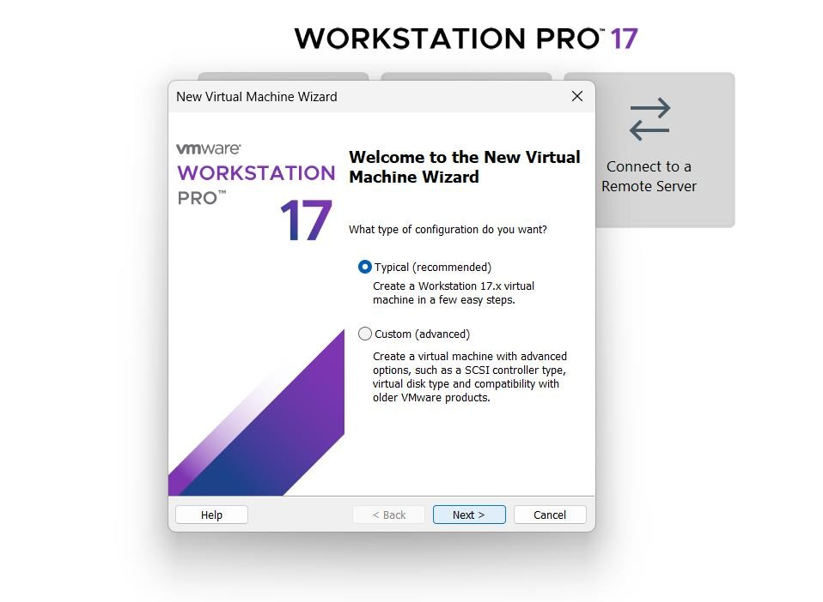

1. Set the Debian VM's hardware compatibility to 17.x. If you upgrade the Workstation software, update this setting to match the new version. Updating hardware compatibility improves performance and helps avoid future issues.

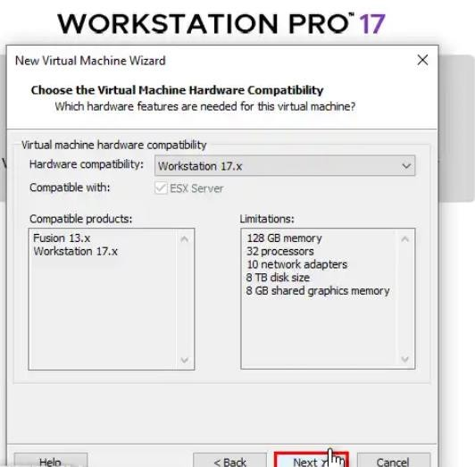

1. In the Guest OS Installation wizard, select "I will install the operating system later"and click **Next** to proceed. This allows you to install the operating system later.

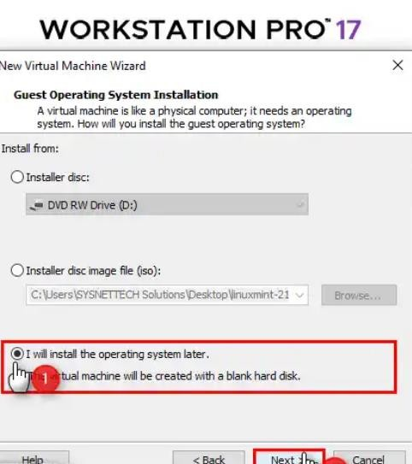

1. In this window, select the operating system type and version. Choose **Linux** as the OS type and **Debian 12.x 64-bit** from the Version section.

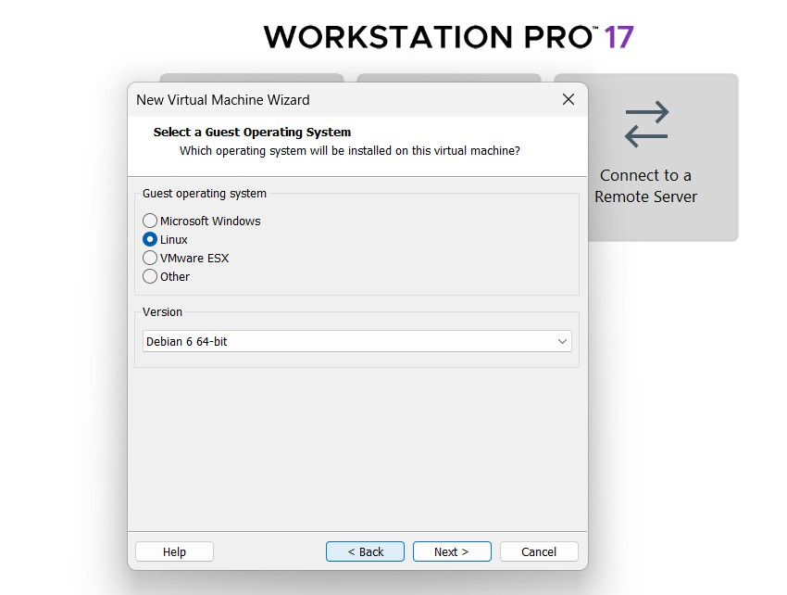

1. In this window, type a name for your Debian virtual machine and select a location to store it. Store the virtual machine on an external SSD using a mechanical disk for better performance, especially on older PCs. This can significantly improve performance.

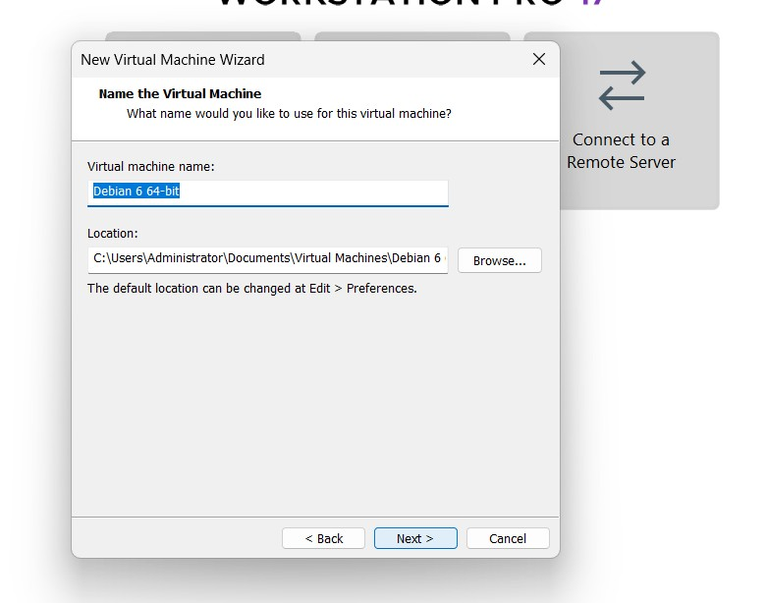

1. In the CPU Configuration, choose settings that match your processor's power and your PC's capacity. A well-chosen setup improves VM performance. Once configured, click **Next** to continue.

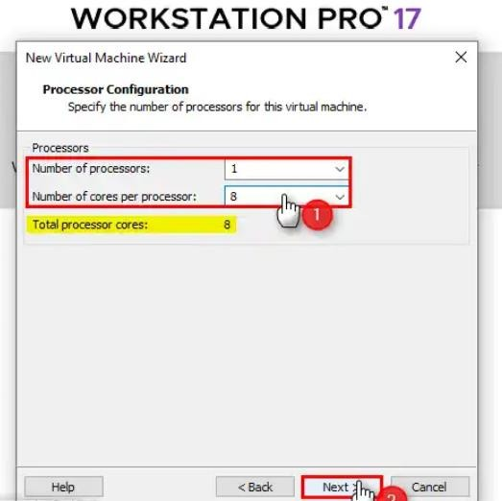

1. In the Memory window, choose a value based on your host PC's RAM size. Setting this value correctly will help improve your VM's performance.

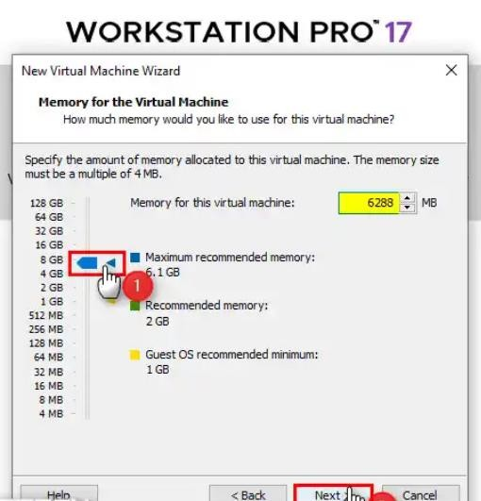

1. In the Network Type window, the default option is NAT, which you can use. If you've set up a Bridged network in the Virtual Network Editor, you can select that option instead.

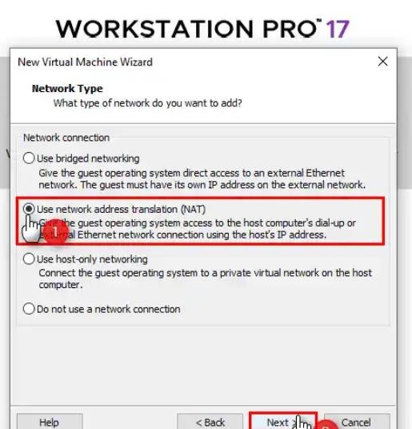

1. In the Controller Type window, keep the default option (LSI Logic) selected and click Next to continue.

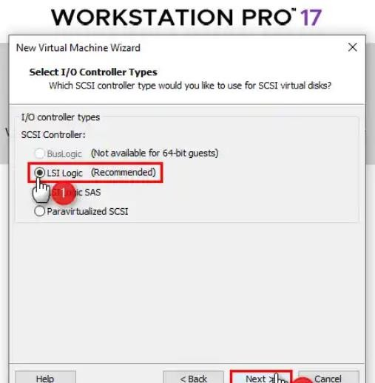

1. Select NVMe as the virtual disk type, as it is the latest technology. For older Debian systems, check if NVMe is supported. If not, switch the disk type to SATA or SCSI.

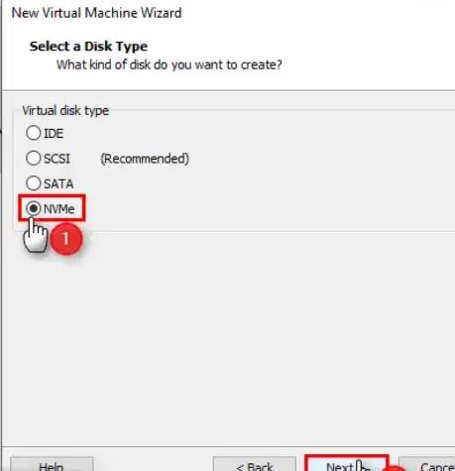

1. In the Select a Disk window, choose Create a new virtual disk to start installing Debian from scratch. Alternatively, if you have a pre-existing virtual disk, select Use an existing virtualdisk to use a VMDK file instead of the Debian ISO.

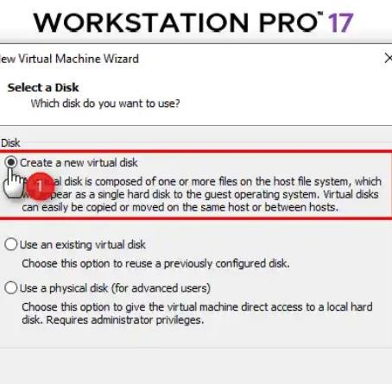

1. In the Specify Disk Capacity section, set the size of the virtual disk and check the option to store the disk as a single file. This helps improve the VM's read and write speeds.

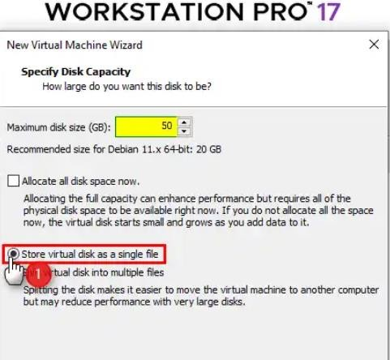

1. In this window, you can change the location where the virtual disk file will be stored. This setting only affects the location of the virtual disk being created.

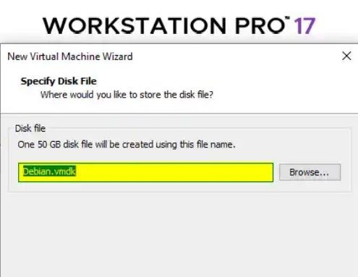

1. In this window, you can change the location where the virtual disk file will be stored. This setting only affects the location of the virtual disk being created.

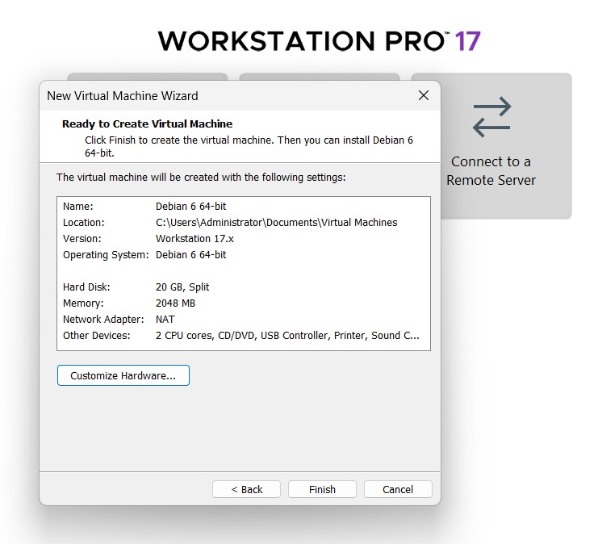

1. After selecting the Processor device, locate the Virtualization Engine section on the right.

Enable the following three options:

* + Virtualize Intel VT-x/EPT or AMD-V/RVI
  + Virtualize CPU Performance Counters
  + Virtualize IOMMU (IO Memory Management Unit)

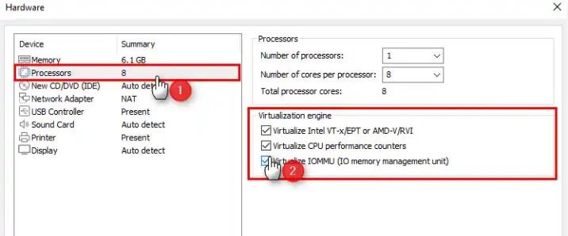

1. To add the Debian 12 ISO file to the virtual machine:
   * Click on the CD/DVD option.
   * Select Use ISO image file.
   * Click Browse and locate the Debian 12 ISO file to add it.

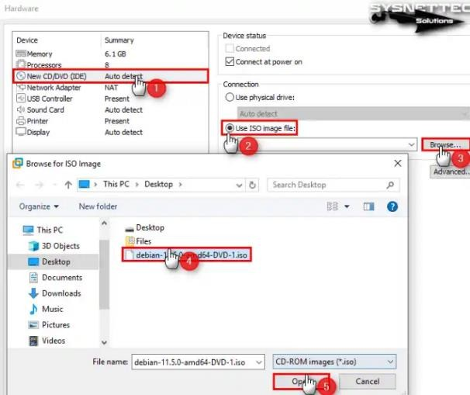

1. To enable faster file transfers in your Debian virtual machine, change the USB Controller device's Compatibility setting to USB 3.1.

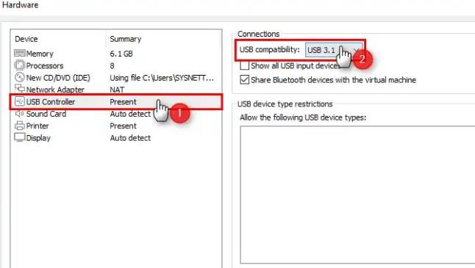

1. Finally, configure the Display virtual hardware by enabling Accelerate 3D Graphics. Additionally, set the video memory to a size that your host system can support for optimal performance.

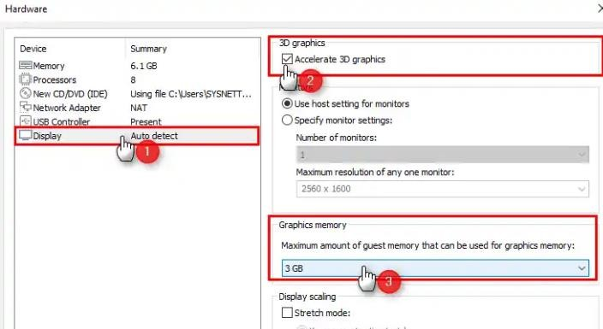

1. You have completed configuring all the settings for your Debian virtual machine. Review the settings in the summary window one last time, and then close the wizard to finish.

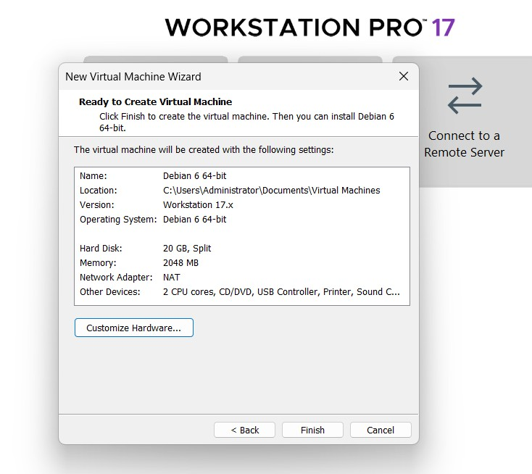

1. You have successfully prepared a new virtual system for the Debian distribution. To start the system installation, power up the virtual machine by clicking the green Power icon.

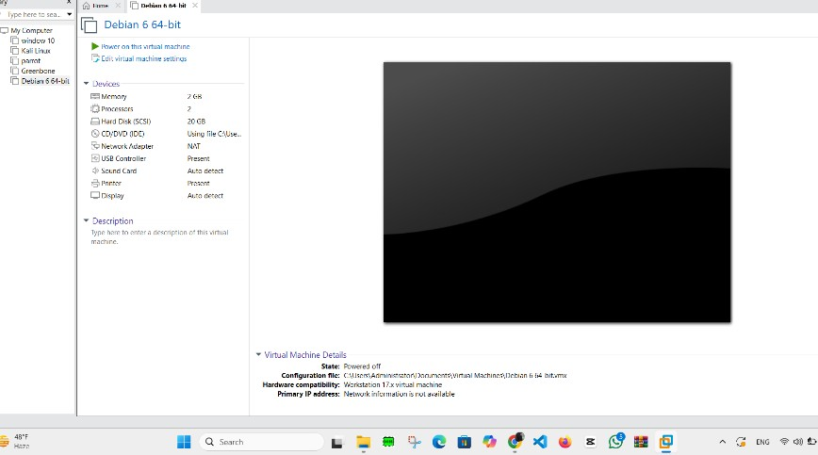

1. First, start your Debian OS in Workstation Pro. Once the GNU/Linux installer menu appears in BIOS mode, select Graphical Install and press Enterto begin the installation.

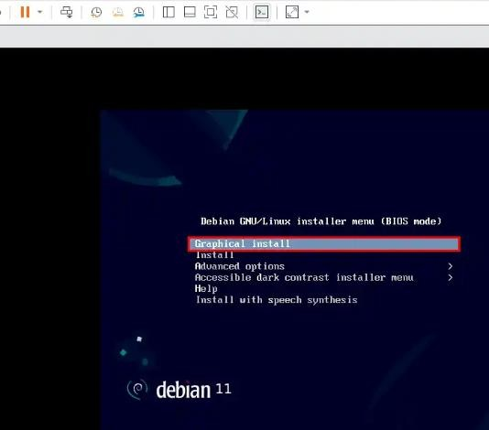

1. Now, select the system language for your Debian, then press Continue.

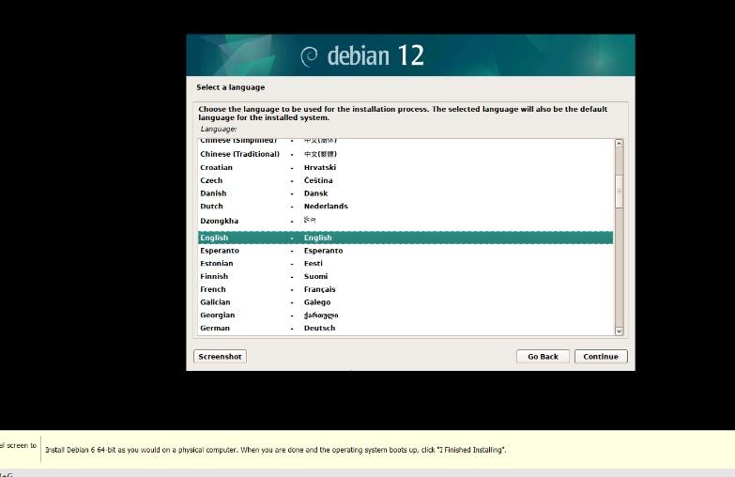

1. In the “Select your location” area, pick your country and click Continue.

 