**The University of Azad Jammu and Kashmir, Muzaffarabad**



|  |  |
| --- | --- |
| **Submitted to:** | **Engr. Sidra Rafique** |
| **Course Title:** | **Operating System** |
| **Course Code:** | **SE-3205** |
| **Session:** | **2022-26** |
| **Semester:** | **6th** |
| **Roll No:** | **2022-SE-01** |
| **Submitted from:** | **Khurram Farman** |
| **Lab Task No** | **6** |
|  |  |

**Bachelors of Science in Software Engineering (2022-26)**

**Department of Software Engineering**

**Exploring the GUI in VMware**

In this part, you will install the Virtual Box guest additions and explore the Debian GUI.

1. Open the VMware.
2. First, start your Debian OS in Workstation Pro. Once the GNU/Linux installer menu appears in BIOS mode, select Graphical Install and press Enterto begin the installation.

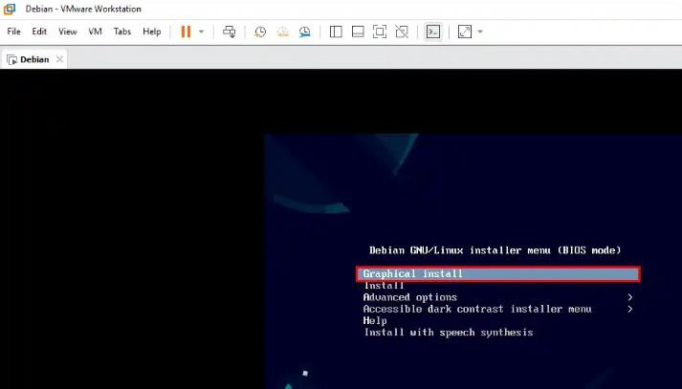

1. In the Configure the Network window, enter a hostname to identify your system on the network. You can use the default hostname provided or specify one that better suits your network environment.

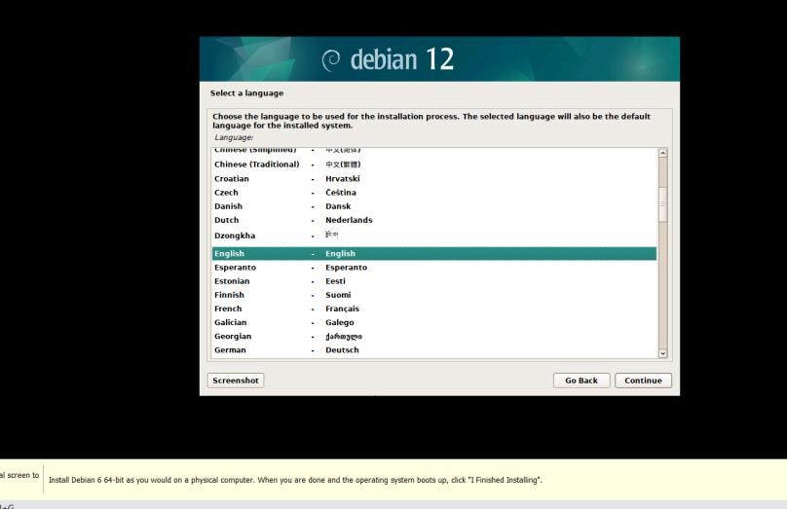

1. In the “Configure the keyboard” section, pick the layout for your host. Then, click Continue to go ahead.

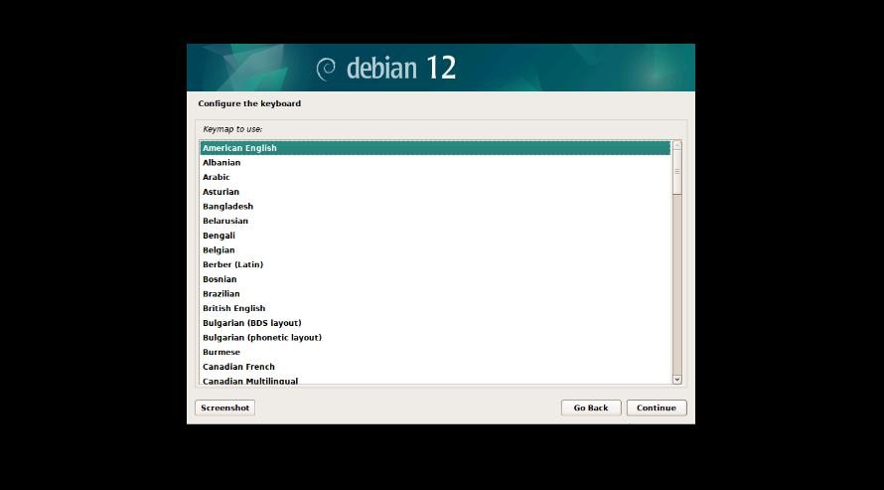

1. In the Configure the Network window, enter a hostname to identify your system on the network. You can either use the default hostname provided or specify one that is appropriate for your network environment.

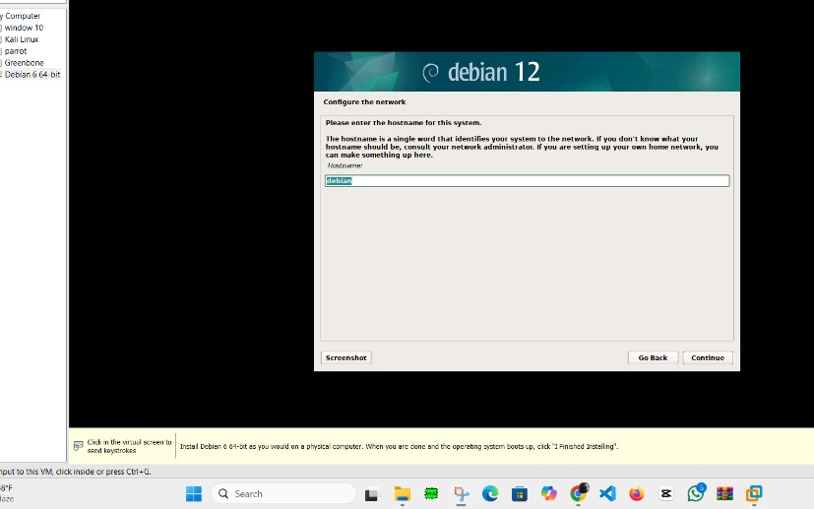

1. If you are a home user, you can leave the Domain Name section blank.

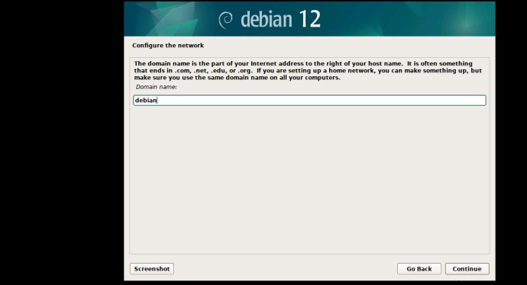

1. In this step, create a strong password for the Root account of your Debian system and press Continue.

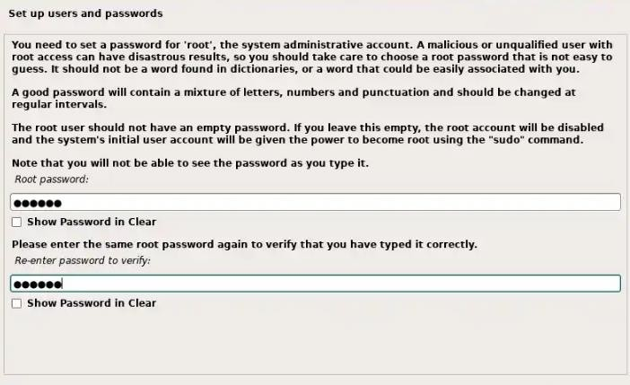

1. In the Configure the Network window, enter a hostname to identify your system on the network. You can either use the default hostname provided or specify one that is appropriate for your network environment.

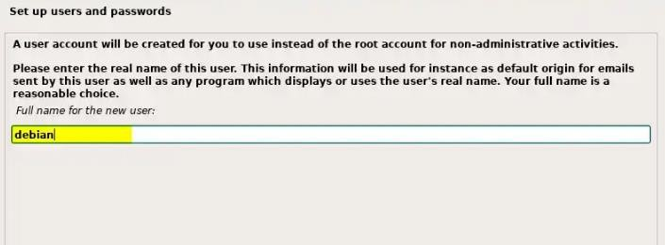

1. In the Set up users andpasswords window, create a new user account instead of using the Root account. Enter your full name or another name for non-administrative tasks.

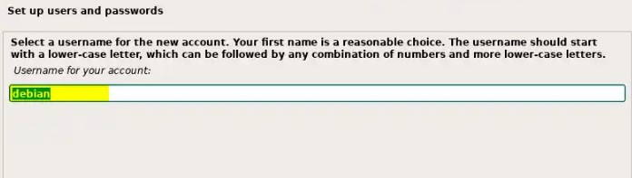

1. I recommend that you add a password to the new user account you created. Therefore, write a strong password in both text fields here.

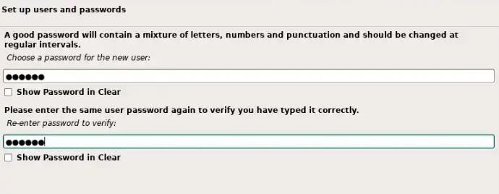

1. Proceed by adjusting your time zone based on your location on the map provided.

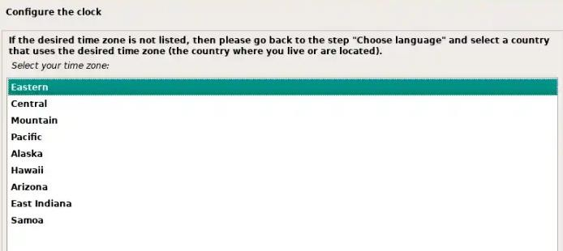

1. Let’s say you are going to use the Linux/Debian system for the first time. In this case, continue with the Guided – Use Entire Disk in Partition Disks window.

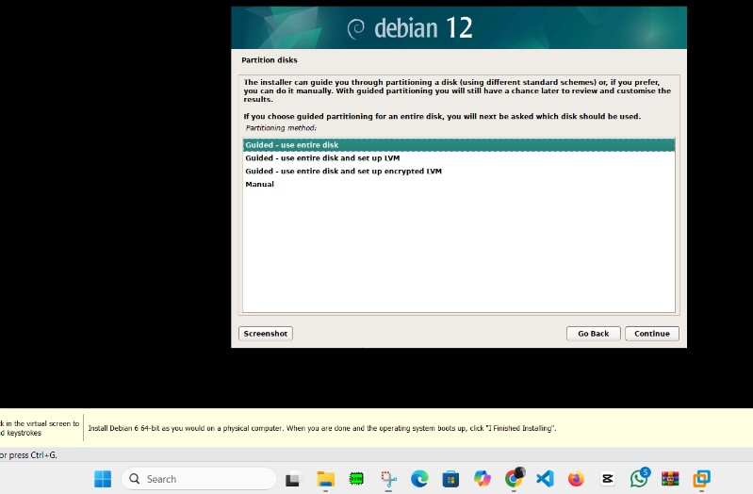

1. At this stage, select the virtual disk (vdisk) you want to partition. Creating separate partitions for different uses will help you manage disk space more efficiently.

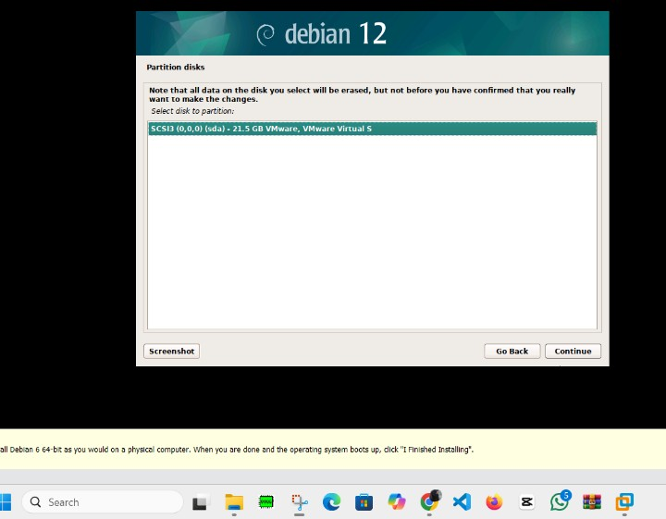

1. In this wizard, you will see three options. If you're a new Debian user, select All files in one partition and press Continue to proceed. Disk settings for your Debian virtual machine. If you need to make any changes to the partitioning, select Go Back. Otherwise, click Continue to move on to the next step. To complete the partitioning, select Finish partitioning and writechanges to disk. This will save all changes to the hard disk.

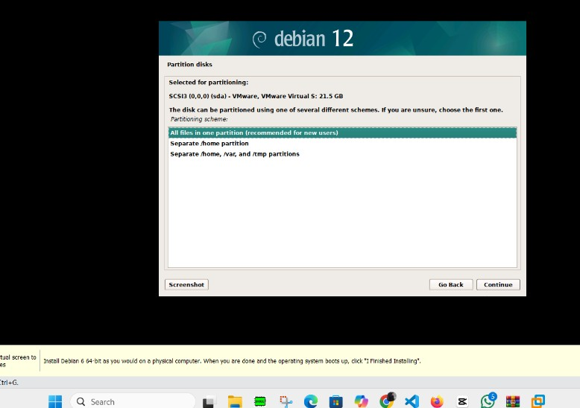

1. Changes made to the virtual NVMe disk need to take effect, so select Yes to continue.

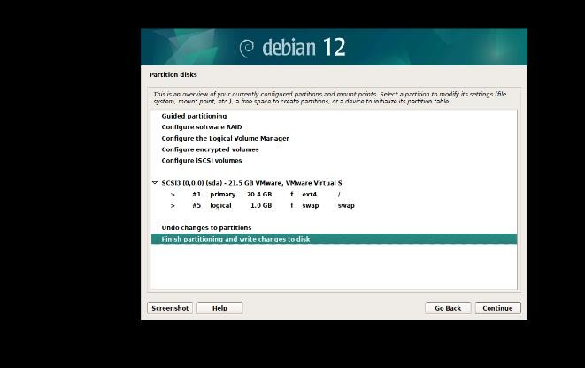

1. You may want to install some extra packages on your Debian system without using the Internet.

If you’re going to scan the DVD media for offline use, check Yes.

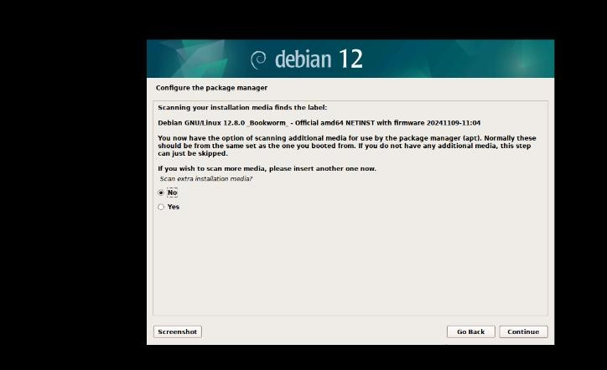

1. In the Debian archive mirror country window, you can select your country for the Network Mirror setting. After that, you can download files faster from servers closer to you.

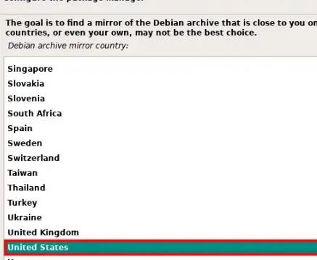

1. We usually choose deb.debian.org for the Debian archive mirror. Honestly, both I and most users think it is safer.

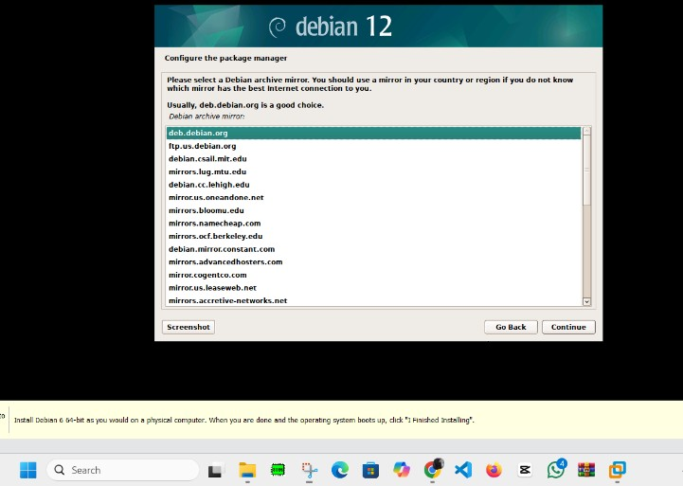

1. If you are using a proxy server in your network environment, you can make the relevant settings here. If you are not going to use something like this, leave the information box blank.

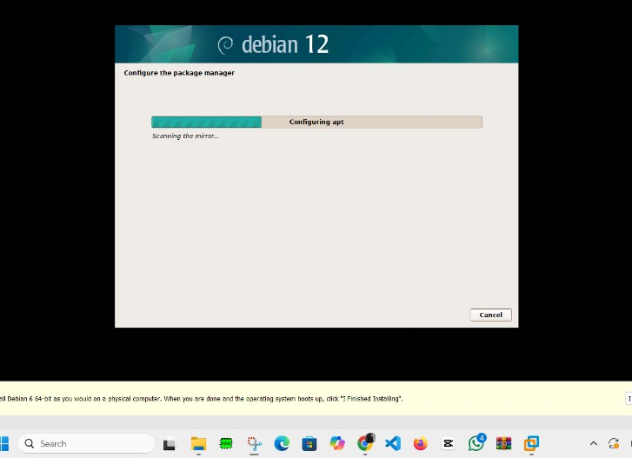

1. In the Software Selection window, choose the desktop environment you prefer (default is GNOME) and click Continue.

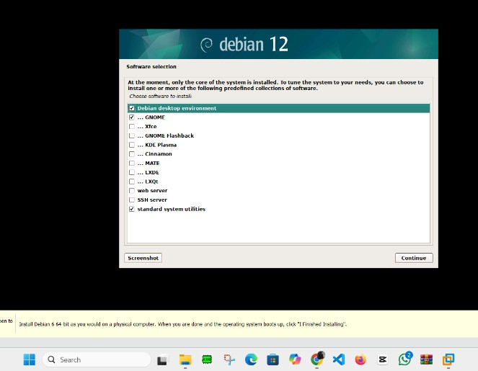

1. Select the /dev/nvme0n1/ drive for the boot loader installation and click Continue.

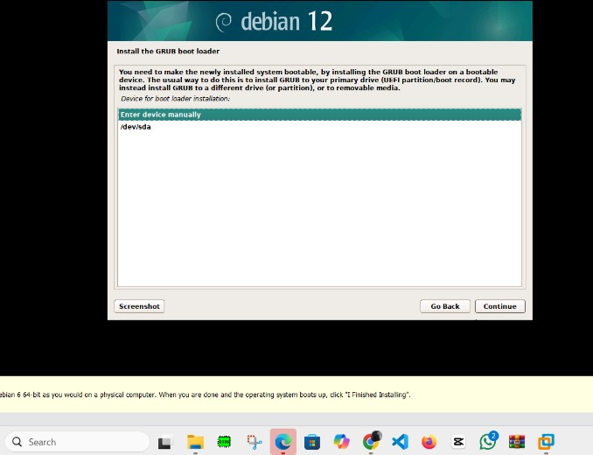

1. After finishing the Debian installation with VMware, you need to do one action. That is, extract the ISO file from your virtualized PC and reboot it.



 