**The University of Azad Jammu and Kashmir, Muzaffarabad**



|  |  |
| --- | --- |
| **Submitted to:** | **Engr. Sidra Rafique** |
| **Course Title:** | **Operating System** |
| **Course Code:** | **SE-3205** |
| **Session:** | **2022-26** |
| **Semester:** | **6th** |
| **Roll No:** | **2022-SE-01** |
| **Submitted from:** | **Khurram Farman** |
| **Lab Task No** | **7** |
|  |  |

**Bachelors of Science in Software Engineering (2022-26)**

**Department of Software Engineering**

# UNIX Commands

## ls Command

Lists the files and directories in the current directory. It helps to view the contents of a directory.

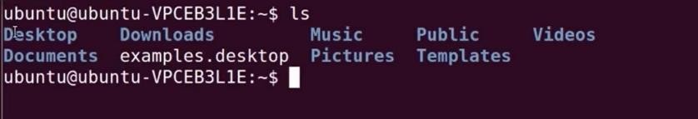

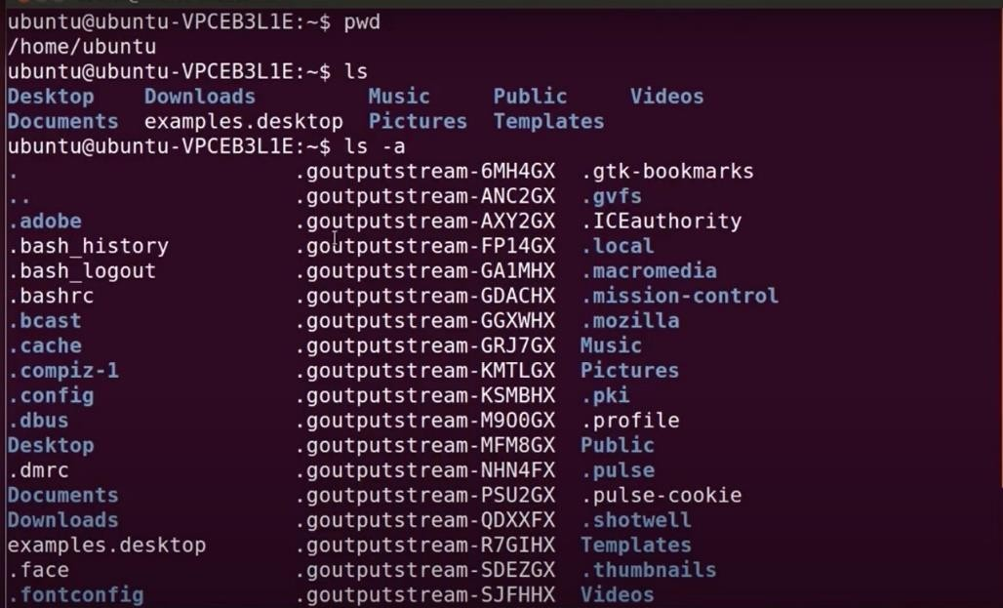

## rmdir Command

Remove Directory. Deletes an empty directory. rmdir <directory-name> removes the specified directory if it is empty.

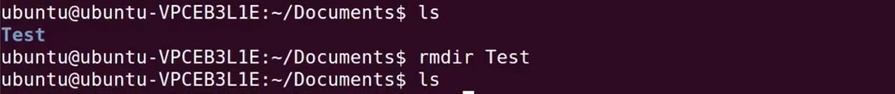

## clear Command

Clears the terminal screen. Removes all the previous output on the terminal to give a clean workspace.

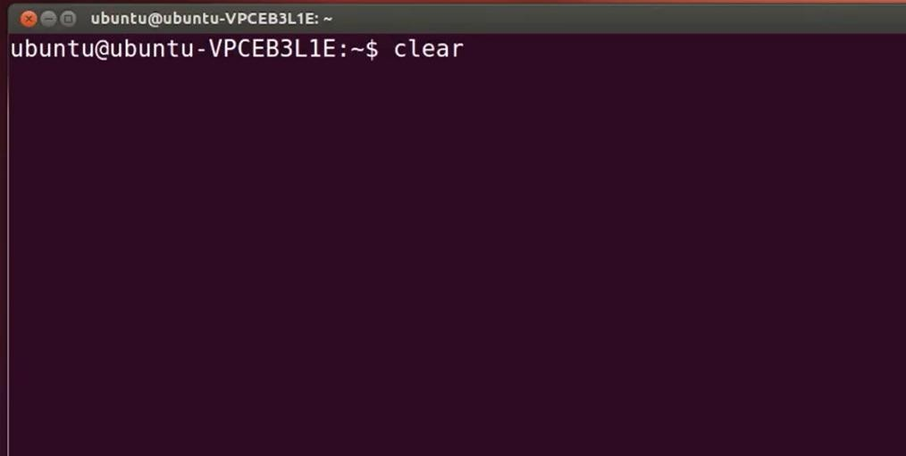

## Pwd Command

Displays the full path of the current working directory. Helps to identify where you are in the directory structure.

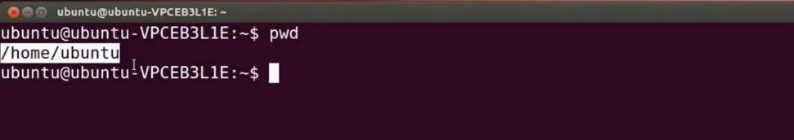

## mkdir Command

Make Directory. Creates a new directory. mkdir <directory-name> creates a directory with the specified name.

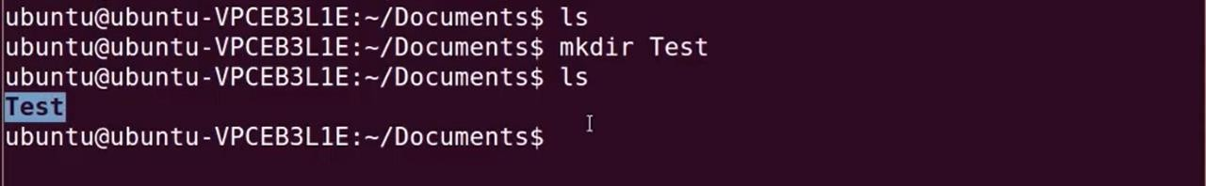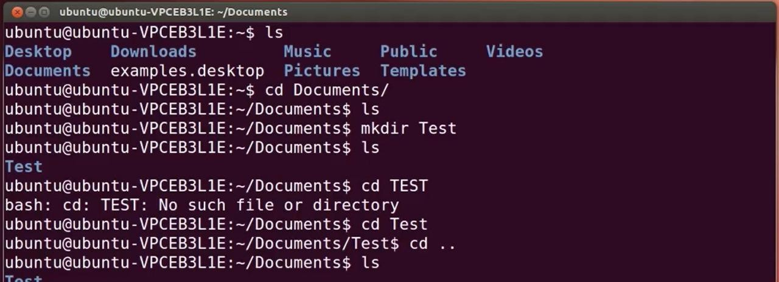

## nano Command

A command-line text editor for creating and editing files. nano <filename> opens or creates the specified file in the nano editor.

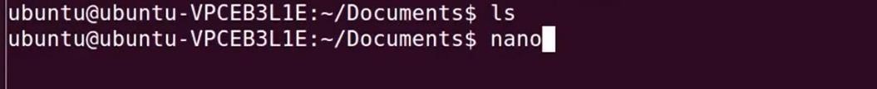

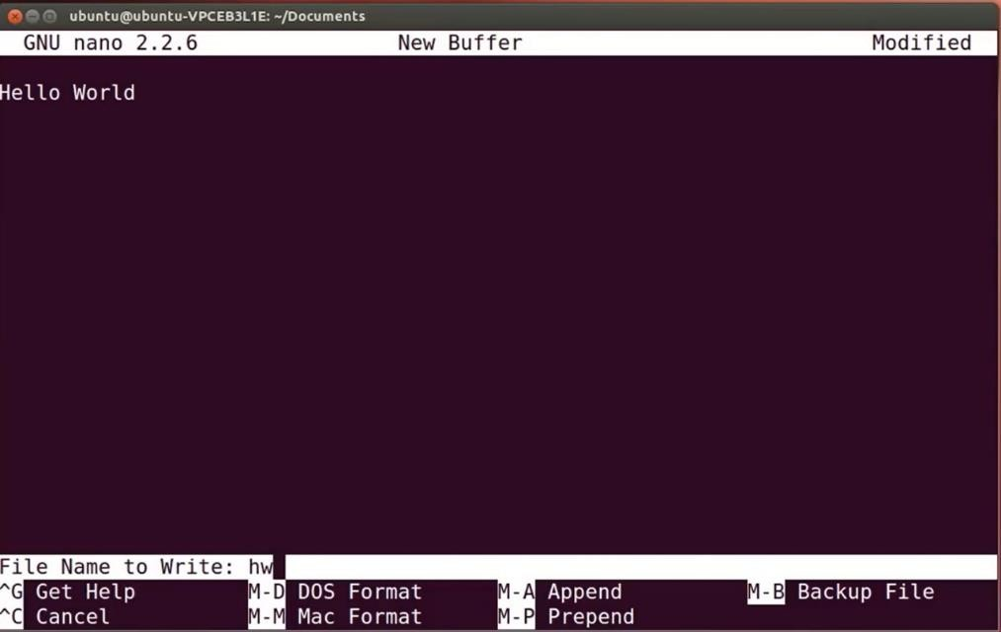

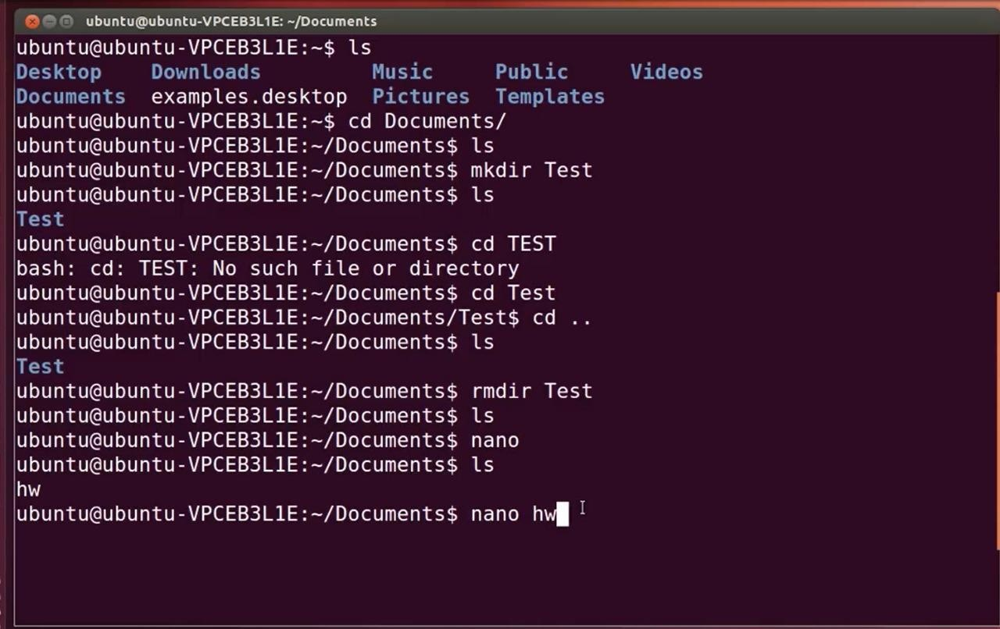

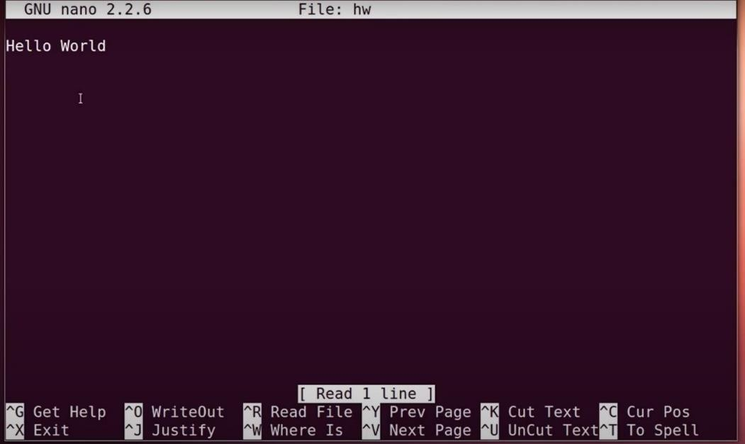

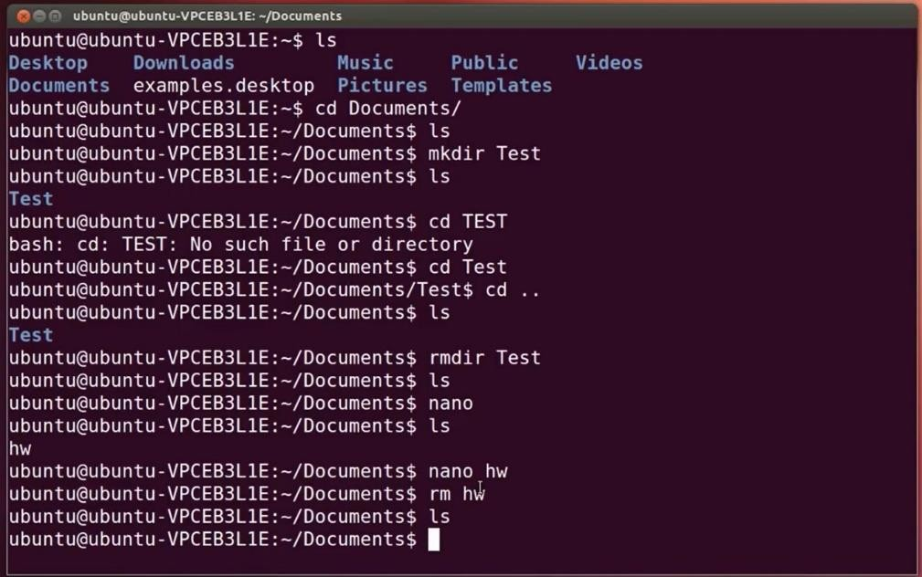

## Command

Change Directory. Used to navigate between directories in the filesystem. cd <directory-path> changes the current directory to the specified one.

