**The University of Azad Jammu and Kashmir, Muzaffarabad**



|  |  |
| --- | --- |
| **Submitted to:** | **Engr. Sidra Rafique** |
| **Course Title:** | **Operating System** |
| **Course Code:** | **SE-3205** |
| **Session:** | **2022-26** |
| **Semester:** | **6th** |
| **Roll No:** | **2022-SE-01** |
| **Submitted from:** | **Khurram Farman** |
| **Lab Task No** | **9** |
|  |  |

**Bachelors of Science in Software Engineering (2022-26)**

**Department of Software Engineering**

# ****CPU Scheduling Algorithms Report****

## ****Introduction****

This report presents the implementation and comparison of CPU scheduling algorithms. The focus is on **First Come First Serve (FCFS)** and **Shortest Job First (SJF)**.  
These algorithms are fundamental in process scheduling and play a significant role in determining CPU performance and efficiency.

## ****Objectives****

* To understand the working of FCFS and SJF scheduling algorithms.
* To analyze performance metrics such as Waiting Time and Turnaround Time.
* To compare results of both algorithms.

## ****Methodology****

The algorithms were implemented in Python using Jupyter Notebook.  
The following steps were followed:

1. Define processes with their burst times.
2. Apply FCFS algorithm.
3. Apply SJF algorithm.
4. Compute average waiting time and turnaround time.
5. Compare results.

## ****Code Implementation****

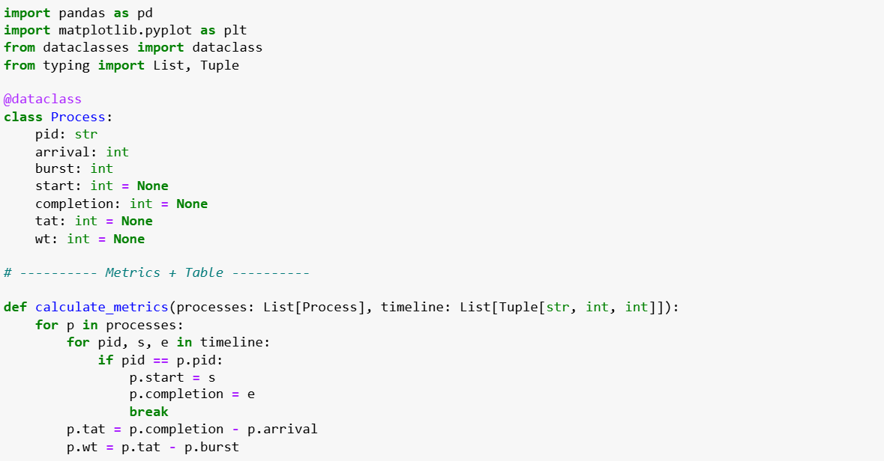

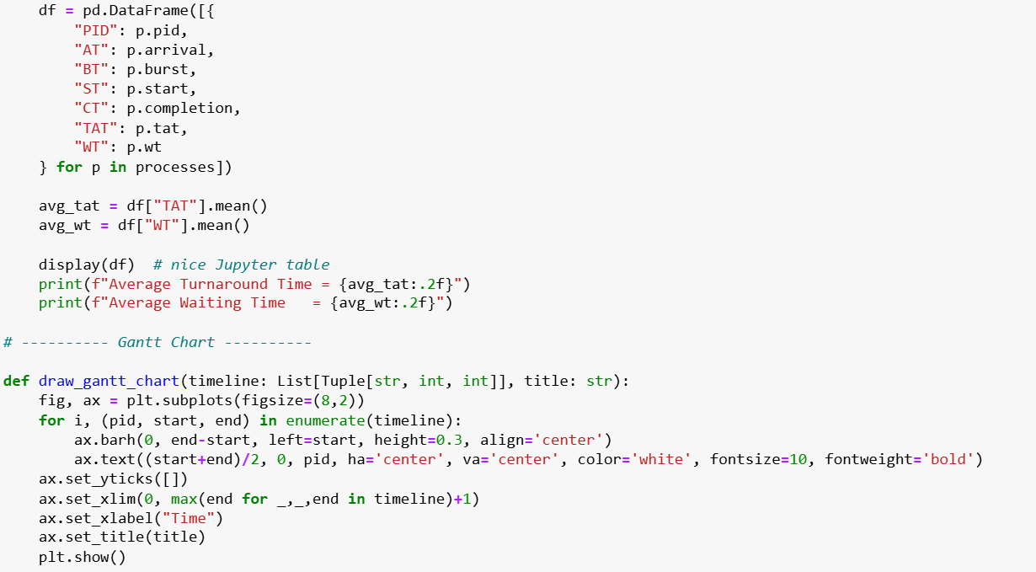

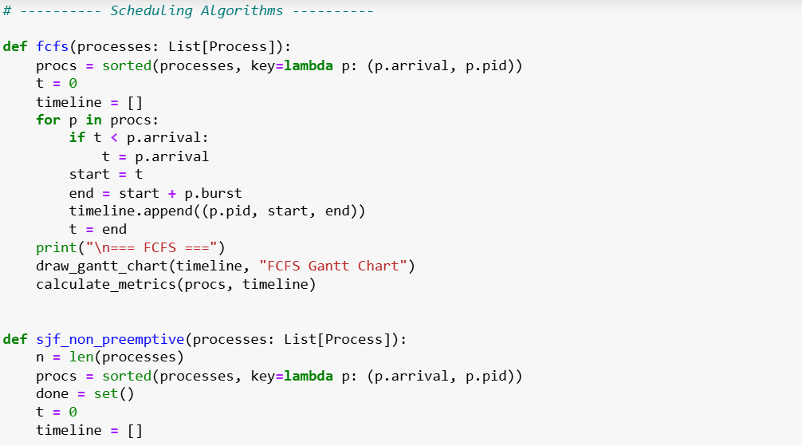

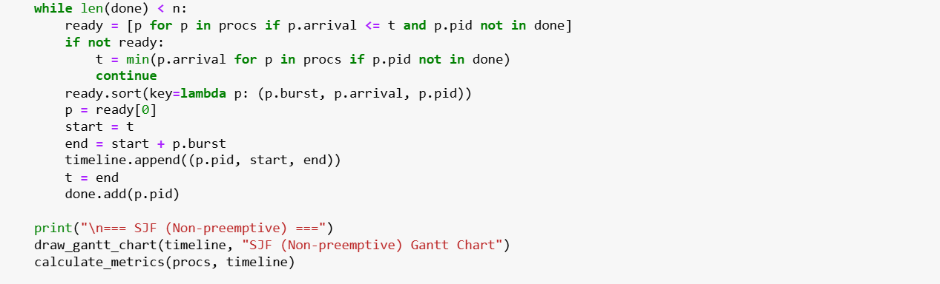

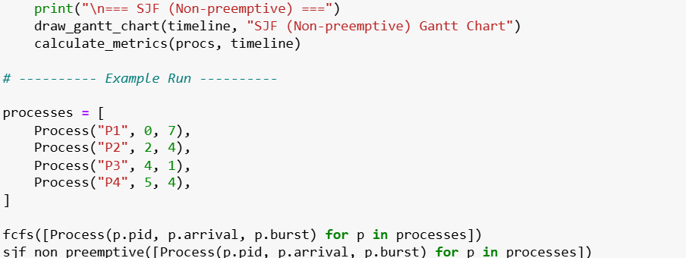

## ****Output****

## 

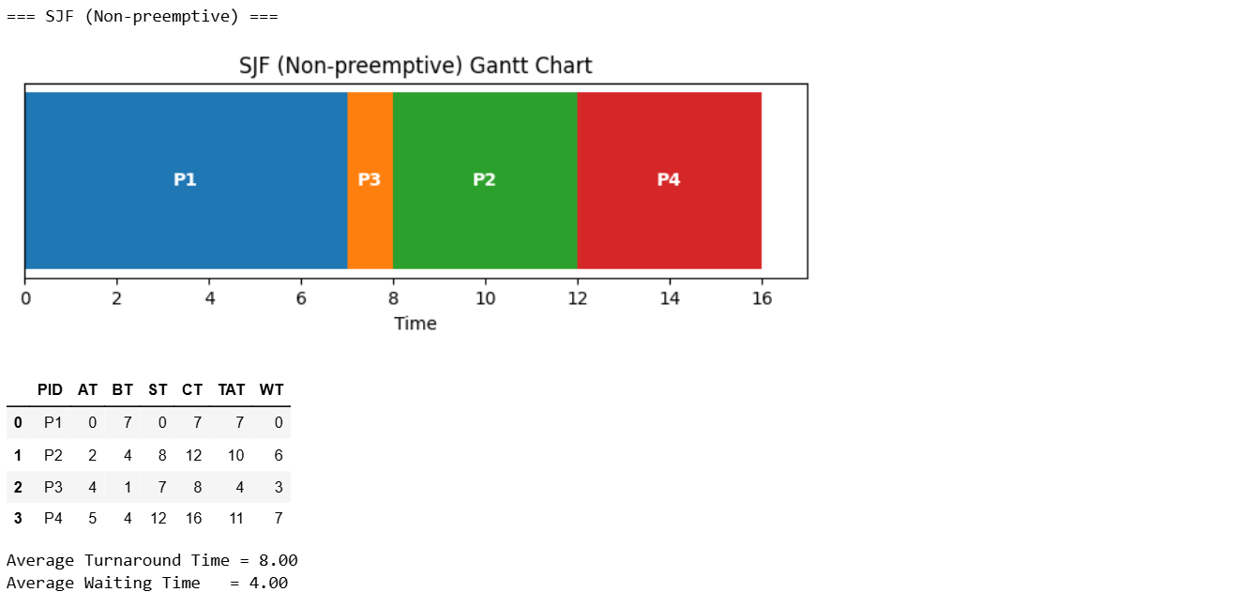

## ****Results and Discussion****

* **FCFS** executes processes in the order they arrive. It is simple but may lead to higher waiting times for shorter jobs.
* **SJF** executes processes based on shortest burst time. It reduces waiting time but may cause starvation for long processes.

### ****Comparison Table****

|  |  |  |
| --- | --- | --- |
| Algorithm | Average Waiting Time | Average Turnaround Time |
| FCFS | 8.75 ms | 4.75 ms |
| SJF | 8 ms | 4 ms |

## ****Conclusion****

* **FCFS** is fair and easy to implement but less efficient in minimizing waiting time.
* **SJF** provides better average waiting and turnaround times but may not be fair to long processes.

This study shows how the choice of scheduling algorithm can significantly affect CPU performance.