USER MANUAL

Welcome to the user manual for our IBM SkillsBuild web application. This guide will walk you through navigating our platform.

# Navigating the Login and Registration

1. Upon reaching the landing page, you will be greeted with our application's welcome message and branding.
2. A screenshot of a computer

   Description automatically generatedOn the landing page itself, locate the options for "Login" and "Register."
3. If you are a new user and need to create an account, click on the "Register" option.
   1. You will be redirected to the register page.
   2. Enter your name in the "Name" field.
   3. Provide a valid email address in the "Email Address" field. You will use this email when you sign into your account.
   4. Create a secure password in the "Password" field. Your password should be at least 8 characters long. Ensure you choose a password that is not easily guessable.
   5. A screenshot of a computer

      Description automatically generatedClick on the "Register" button to proceed with creating your account.
4. If you already have an account, click on the "Login" option.
   1. You will be redirected to the login page.
   2. Enter your registered email and password in the "Email" and "Password" fields.

(Note: Fields are case-sensitive.)

* 1. A screenshot of a computer

     Description automatically generatedAfter entering your credentials, click on the "Login" button below the input fields.

1. Upon successful login or registration, you will be redirected to your account dashboard.

# Dashboard

1. **A screenshot of a computer

   Description automatically generated**After logging in, you will be presented with an overview of the courses you are currently enrolled in. This allows you to quickly track your progress and stay updated on your ongoing learning activities.
2. Your current courses on this page include a brief summary, the option to review the course and also to continue the course if it has not yet been completed.
   1. The course specific page will open when you click the “Continue” option, where you can continue using the resources.
   2. A screenshot of a website

      Description automatically generatedWhen you have successfully completed the course, click the “Finish” button.
3. A screenshot of a computer

   Description automatically generatedOnce you have marked the course as finished, on the dashboard the course will appear as “Complete” and the date you started and completed the course will be displayed on your dashboard and you will be awarded points.
4. To find additional courses, click on “Courses” option. You will be directed to the Courses page, where you can discover a wide range on available courses.
   1. A screenshot of a computer

      Description automatically generatedThis page lists available courses, with a brief summary, points awarded for completion and an average user rating.
   2. Click on a course that interests you to view further information and enroll.
      1. A course specific page will open with further details about the course: a summary, duration, location, points for completion and difficulty level.
      2. Additionally, you’ll find user reviews on the course page to help you make an informed decision about your course selection.
      3. 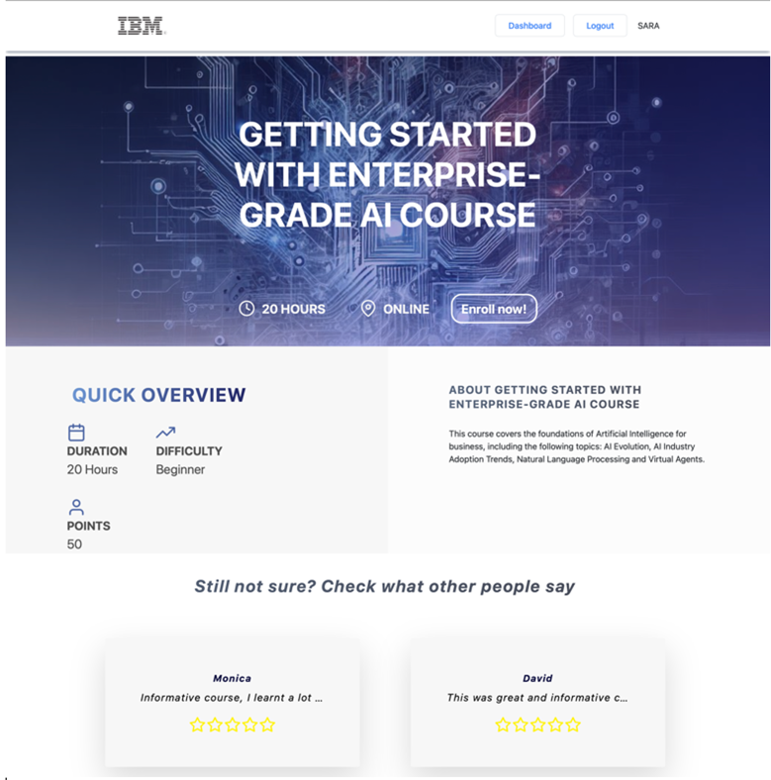To enroll onto the course, click the “Enroll now” option. This course will then be available to access on your dashboard.
5. Your points are also shown on your dashboard page, which increase as you successfully complete each course.
6. To log out from your IBM SkillsBuild account, locate the “Logout” option at the top of the page to securely end your session. You will be redirected to the landing page.

# Tracking Course Start and Completion Time

1. When you start a course on IBM SkillsBuild, the time you begin is automatically recorded. Similarly, upon completing the course, the time you complete the course is also recorded.
2. Your course start and completion times are displayed on each course on your dashboard when you complete the course, allowing you to easily access and review your learning history for each course.

# Points

1. Your points are displayed on your personalised dashboard, so you can see your progress.
2. When you successfully complete a course, and mark that it’s been completed, your total points will increase.
3. Points awarded for completing each course may vary based on the course's level of difficulty to ensure that your efforts are appropriately recognized.

# Posting reviews

1. To view reviews from other users enrolled in a course, click the “Details” option on the “All Courses” page. Navigate to the bottom of the courses page to see reviews. Each review shows the users name, review, and star rating.
2. Once you have enrolled on a course, you can post a review.
   1. Navigate to your dashboard.
   2. Locate the “Review” option of a course.
   3. This will give direct you to a form to fill in to review the course, where you can enter a star rating out of 5 and a review.
   4. Click the “Submit” button to post the review. This will make your review available to other users.

(Note : Only one review can be posted per user to prevent spam.)