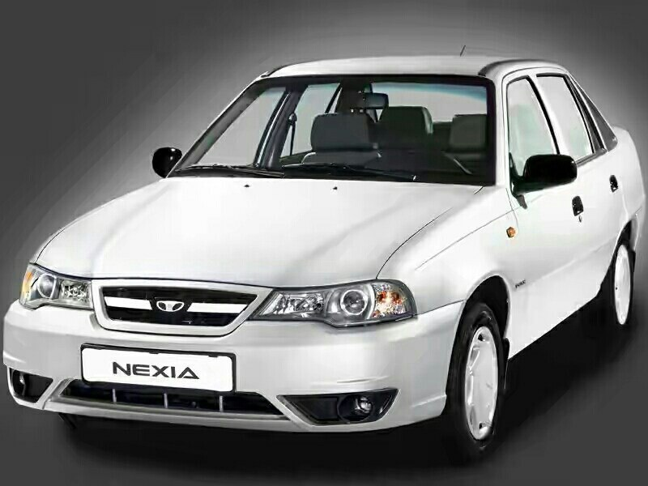

AutoShop Project

Khurshid Yakubov U1610112

Abduvokhid Abduvokhidov U1610011

Azimsher Akhmedov U1610034

Aslidddin Kholimov U1610028

Javlonbek Isroilov U1610099

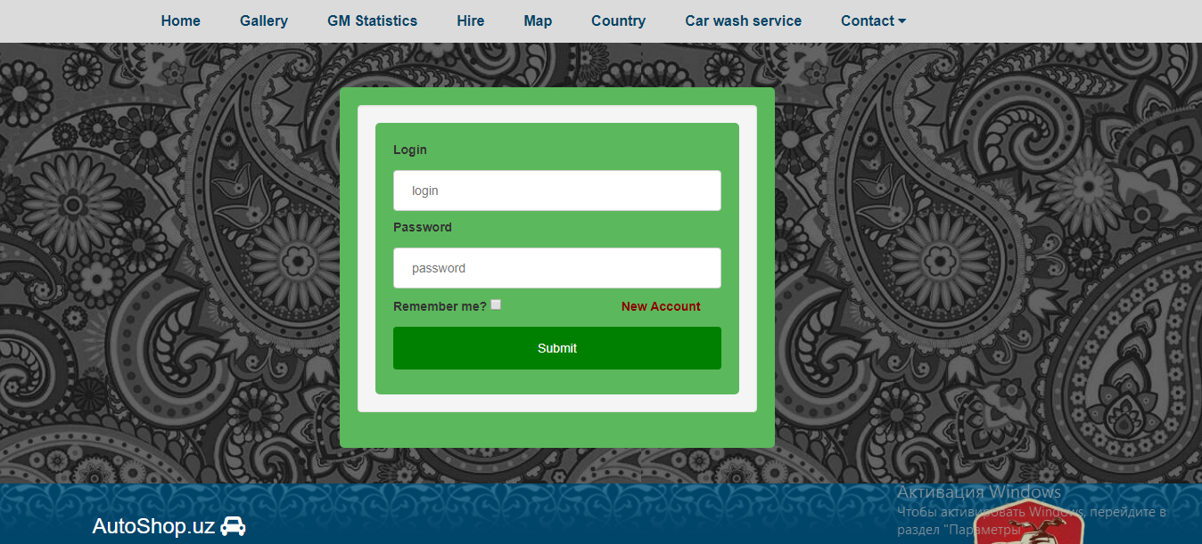

**About our project**

Our project is very helpful for people who want to buy or sell their car easily. We can say this project in near future will be one of the best dealership websites ever. There are a lot of functions such as car wash system, hire system, new top cheapest cars system and so on. In car wash system you can easily get queue by filling text boxes any time you wish. If people want to compare price of new GM cars, then we have statistics page where they can see latest price and price of dollar. And also it should be pointed out that we added calculator for converting dollar into “SO’M”.

In our project we worked with HTML, CSS, Bootstrap and also JavaScript in order to create frontend design.

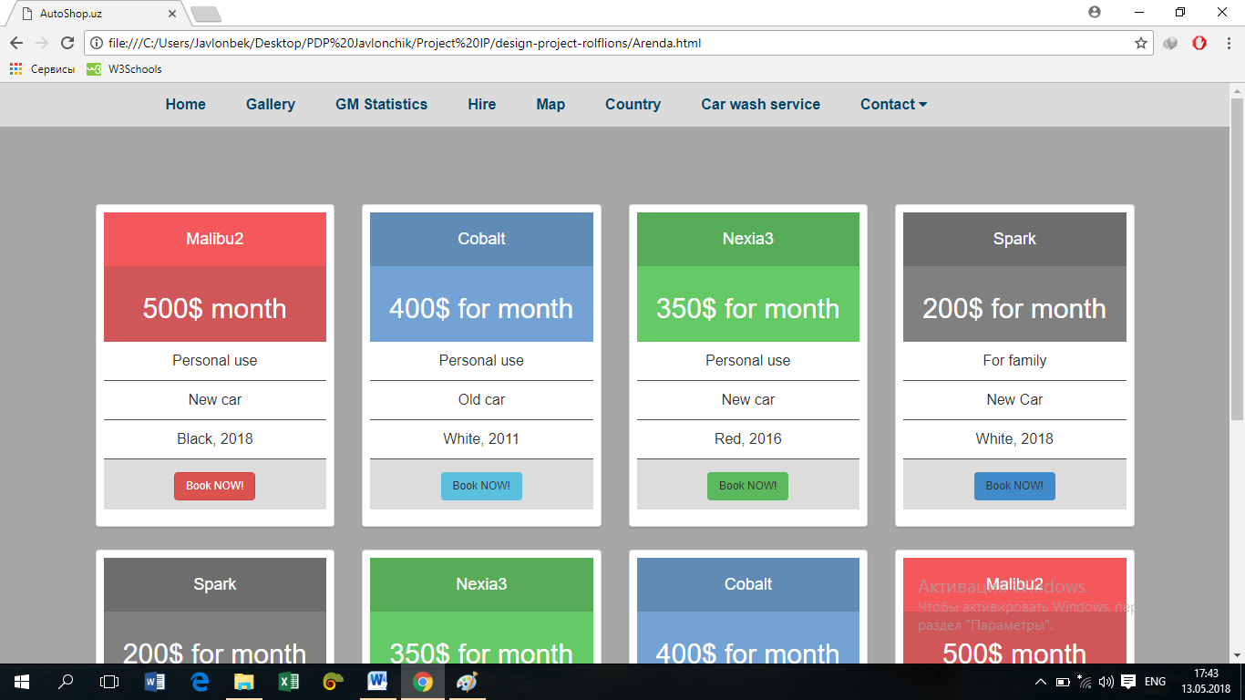

There are a number of frameworks for backend, but we used Laravel as it is one of the most popular and convenient frameworks in GitHub for web-development. For logging in, registering, resetting your password solely Laravel was used. All of these are connected to localhost database. All information such as password, emails and username will appear in our database.

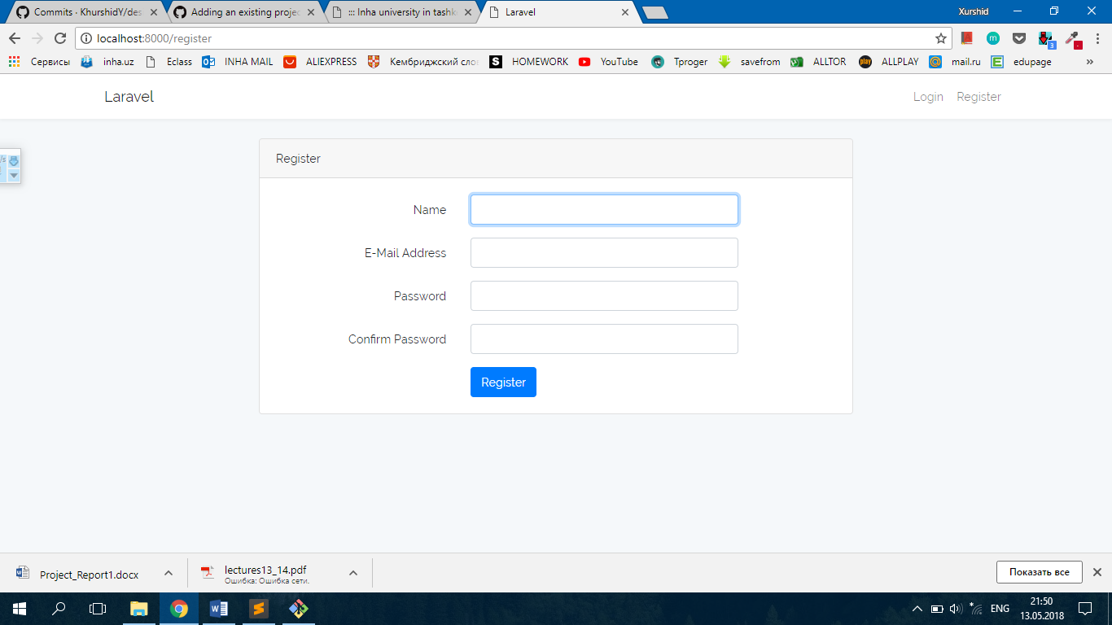

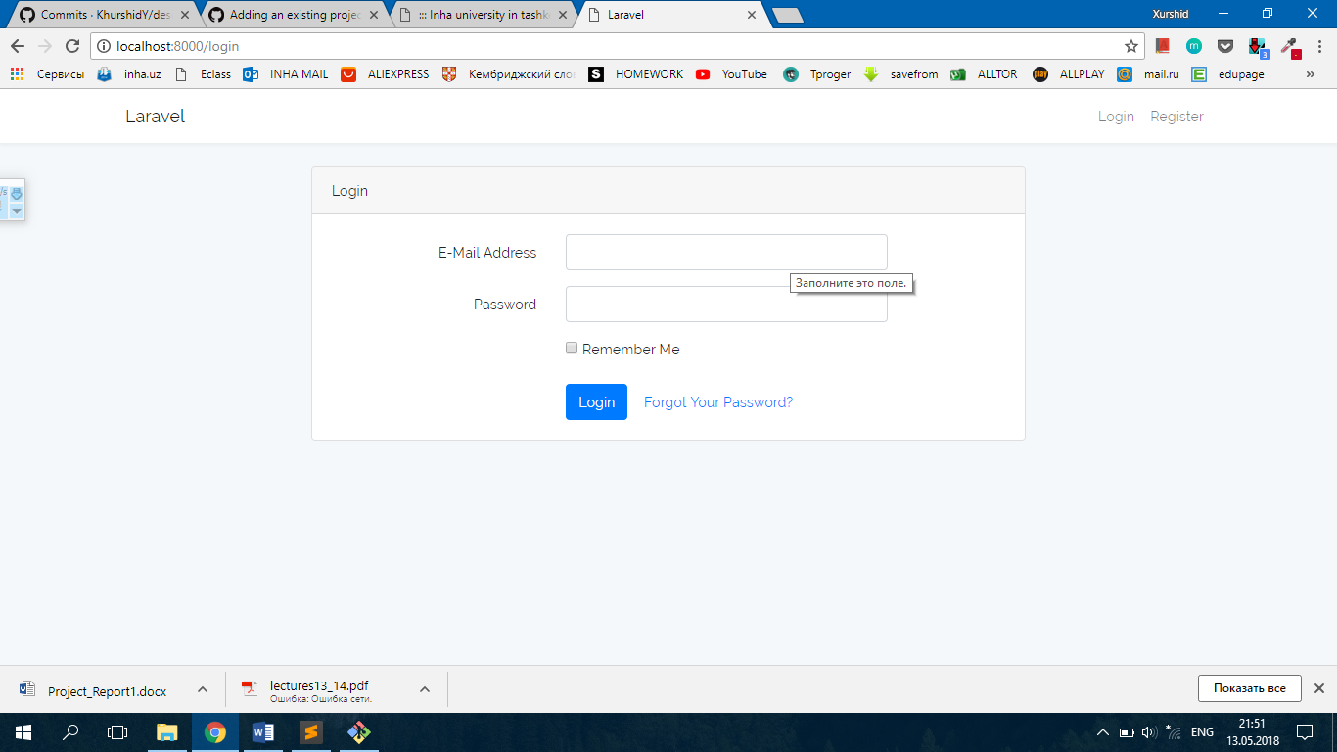

By using free domain .gq, we hosted our website. By entering **rolflions.gq**, you can look through our project.