**Week 1 – Linux**

**Exercises:**

1. **Find the variant of the ls command (i.e. argument(s) to be used) to list contents of a folder including its hidden files, the variant of cp to copy folder and the command to rename a file.**
2. ‘ls’ command

**‘ls’** lists the contents of your current working directory.

**‘ls –a’** lists files that are normally hidden.

**‘ls unixstuff’** lists the contents of your unixstuff directory.

**‘ ls unixstuff/backup’** lists the contents of backup’s directory.

**‘ls ~/unixstuff’** lists the contents of unixstuff directory, no matter where you currently are . in the file system.

**‘ls ~/..’** lists name of parent directory.

**‘ls ~’** lists the name of home directory.

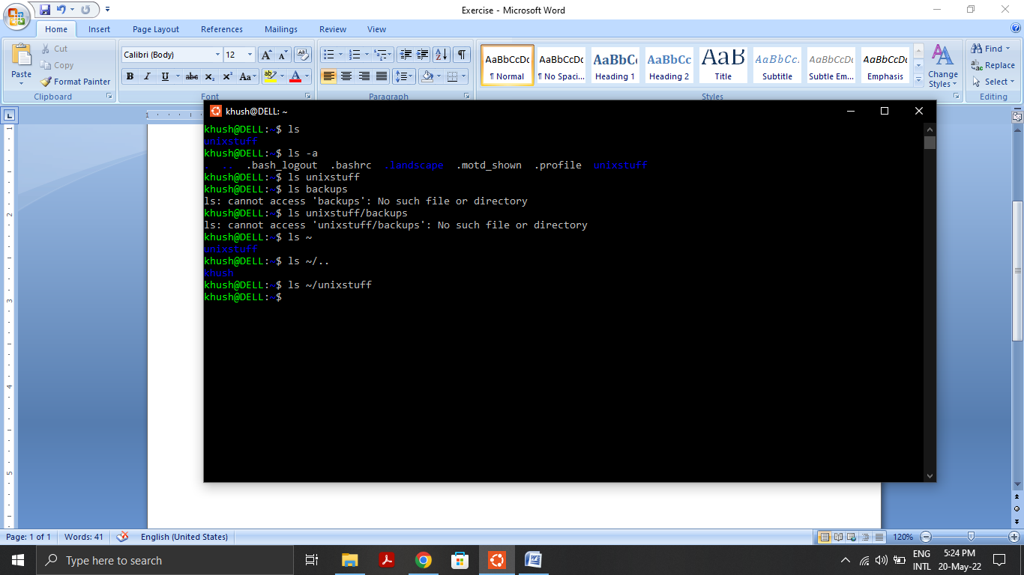

1. ‘cp’ command

**‘cp file1.txt file2.txt’** copies ‘file1.txt’ and saves it in the same directory as ‘file2.txt’.

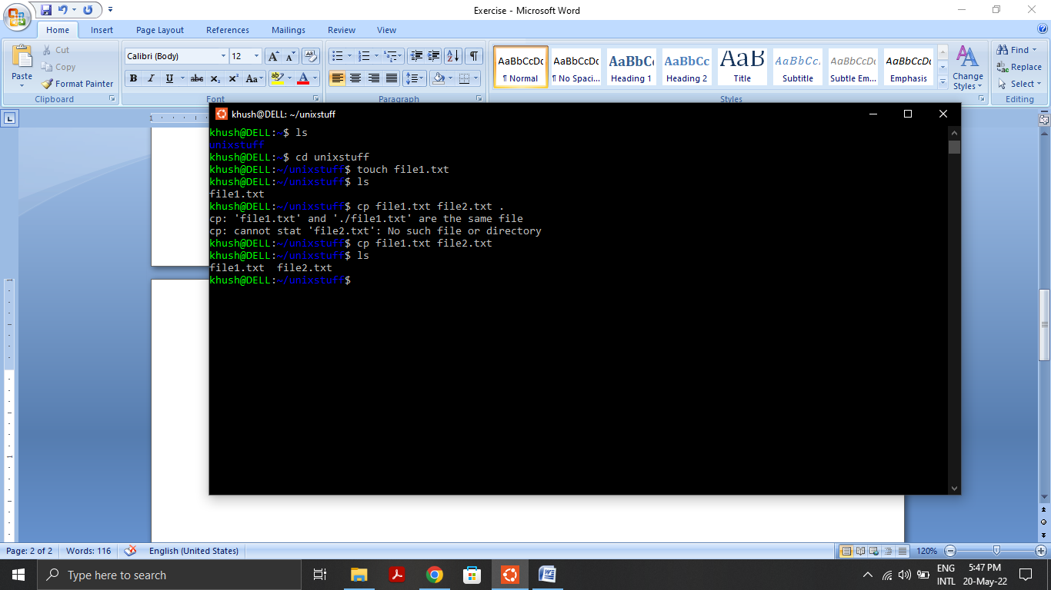

1. Renaming a file

**‘mv file1.txt renamed.text’** it renames the file ‘file1.txt’ to ‘renamed.txt’.

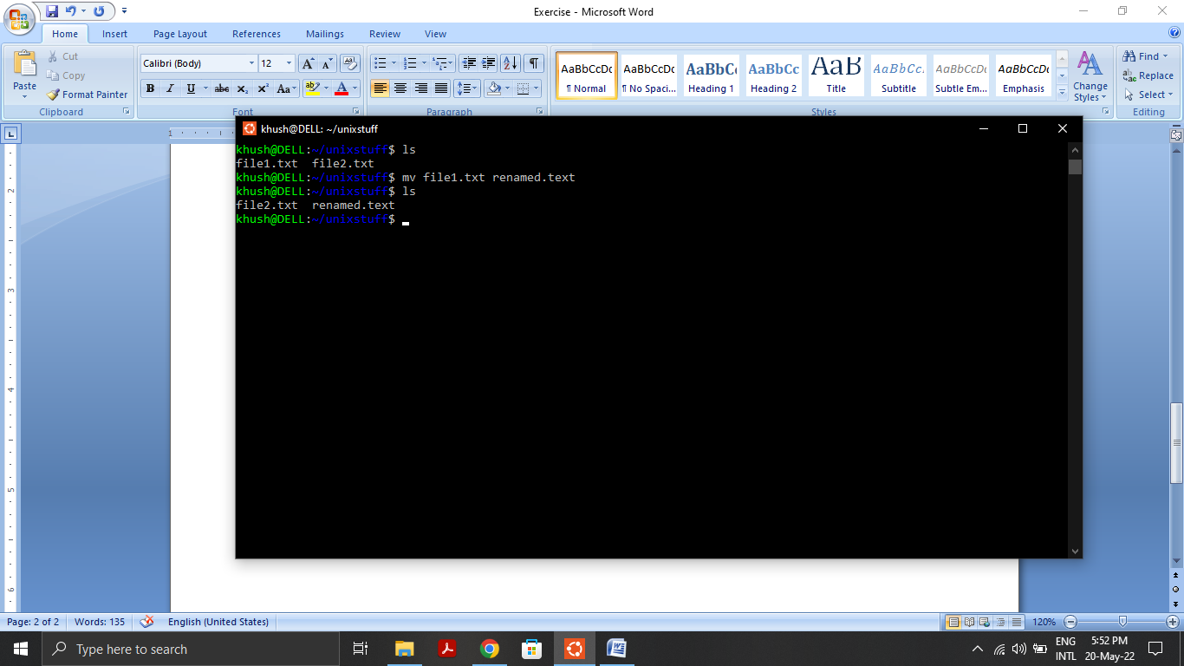

1. **In this question, we will understand the hardware configuration of your working machine using the /proc filesystem.**
2. **Run command more /proc/cpuinfo and explain the following terms: processor and cores. Use the command lscpu to verify your definitions.**

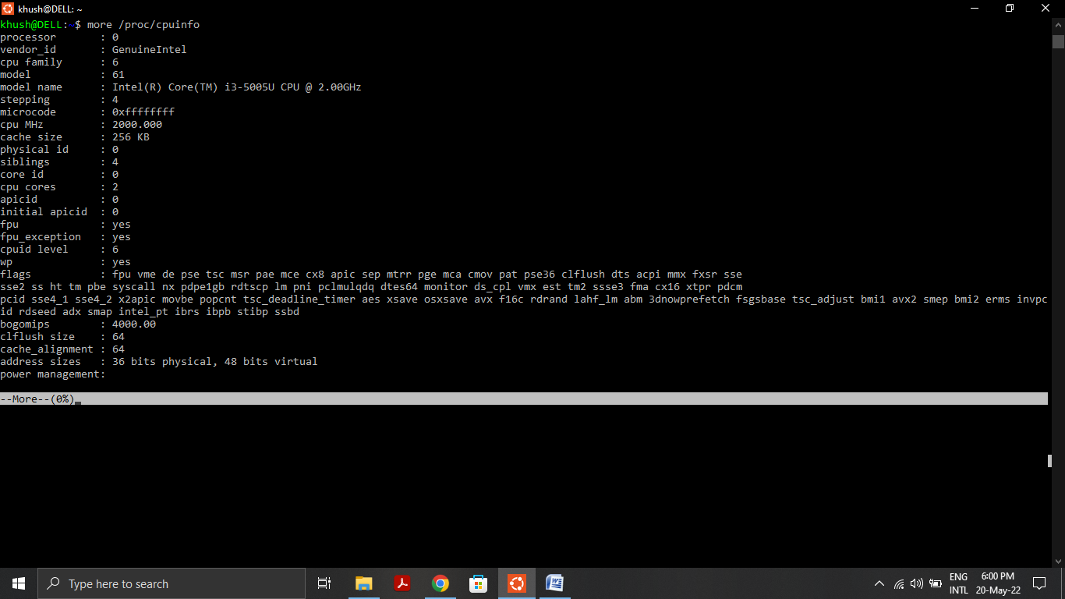

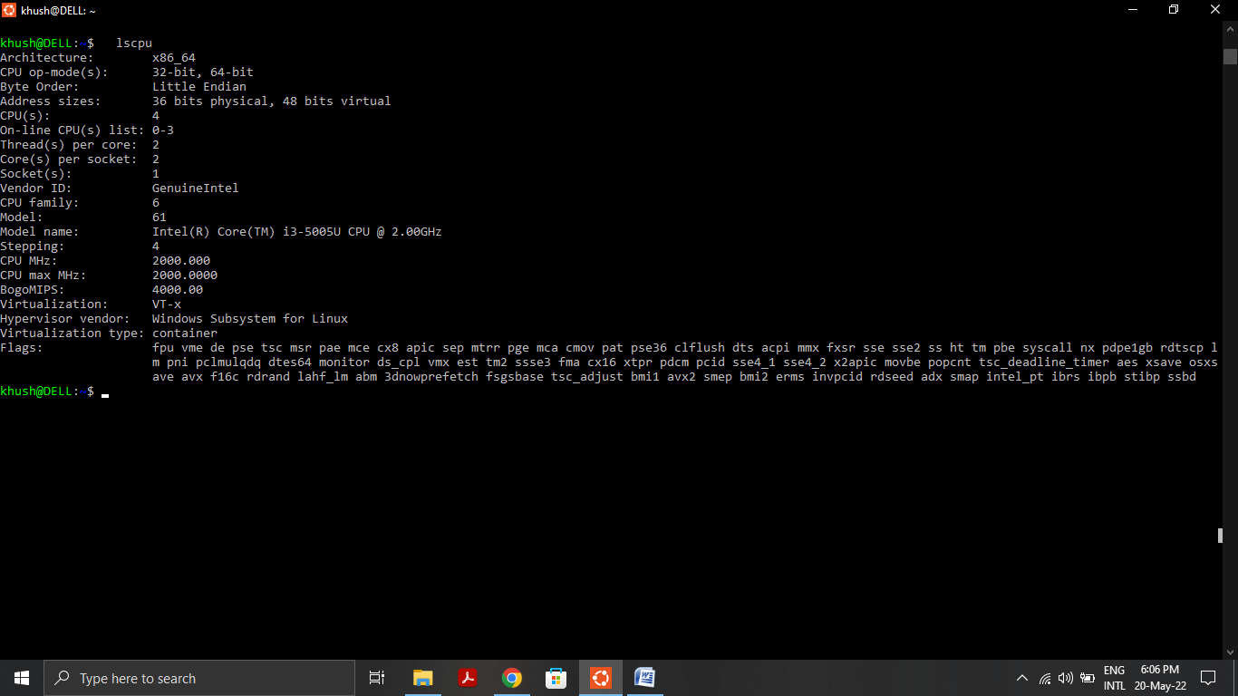

**Processor:** A processor (CPU) is the logic circuitry that responds to and processes the basic instructions that drive a computer. The CPU is seen as the main and most crucial integrated circuitry (IC) chip in a computer, as it is responsible for interpreting most of computers commands.

**Cores:** A core, or CPU core, is the "brain" of a CPU. It receives instructions, and performs calculations, or operations, to satisfy those instructions. A CPU can have multiple cores.

1. **How many CPU sockets, cores, and processors does your machine have?**

CPU Sockets: 1

Cores: 2 per socket

Processors: 4

1. **What is the frequency of each processor?**

Processor 0: Frequency – 2.0 GHz

Processor 1: Frequency – 2.0 GHz

Processor 2: Frequency – 2.0 GHz

Processor 3: Frequency – 2.0 GHz

1. **How much memory does your machine have?**

4006 mB

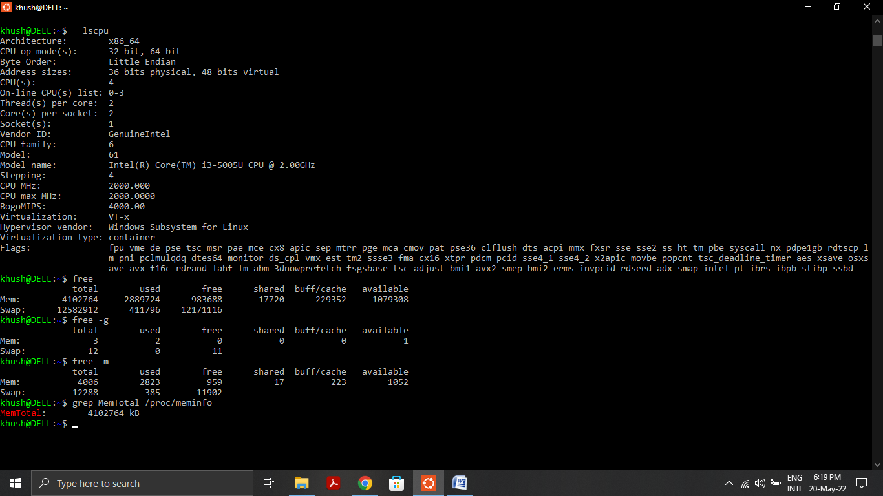

1. **How much of it is free and available? What is the difference between them?**

**Free Memory:** 956 mB

Free Memory is memory that is currently unused by the system and contains no useful data at all. It is free to be used by the system at any time.

**Available Memory:** 1052 mB

Available memory is the sum of Free memory, which is the memory that has or will have all zeroes written to it, and Standby memory, which is the memory that contains data that is already on the disk.

1. **What is the total number of user-level processes in the system?**

6

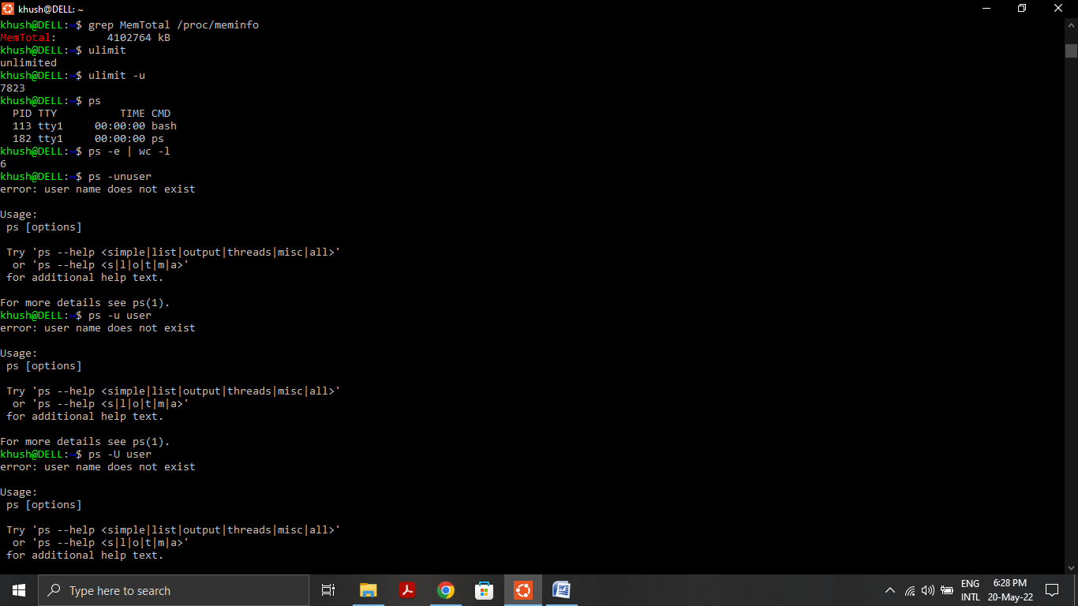

1. **What is the total number of number of forks since the boot in the system?**

198

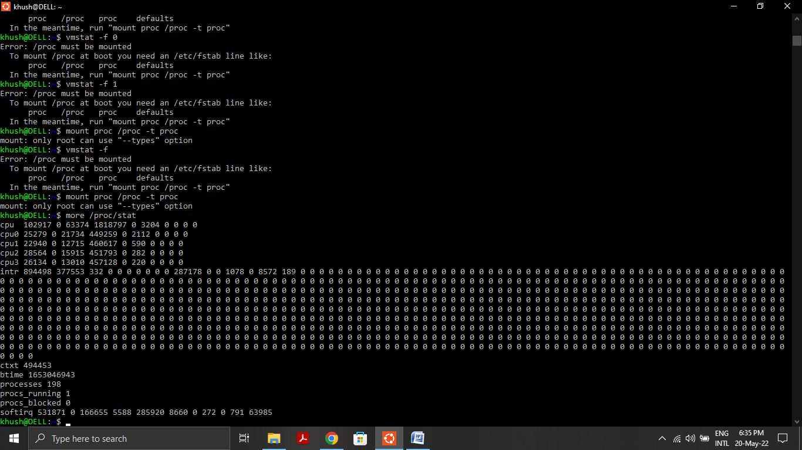

1. **In this question, we will understand how to monitor the status of a running process using the top command. Compile the program cpu.c given to you and execute it in the bash or any other shell of your choice as follows.**

**gcc --version**

**# If gcc is not installed then run :- sudo apt-get install gcc**

**gcc cpu.c -o cpu**

**./cpu**

**This program runs in an infinite loop without terminating. Now open another terminal, run the top command and answer the following questions about the cpu process.**

1. **What is the PID of the process running the cpu command?**

PID: 6475

1. **How much CPU and memory does this process consume?**

CPU: 99%

Memory: 0.0%

1. **What is the current state of the process? For example, is it running or in a blocked state or a zombie state?**

Current state: Running

