Q1. Define a function overlapping () that takes two lists and returns True if they have at
least one member in common, False otherwise.

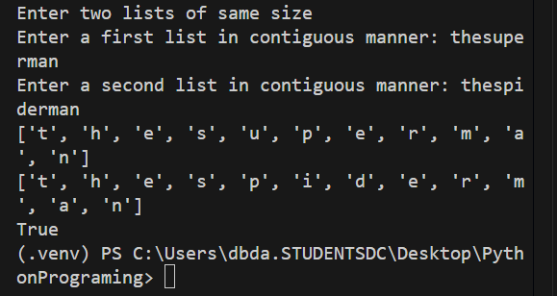

Q.2. Write a function find_longest_word() to find the longest word from the list of words
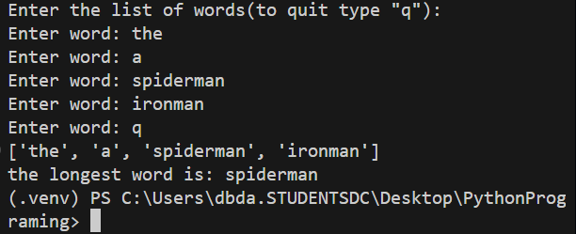

Q.3.In English, present participle is formed by adding suffix -ing to infinite form: go -> going. A simple set of rules can be given as follows:
a. If the verb ends in e, drop the e and add ing
b. If the verb ends in ie, change ie to y and add ing
Write a function make_ing_form() which accepts a list of verbs and returns a dictionary with verb : present participle

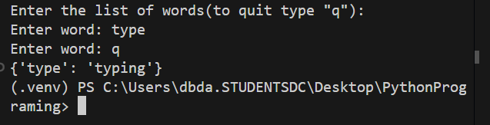

Q.4. Decorate the display_greeting() function using a decorator so that greeting is displayed in uppercase

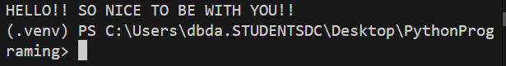

Q. 5. Create a infinite series on fib numbers and print first few
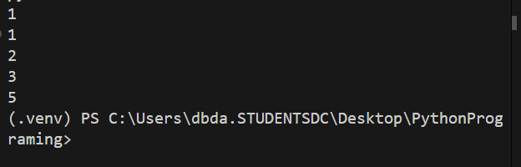
Q.6
1.Find employees that know 'python'
2. Add a new skill - 'test' in skillset of all employees
3. Sort employees by skills
for the given dictionary of employees

emp_data = {'Amol': ['C', 'C++', 'Java'], 'Aditya': ['Angular', 'Java'],
'Aditi': ['Python', 'PHP', 'Database']}

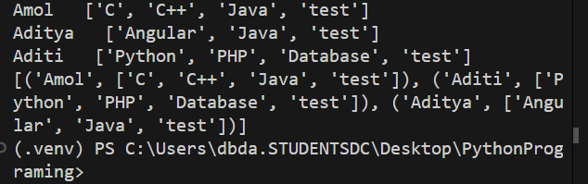

Q.7
Following data displays min/max/average temp for cities
weather= [{'Mumbai' : [28, 30, 32]},.....]

1. Print the weather data
2. Print the city with maximum/min temp
3. Print all the cities that expereince min temp more than 30 degree
4. Create a dictionary to print 'City':'Ave temp'

