
ITM(SLS) BARODA UNIVERSITY, VADODARA
School of Computer Science, Engineering and Technology Semester - 1
Course Name : Web Technologies
Course Code : C2111C3

Problem Statement :
Your Communications instructor has asked each student in the class to create a two-page Web site to help students in the class get to know more about the area in which you are majoring in school. The first Web page is a home page that includes basic information about your major. If you can, add an image related to your chosen field somewhere on the Web page. Add a link to the second Web page. The second Web page includes a paragraph of text and numbered lists with links.

HTML CODE FOR HOME PAGE :

<DOCTYPE HTML>
<html>
<header>
<title>Home Page</title>
</header>
<body>
<h1 style = "text-align : center;"> HOME PAGE</h1>
<h2>Hello! I am Khush, Want to know about my major?</h2>
<p>I am a student of BTECH CSE curriculum. i have no current specializations of majors since i study CSE core.</p>
<p>In core CSE, you get to learn and experience vareity of subjects in computer science division instead of focusing on a particular one.</p>
<p>I get to learn about coding, web designing, AI/ML, Data science and etc</p>
<p><br><br></p>
<p><b>To know more about my major and career opportunities, Kindly visit this page below.</b></p>
<p><a href="file:///C:/Users/Khush/Documents/COLLEGE%20PROJECTS/WEB%20TECH%20PRACTICALS/5TH%20PRACTICAL/2nd%20page.html" title="Know more about this major" target="_blank">Get more info here.</a></p>
</body>
</html>
</DOCTYPE>

Name : Khush Patel Branch : Btech Cse Core Enrollment No. : 26UGC0255

OUTPUT :

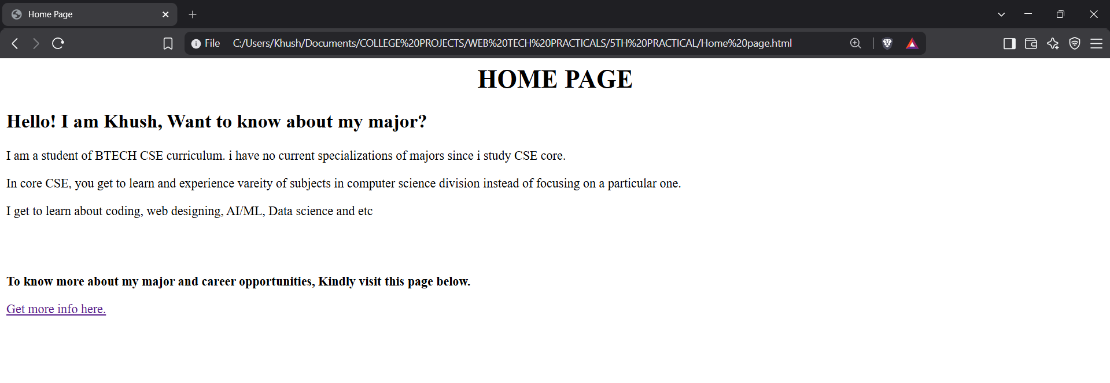

HTML CODE FOR PAGE 2 :

<DOCTYPE HTML>
<html>
<header>
<title>Page 2</title>
</header>
<body>
<h3>Glad to see your curiosity about my major. Here are some good career opportunities from Cse course.</h3>
<h2 style="text-align:center;">Career opportunities : </h2>
<p><b>Software Developer</b></p>
<p><b>Data Analyst</b></p>
<p><b>Fullstack Developer</b></p>
<p><b>LLMs, AI engineer</b></p>
<p><b>Cloud Computing</b></p>
<p><b>Ethical Hacking</b></p>
<p><b>Web Designer</b></p>
<p><br></p>
<p>Here's the course and full guide link to proceed</p>
<p>1.<a href="https://www.geeksforgeeks.org/software-engineering/how-to-become-a-software-developer-complete-guide/" title="click to see full guide" target="_blank">Software Developing Guide</a></p>
<p>2.<a href="https://www.netacad.com/courses/data-analytics-essentials?courseLang=en-US" title="click to see full guide" target="_blank">Data Analysis Guide</a></p>
<p>3.<a href="https://roadmap.sh/full-stack" title="click to see full guide" target="_blank">Fullstack Developer Guide</a></p>
<p>4.<a href="https://cloud.google.com/learn/training/machinelearning-ai" title="click to see full guide" target="_blank">AI/ML Guide</a></p>
<p>5.<a href="https://www.eccouncil.org/cybersecurity-exchange/cloud-security/cloud-computing-course" title="click to see full guide" target="_blank">Cloud Computing Guide</a></p>
<p>6.<a href="https://www.eccouncil.org/train-certify/certified-ethical-hacker-ceh/" title="click to see full guide" target="_blank">Ethical Hacking Guide</a></p>
<p>7.<a href="https://www.coursera.org/courses?query=web%20design" title="click to see full guide" target="_blank">Web Designing Guide</a></p>
<h2 style="text-align:center;">Thanks for visiting my site</h2>
<h3>To go back to home page kindly click the below redirecting link</h3>
<p><a href="file:///C:/Users/Khush/Documents/COLLEGE%20PROJECTS/WEB%20TECH%20PRACTICALS/5TH%20PRACTICAL/Home%20page.html" title="back to home page">Go back to Home page</a></p>
</body>
</html>
</DOCTYPE>

OUTPUT :

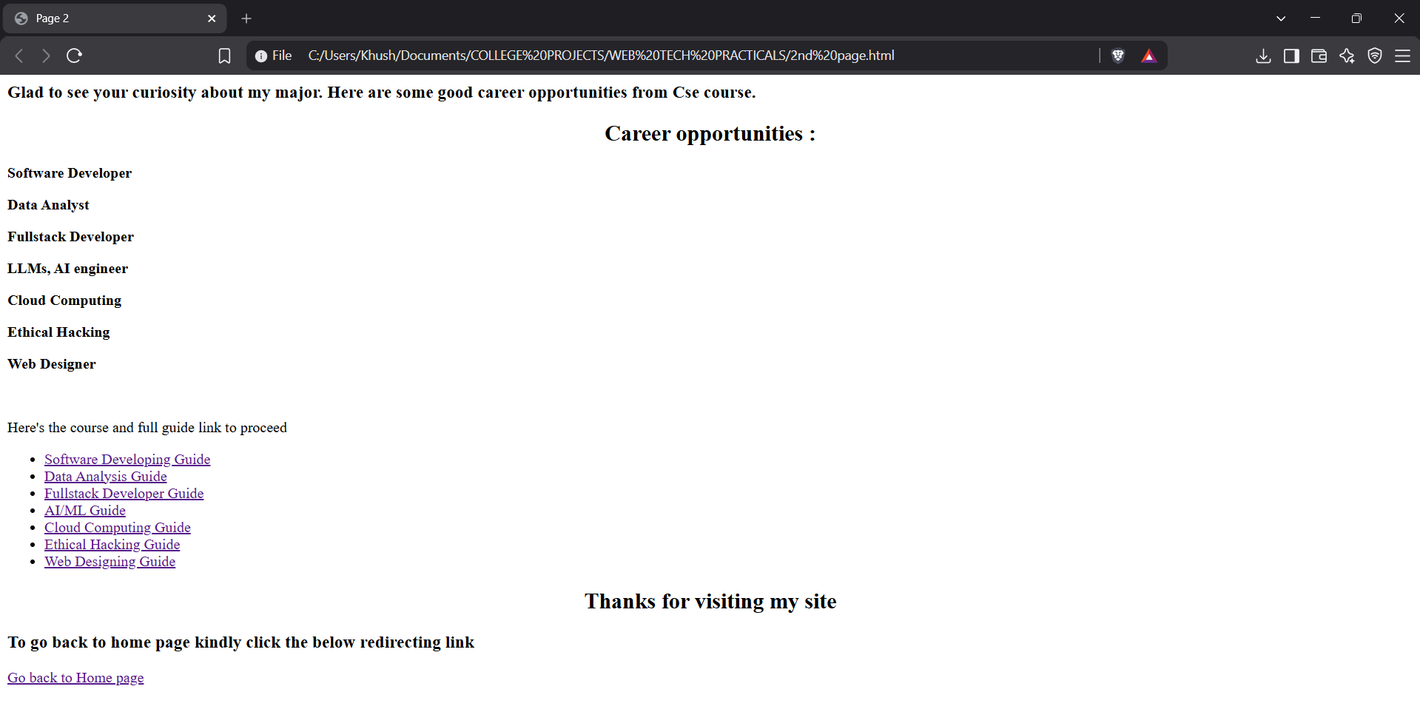

Name : Khush Patel Branch : Btech Cse Core Enrollment No. : 26UGC0255

