**1. Write a Scala program to check two given integers, and return true if one of them is 30 or if their sum is 30**

CODE:-

object scala_basic

{

def test(x:Int, y:Int) :

Boolean = { x == 30 || y == 30 || x + y == 30

}

def main(args: Array[String]):

Unit = {

println("Result: " + test(30, 0));

println("Result: " + test(25, 5));

println("Result: " + test(30, 20));

println("Result: " + test(25, 20));

}

}

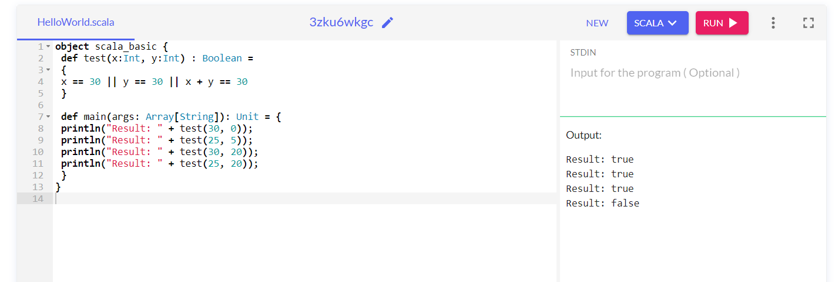

**2.Check if X is Greater or Y**

**CODE:-**

object scala_basic {

def test(x:Int, y:Int) : Unit =

{

if(x==y){

println("X is Equal to Y")

}

else if(x>y){

println("X is greater than Y")

}

else{

println("Y is Grater than X")

}

}

def main(args: Array[String]): Unit = {

test(30, 0);

test(25, 5);

test(30, 20);

test(25, 20);

}

}

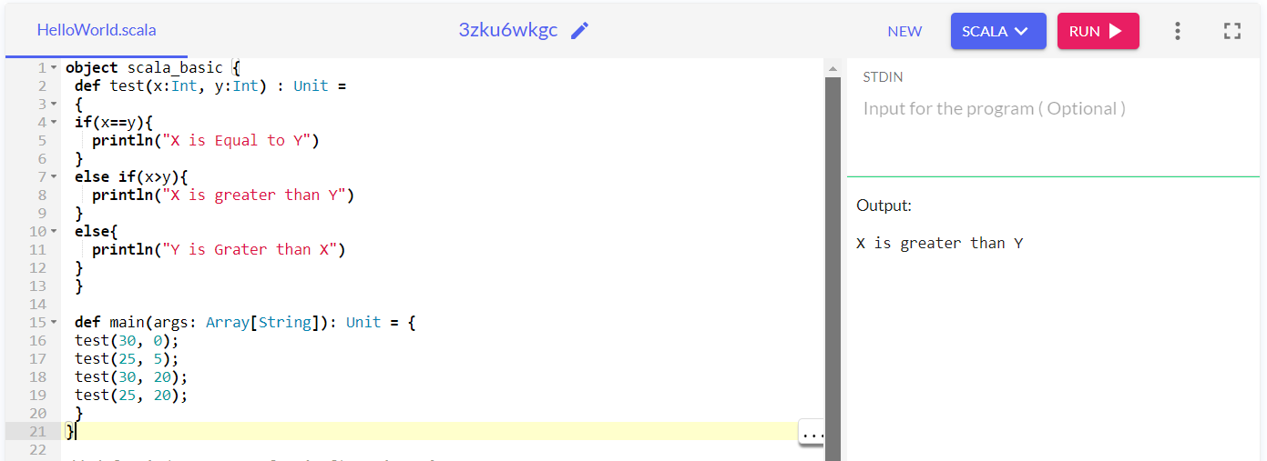

**3.** **Write a Scala program to check a given integer and return true if it is within 20 of 100 or 300.**

**CODE:-**

object scala_basic {

def test(x:Int) : Boolean =

{

Math.abs(100 - x) <= 20 || Math.abs(300 - x) <= 20

}

def main(args: Array[String]): Unit =

{

println("Result: " + test(115));

println("Result: " + test(200));

println("Result: " + test(250));

println("Result: " + test(70));

}

}

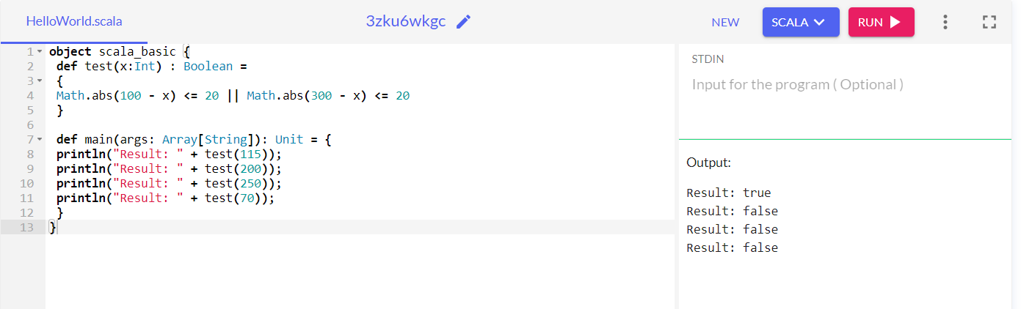

**GITHUB LINK :-** [KhushalVijayDonga07 (github.com)](https://github.com/KhushalVijayDonga07)