**QUESTION:- WRITE A SCALA PROGRAM THAT CREATES AN ABSTRACT CLASS SHAPE WITH AN ABSTRACT METHOD AREA. IMPLEMENT SUBCLASSES RECTANGLE AND CIRCLE THAT OVERRIDE THE AREA METHOD**

**CODE :-**

**abstract class Shape {**

**def area: Double**

**}**

**class Rectangle(width: Double, height: Double) extends Shape {**

**override def area: Double = width * height**

**}**

**class Circle(radius: Double) extends Shape {**

**override def area: Double = math.Pi * radius * radius**

**}**

**object ShapeApp {**

**def main(args: Array[String]): Unit = {**

**val rectangle = new Rectangle('A' , 5)**

**println(s"Rectangle Area: ${rectangle.area}")**

**val circle = new Circle(4.5)**

**println(s"Circle Area: ${circle.area}")**

**}**

**}**

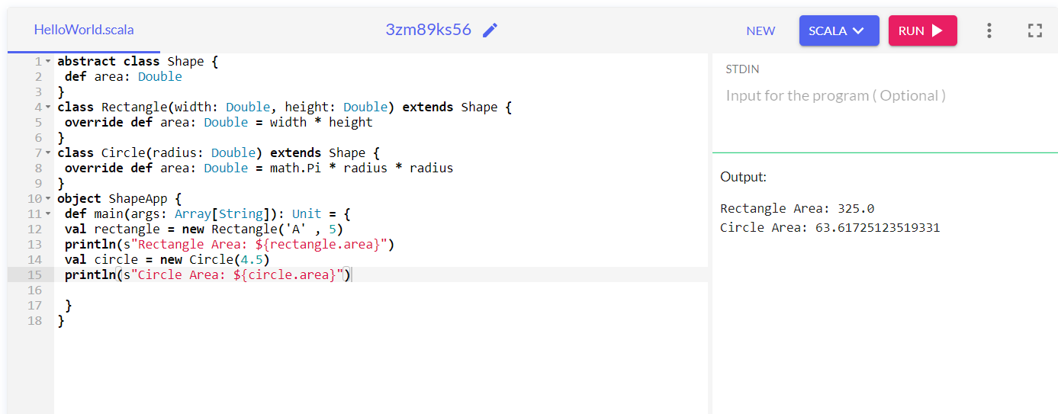

**GITBUB :-** [KhushalVijayDonga07 (github.com)](https://github.com/KhushalVijayDonga07)