# Chatbot through RASA

1. **Chatbot Fundamentals**
   1. **What is a chatbot?**

**A chatbot is a software application used to conduct an on-line chat conversation via text or text-to-speech, in lieu of providing direct contact with a live human agent.Today, most chatbots are accessed on-line via website popups, or through virtual assistants such as Google Assistant, Amazon Alexa, or messaging apps such as Facebook Messenger or WeChat.**

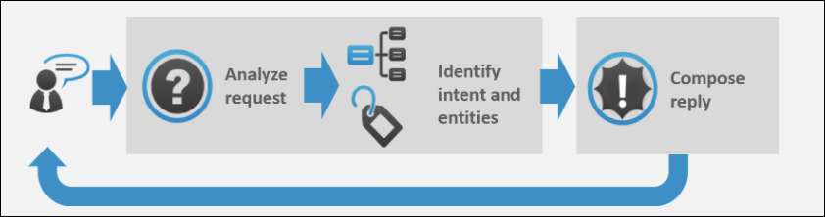

Image Courtesy: <https://expertsystem.com/chatbot/>

* 1. **Uses of chatbots:**

**Here are some of the use case of chatbot:-**

1. **Chatbots Answer Questions And Inquiries**
2. **Book Tickets To Events/Shows With Chatbots**
3. **Use Chatbots To Find Products, Check Inventory and Recommend Items**
4. **Chatbots To Build Remarkable Customer Experience**
5. **Chatbots Can Confirm Orders And Track Shipping**
6. **Chatbots Can Do Quizzes, Promotions, And Contests With Customers**
7. **Chatbots Become Personal Shopping Assistants**
   1. **Advantages of Chatbots**
8. **1- 24 hour availability**
9. **Keeping Up with the Trends: Being Present on Messaging Platforms**
10. **Improved Customer Service**
11. **Increased Customer Engagement**
12. **Cost Savings**
13. **Management of multiple clients**
14. **Gaining a deeper understanding of customers**
15. **Prerequisites**

The prerequisites for developing and understanding a chatbot using Microsoft Azure are:

* Python installed
* Microsoft Build tools with visual c++ 14.0 installed. Link: <https://visualstudio.microsoft.com/downloads/>

1. **Introduction to RASA**

Rasa is an open source machine learning framework for building [contextual AI assistants and chatbots](http://blog.rasa.com/level-3-contextual-assistants-beyond-answering-simple-questions/).

Rasa has two main modules:

* **NLU** for understanding user messages
* **Core** for holding conversations and deciding what to do next
  1. **RASA Architecture:**

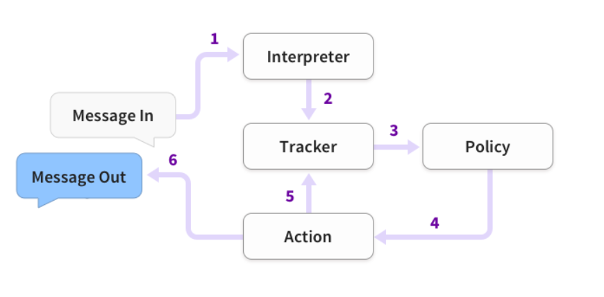

1. **The problem statement**

The goal here is to build a chatbot which can answer queries related to the COVID-19 disease.

* 1. **Technical stack:**
  + Python
  + Rasa X
  1. **The application flow**

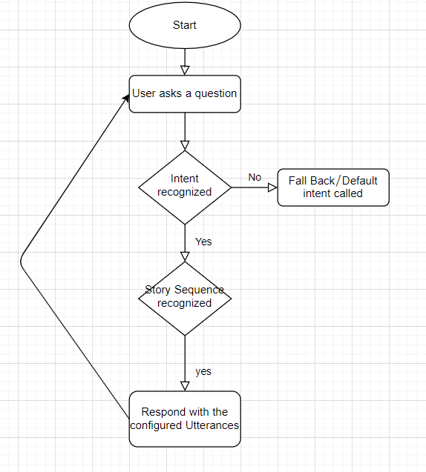

1. **Implementation:**

* Create a new folder for your chatbot project.
* Open that folder using Pycharm
* Create a new environment for your chatbot project from pycharm or from anaconda prompt.
* Run the command **pip install rasa x** for installing all the rasa dependencies
* Run the command **pip install spacy** for installing spacy library.
* Then enter the following commands:
  + - **python -m spacy download en**
    - **python -m spacy download en_core_web_md**
    - **python -m spacy link en_core_web_md en**
* After all this command run successfully, enter the command **rasa init** and for all the subsequent actions choose Y (for training the model etc).
* You’ll then end up with all the predefined structures which RASA would have built, as shown below:

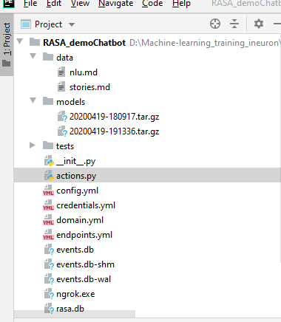

* After all this, you can just enter the command ‘**rasa train’** to train the model with new conversation elements.
* After the training is completed, enter the command ‘**rasa x**’ to test your chatbot in the web UI. You’ll see :

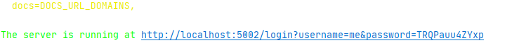

* Copy this URL in your web browser and you’ll see the web UI for your chatbot:

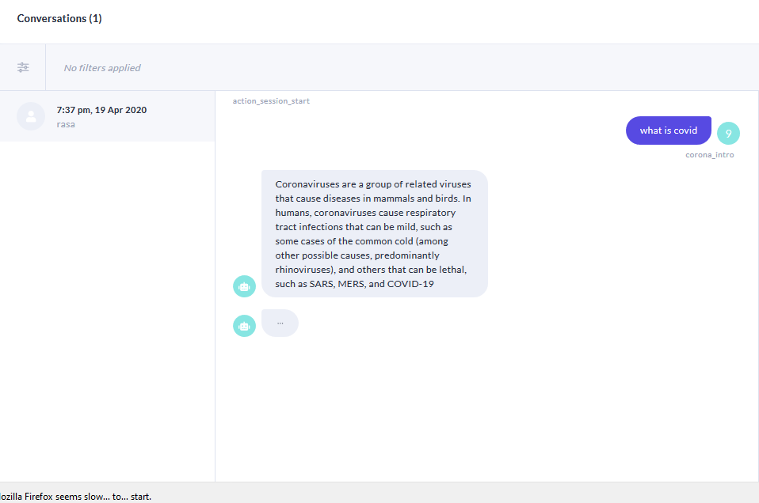

1. **Telegram Integration:**
   * Download ngrok from<https://ngrok.com/download>
   * After extracting the zip file, open the ngrok file and run it.
   * In ngrok, enter the command ‘**ngrok http 5005** ’:

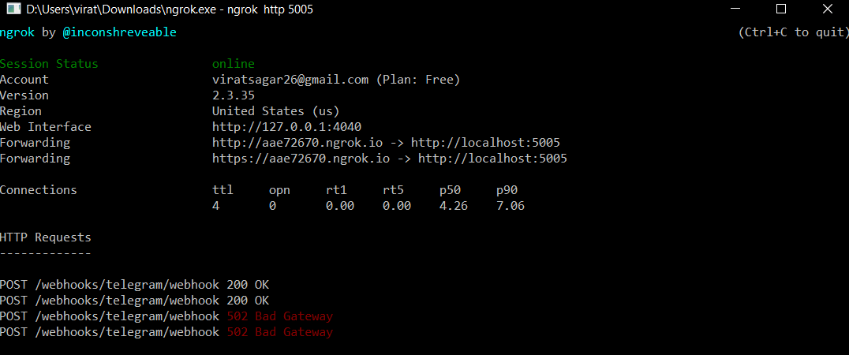

* Then go to telegram and create your own bot using Botfather:

1. Open the telegram app and search for botfather(it is an inbuilt bot used to create other bots)
2. Start a conversation with botfather and enter /newbot to create a newbot.
3. Give a name to your bot
4. Give a username to your bot, which must end in _bot.This generates an access token.

* Open ‘credentials.yml’ and enter:

telegram:

access_token: "obtained from telegram"

verify: "your bot username"

webhook_url: " https://bbdfb8be.ngrok.io/webhooks/telegram/webhook"

* Go to terminal and enter the command ‘rasa run’
* Open one more terminal and run the command ‘rasa run actions’
* Now, you can chat with your bot from Telegram.

Bot name:- corona_rasa

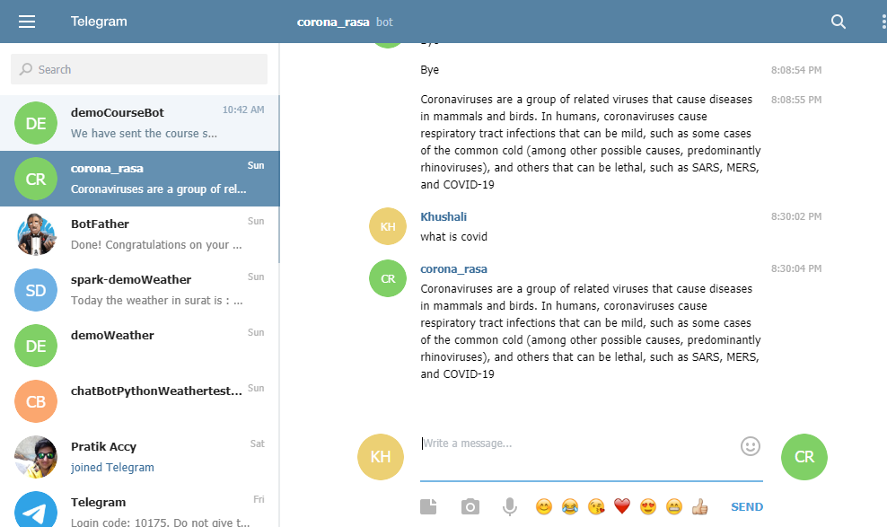

References:

1. Rasa Official documentation <https://rasa.com/docs/rasa/user-guide/installation/>
2. CDC Corona FAQ.