**Install Power BI Desktop and share the final screenshot of the report view page**

**which appears when power desktop starts**

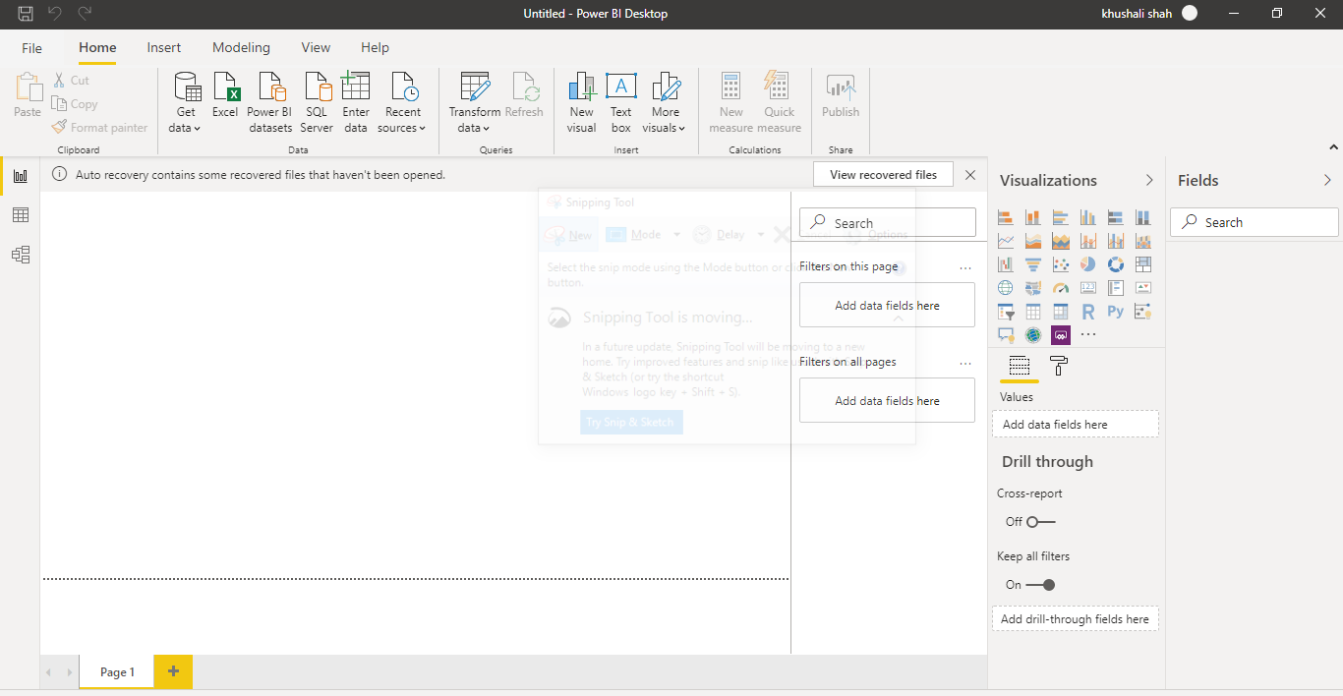

**Prepare a document and with the following screenshot**

*Report View*:-

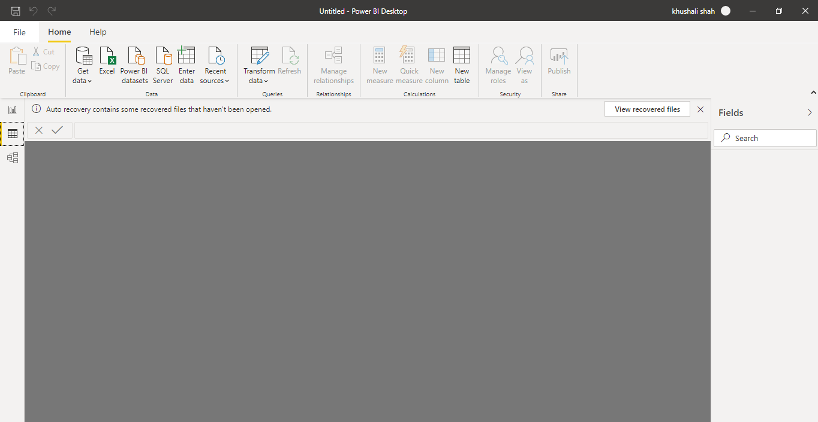

*Data View*:-

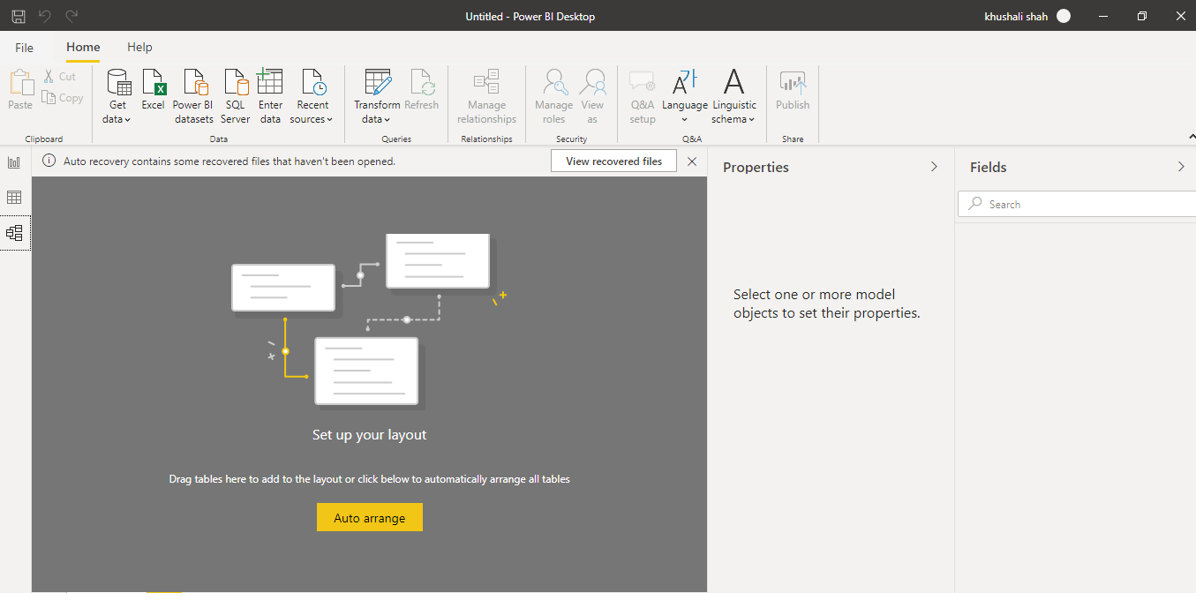

*Model View*:-

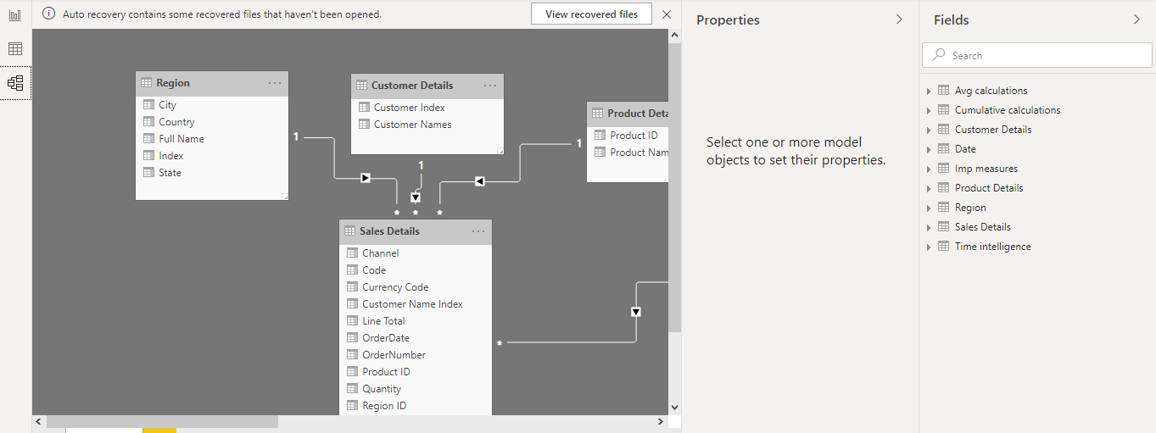

*Power Query Editor*

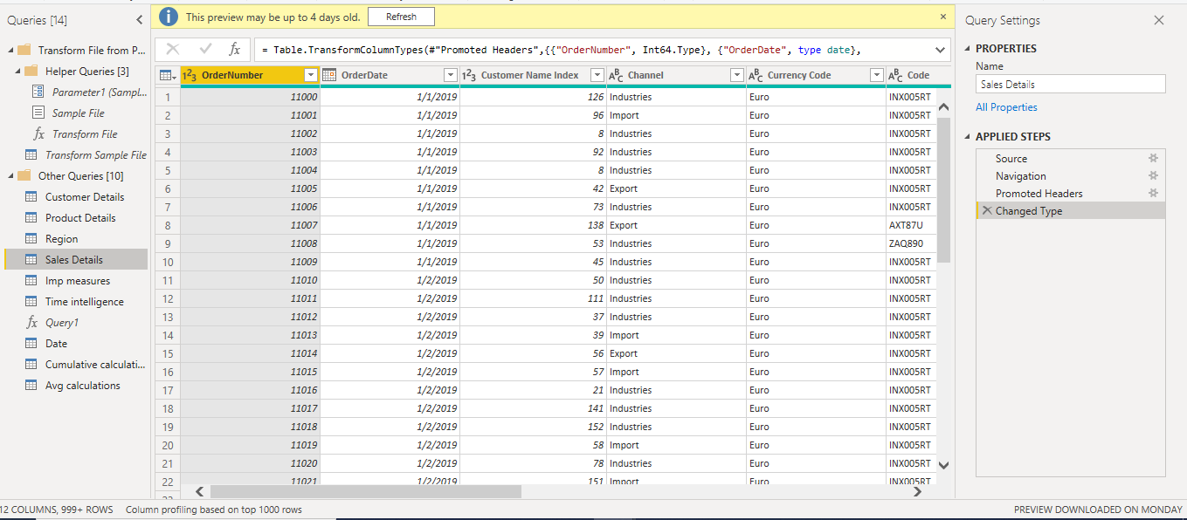

*Advance Editor*:-

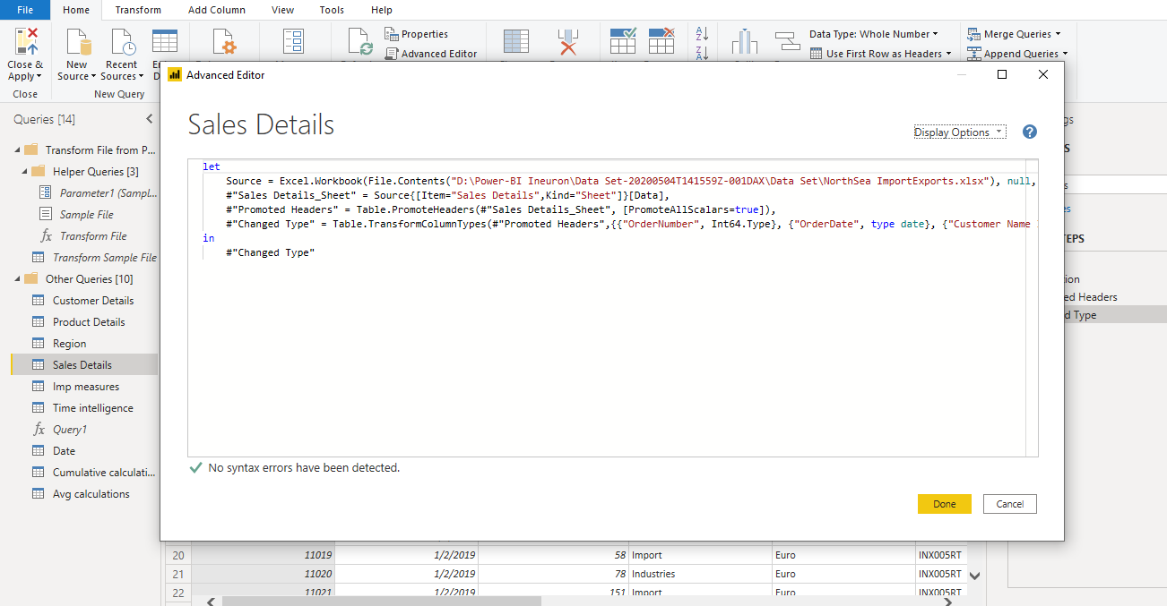

**Prepare a document with details of the following along with their price**

*Power BI Desktop,Power BI Pro, Power BI Premium*:-

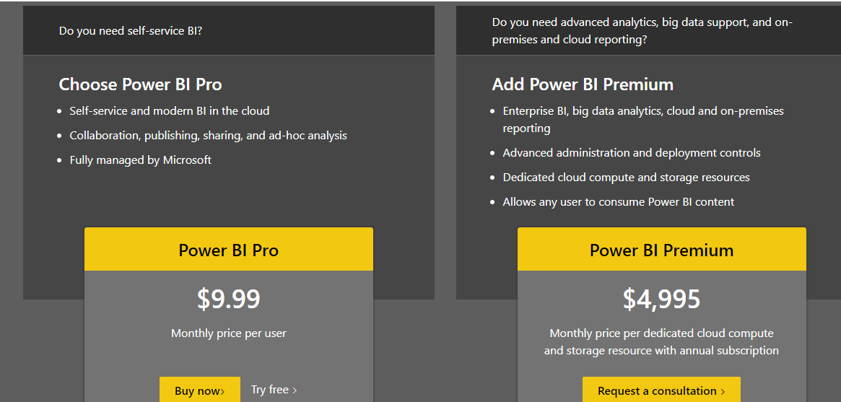

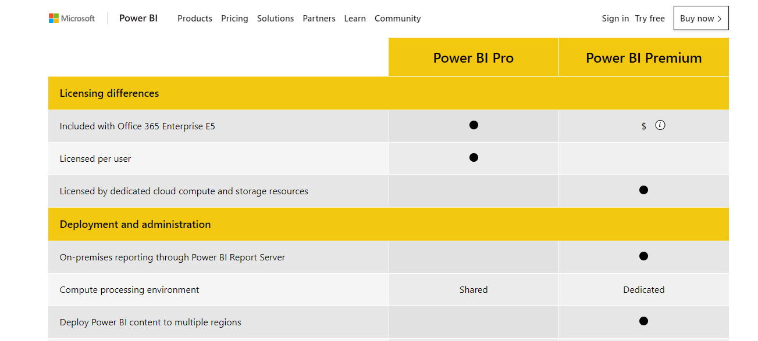

Ref link:- <https://powerbi.microsoft.com/en-us/pricing/#powerbi-comparison-table>