**AWS EC2 Assignment**

**ASSIGNMENT 1:**

1. How to create Key Pair?
2. How can we create Putty key?
3. How can we create Putty key with more security?

1.Created new key pair and download the key pair.

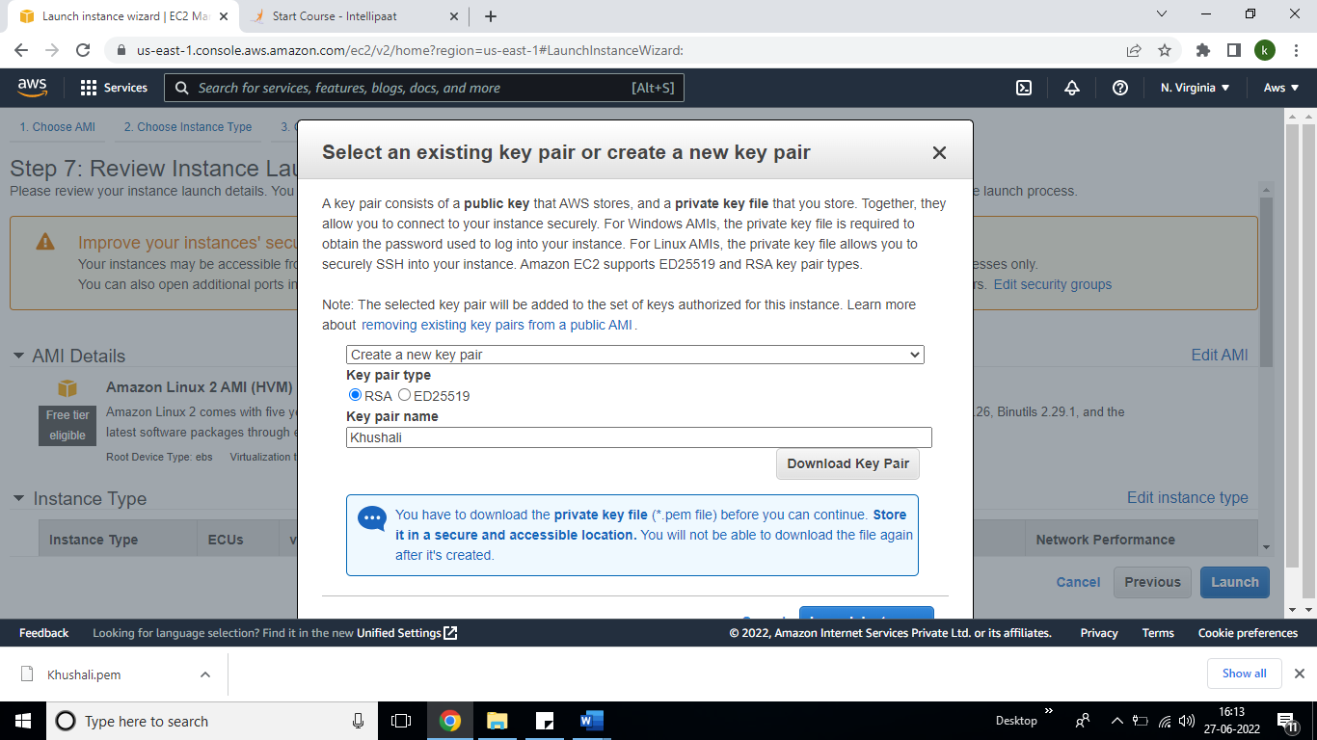

1. How can we create Putty key?

We have to load the file first then create Pem file into PPK file through Puttygen. Please find screen shot below.

