AWS Certification Course

**Module 3: Assignment**

**Problem Statement:**

You work for Xyz Corporation that uses on premise solutions and some limited number of systems. With

the increase in requests in their application, the load also increases. So, to handle the

load the

corporation had to buy more systems almost on regular basis. Realizing the need to cut down the

expenses on systems, they decided to move their infrastructure on AWS.

Once migrated, you have been asked to:

1.

Manage the scaling requirements of the company by:

•

Deploying multiple compute resources on the cloud as soon as the load increases and

the CPU utilization exceeds 80%

•

Removing the resources when the CPU utilization goes under 60%

2.

Create a Load balancer to distribute the load between compute resources

3.

Rout

e the traffic to the company’s

domain

**Note: You can get a free domain from**

[**Freeno**](https://www.freenom.com/en/index.html?lang=en)

[**m**](https://www.freenom.com/en/index.html?lang=en)



1. We have created two EC2.

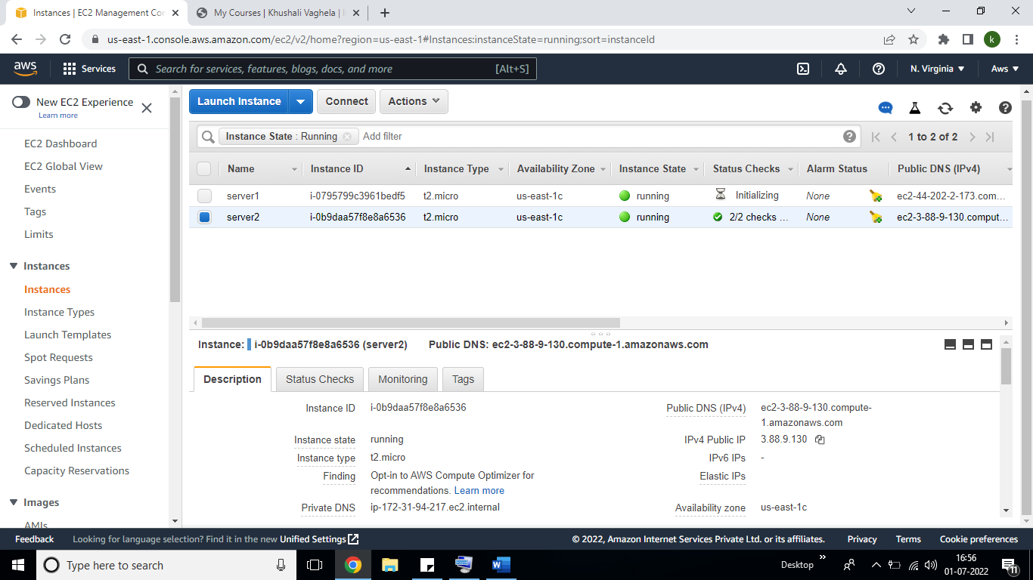

Put all commands in user data:-

#!/bin/bash

#install httpd

yum update -y

yum install -y httpd

systemctl start httpd

systemctl enable httpd

echo "<h1> This is khushi lab $(hostname -f) </h1>">/var/www/html/index.html

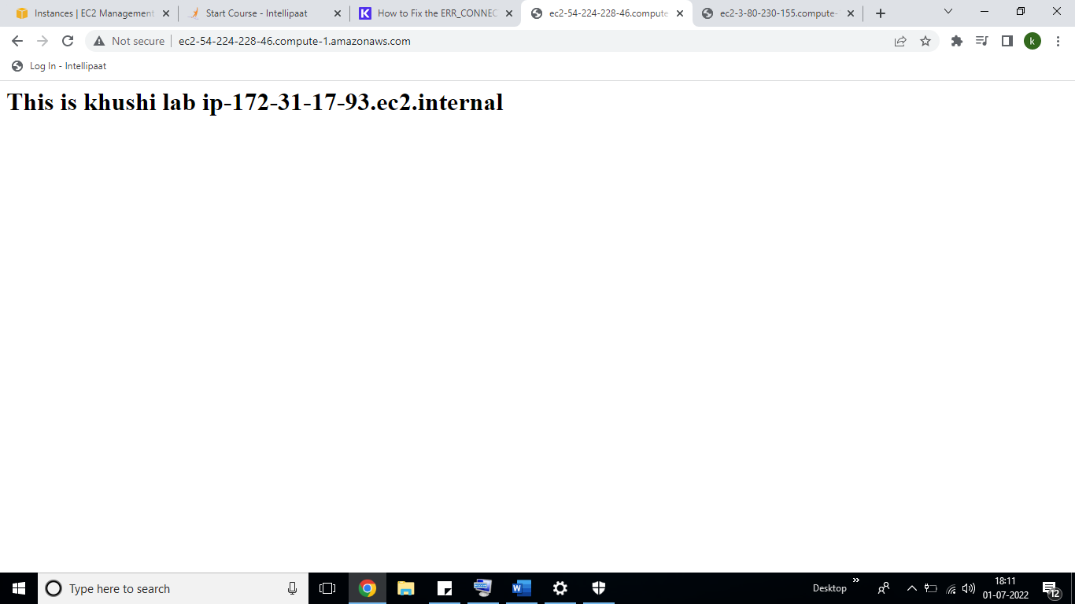

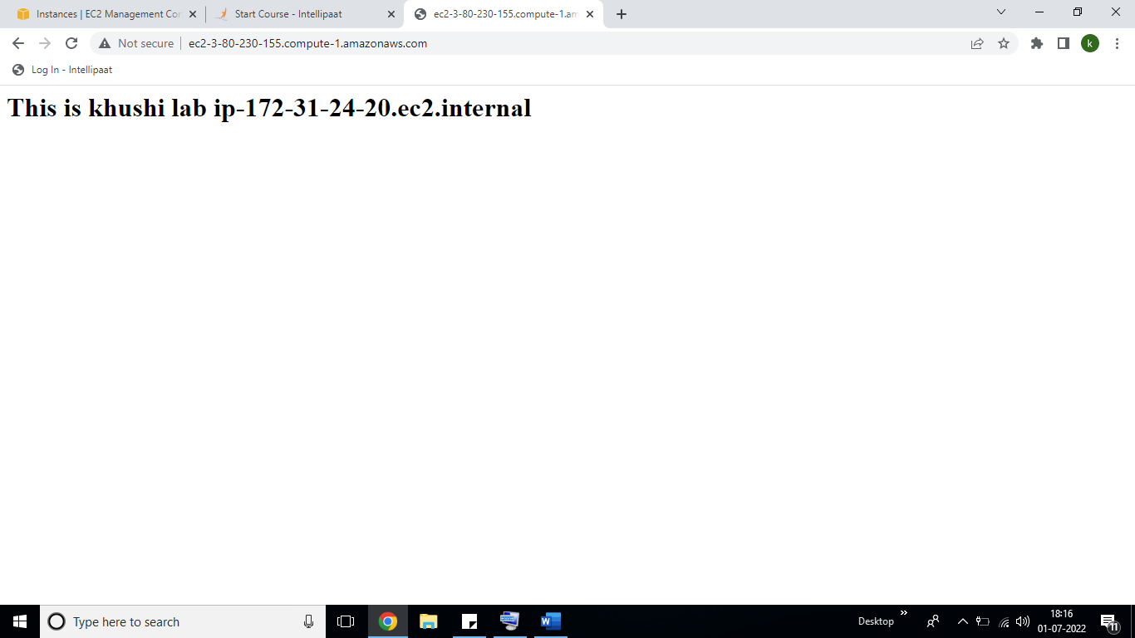

Created classic load balancer and set the threshold time In health check:-

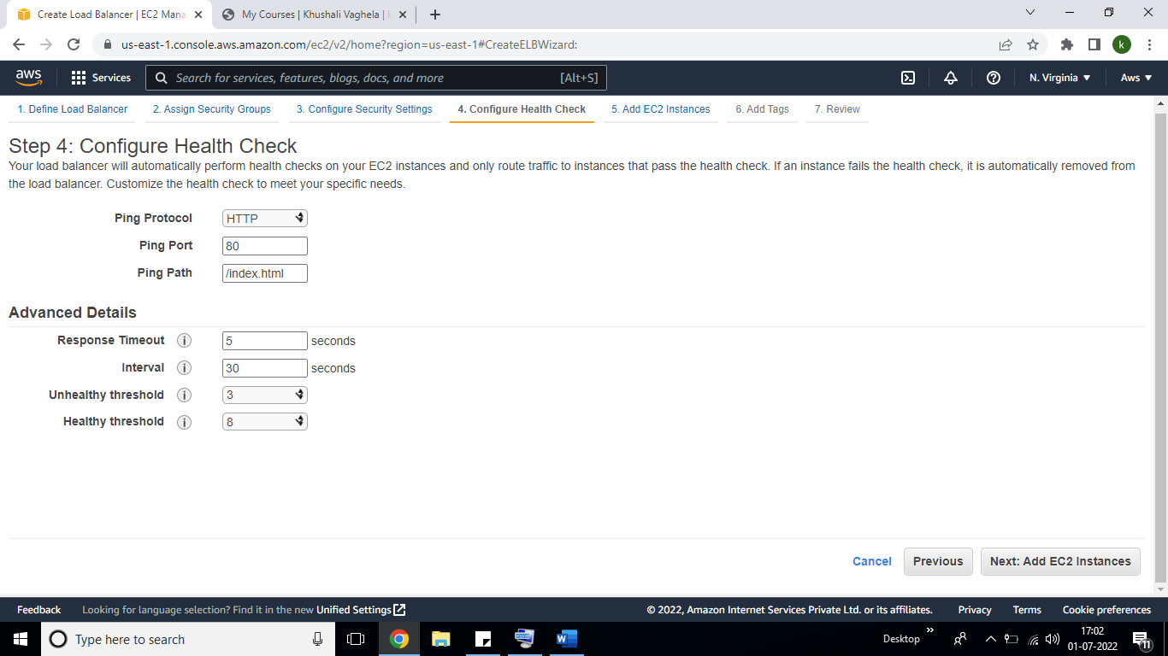

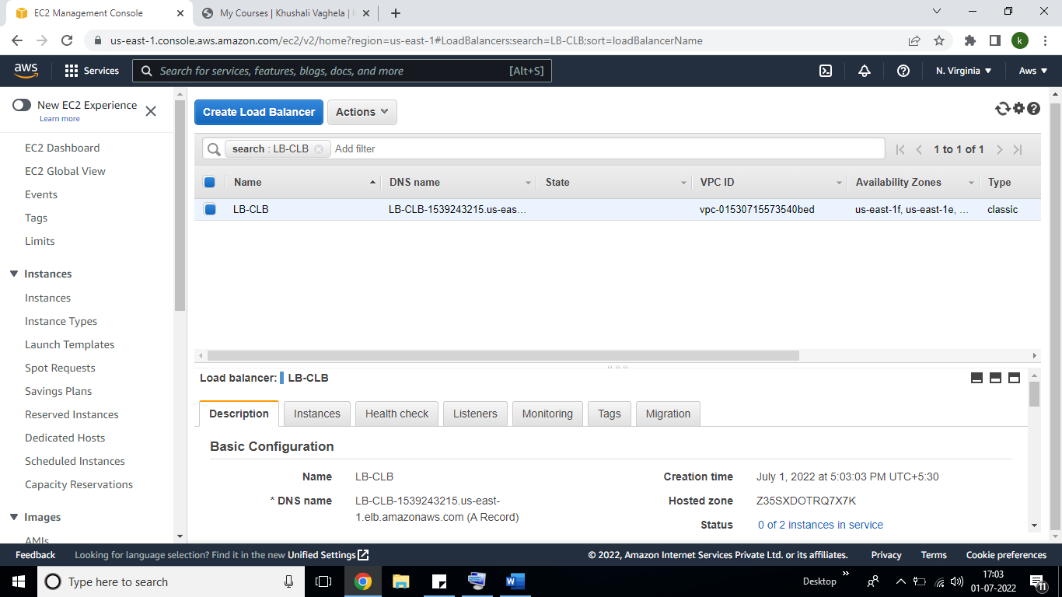

Created launch template and now creating ASG group:-

