AWS Certification Course

**Module 4: Assignment**

**Problem Statement:**

You work for Xyz Corporation and based on the expansion requirements of your corporation you have been asked to create and setup distinct Amazon VPC for production and development team.



You are expected to perform the following tasks for the respective VPCs:

**Production Network:**

1.

Design and build a 4 tier architecture

2.

Create 5 subnets out of which 4 should be private with names app1, app2, dbcache and db and

one should be public named web.

3.

Launch instances in all subnets and name them as per the subnet that they have been launched

in.

4.

Allow dbcache instance and app1 subnet to send internet requests

5.

Manage security groups and NACLs

**Development Network:**

1.

Design and build 2 tier architecture with two subnets named web and db and launch instances

in both subnets and name them as per the subnet names.

2.

Make sure only web subnet can send internet requests

3.

Create peering connection between production network and development network

4.

Setup connection between db subnets of both production network and development network

respectively

**support@intellipaat.com - +91-7022374614 - US: 1-800-216-8930 (Toll Free)**

# Created 1 VPC and 4 Subnets:

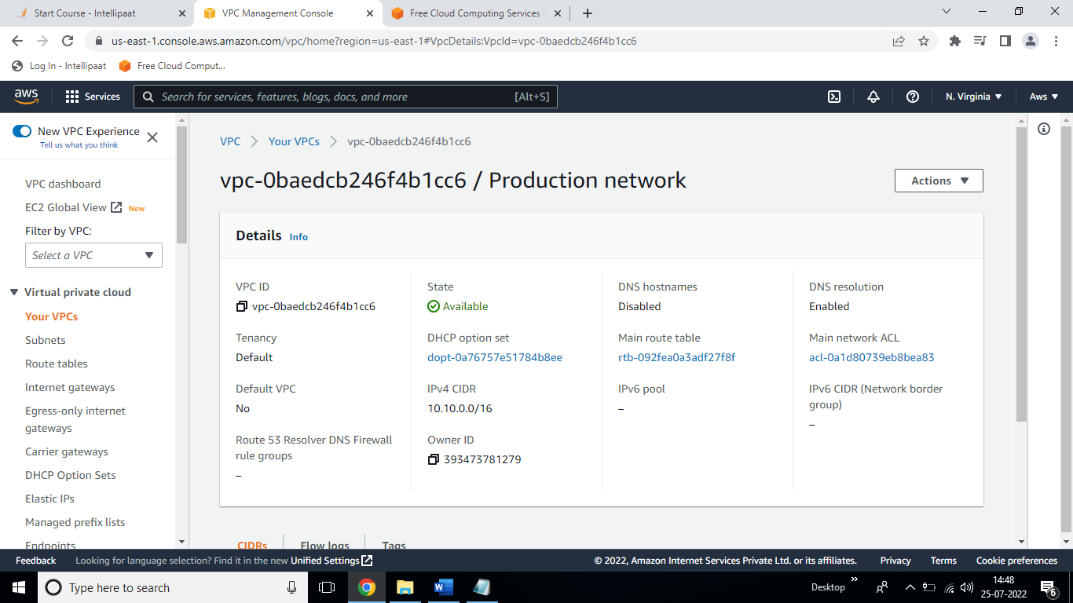

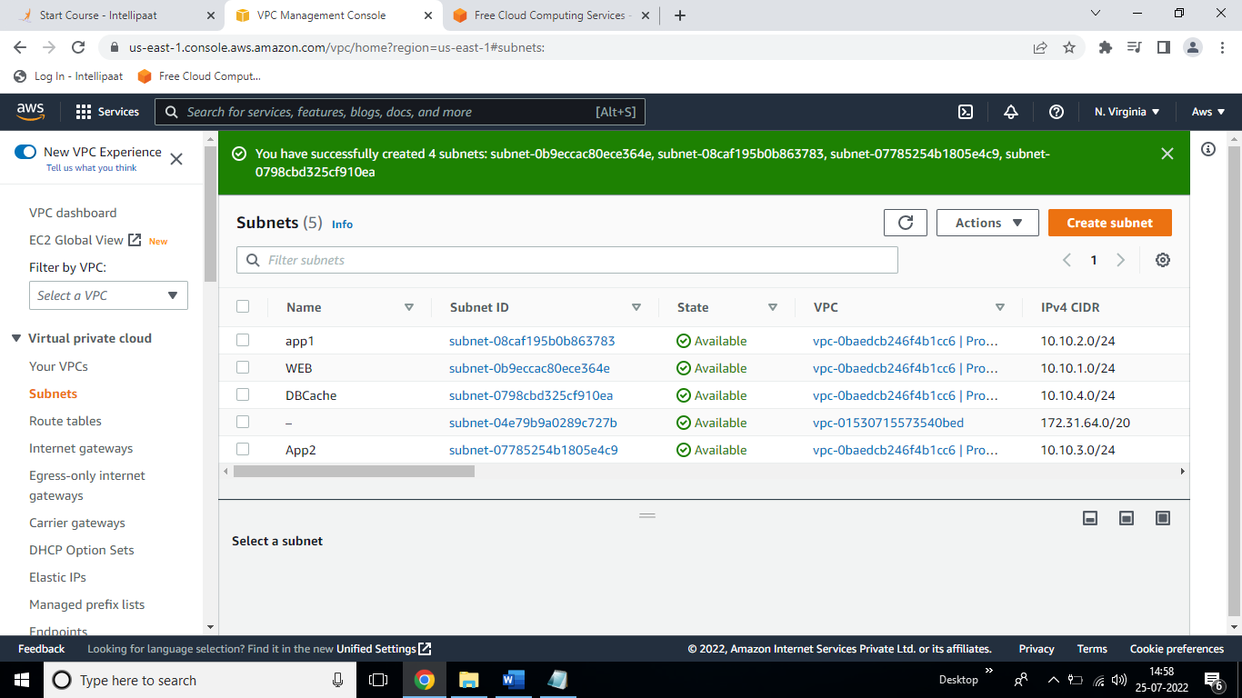

#Created IGW and NAT gateway and attached with VPC:

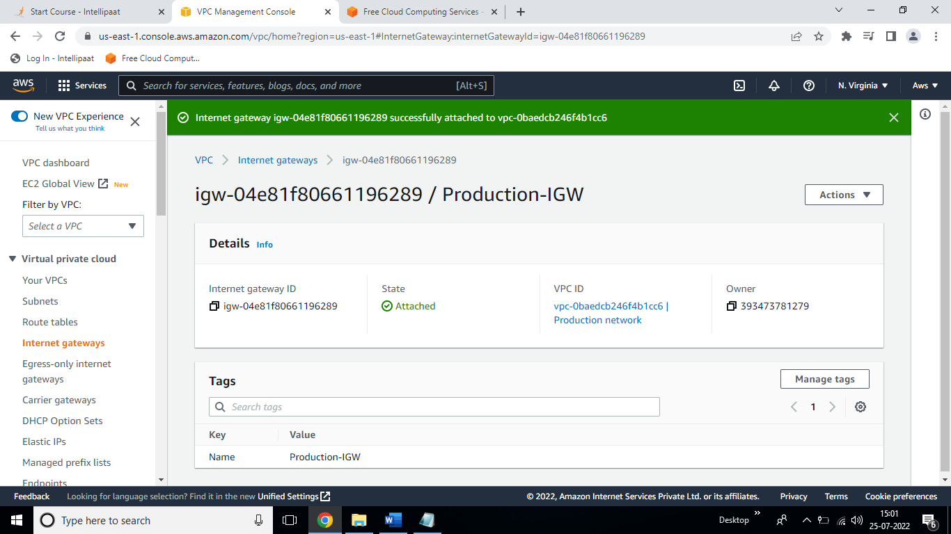

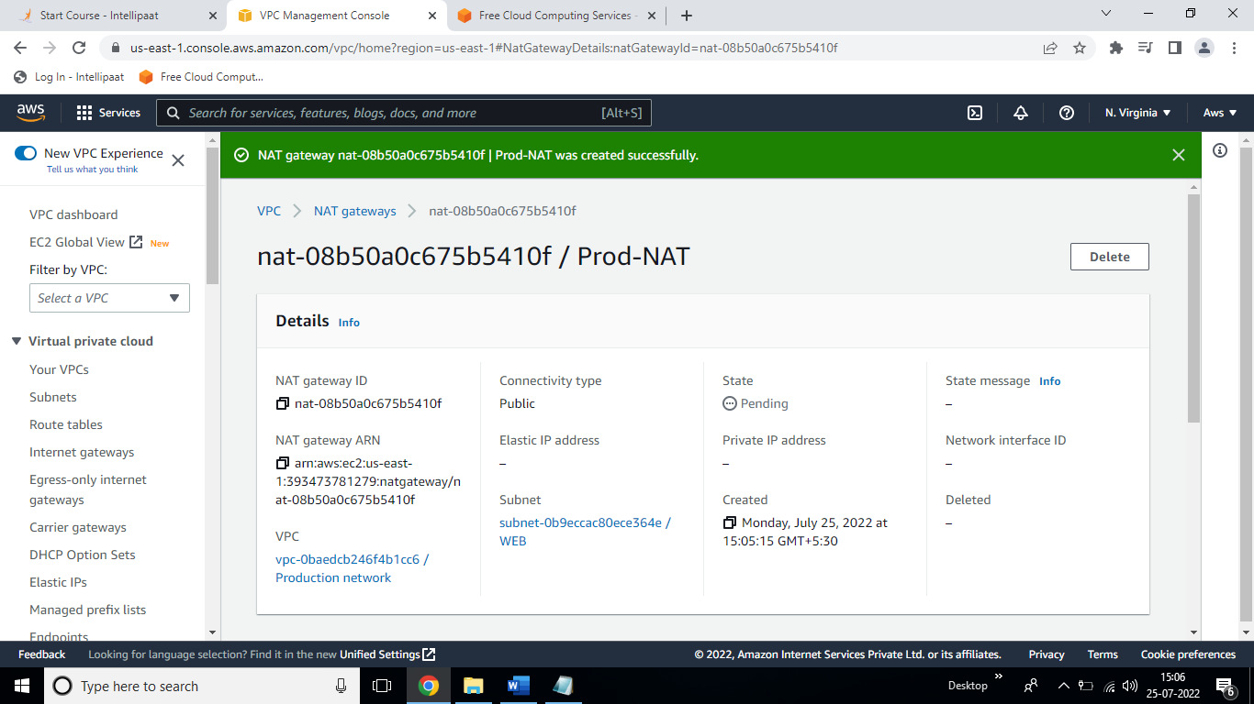

#Created Route table and associate with subnet:

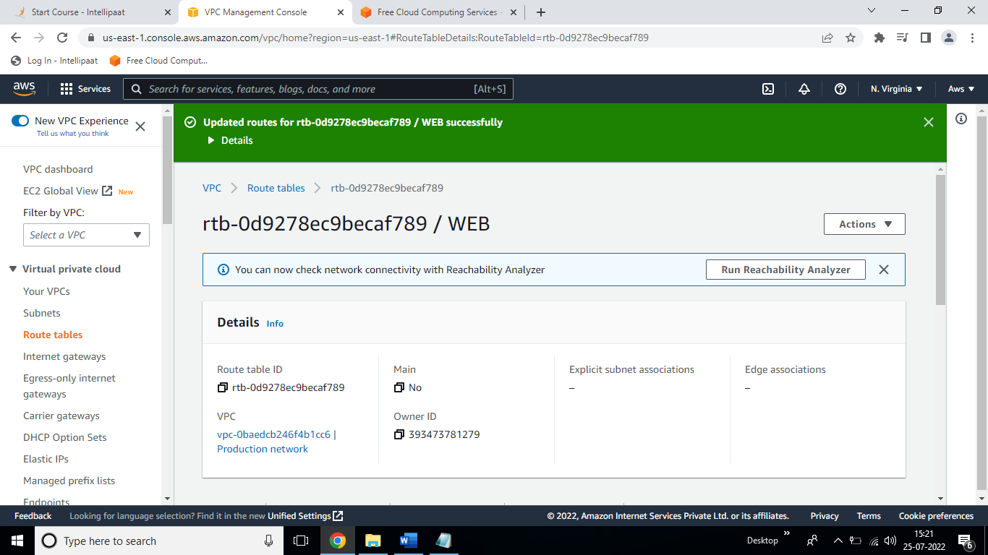

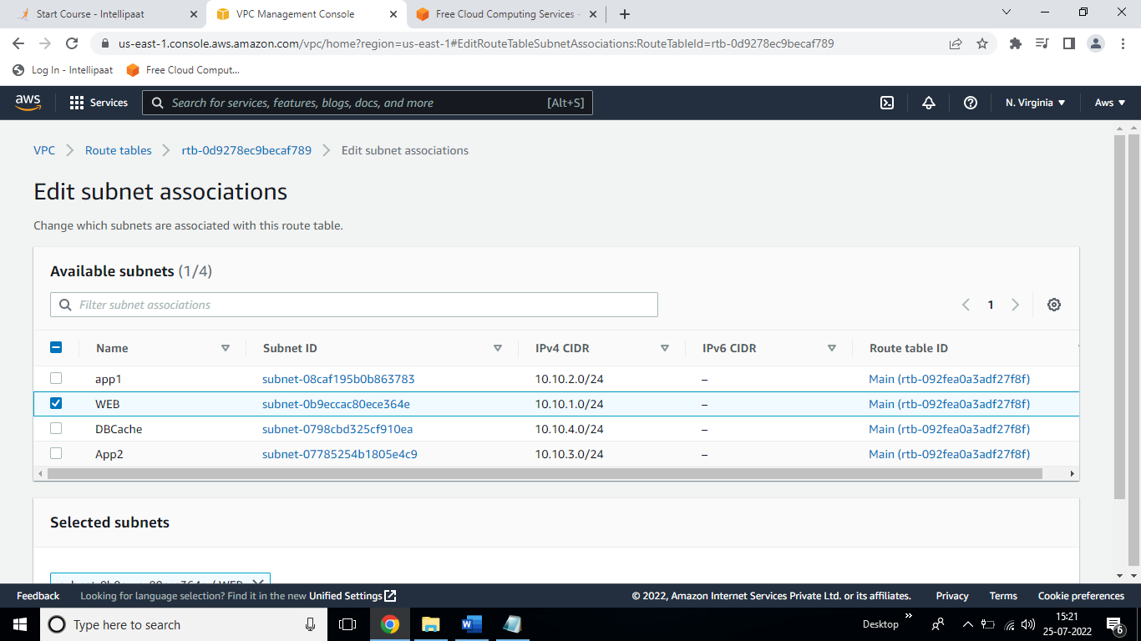

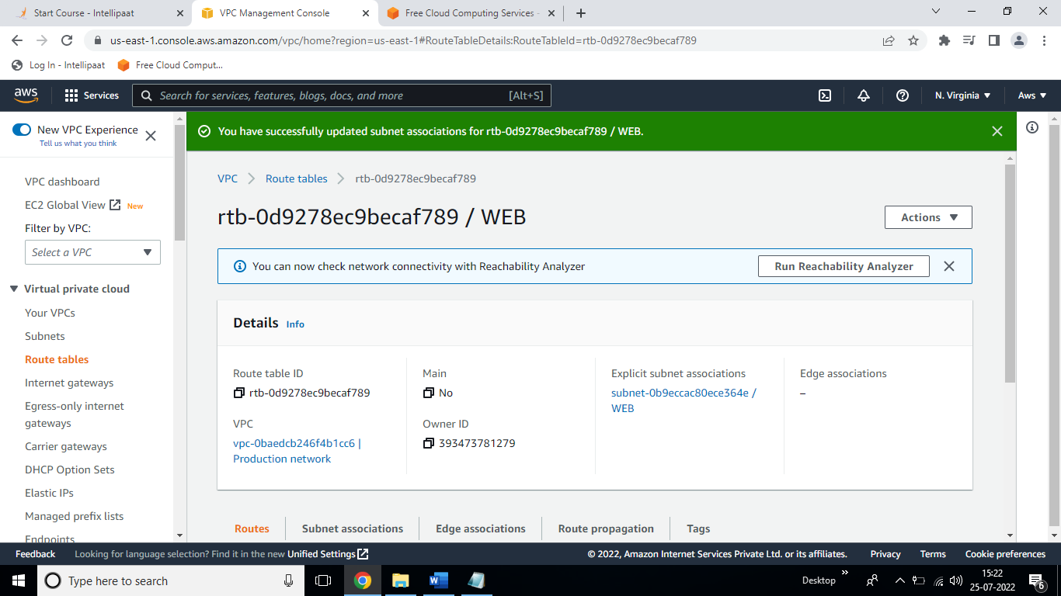

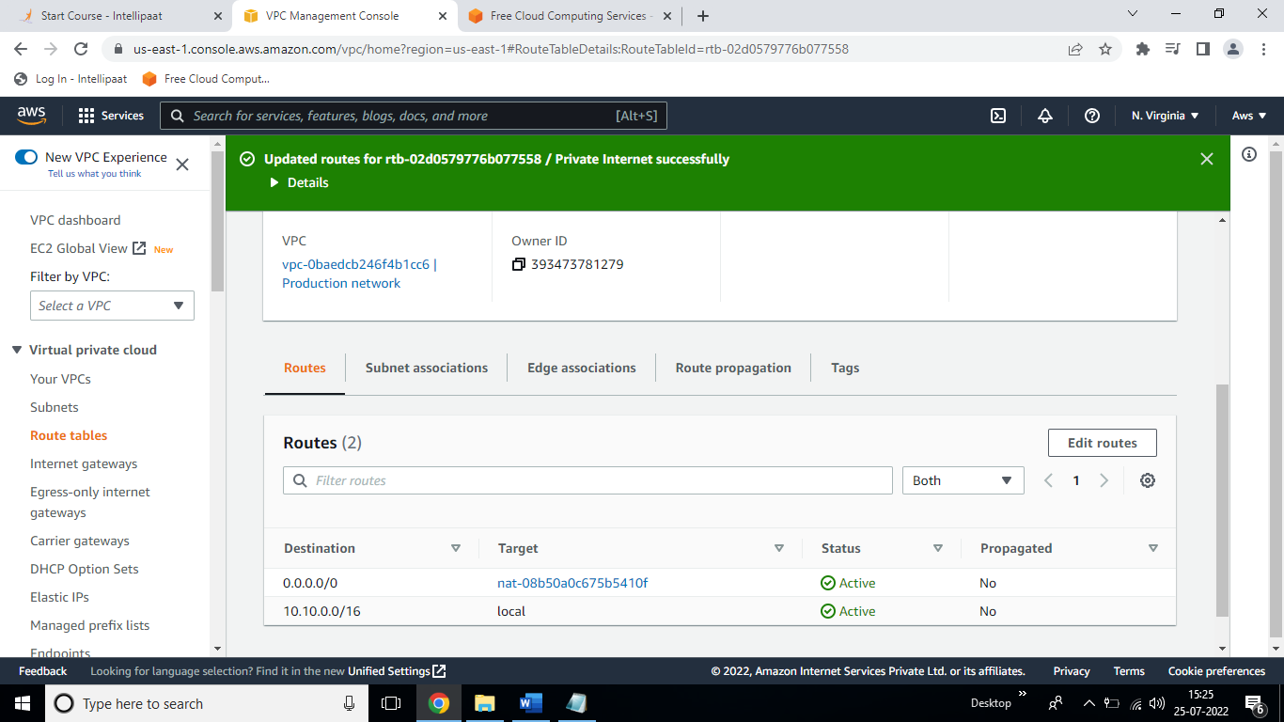

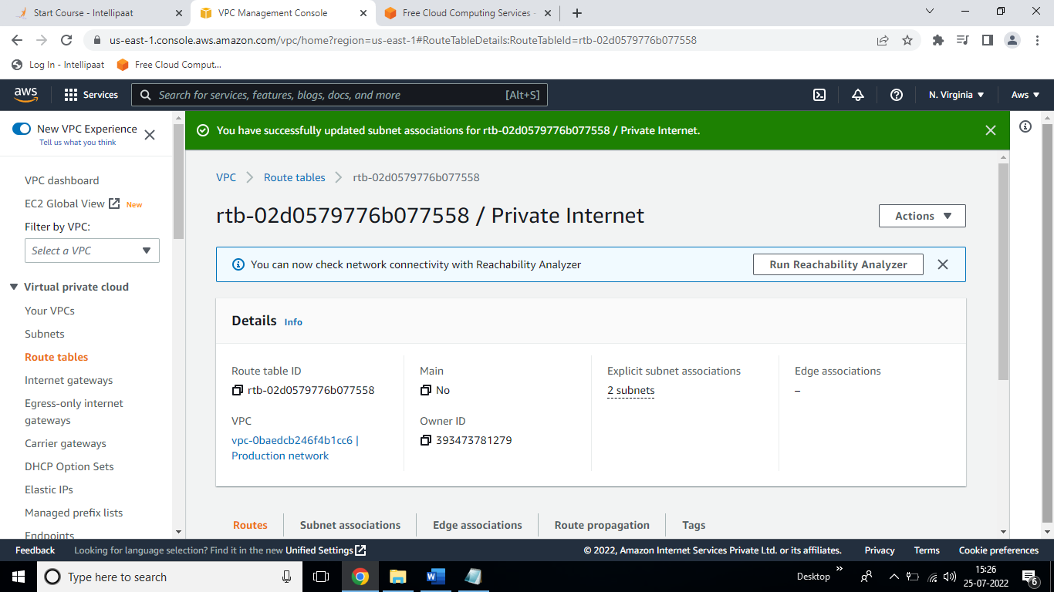

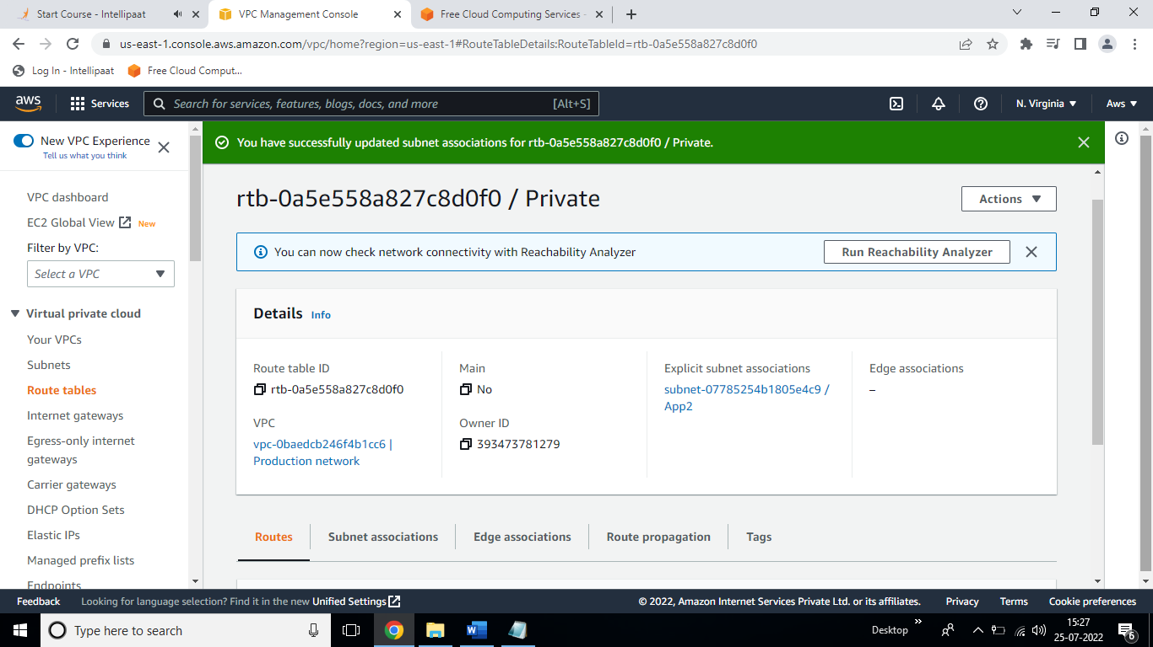

#Created EC2:

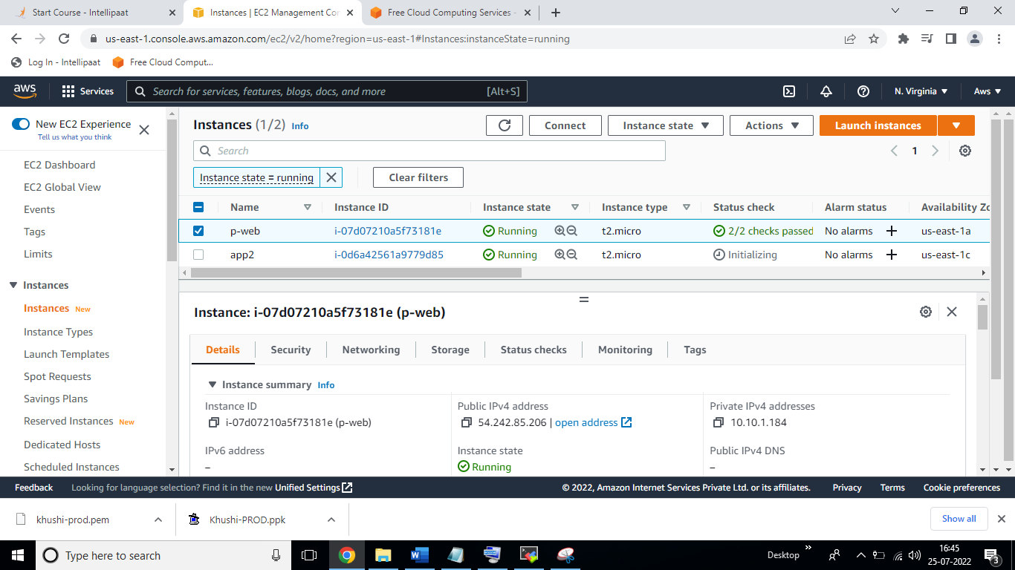

#Creating development network and IGW.

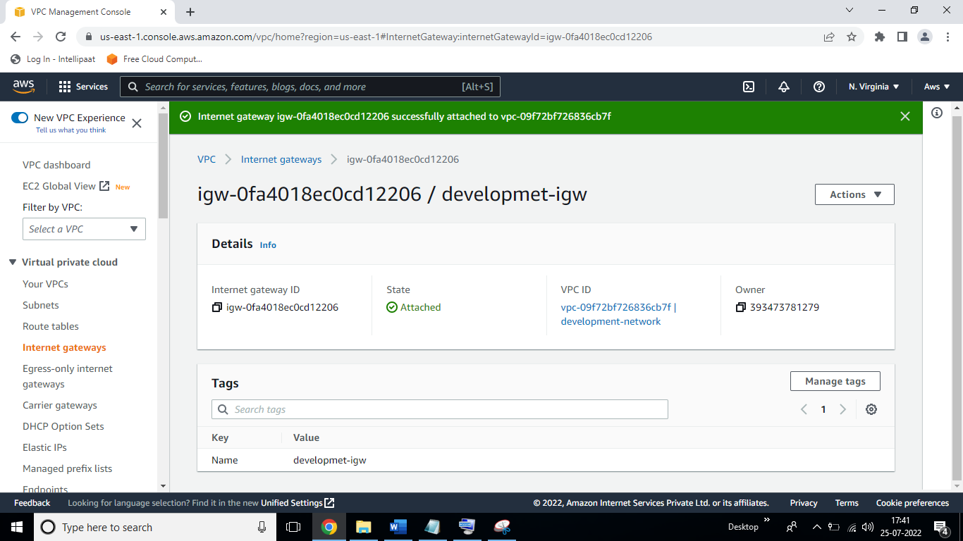

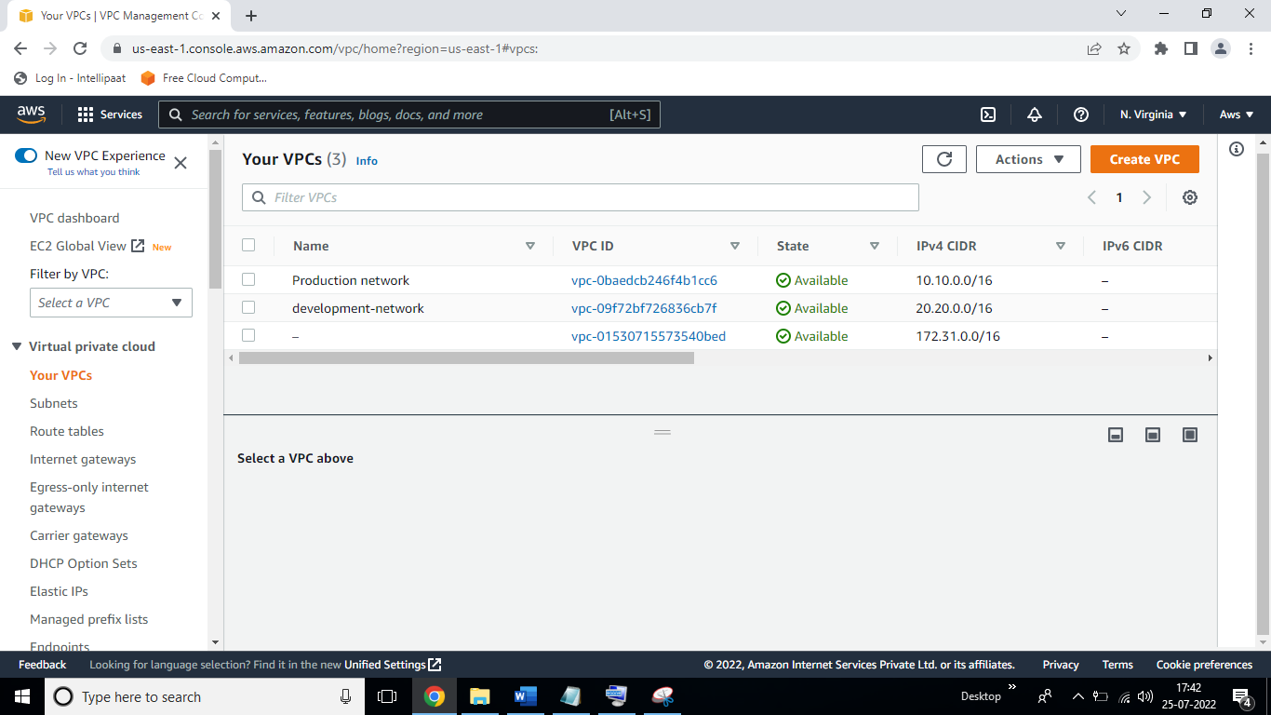

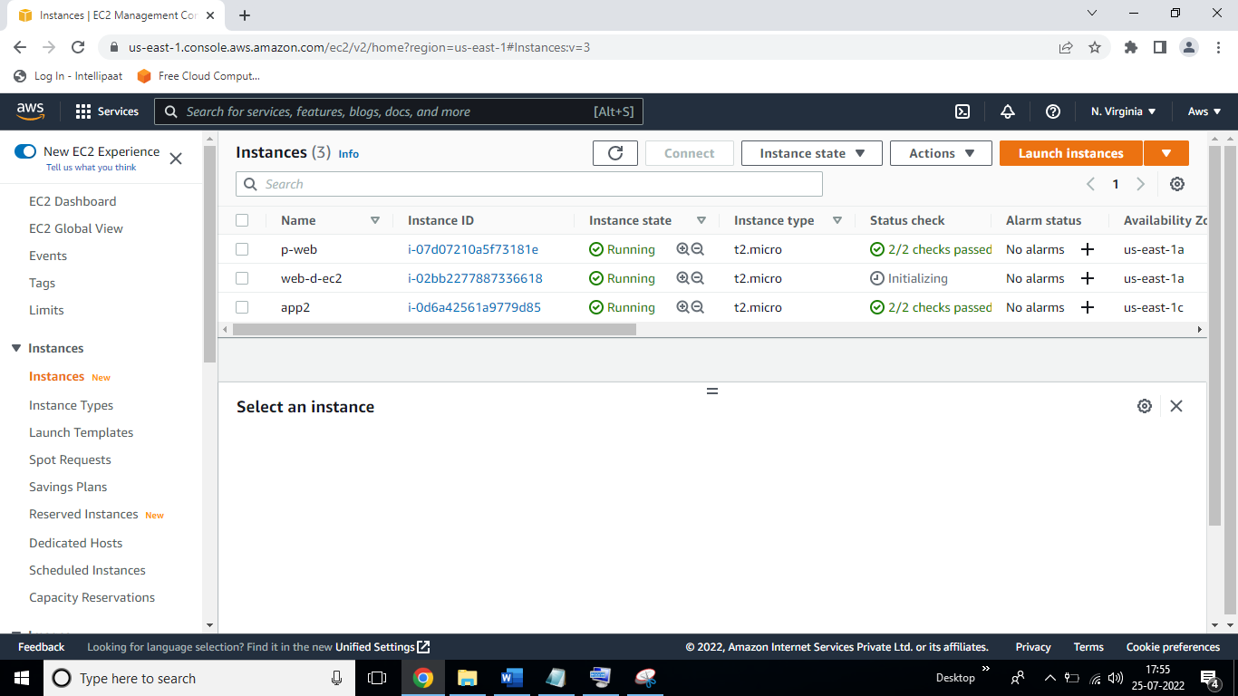

#Created VPC peering.

