Name: Khushal Pareta

Student ID: 240840325031

**#HIVE**

**Question 1:**

1-> airports that are listed as both source and destination

SELECT ap.airport_id, ap.name

FROM airports ap

JOIN routes r1 ON ap.airport_id = r1.src_airport_id

JOIN routes r2 ON ap.airport_id = r2.dest_airport_id

LIMIT 10;

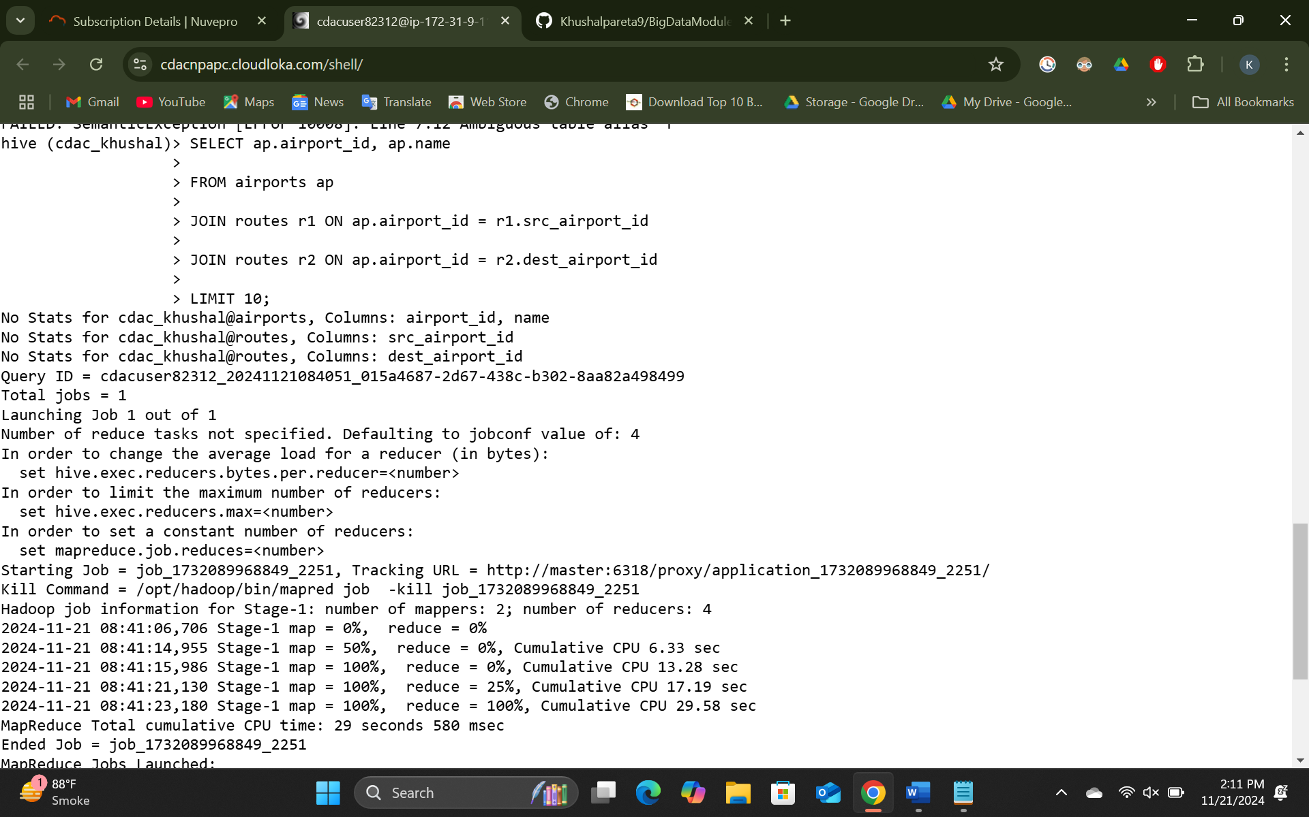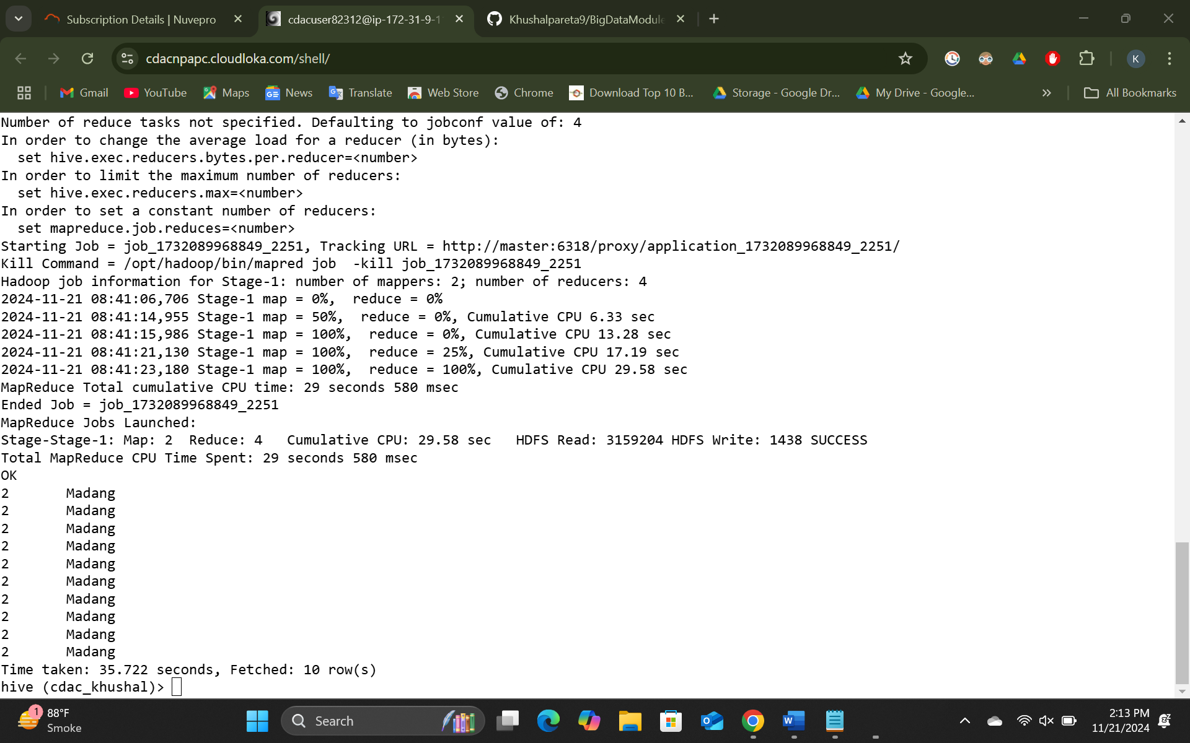

2 -> determine equipment that is used on highest number of routes

SELECT equipment, COUNT(equipment) AS HIGHEST_COUNT

FROM routes

GROUP BY equipment, src_airport_id, dest_airport_id

ORDER BY HIGHEST_COUNT DESC

LIMIT 1;

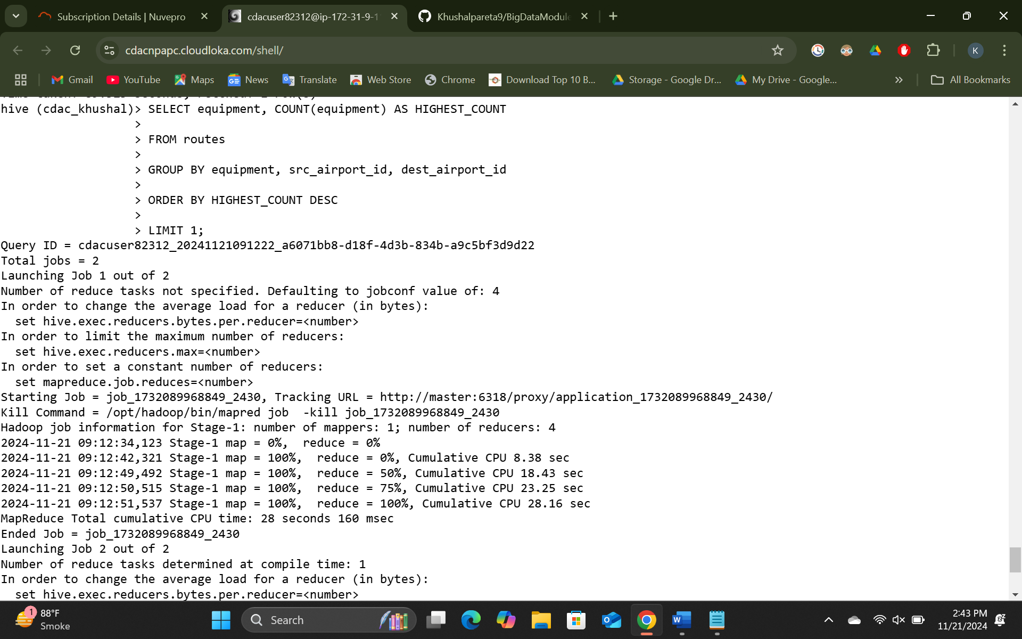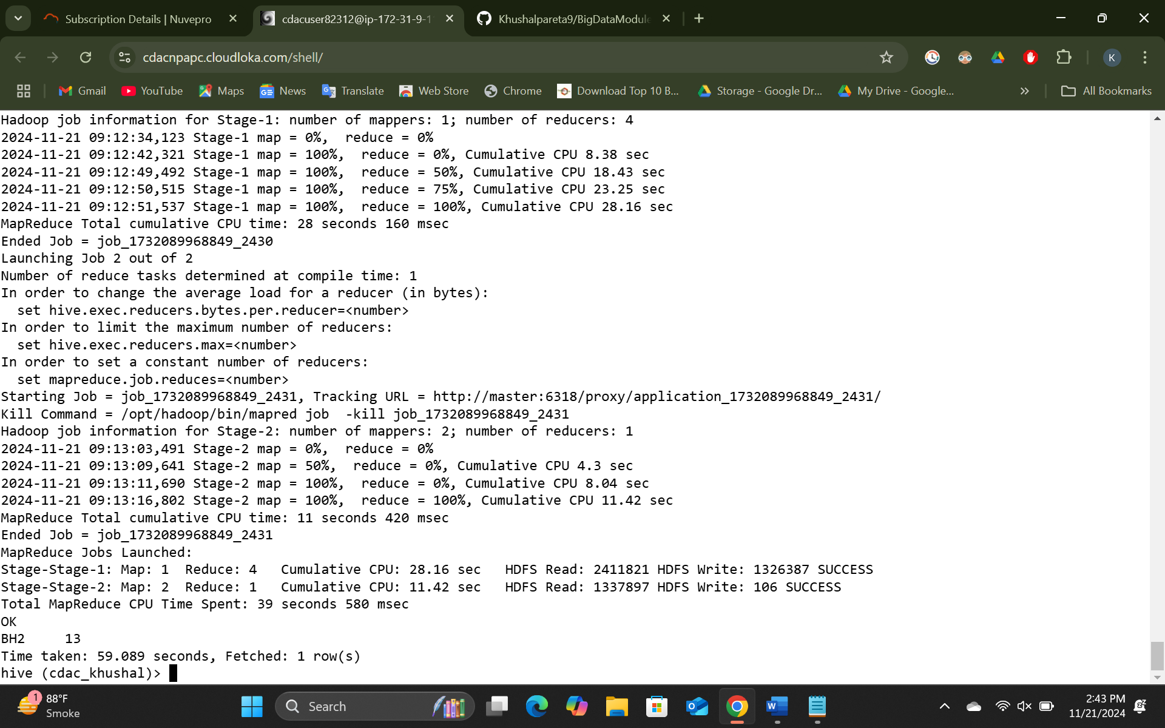

3 - > Airline which operates the highest number of routes and count of those routes

SELECT a.name, COUNT(a.airline_id) AS ROUTE_COUNT

FROM airlines a

JOIN routes r ON a.airline_id = r.airline_id

GROUP BY a.name, r.src_airport_id, r.dest_airport_id

ORDER BY ROUTE_COUNT DESC

LIMIT 1;

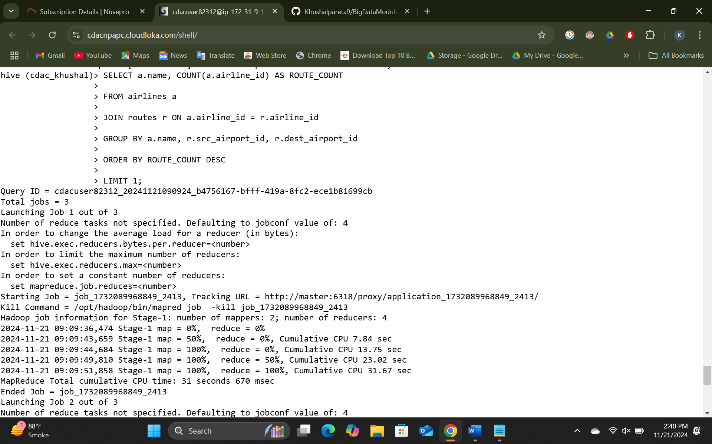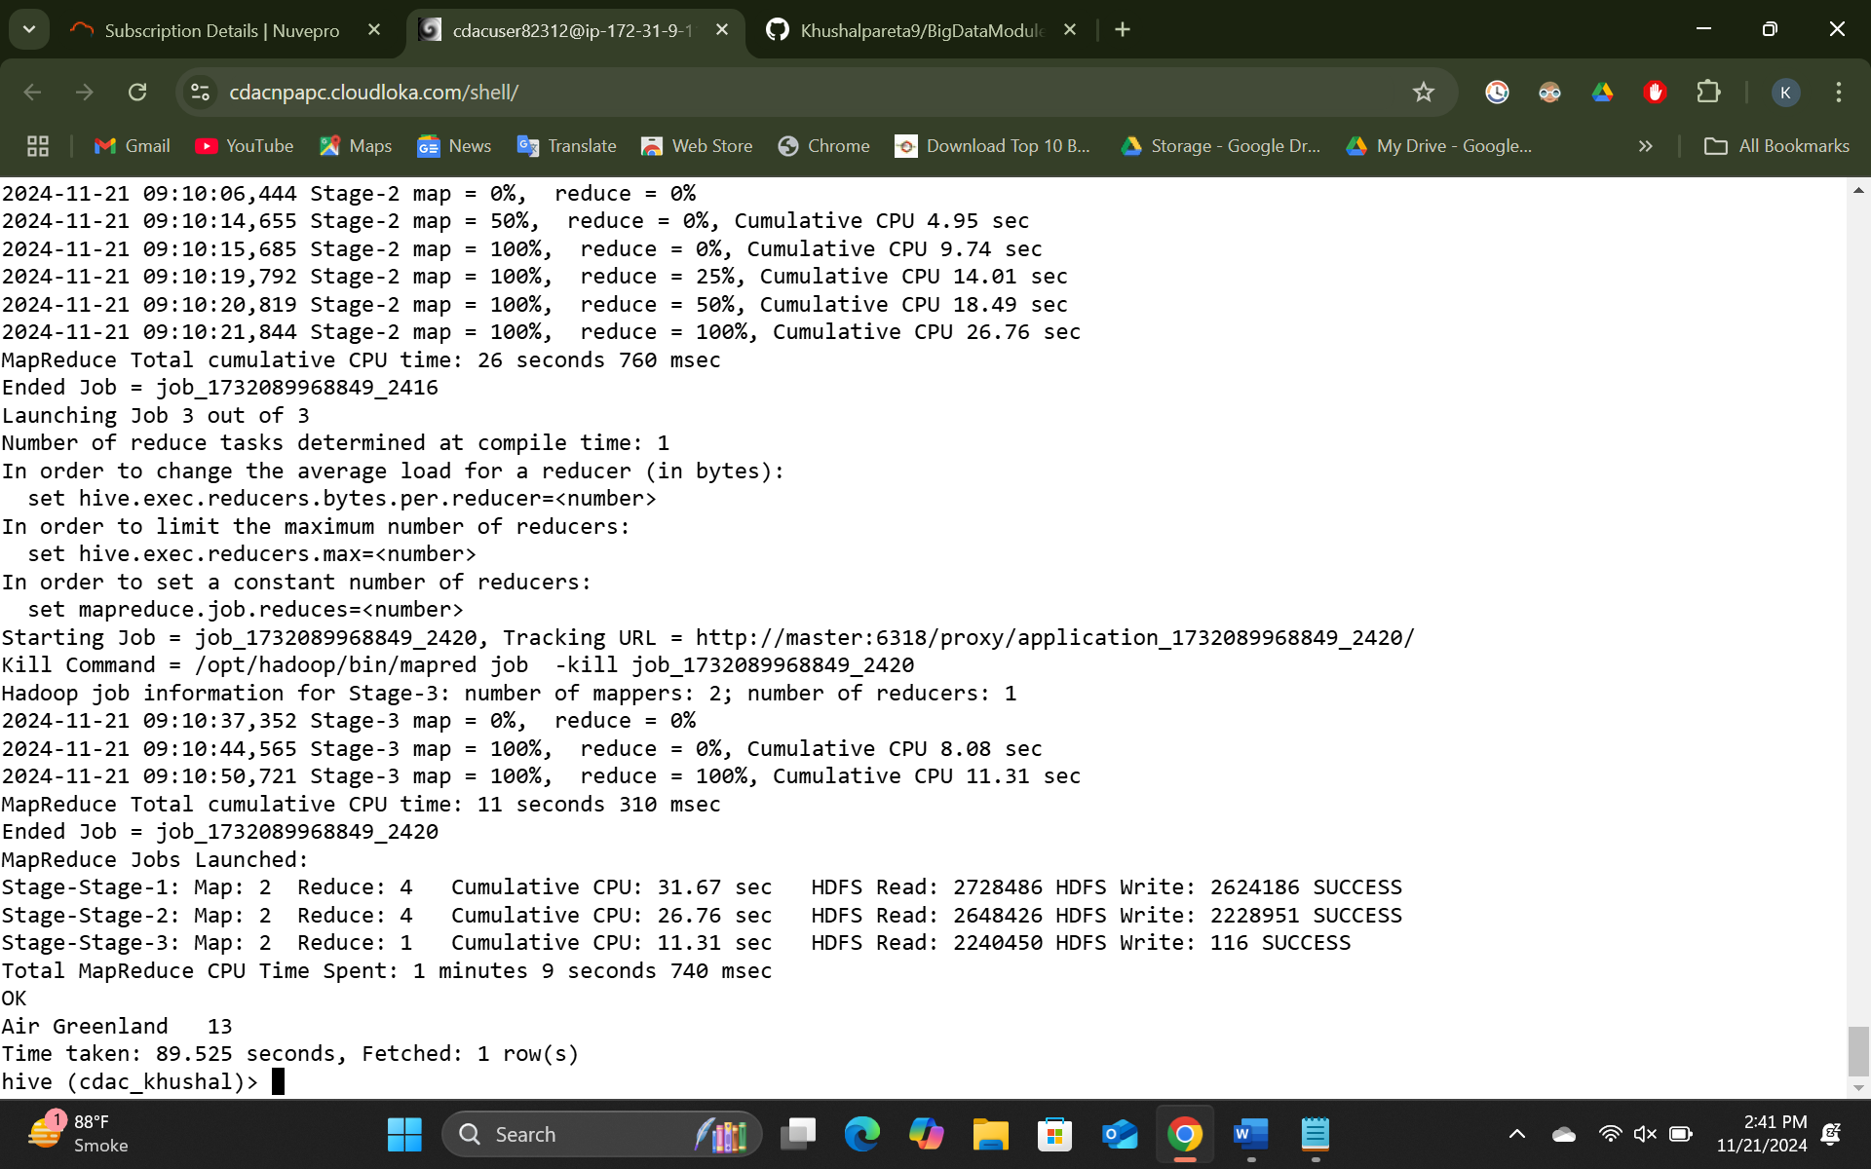

**Question 2:**

1 -> Create a partition table for the source_airport, write a sql query to create this table and insert data into it.

SET hive.exec.dynamic.partition=true;

SET hive.exec.dynamic.partiton.mode=nonstrict;

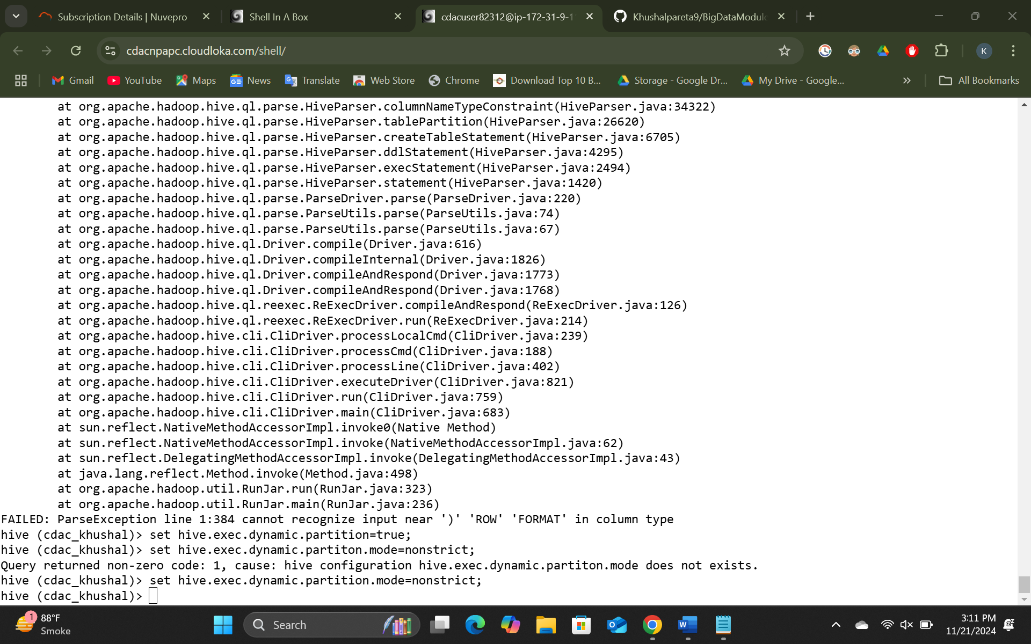

CREATE TABLE partitioned_table (

airline_iata string, airline_id int, src_airport_id int, dest_airport_iata string, dest_airport_id int, codeshare string, stops int, equipment string

)

PARTITIONED BY (source_airport_iata=‘JFK’)

ROW FORMAT DELIMITED FIELDS TERMINATED BY ‘,’ STORED AS TEXTFILE;

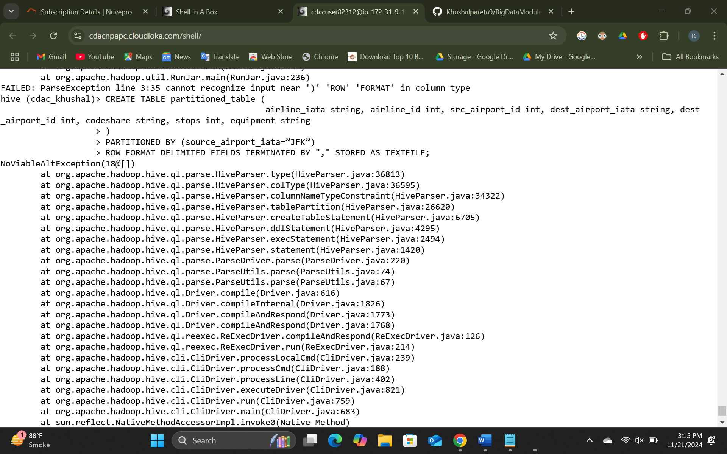

2 ->

INSERT INTO TABLE partitioned_table SELECT * FROM airports WHERE src_airport_iata=‘JFK’

3 ->

SELECT * FROM partitioned_table WHERE src_airport_iata=‘LAX’;

4 ->

SHOW paritions partitioned_table

**#SPARK**

Question 1:

df = spark.read.csv(‘/user/cdacuser82312/sparkAirlines/spark_airlines.csv’, header=True, inferSchema=True)

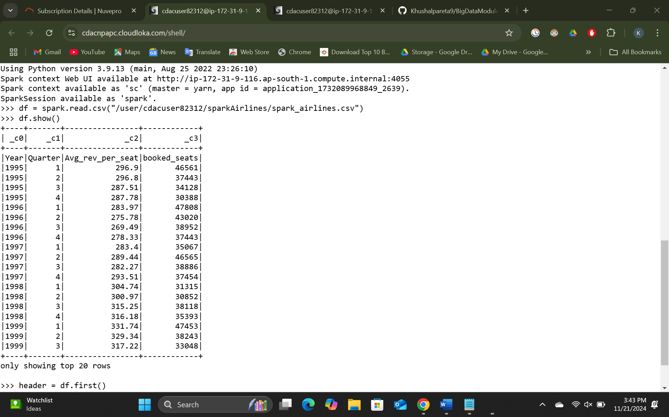

1 ->

From pyspark.sql.functions import sum

df.groupBy(‘Year’, ‘Quarter’).agg(count(sum(‘booked_seats’)) > 40000).show()

2 ->

df.groupBy(‘Year’).show()

QUESTION 2:

1->

From pyspark.sql.functions import sum, avg, min

df.groupBy(‘Year’, ‘Quarter’).agg(sum(‘Avg_rev_per_seat’).alias(‘TotalRevenuePerSeat’), avg(‘Avg_rev_per_seat’).alias(‘AverageRevenuePerSeat’), min(‘Avg_rev_per_seat’).alias(‘MinimumRevenuePerSeat’)).show()

2 ->

df.groupBy(‘Year’, ‘Quarter’).agg(count(avg_rev_per_seat).alias(‘Total_Count’) > 290)).show()

3 ->

From pyspark.sql.functions import sum

df.groupBy(‘Year’).agg(sum(‘booked_seats’).alias(‘Total_Booked_Seats)).show()

4 ->

df.groupBy(‘year’).show()

5 ->

From pyspark.sql.functions import sum

df.groupBy(‘Year’).agg(sum(‘avg_rev_per_seat’).alias(‘Total_Avg_Revenue’)).show()