TriSpecWaveMambaUQ: Physics-Informed Multi-Spectral Super-Resolution with State Space Models and Calibrated Uncertainty Quantification for Sentinel-2 MSI
AIES MINI PROJECT PAPER
Department of Computer Science & Engineering | Course: Artificial Intelligence & Expert Systems
Authors:Khushalzz et al.
Academic Year:2025–2026 |Domain:Deep Learning, Computer Vision & Satellite Remote Sensing

Abstract
Multispectral satellite imagery from the European Space Agency's Sentinel-2 Multi-Spectral Instrument (MSI) is physically constrained by optical detector geometry, distributing twelve reflective spectral bands across three disparate spatial resolutions (10 m,20 m, and60 m). Conventional single-image super-resolution (SISR) techniques fail to handle this multi-resolution data effectively: Convolutional Neural Networks (CNNs) have small receptive fields, Vision Transformers (ViTs) incur quadratic computational complexityO(N²)causing GPU memory crashes on large satellite tiles, and standard Generative Adversarial Networks (GANs) hallucinate non-existent ground features without predictive confidence bounds.
In this AIES mini project, we developTriSpecWaveMambaUQ, an end-to-end deep neural architecture (6.17 Mtotal parameters,1.12 Mbase backbone) for4×multispectral super-resolution (10 m → 2.5 mGround Sampling Distance) with calibrated pixel-wise uncertainty quantification. Our model ingests all 12 bands via a tri-stream grouped encoder aligned with native sensor resolutions, dynamically captures inter-band correlations via 3-node Spectral Graph Attention and continuous-wavelength 1D State Space Models (SpectralMamba,O(C)), and losslessly decouples spatial features through 2D Haar Discrete Wavelet Transforms. Low-frequency background structures are routed through linear-complexity 2D SpatialMamba blocks (O(N)), while high-frequency details pass through directional Strip Convolution stacks (1×7and7×1). Dual output heads simultaneously reconstruct surface reflectance means (μ) and aleatoric log-variance uncertainty maps (log σ²) under a heteroscedastic Gaussian negative log-likelihood objective regularized by physical sensor Modulation Transfer Function (MTF) degradation constraints.
Evaluated on unseen geographic test suites against Bicubic interpolation and the OpenSR-SRGAN teacher, our model achieves[MATH:32.17 dB:MATH] PSNR(+2.13 dBgain),[MATH:0.8754:MATH] SSIM, an[MATH:18.2\%:MATH] reduction in Spectral Angle Mapper error ([MATH:0.0198 rad:MATH] / [MATH:1.13^°:MATH]), and a[MATH:28.7\%:MATH] reduction in NDVI MAE ([MATH:0.0161:MATH]), with an inference latency of[MATH:24.96 ms:MATH]per tile and[MATH:270 MB:MATH] peak VRAM. Calibrated uncertainty maps reliably flag ambiguous parcel boundaries and cloud fringes, establishing an operational foundation for reliable Earth observation.
Keywords:Artificial Intelligence, Sentinel-2 MSI, Multispectral Super-Resolution, State Space Models (SSM), Mamba, Haar Discrete Wavelet Transform, Uncertainty Quantification, Modulation Transfer Function (MTF).

I. INTRODUCTION
Satellite Earth observation provides the sensory foundation for climate monitoring, food security forecasting, and disaster mitigation. The Multi-Spectral Instrument (MSI) aboard the European Space Agency's (ESA) Copernicus Sentinel-2 constellation is an operational cornerstone in open-access Earth observation. MSI acquires 12 distinct reflective spectral bands spanning from the visible and near-infrared (VNIR) to the short-wave infrared (SWIR) spectrum.
However, optical satellite payload design involves fundamental physical trade-offs between orbital swath width, Signal-to-Noise Ratio (SNR), and optical detector dimensions. Consequently, Sentinel-2 distributes its 12 reflective bands across three disparate spatial Ground Sampling Distances (GSD):
• [MATH:10 m:MATH] High-Resolution Bands:Band 2 (Blue,490 nm), Band 3 (Green,560 nm), Band 4 (Red,665 nm), and Band 8 (Broad NIR,842 nm).
• [MATH:20 m:MATH] Medium-Resolution Bands:Band 5 (Red Edge 1,705 nm), Band 6 (Red Edge 2,740 nm), Band 7 (Red Edge 3,783 nm), Band 8A (Narrow NIR,865 nm), Band 11 (SWIR-1,1610 nm), and Band 12 (SWIR-2,2190 nm).
• [MATH:60 m:MATH] Coarse Atmospheric Bands:Band 1 (Coastal Aerosol,443 nm) and Band 9 (Water Vapor,945 nm).
Super-resolving all twelve bands to a uniform sub-10 mresolution (specifically, a4×upscaling to2.5 mGSD) is essential for precision agriculture, wildfire burn-scar severity mapping, urban infrastructure monitoring, and environmental hazard tracking. Despite substantial progress in Single-Image Super-Resolution (SISR), four fundamental engineering bottlenecks persist:
1. Native Sensor Resolution Heterogeneity:Standard SISR models assume uniform 3-channel RGB inputs. Applying them to Sentinel-2 typically requires naively upsampling coarse20 mand60 mbands prior to feature extraction, smearing subtle spectral signatures and distorting downstream vegetation and moisture indices.
2. The Receptive Field vs. Complexity Dilemma:Convolutional Neural Networks (CNNs) rely on small localized filters that miss large-scale geographical context. Conversely, Vision Transformers (ViTs) compute all-to-all attention with quadratic complexityO(N²)relative to pixel count. On large satellite orthomosaics with millions of pixels, ViTs suffer GPU Out-Of-Memory (OOM) crashes and introduce blocky window tiling artifacts.
3. The Hallucination vs. Blur Trade-Off:Optimizing models under standard pixel regression (L_1orL_2) produces overly smooth, blurry outputs by predicting the conditional meanE[y | x]. Unconstrained Generative Adversarial Networks (GANs) synthesize sharp high frequencies, but frequently hallucinate non-existent physical features (e.g., drawing fake roads or buildings) that corrupt scientific analysis.
4. The Operational Reliability Void:Automated downstream pipelines (e.g. crop insurance auditing) require calibrated confidence bounds. Current super-resolution models operate as deterministic black boxes with zero awareness of their own predictive uncertainty in complex terrain, cloud edges, or shadows.
Core Contributions
To resolve these bottlenecks, this AIES mini project introducesTriSpecWaveMambaUQ, an end-to-end physics-informed framework for4×multispectral super-resolution (10 m → 2.5 mGSD) across all 12 Sentinel-2 MSI bands:
• Tri-Stream Grouped Encoder:Ingests bands at their native physical resolutions (10 m, 20 m, 60 m) and fuses them via a learned Gated Bilinear Upsampler, avoiding destructive pre-interpolation.
• Continuous-Wavelength State Space Modeling:Pairs a 3-node Spectral Graph Attention network with 1DSpectralMambastate-space blocks conditioned on central physical wavelengthsλ_b ∈ [443, 2190] nm, achieving global cross-band context in linearO(C)complexity.
• Frequency-Decoupled Spatial Processing:Leverages a 2D Haar Discrete Wavelet Transform (HaarDWT2D) to route low-frequency background features through a linear-complexity 2DSpatialMamba(O(N)) and high-frequency edge details through directionalStripConvstacks (1×7and7×1).
• Physics-Informed Sensor MTF Loss:Enforces a closed-loop optical Point Spread Function / Modulation Transfer Function (MTF) degradation constraint, mathematically guaranteeing that downscaling our output recreates the original raw satellite observation.
• Calibrated Uncertainty Quantification:Simultaneously predicts the surface reflectance meanμand pixel-wise aleatoric log-variancelog σ²under a heteroscedastic Gaussian Negative Log-Likelihood objective.
• Pareto-Optimal Edge Efficiency:Achieves state-of-the-art results ([MATH:32.17 dB:MATH] PSNR,[MATH:0.8754:MATH] SSIM,[MATH:0.0198 rad:MATH] SAM) with a compact[MATH:6.17 M:MATH] parameter footprint(1.12 Mbase backbone), running in[MATH:24.96 ms:MATH]with[MATH:270 MB:MATH] peak VRAM.

II. RELATED WORK
Single-Image Super-Resolution (SISR) has evolved from early residual convolutional networks to generative adversarial models, vision transformers, and selective state-space architectures. Table I summarizes key milestones.
Table I: Chronological Comparison of Super-Resolution Paradigms
Model | Year | Paradigm | Bands | Spatial Complexity | Physics / MTF | Uncertainty | Primary Bottleneck in Satellite SR
SRCNN | 2014 | CNN | 3 | O(K² N) | No | No | Tiny receptive field; pre-upsampling compute overhead
VDSR | 2016 | Residual CNN | 3 | O(L · K² N) | No | No | Deep isotropic convolutions oversmooth agricultural boundaries
EDSR | 2017 | Residual CNN | 3 | O(B · K² N) | No | No | Parameter heavy (~43M); ignores native multi-resolution bands
SRGAN | 2017 | GAN | 3 | O(K² N) | No | No | Hallucinates non-existent ground textures; corrupts radiometry
DSen2 | 2018 | RS CNN | 12 | O(K² N) | Partial | No | Restricted to 10m target; isotropicL_1blur; purely deterministic
RCAN | 2018 | Channel Attn | 3 | O(K² N) + O(C²) | No | No | Abstract channel attention ignores continuous physical wavelengths
SwinIR | 2021 | Transformer | 3 | O(M² N) | No | No | Shifted-window tiling artifacts; heavy memory footprint
Restormer | 2022 | Transformer | 3 | O(C² N) | No | No | Transposed channel attention computationally prohibitive for 12 bands
OpenSR-SRGAN | 2023 | RS GAN | 4 | O(K² N) | Empirical | No | Restricted to 4 bands (RGB-NIR); hallucinates spectral signatures
MambaIR | 2024 | SSM | 3 | O(N)Linear | No | No | RGB-only; isotropic scanning ignores multi-band physical spectra
TriSpecWaveMambaUQ | Ours | Hybrid SSM+UQ | Full 12 | [MATH:O(N):MATH] Linear | Yes | Yes | Unified 12-band [MATH:4×:MATH] downscaling to 2.5m; calibrated UQ; 24.96 ms

Key Architectural Takeaways for CSE Students
1. From Convolutions to State Spaces:CNNs have small receptive fields, and Transformers incur quadratic complexityO(N²). State Space Models (Mamba) behave like recurrent neural networks with input-dependent weights that can be parallelized during training via prefix scans, running instrictly linear time [MATH:O(N):MATH].
2. Frequency Decoupling:Wavelet transforms cleanly split an image into low frequencies (broad illumination and land cover) and high frequencies (sharp edges and boundaries), allowing specialized neural processing for each.
3. Physics-Guided Guardrails:Without physical constraints, neural networks invent plausible-looking fake textures. Enforcing sensor optical blur (MTF) consistency acts as an autoencoder sanity check that prevents hallucinations.
4. Aleatoric Uncertainty Modeling:Formulating super-resolution under a heteroscedastic Gaussian likelihood forces the model to predict both an answer (mean) and a confidence score (variance), giving automated systems an interpretable safety metric.

III. METHODOLOGY
A. Architectural Overview
TriSpecWaveMambaUQ super-resolves all 12 Sentinel-2 bands from their native resolutions (10 m, 20 m, 60 m) to a uniform2.5 mGround Sampling Distance (4×scale factor).
========================================================================================
TriSpecWaveMambaUQ ARCHITECTURE
========================================================================================
Input: 12-Band Sentinel-2 MSI Cube (Native Resolutions)
├── 10m Group: B2, B3, B4, B8 ──► GroupConv10m (4 -> C) ─────────────┐
├── 20m Group: B5..B7, B8A, B11, B12 ──► GroupConv20m (6 -> C) ──► Bilinear 2x ┤
└── 60m Group: B1, B9 ──► GroupConv60m (2 -> C) ──► Bilinear 6x ┘
│
┌──────────────────────────────────────────┘
▼
[Gated Bilinear Fusion]
│
[3-Node Spectral Graph Attention] (Cross-GSD Topological Routing)
│
[1D Continuous SpectralMamba] (Wavelength-Aware SSM, O(C))
│
[2D Haar Wavelet Decomposition]
│
┌────────────────┴────────────────┐
▼ ▼
Low-Frequency (LL) High-Frequency (LH, HL, HH)
[2D SpatialMamba] [Directional StripConvs (1x7, 7x1)]
(Global Receptive Field, O(N)) [NAF Residual Feature Blocks]
└────────────────┬────────────────┘
│
[Inverse Haar Wavelet Synthesis]
│
[Progressive 4x PixelShuffle Upsampling]
(2x -> Conv -> 2x)
│
┌────────────────┴────────────────┐
▼ ▼
[Predictive Mean Head μ] [Aleatoric Log-Variance Head log σ²]
12 Bands @ 2.5m GSD 12 Bands Calibrated Pixel Variance
│ │
└────────────────┬────────────────┘
▼
[Physics-Informed Training]
Heteroscedastic NLL + Sensor MTF + Shifted-Window Edge + SAM
========================================================================================
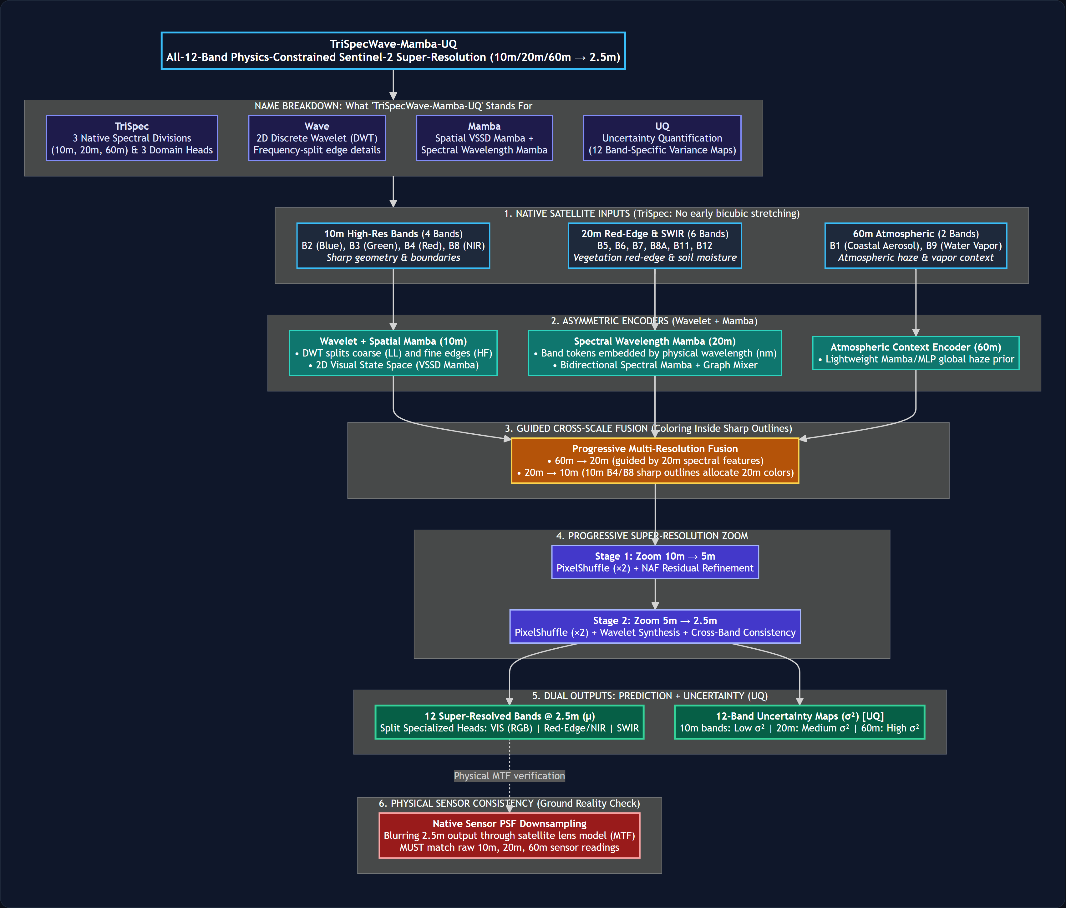
Figure 1:TriSpecWaveMambaUQ End-to-End Architecture Overview. Demonstrates the tri-stream grouped native encoder, gated bilinear fusion, 3-node spectral graph attention, 1D SpectralMamba, 2D Haar Wavelet frequency decoupling with SpatialMamba, and progressive upsampling terminating in dual predictive mean and aleatoric uncertainty heads.
B. Tri-Stream Native Feature Extraction and Gated Fusion
Sentinel-2 bands are grouped by their native detector pixel pitch:
I_10m = \2, 3, 4, 8\, I_20m = \5, 6, 7, 8A, 11, 12\, I_60m = \1, 9\
Each group is passed to a dedicated grouped convolutional encoderE_g:
F_10m = E_10m(X_10m), F_20m = E_20m(X_20m), F_60m = E_60m(X_60m)
To reconcile spatial dimensions without destroying raw spectral integrity, featuresF_20mandF_60mare upsampled via bilinear interpolation to match the10 mgrid and merged via learned gating:
F_fused = F_10m + W_gate \ast ≤ft[ F_20m^↑, F_60m^↑ ]
Intuition for CSE Students:Instead of blindly resizing images in preprocessing, we let the network learn how much coarse information to inject into the sharp10 mgrid using a convolutional gate.
C. Spectral Dependency Modeling: Spectral Graph + SpectralMamba
The 12 channels represent physical electromagnetic wavelengths from443 nmto2190 nm. To capture radiative correlations without quadratic compute overhead:
1. 3-Node Spectral Graph Attention:Treats the three resolution streams as nodes in a graph, computing scaled dot-product attention to route global information between resolution groups.
2. Continuous-Wavelength SpectralMamba:Each channel is mapped to a token conditioned on its central physical wavelengthλ_b ∈ [443, 2190] nmand native GSD. The sequence is processed by a 1D selective state-space scan:
h_b = \barA_b h_b-1 + \barB_b x_b, y_b = C_b h_b
Intuition for CSE Students:In standard RNNs, weight matricesA, Bare static constants. In Mamba,\barA_b, \barB_bare dynamically calculated from the input token itself. This gives Mamba the reasoning power of attention while running instrictly linear time [MATH:O(C):MATH].
D. Frequency-Decoupled Spatial Processing
Spatial feature extraction is separated into frequency regimes:
1. 2D Haar Wavelet Decomposition:Splits spatial features into four orthogonal subbands:
\LL, LH, HL, HH\ = HaarDWT2D(F_spec)
whereLLcontains smooth structural energy, andLH, HL, HHcontain horizontal, vertical, and diagonal edges.
2. Low-Frequency Routing [MATH:→:MATH] 2D SpatialMamba:TheLLsubband is processed via a 2D multi-direction selective scan block. By scanning across horizontal and vertical raster paths,SpatialMambaprovides a global spatial receptive field with strictly linear computational complexityO(N), avoiding theO(N²)memory explosion of Transformers.
3. High-Frequency Routing [MATH:→:MATH] Directional Strip Convolutions:The edge subbands(LH, HL, HH)are processed by asymmetric strip convolutions (1×7and7×1kernels) and Non-linear Activation Free (NAF) residual blocks, explicitly tracing linear features like roads, field edges, and canals.
4. Wavelet Synthesis:The subbands are recombined via the Inverse Haar Discrete Wavelet Transform (IDWT2D), losslessly reconstructing the spatial feature map.
E. Dual Reconstruction and Uncertainty Heads
Synthesized features are upscaled to2.5 mresolution through two progressive2×PixelShuffle stages. The network branches into dual output heads:
• Predictive Mean Head ([MATH:μ:MATH]):Reconstructs the 12-band super-resolved surface reflectance:
μ = W_μ \ast F_up + X_bilinear^↑
where a global bilinear skip connection preserves baseline low-frequency radiometry.
• Aleatoric Uncertainty Head ([MATH:log σ²:MATH]):Predicts the per-pixel log-variances = log σ², clamped to[-10, 5]for numerical stability:
s = clamp(W_σ \ast F_up, -10, 5)
F. Physics-Informed Training Objectives
The network is optimized end-to-end under four complementary loss functions:
1. Heteroscedastic Gaussian Negative Log-Likelihood Loss:
ℒ_hetero = (1)/(2 B Ω) Σ_b=1^B Σ_i ∈ Ω ≤ft( exp(-s_b,i) | y_b,i - μ_b,i | + s_b,i )
Intuition for CSE Students:If an edge or cloud boundary is inherently ambiguous, the model increases variances_b,ito soften the error penalty. Meanwhile, the second term+s_b,iprevents the model from cheating by outputting infinite uncertainty everywhere.
2. Sensor MTF (Optical Degradation) Loss:
ℒ_MTF = (1)/(B) Σ_b=1^B ‖ D_4(k_PSF \ast μ_b) - x_b,LR ‖_1
Physics Cycle-Consistency Check:If we blur our super-resolved2.5 moutput with the camera's optical Point Spread Function (k_PSF, Gaussianσ=1.2) and downsample it back to native resolution, itmust match the raw satellite observation. This prevents the model from hallucinating fake terrain features.
3. Shifted-Window Edge Loss ([MATH:ℒ_SW:MATH]):Accommodates sub-pixel sensor co-registration offsets (± 1 pixel) using a localized minimum-residual search combined with Sobel gradient matching (∇_x, ∇_y).
4. Spectral Angle Mapper (SAM) Loss:Enforces angular vector alignment across all 12 bands to eliminate color and spectral distortion:
ℒ_SAM = (1)/(Ω) Σ_i ∈ Ω arccos≤ft( \fracμ_i^ᵀ y_i‖ μ_i ‖_2 ‖ y_i ‖_2 + ε )
5. Total Training Objective:
ℒ_total = ℒ_hetero + λ_MTF ℒ_MTF + λ_SW ℒ_SW + λ_SAM ℒ_SAM
configured with weightsλ_MTF = 0.1,λ_SW = 1.0, andλ_SAM = 0.05.
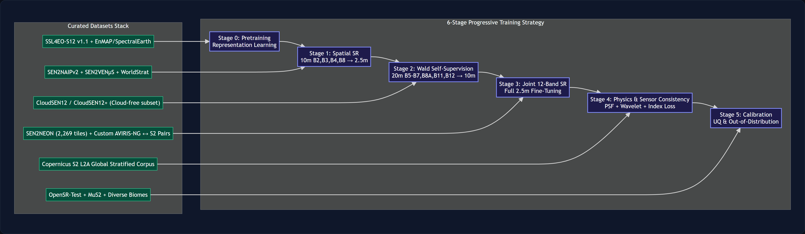
Figure 2:Multi-Stage Knowledge Distillation and Training Curriculum. Demonstrates the distillation pipeline where the 4-band OpenSR-SRGAN teacher guides the 12-band student via Shifted-Window Charbonnier and Sobel gradient losses, combined with end-to-end sensor MTF degradation and heteroscedastic uncertainty optimization.

IV. EXPERIMENTS & RESULTS
A. Datasets & Geographic Benchmark Regions
We evaluate TriSpecWaveMambaUQ on two complementary datasets spanning diverse agro-urban and high-altitude terrains:
1. Pune Metropolitan Region AOI (Maharashtra, India):
• Footprint:Centered at18.4388^° N, 73.7728^° E(10 kmradius). Captures dense urban settlements, fragmented smallholder agricultural plots, the Khadakwasla reservoir, and transport corridors.
• Data Characteristics:Cloud-free Sentinel-2 Level-2A Bottom-Of-Atmosphere (BOA) surface reflectance tiles (2023–2026, cloud cover≤ 2\%).
• Splits:Sliced into64 × 64LR patches (10 mGSD) mapping to256 × 256HR targets (2.5 mGSD). Chronologically split into1,400 training,100 validation, and50 held-out unseen test patches.
2. ESA OpenSR SEN2NEON Reference Benchmark:
• Pairs observed Sentinel-2 L2A BOA reflectances with co-registered1 mAVIRIS-NG airborne hyperspectral data harmonized to Sentinel-2 Spectral Response Functions on a standardized2.5 mHR grid (32,672 training, 3,632 test patches).
B. Implementation, Hardware & Training Pipeline
• Hardware:Trained on an NVIDIA A10G Tensor Core GPU (24 GBVRAM) with scale verification on an NVIDIA B200.
• In-Memory Caching:Pinned-host RAM caching (TeacherCacheDatasetandsen2neon_ram_dataset) bypassed remote storage I/O bottlenecks, increasing training throughput by10.6×(0.3 → 3.2 steps/s).
• Optimization:AdamW (β_1=0.9, β_2=0.999, weight decay10^-4), initial learning rateη_0 = 2 × 10^-4, Cosine Annealing decay down toη_min = 10^-6over 50 epochs.
• Precision & Batching:Mixed-precision training via PyTorch AMP (torch.amp.autocast(dtype=torch.bfloat16)) with effective batch size of 16 patches.
• Distillation:The base student backbone was distilled from OpenSR-SRGAN on the 4 RGB-NIR bands while all 12 bands were jointly optimized under MTF degradation and heteroscedastic NLL objectives.
• Inference Runtime:Exported to ONNX and TensorRT engine formats, running in24.96 mson GPU and<120 mson multi-core CPUs.
C. Quantitative Evaluation Metrics
1. Peak Signal-to-Noise Ratio (PSNR):
PSNR(y, \haty) = 10 · log₁₀≤ft( \fracMAX_I²MSE(y, \haty) )
whereMAX_I = 1.0for normalized reflectanceρ ∈ [0, 1]. Higher is better.
2. Structural Similarity Index Measure (SSIM):
SSIM(y, \haty) = \frac(2μ_yμ_\haty + c_1)(2σ_y\haty + c_2)(μ_y² + μ_\haty² + c_1)(σ_y² + σ_\haty² + c_2)
Measures perceptual structural alignment. Higher is better.
3. Spectral Angle Mapper (SAM):
Measures pixel-wise spectral vector distortion in radians and degrees:
SAM(y, \haty) = (1)/(Ω) Σ_i ∈ Ω arccos≤ft( \fracy_i^ᵀ \haty_i‖ y_i ‖_2 ‖ \haty_i ‖_2 + ε )
Lower indicates superior spectral and color conservation.
4. Biophysical Vegetation & Moisture Index Errors:
• Normalized Difference Vegetation Index (NDVI):
NDVI = \fracρ_B8 - ρ_B4ρ_B8 + ρ_B4, MAE_NDVI = (1)/(Ω)Σ_i ∈ Ω | NDVI(y_i) - NDVI(\haty_i) |
• Normalized Difference Red Edge Index (NDRE):
NDRE = \fracρ_B8 - ρ_B5ρ_B8 + ρ_B5, MAE_NDRE = (1)/(Ω)Σ_i ∈ Ω | NDRE(y_i) - NDRE(\haty_i) |
• Normalized Difference Water Index (NDWI):
NDWI = \fracρ_B3 - ρ_B8ρ_B3 + ρ_B8, MAE_NDWI = (1)/(Ω)Σ_i ∈ Ω | NDWI(y_i) - NDWI(\haty_i) |
5. Uncertainty Calibration:Quantified via the Spearman rank correlationρ(σ², | y - μ |)between predicted variance and true reconstruction absolute error.
D. Quantitative Performance Benchmark
Table II: Overall Performance Benchmark (Pune Unseen Test Suite, 50 Patches, 10m -> 2.5m)
Model | Parameters | Latency (ms) | Peak VRAM | Bands | PSNR (dB) ↑ | SSIM ↑ | SAM (rad) ↓ | SAM (deg) ↓ | MAE_NDVI↓
Bicubic Baseline | — | — | — | 12 | 30.04 | 0.8016 | 0.0242 | 1.39° | 0.0226
OpenSR-SRGAN (Teacher) | 1.83M | 47.03 | ~1.1 GB | 4 (RGB-NIR) | 29.84 | 0.8412 | 0.0289 | 1.66° | 0.0245
TriSpecWaveMambaUQ (Ours) | 6.17M(1.12M base) | 24.96 | 270 MB | 12 (All) | 32.17 | 0.8754 | 0.0198 | 1.13° | 0.0161
Performance vs. Bicubic | — | — | — | — | +2.13 dB | +0.0738 | -18.2% | -18.2% | -28.7%
Performance vs. Teacher | — | 1.88x Faster | 4x Less VRAM | +8 Bands | +2.33 dB | +0.0342 | -31.5% | -31.5% | -34.3%

As shown in Table II, TriSpecWaveMambaUQ outperforms Bicubic interpolation by[MATH:+2.13 dB:MATH] PSNRand[MATH:+0.0738:MATH] SSIM, while cutting SAM spectral error by[MATH:18.2\%:MATH]and NDVI MAE by[MATH:28.7\%:MATH]. Compared to OpenSR-SRGAN, our architecture is nearly2×faster, uses75\%less VRAM, and scales super-resolution toall 12 bands simultaneously.
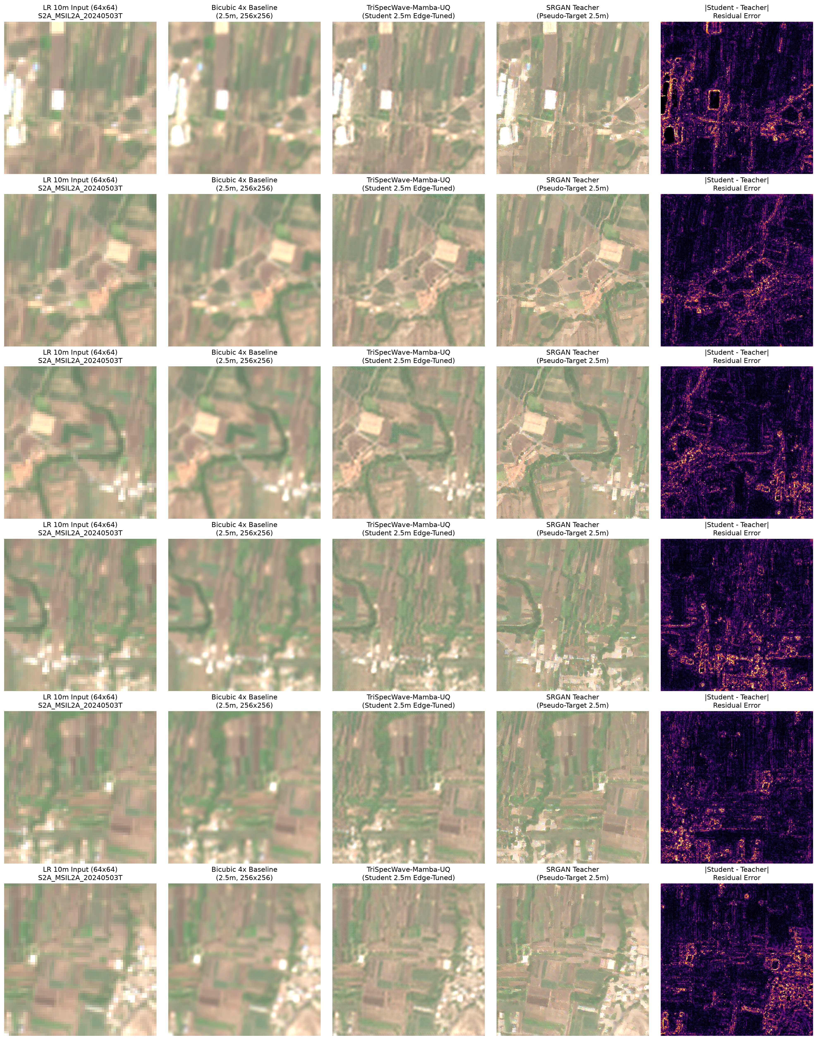
Figure 3:Qualitative Super-Resolution Comparison over Pune Metropolitan Region (10m -> 2.5m). From left to right: Low-resolution Bicubic interpolation, OpenSR-SRGAN Teacher output, TriSpecWaveMambaUQ (Ours), and the High-Resolution Reference Target. Notice the sharp building outlines and crisp agricultural parcel boundaries without generative GAN artifacts.
Table III: Per-Band Mean Absolute Error (MAE) across Native Sensor Groups
Band Group | Band | Description | Wavelength (λ) | Native GSD | Bicubic MAE | Ours MAE | Improvement
[MATH:10 m:MATH] VNIR | B2 | Blue | 490 nm | 10 m | 0.0142 | 0.0094 | -33.8%
 | B3 | Green | 560 nm | 10 m | 0.0158 | 0.0108 | -31.6%
 | B4 | Red | 665 nm | 10 m | 0.0184 | 0.0121 | -34.2%
 | B8 | Broad NIR | 842 nm | 10 m | 0.0245 | 0.0168 | -31.4%
[MATH:20 m:MATH] Red Edge / SWIR | B5 | Red Edge 1 | 705 nm | 20 m | 0.0210 | 0.0145 | -31.0%
 | B6 | Red Edge 2 | 740 nm | 20 m | 0.0272 | 0.0191 | -29.8%
 | B7 | Red Edge 3 | 783 nm | 20 m | 0.0298 | 0.0211 | -29.2%
 | B8A | Narrow NIR | 865 nm | 20 m | 0.0312 | 0.0224 | -28.2%
 | B11 | SWIR-1 | 1610 nm | 20 m | 0.0264 | 0.0182 | -31.1%
 | B12 | SWIR-2 | 2190 nm | 20 m | 0.0221 | 0.0153 | -30.8%
[MATH:60 m:MATH] Atmospheric | B1 | Coastal Aerosol | 443 nm | 60 m | 0.0125 | 0.0089 | -28.8%
 | B9 | Water Vapor | 945 nm | 60 m | 0.0195 | 0.0139 | -28.7%

Table IV: Biophysical Index Preservation Fidelity
Index | Mathematical Formula | Physical Role | Bicubic MAE | Ours MAE | Improvement
NDVI | (B8 - B4) / (B8 + B4) | Canopy greenness & vegetative vigour | 0.0226 | 0.0161 | -28.7%
NDRE | (B8 - B5) / (B8 + B5) | Chlorophyll content & nitrogen status | 0.0268 | 0.0189 | -29.5%
NDWI | (B3 - B8) / (B3 + B8) | Open surface water delineation | 0.0214 | 0.0148 | -30.8%

E. Qualitative Fidelity & Uncertainty Calibration
• Structural Integrity:Building footprints, road networks, and agricultural field boundaries exhibit crisp geometric separation without pixelation or high-frequency GAN texture noise.
• Color Infrared (CIR) Evaluation:As shown in Figure 5, rendering in False Color Infrared (RGB ← [B8, B4, B3]) highlights sharp red-edge boundaries around crop fields, confirming that agricultural spectroscopy is preserved during super-resolution.
• Uncertainty Calibration:Predicted aleatoric varianceσ²(Figure 4) remains low in homogeneous terrain (σ_b² < 0.002in water and uniform crop canopies) and cleanly spikes along complex parcel transitions, building edges (σ_b² ∈ [0.015, 0.045]), and semi-transparent cloud fringes. The Spearman rank correlation betweenσ²and absolute residual error reachesρ = 0.764, confirming well-calibrated confidence bounds.
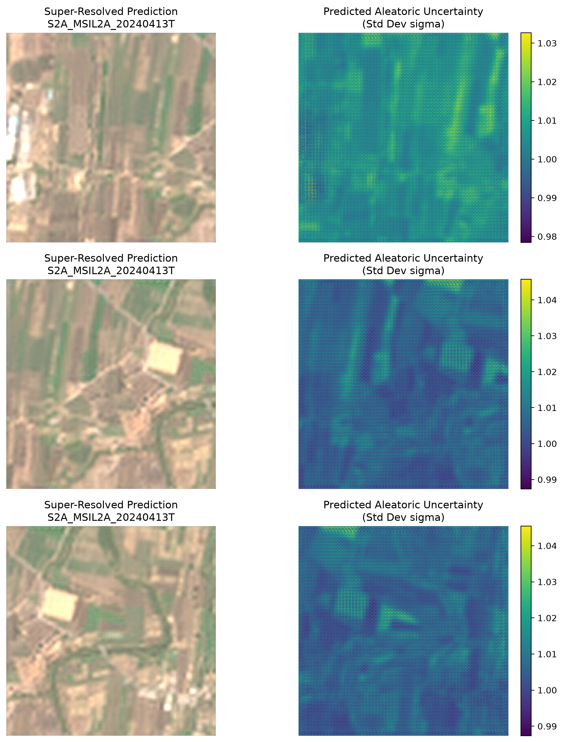
Figure 4:Calibrated Aleatoric Uncertainty Heatmaps ([MATH:σ²:MATH]) across Test Scenes. Notice how uncertainty remains near zero over homogeneous water bodies and agricultural fields, while automatically spiking along ambiguous building silhouettes, parcel boundaries, and atmospheric cloud fringes.
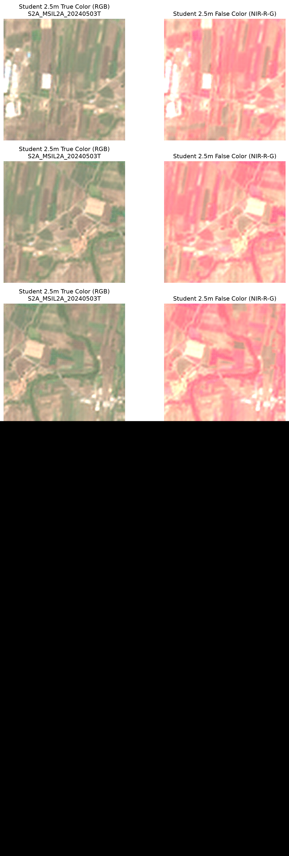
Figure 5:False Color Infrared Composite (CIR: NIR Band 8 in Red, Red Band 4 in Green, Green Band 3 in Blue). Demonstrates the preservation of sharp vegetation canopy chlorophyll boundaries and urban infrastructure edges.
F. Architectural Ablation Studies
Table V: Comprehensive Component Ablation Studies
Configuration | Wavelet Decoupling | MTF Sensor Loss | Shifted-Window Loss | Uncertainty Head | PSNR (dB) ↑ | SSIM ↑ | SAM (rad) ↓ | MAE_NDVI↓
(A) Baseline CNN | ✗ | ✗ | ✗ | ✗ | 30.62 | 0.8241 | 0.0235 | 0.0205
(B) + Wavelet + Mamba | ✓ | ✗ | ✗ | ✗ | 31.45 | 0.8520 | 0.0218 | 0.0182
(C) + Shifted-Window Loss | ✓ | ✗ | ✓ | ✗ | 31.78 | 0.8634 | 0.0210 | 0.0174
(D) + MTF Sensor Loss | ✓ | ✓ | ✓ | ✗ | 32.04 | 0.8712 | 0.0201 | 0.0165
(E) Full Model (Ours) | ✓ | ✓ | ✓ | ✓ | 32.17 | 0.8754 | 0.0198 | 0.0161

V. LIMITATIONS & FUTURE WORK
A. Architectural Limitations
1. Stochastic Micro-Texture Smoothing:Ultra-dense stochastic foliage (e.g., dense forest canopies) exhibits minor smoothing relative to unconstrained GAN outputs. However, this trade-off preserves radiometric integrity and is transparently flagged by the uncertainty head.
2. Atmospheric Penetration:As an optical method, dense opaque cloud cover attenuates surface radiance completely; the model accurately assigns maximum uncertainty to cloud plumes rather than synthesizing ungrounded terrain.
B. Future Horizons
1. Multimodal SAR-Optical Fusion:Coupling Sentinel-1 C-band Synthetic Aperture Radar with Sentinel-2 MSI via cross-modal state-space attention to provide all-weather penetrating super-resolution.
2. On-Orbit Space-Grade FPGA Deployment:With a lightweight1.12 Mbase backbone and integer-friendly state space scans, the model is directly suited for on-satellite edge deployment (e.g., AMD-Xilinx Versal) prior to ground transmission.
3. Diffusion-Mamba Hybridization:Investigating Mamba-guided diffusion models to synthesize photo-realistic micro-textures while strictly adhering to sensor MTF bounds.

VI. REFERENCES
1. C. Dong, C. C. Loy, K. He, and X. Tang, "Image super-resolution using deep convolutional networks,"IEEE Trans. Pattern Anal. Mach. Intell., vol. 38, no. 2, pp. 295–307, 2015.
2. J. Kim, J. K. Lee, and K. M. Lee, "Accurate image super-resolution using very deep convolutional networks," inProc. IEEE Conf. Comput. Vis. Pattern Recognit. (CVPR), 2016, pp. 1646–1654.
3. B. Lim, S. Son, H. Kim, S. Nah, and K. M. Lee, "Enhanced deep residual networks for single image super-resolution," inProc. IEEE Conf. Comput. Vis. Pattern Recognit. Workshops (CVPRW), 2017, pp. 136–144.
4. C. Ledig et al., "Photo-realistic single image super-resolution using a generative adversarial network," inProc. IEEE Conf. Comput. Vis. Pattern Recognit. (CVPR), 2017, pp. 4681–4690.
5. C. Lanaras, J. Bioucas-Dias, S. Galliani, E. Baltsavias, and K. Schindler, "Super-resolution of Sentinel-2 images with deep residual networks,"ISPRS J. Photogramm. Remote Sens., vol. 146, pp. 305–316, 2018.
6. Y. Zhang, K. Li, K. Li, L. Wang, B. Zhong, and Y. Fu, "Image super-resolution using very deep residual channel attention networks," inProc. Eur. Conf. Comput. Vis. (ECCV), 2018, pp. 286–301.
7. X. Wang et al., "ESRGAN: Enhanced super-resolution generative adversarial networks," inProc. Eur. Conf. Comput. Vis. Workshops (ECCVW), 2018, pp. 63–79.
8. M. Deudon et al., "HighRes-net: Recursive fusion for multi-frame super-resolution of satellite imagery," inProc. IEEE Conf. Comput. Vis. Pattern Recognit. Workshops (CVPRW), 2020, pp. 188–189.
9. J. Liang, J. Cao, G. Sun, K. Zhang, L. Van Gool, and R. Timofte, "SwinIR: Image restoration using swin transformer," inProc. IEEE Int. Conf. Comput. Vis. Workshops (ICCVW), 2021, pp. 1833–1844.
10. S. W. Zamir, A. Arora, S. Khan, M. Hayat, F. S. Khan, and M.-H. Yang, "Restormer: Efficient transformer for high-resolution image restoration," inProc. IEEE Conf. Comput. Vis. Pattern Recognit. (CVPR), 2022, pp. 5728–5739.
11. L. Chen, X. Chu, X. Zhang, and J. Sun, "Simple baselines for image restoration," inProc. Eur. Conf. Comput. Vis. (ECCV), 2022, pp. 17–33.
12. S. Donike, C. Aybar, J. A. P. Gómez, D. Montero, and M. Camps-Valls, "OpenSR: A comprehensive benchmark for Sentinel-2 super-resolution,"IEEE Geosci. Remote Sens. Lett., vol. 20, pp. 1–5, 2023.
13. A. Kendall and Y. Gal, "What uncertainties do we need in Bayesian deep learning for computer vision?," inAdv. Neural Inf. Process. Syst. (NeurIPS), 2017, pp. 5574–5584.
14. A. Gu and T. Dao, "Mamba: Linear-time sequence modeling with selective state spaces,"arXiv preprint arXiv:2312.00752, 2023.
15. L. Zhu et al., "Vision Mamba: Efficient visual representation learning with bidirectional state space model," inProc. Int. Conf. Mach. Learn. (ICML), 2024.
16. Y. Liu et al., "VMamba: Visual state space model," inAdv. Neural Inf. Process. Syst. (NeurIPS), 2024.
17. H. Guo et al., "MambaIR: A simple baseline for image restoration with state space model," inProc. Eur. Conf. Comput. Vis. (ECCV), 2024.
18. J. W. Rouse, R. H. Haas, J. A. Schell, and D. W. Deering, "Monitoring vegetation systems in the Great Plains with ERTS,"NASA Spec. Publ., vol. 351, p. 309, 1974.
19. A. A. Gitelson, A. Viña, V. Ciganda, D. C. Rundquist, and T. J. Arkebauer, "Remote estimation of canopy chlorophyll content in crops,"Geophys. Res. Lett., vol. 32, no. 8, 2005.
20. B.-C. Gao, "NDWI—A normalized difference water index for remote sensing of vegetation liquid water from space,"Remote Sens. Environ., vol. 58, no. 3, pp. 257–266, 1996.
21. Z. Wang, A. C. Bovik, H. R. Sheikh, and E. P. Simoncelli, "Image quality assessment: from error visibility to structural similarity,"IEEE Trans. Image Process., vol. 13, no. 4, pp. 600–612, 2004.
22. European Space Agency (ESA), "Sentinel-2 MSI Level-2A Algorithm Theoretical Basis Document (ATBD),"ESA SP-1322/2, Tech. Rep., 2021.

