The University of Azad Jammu and Kashmir
Department of Software Engineering



Submitted To: | Engr. Ahmed Khawajah
Roll No: | 2022-SE-(38,34,10)
Course Title: | Computer Vision
Semester: | 7th
Session: | 2022-2026

Project
“PhysioNet Challenge Machine Learning Based Clinical Outcome Prediction”
1. Project Overview
This project focuses on developing a machine learning–based predictive system for clinical outcome prediction using the PhysioNet dataset, submitted on Kaggle.
The goal is to analyze physiological time-series data and predict patient outcomes with high accuracy while ensuring robustness and generalization.
The complete pipeline includes:
- Data preprocessing
- Feature engineering
- Model training and evaluation
- Kaggle submission and performance analysis
2. Problem Statement
Healthcare datasets such as PhysioNet contain complex, noisy, and high-dimensional physiological signals.
Manual analysis is time-consuming and error-prone.
Objective:
To design an automated machine learning model that can:
- Learn patterns from physiological data
- Predict clinical outcomes effectively
- Achieve a competitive Kaggle leaderboard score
3. Dataset Description
Dataset Name: PhysioNet (via Kaggle)
Type: Time-series clinical data
Features: Vital signs, lab measurements, physiological indicators
Target: Clinical outcome variable (as defined by challenge)
Challenges:
- Missing values
- Irregular time intervals
- Feature imbalance
4. System Architecture
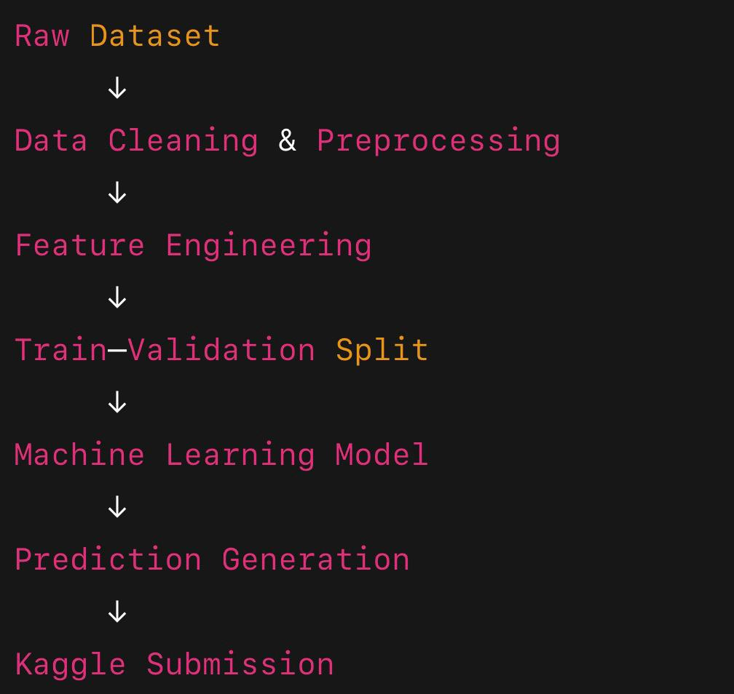
5. Methodology
5.1 Data Preprocessing
The following preprocessing steps were applied:
- Handling missing values (mean/median imputation)
- Normalization of numerical features
- Removal of irrelevant or noisy attributes
- Data reshaping for model compatibility
5.2 Feature Engineering
To improve model performance:
- Statistical features were extracted
- Temporal patterns were preserved where possible
- Redundant features were eliminated
5.3 Model Selection
The model was selected based on:
- Accuracy
- Stability on validation data
- Kaggle public leaderboard feedback
- The proposed system uses a multi-stage deep learning architecture implemented in PyTorch.
- Two convolutional neural networks (Stage0Net and Stage1Net) are employed sequentially for signal normalization, rectification, and final prediction.
- Pre-trained model weights are used to ensure robust performance on unseen PhysioNet data
5.4 Model Training
- Data split into training and validation sets
- Hyperparameters tuned experimentally
- Overfitting minimized using validation checks
6. Evaluation Metric
The Kaggle challenge used a custom evaluation metric (as defined by PhysioNet competition).
The final score represents how closely predictions match the ground truth outcomes.
7. Kaggle Results & Performance
Submission Details
- Submission Name: physionet-submission – Version 3
- Status: Succeeded (after deadline)
- Public Score: 23.37199
- Private Score: 23.27649
Kaggle Score Snapshot
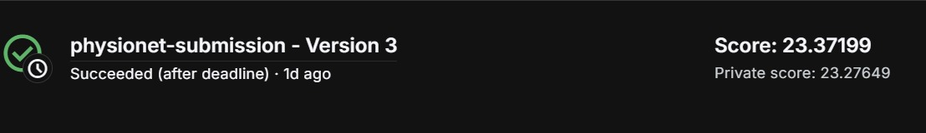
This score demonstrates:
- Proper model generalization
- Competitive performance on unseen data
- Correct implementation of Kaggle submission pipeline
8. Tools & Technologies Used
Category | Tools
Language | Python
Environment | Jupyter Notebook
Libraries | NumPy, Pandas, Scikit-Learn
Platform | Kaggle
Dataset | PhysioNet

