Q23. Butterfly Pattern
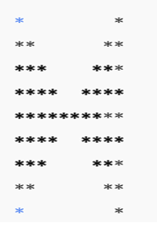
#include <iostream>
using namespace std;
int main() {
int n = 5;
// upper part
for(int i = 1; i <= n; i++) {
for(int j = 1; j <= i; j++)
cout << "*";
for(int j = 1; j <= 2*(n-i); j++)
cout << " ";
for(int j = 1; j <= i; j++)
cout << "*";
cout << endl;
}
// lower part
for(int i = n; i >= 1; i--) {
for(int j = 1; j <= i; j++)
cout << "*";
for(int j = 1; j <= 2*(n-i); j++)
cout << " ";
for(int j = 1; j <= i; j++)
cout << "*";
cout << endl;
}
return 0;
}

