Q27. Maximum Price (10 Items)
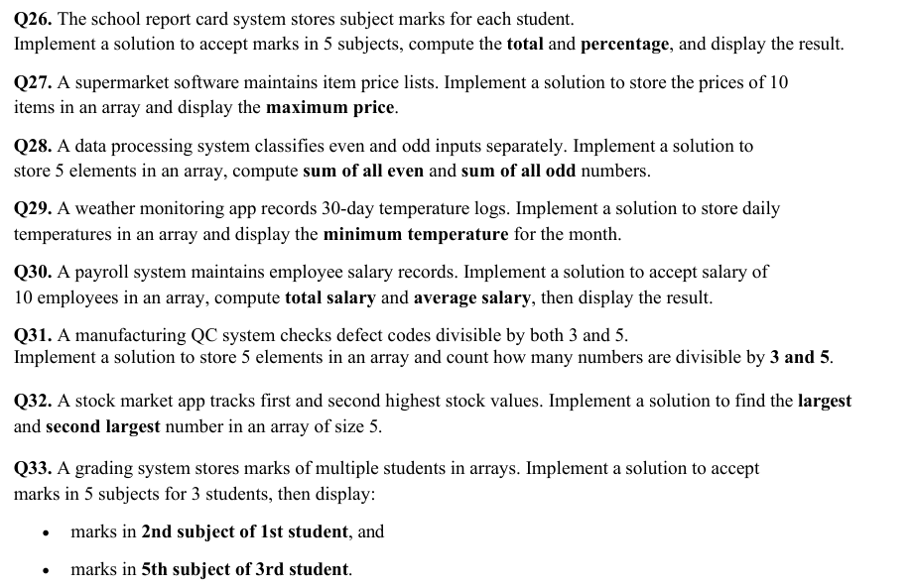
#include <iostream>
using namespace std;
int main() {
float price[10], max;
for(int i = 0; i < 10; i++)
cin >> price[i];
max = price[0];
for(int i = 1; i < 10; i++) {
if(price[i] > max)
max = price[i];
}
cout << "Max Price = " << max;
return 0;
}

