**PROJECT REPORT OF**

**WEB DEVELOPMENT FRAMEWORK USING PYTHON (24CAI1105)**

**ON**

**INVENZO - INVENTORY MANAGEMENT SYSTEM**

**BACHELOR OF ENGINEERING**

**In**

**COMPUTER SCIENCE AND ENGINEERING (ARTIFICIAL INTELLIGENCE)**

**Submitted by: Supervised By:**

**Khushboo Jain (LEADER) 2410993045 Mr. Pavan Ambulkar**

**Ishleen Kaur 2410993197 Mentor, CSE - AI**

**Gurleen Kaur 2410993030**

**Liza 2410993056**



**DEPARTMENT OF COMPUTER SCIENCE AND ENGINEERING**

**(ARTIFICIAL INTELLIGENCE)**

**CHITKARA UNIVERSITY INSTITUTE OF ENGINEERING AND TECHNOLOGY**

**CHITKARA UNIVERSITY, PUNJAB, INDIA**

**CONTENTS**

|  |  |  |
| --- | --- | --- |
| S.No. | Title | Page No. |
|  | Acknowledgement | 4 |
|  | List of Figures and Tables |  |
|  | Abstract | 5 |
| 1 | Introduction | 6 |
| 2 | Methodology | 7-8 |
| 3 | Tools and Technologies | 9-10 |
| 4 | Implementation | 11-14 |
| 5 | Major Findings/Outcomes/Output/Results | 15-22 |
| 6 | Conclusion and Future Scope | 23 |
|  | References | 24 |
|  | Appendices | 25 |

**DECLARATION**

I hereby certify that the work which is being presented in the project report entitled **“Inventory Management System”** in partial fulfilment of requirement for the award of the degree of Bachelor of Engineering (Computer Science and Engineering) submitted in the Department of Computer Science and Engineering(Artificial Intelligence) at Chitkara University Institute of Engineering and Technology, Chitkara University, Punjab, India, is an authentic record of my own work carried out under the supervision of Mr. Pavan Ambulkar. The matter presented in this project report has not been submitted in any other university/institute for the award of any degree.

Place: Chitkara University, Rajpura KHUSHBOO JAIN

Date: 6 May 2025 241099303045

This is to certify that the above statement made by the candidate is correct to the best of my knowledge and belief.

**Mr. Pavan Ambulkar**

Mentor

Department of Computer Science and Engineering (Artificial Intelligence)

Chitkara University Institute of Engineering and Technology,

Chitkara University, Punjab, India

**ACKNOWLEDGEMENT**

I would like to express my sincere gratitude to Mr. Pavan Ambulkar for their invaluable guidance, support, and encouragement throughout the duration of this project. Their expertise and insights have greatly contributed to the development of this web application.

I also extend my appreciation to Chitkara University for providing the necessary resources and an environment conducive to learning and experimentation.

A special thanks to my teammates and peers, whose collaboration and feedback have helped shape and refine various aspects of this project. Their input and encouragement have been instrumental in overcoming challenges and improving the final outcome.

Finally, I am grateful to my family and friends for their unwavering support and motivation, which have kept me focused and determined throughout this journey.

Thank you all for being a part of this experience and contributing to its success.

**ABSTRACT**

**Invenzo** is a cutting-edge, web-based inventory management platform that combines functionality, security, and visual elegance to transform the traditional process of stock tracking and order management. Built with a powerful tech stack including **HTML**, **CSS**, **JavaScript**, **Bootstrap**, **Flask**, **Django**, and **RESTful APIs**, Invenzo offers a seamless user experience designed to cater to both small businesses and large enterprises. The platform provides real-time updates, intuitive dashboards, and robust inventory management features, ensuring that users can manage their stock, orders, and movements efficiently and securely.

One of Invenzo's key features is its **user-specific inventory tracking**, allowing each user to access and manage only their respective data. This enhances both **privacy** and **security**, ensuring that sensitive business information is protected at all times. The platform also supports **real-time stock updates**, **automated low stock alerts**, and **product categorization**, all aimed at streamlining inventory management and reducing manual effort.

Invenzo goes beyond functionality by offering an **engaging user interface** that is both beautiful and intuitive. With **animated interfaces** and **dynamic dashboards**, it redefines how inventory management is perceived—turning a traditionally mundane task into a visually appealing, interactive experience. The seamless integration of elegant animations and user-friendly design ensures that managing inventory is not only efficient but also enjoyable.

Designed for scalability, Invenzo can grow alongside businesses as their needs evolve. Whether it’s a small startup or a large enterprise, the platform is adaptable to various scales of operations, ensuring reliable performance even with large inventories and multiple users. Invenzo also incorporates a simple yet effective **"Talk to Us" feature**, enabling seamless communication between users and support teams, further enhancing the overall user experience.

At its core, **Invenzo** is more than just an inventory management tool—it’s a holistic solution that combines **innovation**, **security**, and **aesthetic design** to set new standards in inventory management

1. **INTRODUCTION**

***It can serve multiple purposes:***

* To develop a modern and visually appealing inventory management platform that stands out for both its beauty and functionality.
* To ensure user-specific inventory tracking, so that every user sees and manages only their own data securely and privately.
* To create a seamless and intuitive user experience, minimizing complexity while maximizing efficiency.
* To provide real-time updates and management of stock, orders, and inventory movements.
* To design elegant dashboards and animated interfaces that transform inventory management into an engaging experience.
* To offer fast and reliable performance, even with large inventories and multiple users.
* To maintain robust data security and integrity, ensuring the confidentiality of every user's information.
* To build a scalable system that can grow and adapt to the evolving needs of businesses and individuals.
* To integrate simple communication tools like a "Talk to Us" section, fostering better support and interaction.
* To set a new benchmark in inventory management by combining technical innovation with artistic design.

1. **METHODOLOGY**
   1. The primary aim of **Invenzo** is to revolutionize the inventory management process by creating a comprehensive, intuitive, and visually engaging platform that simplifies the way businesses and individuals manage their stock and orders. Designed with both functionality and aesthetic appeal in mind, Invenzo aims to provide users with a seamless and efficient experience, ensuring that inventory tracking is both easy and enjoyable.
   2. Invenzo seeks to offer real-time inventory updates, accurate order management, and personalized dashboards for each user, ensuring that they only access and manage their respective data. This enhances security, privacy, and control. By integrating powerful features like product categorization, stock movement tracking, and automated alerts, Invenzo aims to minimize manual effort and increase productivity.
   3. Moreover, Invenzo places a strong emphasis on **user experience** through its elegant, user-friendly interface and **beautiful animations**, transforming the traditionally mundane task of inventory management into a highly engaging activity. With a focus on **scalability**, the platform is designed to grow and evolve, adapting to the changing needs of users, whether they are small businesses or large enterprises.
   4. Ultimately, the goal of Invenzo is to combine **innovation, security, and beauty**, creating a cutting-edge inventory management solution that sets new standards for ease of use, efficiency, and design. Invenzo is not just about managing inventory, but about enhancing the overall experience of the users while helping them maintain control and organization in a fast-paced world.
   5. Some research for this project is done from various web development tutoring sites and channels.
   6. The primary aim of **Invenzo** is to revolutionize the inventory management process by creating a comprehensive, intuitive, and visually engaging platform that simplifies the way businesses and individuals manage their stock and orders. Designed with both functionality and aesthetic appeal in mind, Invenzo aims to provide users with a seamless and efficient experience, ensuring that inventory tracking is both easy and enjoyable.
   7. Invenzo seeks to offer real-time inventory updates, accurate order management, and personalized dashboards for each user, ensuring that they only access and manage their respective data. This enhances security, privacy, and control. By integrating powerful features like product categorization, stock movement tracking, and automated alerts, Invenzo aims to minimize manual effort and increase productivity.
   8. Moreover, Invenzo places a strong emphasis on **user experience** through its elegant, user-friendly interface and **beautiful animations**, transforming the traditionally mundane task of inventory management into a highly engaging activity. With a focus on **scalability**, the platform is designed to grow and evolve, adapting to the changing needs of users, whether they are small businesses or large enterprises.
   9. Ultimately, the goal of Invenzo is to combine **innovation, security, and beauty**, creating a cutting-edge inventory management solution that sets new standards for ease of use, efficiency, and design. Invenzo is not just about managing inventory, but about enhancing the overall experience of the users while helping them maintain control and organization in a fast-paced world.

Some research for this project is done from various web development tutoring sites and channels.

1. **TOOLS AND TECHNOLOGIES**

**3.1 Flask for building the lightweight backend.**  
Flask is a micro web framework used to develop the server-side of Invenzo. It manages routing, form handling, and API creation, enabling seamless communication between frontend and backend. Its minimalistic and flexible structure makes the system fast, efficient, and easy to maintain, supporting real-time inventory management and user operations.

**3.2 Django for secure and scalable system modules.**  
Django, a high-level framework, handles complex backend operations like authentication, admin management, and database interaction. With its clean MVT (Model-View-Template) architecture and built-in security features, Django ensures that the platform remains robust, scalable, and protected against common web vulnerabilities.

**3.3 API (Application Programming Interface) for smooth communication.**  
APIs created using Flask RESTful and Django REST Framework enable dynamic interactions between the client and server without reloading pages. APIs allow functionalities like updating inventories, tracking orders, and handling real-time user requests, ensuring modularity, security, and seamless data exchange across the system.

**3.4 SQL and Database Schemas for structured data management.**  
SQL databases like SQLite and MySQL store and organize user, inventory, and order information. Well-defined schemas maintain data integrity and relationships through constraints and indexing, ensuring quick access, reliability, and scalability for managing large volumes of structured records.

**3.5 HTML (HyperText Markup Language) for structuring the platform.**  
HTML provides the basic structure of Invenzo, organizing the content into sections like forms, tables, dashboards, and navigation bars. It ensures a consistent layout and supports dynamic data rendering through template engines, making the user interface accessible and well-organized across devices.

**3.6 CSS (Cascading Style Sheets) for styling and responsiveness.**  
CSS enhances the visual appeal of Invenzo by defining the styling of elements such as buttons, forms, tables, and headers. It ensures responsiveness across all devices using flexible grids and media queries. Smooth transitions, hover effects, and animations make the platform visually attractive and easy to navigate.

**3.7 JavaScript (JS) for interactivity and dynamic features.**  
JavaScript brings the frontend to life by handling user actions, dynamic content updates, form validations, and real-time notifications. It allows the platform to react instantly without reloading pages, improving user engagement and providing a smooth, lively browsing experience.

**3.8 Bootstrap for a modern, responsive design.**  
Bootstrap is used to speed up the frontend development of Invenzo by offering ready-made responsive components like navbars, modals, and cards. Its powerful grid system ensures the platform adjusts perfectly across different screen sizes, providing a professional and accessible interface on all devices.

1. **IMPLEMENTATION**

**4.1 Problem Statement**

Effective inventory management is crucial for businesses and individuals alike. Yet, traditional systems often fail to meet modern needs for accessibility, security, scalability, and user experience. Many existing platforms are complex, outdated in design, or lack personalized features for individual users. Invenzo aims to address these gaps and redefine how inventory management is perceived and utilized.

The key problems identified are:

**4.1.1 Lack of User-Specific Inventory Tracking**

Most traditional inventory systems provide a common database accessible to multiple users without properly segmenting their data. This raises privacy concerns and causes confusion.  
Invenzo solves this by ensuring user-specific data visibility — each user can only view and manage their own inventory securely.

**4.1.2 Complex and Unfriendly User Interfaces**

Inventory management platforms are often loaded with confusing menus, poor layouts, and non-intuitive controls, making it hard for users to manage their stock quickly.  
Invenzo focuses on building a clean, beautiful, and user-friendly interface, making navigation simple and pleasant even for non-technical users.

**4.1.3 No Real-Time Updates**

In traditional systems, data updates are often delayed or require manual refreshes, leading to discrepancies between actual stock and system records.  
Invenzo aims to offer real-time inventory updates and instant stock movement tracking, ensuring information is always up-to-date and reliable.

**4.1.4 Lack of Aesthetic Appeal and Engagement**

Most existing platforms prioritize functionality but completely ignore visual design and user engagement.  
Invenzo introduces mind-blowing animations, subtle transitions, and an aesthetically pleasing design, making inventory management not just a task but an enjoyable experience.

**4.1.5 Difficult Scalability**

When businesses grow, traditional inventory systems often struggle to handle increasing volumes of products and users.  
Invenzo is designed with scalability at its core — easily adapting to small, medium, and large inventories without compromising performance.

**4.1.6 Limited Communication and Support Options**

Users often feel disconnected from the platform developers or support teams, with no quick way to report issues or request help.  
Invenzo solves this by integrating a "Talk to Us" feature, offering users a simple channel to communicate with the support team when needed.

**4.1.7 Poor Security and Data Management**

Without proper security mechanisms, user data can be at risk of breaches or misuse.  
Invenzo incorporates strong authentication and data protection measures to ensure that users' inventory data remains safe and confidential at all times.

**4.1.8 Disconnected Workflow**

Inventory tracking, order management, and movement updates are often handled separately, leading to fragmented workflows.  
Invenzo integrates all inventory processes into one cohesive platform, offering users a smooth, connected, and efficient management experience

**4.2 Working**

**4.2.1 Inventory Management**

Invenzo provides a centralized system to manage all inventory-related operations. Users can easily add, update, or remove products from their stock. The system monitors stock levels automatically and notifies users about low stock alerts, ensuring that businesses never run out of essential items. With features like categorization, SKU assignment, and bulk import/export, inventory management becomes effortless and highly organized.

**4.2.2 Inventory Tracking**

Real-time inventory tracking is a core feature of Invenzo. It helps users track the movement of products from suppliers to warehouse shelves and finally to customers. Through automated updates, businesses get complete visibility of stock levels across multiple locations. Inventory aging reports also allow users to analyze how long products stay in the warehouse, aiding better decision-making regarding stock rotation and clearance strategies.

**4.2.3 Warehouse Management**

Invenzo offers tools for efficient warehouse management, ensuring that the storage and retrieval of goods are optimized. Features like warehouse zoning, bin allocation, and location tagging allow users to quickly locate and manage inventory within large warehouses. With smart warehouse layouts and easy-to-navigate dashboards, businesses can reduce handling time, increase accuracy, and streamline their warehouse operations.

**4.2.4 Reports and Analytics**

Invenzo generates detailed reports that provide critical insights into stock movements, sales trends, order fulfillment rates, and warehouse performance. Customizable reporting allows businesses to track key performance indicators (KPIs) such as inventory turnover rates and stock valuation. Advanced analytics assist in forecasting demand, optimizing purchasing decisions, and identifying potential bottlenecks in the supply chain.

**4.2.5 Barcode and QR Code Scanning**

Invenzo integrates barcode and QR code scanning technology to accelerate inventory processes. Users can generate and print barcodes for their products directly from the system. Scanning products for stock-in, stock-out, and audits becomes quick and error-free. This feature significantly reduces manual entry mistakes, speeds up the overall workflow, and ensures higher inventory accuracy.

**4.2.6 Order Management**

Order tracking and fulfillment are seamlessly handled within Invenzo. Users can manage purchase orders, sales orders, returns, and supplier details easily. Automatic updates on order statuses and real-time stock deductions upon sales help maintain inventory balance accurately. This organized approach ensures timely order deliveries and better customer satisfaction.

**4.2.7 User Role Management**

Invenzo provides secure access control through role-based user management. Admins can assign specific roles such as warehouse manager, stock clerk, or auditor, ensuring that users only access features relevant to their responsibilities. This enhances data security, prevents unauthorized changes, and maintains operational discipline.

**4.2.8 Responsive and Intuitive Interface**

Built with modern design principles, Invenzo offers a clean, responsive, and intuitive user interface. The platform adapts seamlessly across desktops, tablets, and smartphones, allowing users to manage their inventory anytime, anywhere.

**4.2.9 Notifications and Alerts**

Invenzo sends automated notifications for critical actions like low stock warnings, order updates, and upcoming maintenance schedules. These timely alerts help businesses stay proactive and avoid potential issues before they arise.

**MAJOR FINDINGS/OUTCOMES/OUTPUTS/RESULTS**

Here are some points you could include:

* **Improved Inventory Tracking:** Implementation of a system that provides real-time updates on stock levels, reducing errors and improving accuracy.
* **Enhanced Efficiency:** Automation of inventory processes, leading to faster order management and reduced manual workload.
* **User-Friendly Dashboard**: Development of an intuitive interface that allows users to easily monitor stock levels, track product movements, and generate reports.
* **Reduced Costs & Waste**: Optimization of inventory processes, minimizing overstock and shortages, ultimately lowering operational costs.
* **Integration Capabilities**: Successful integration with external systems, such as accounting software or supplier databases, for seamless inventory management.
* **Data Analytics & Insights**: Implementation of analytical tools that provide insights on sales trends, product demand, and inventory turnover to aid in decision-making.
* **Security & Access Control**: Strengthened data security and role-based access control to prevent unauthorized modifications and ensure data integrity.

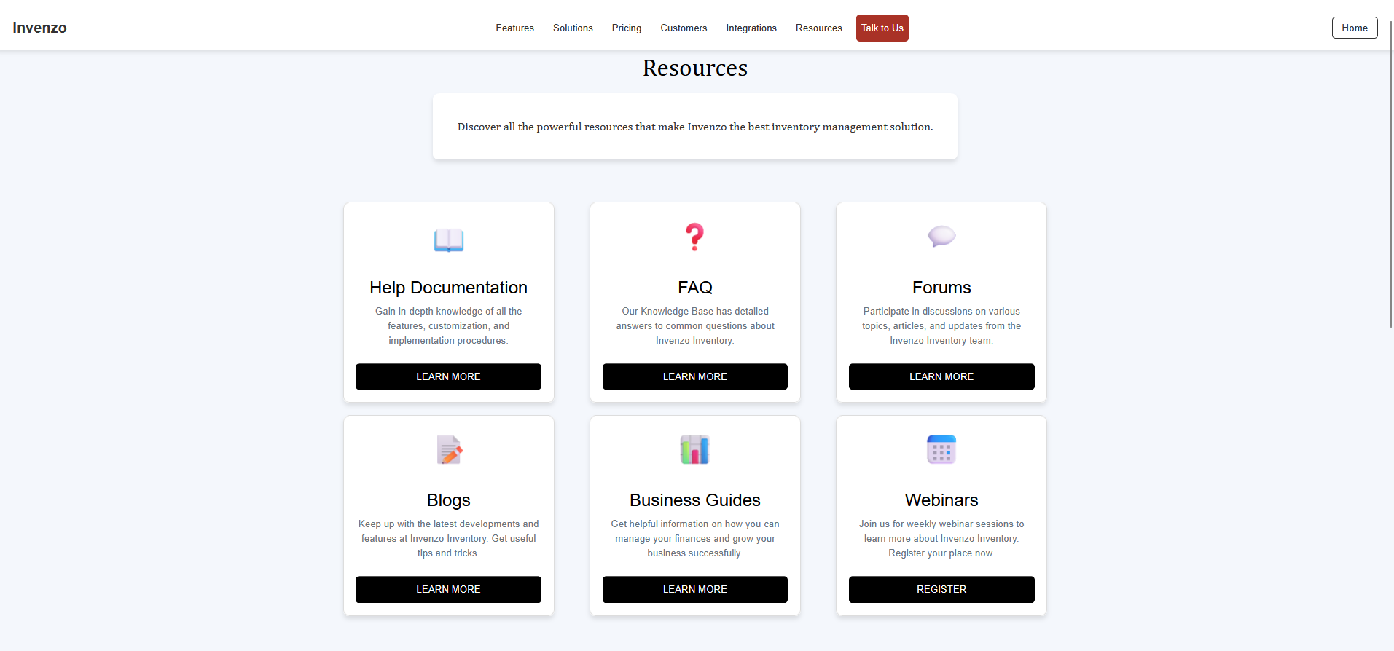

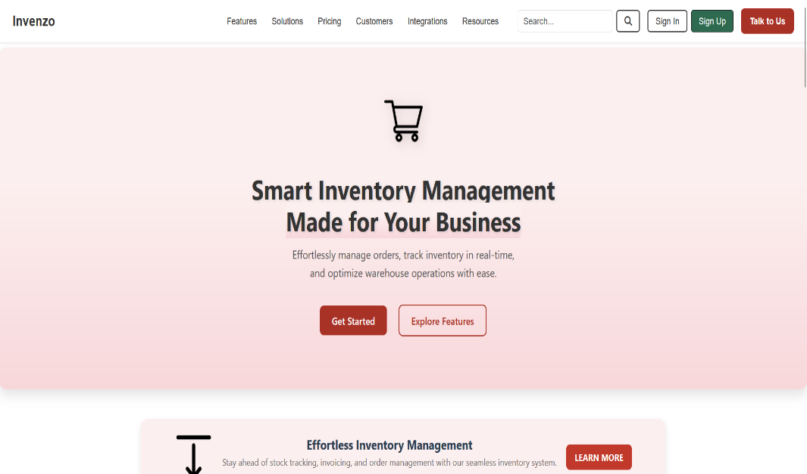

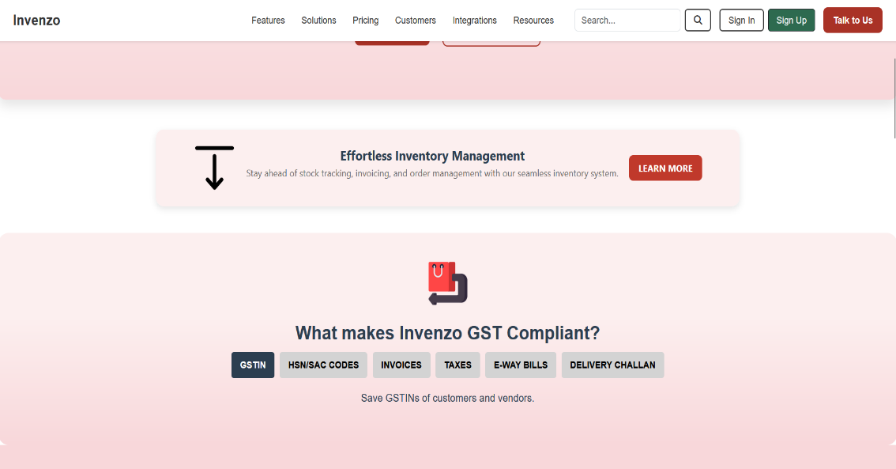

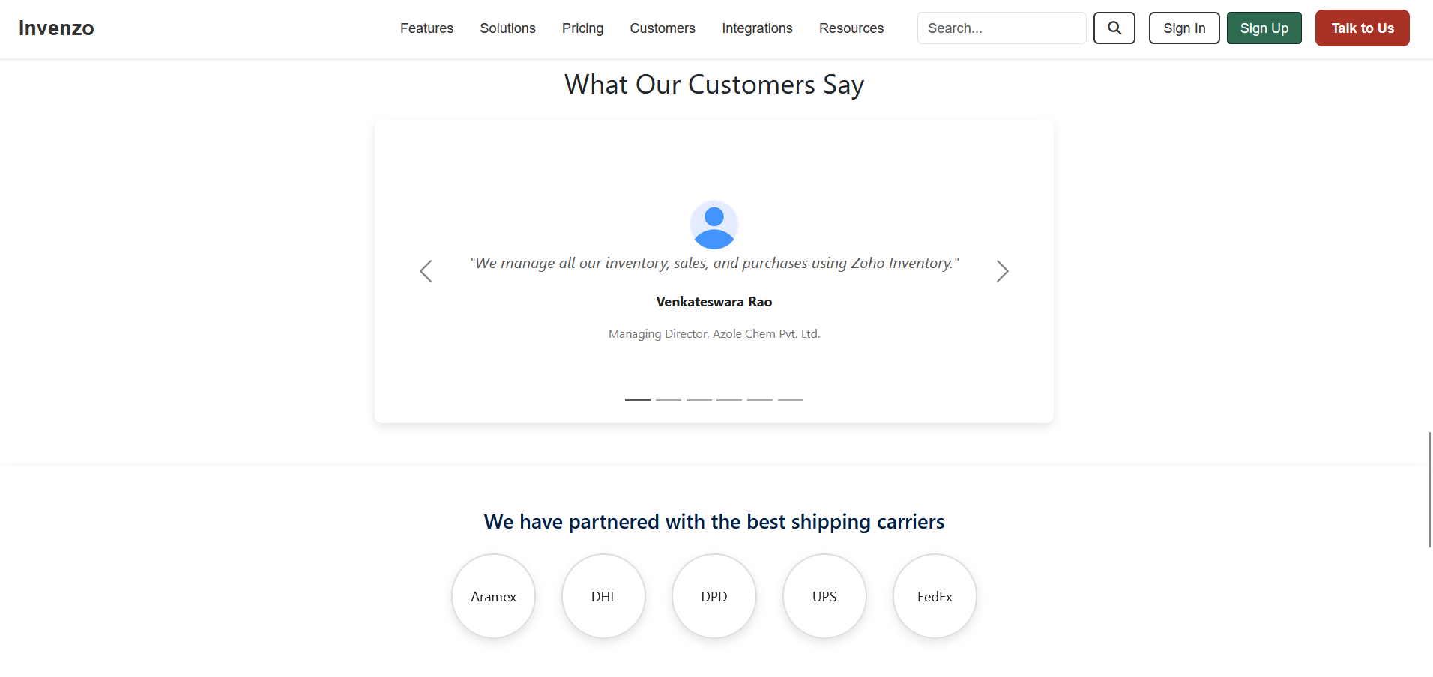

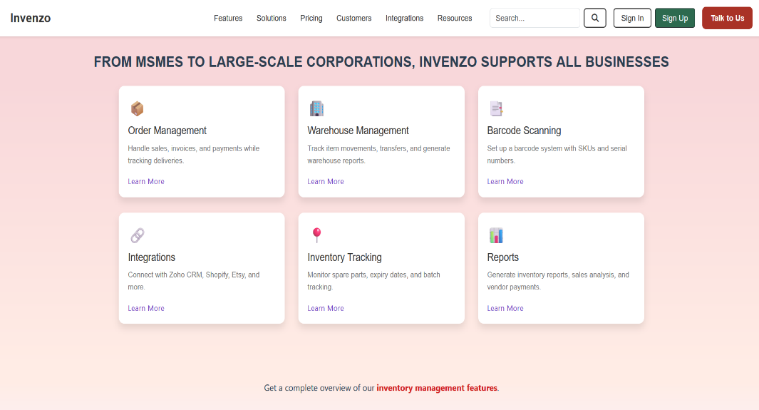

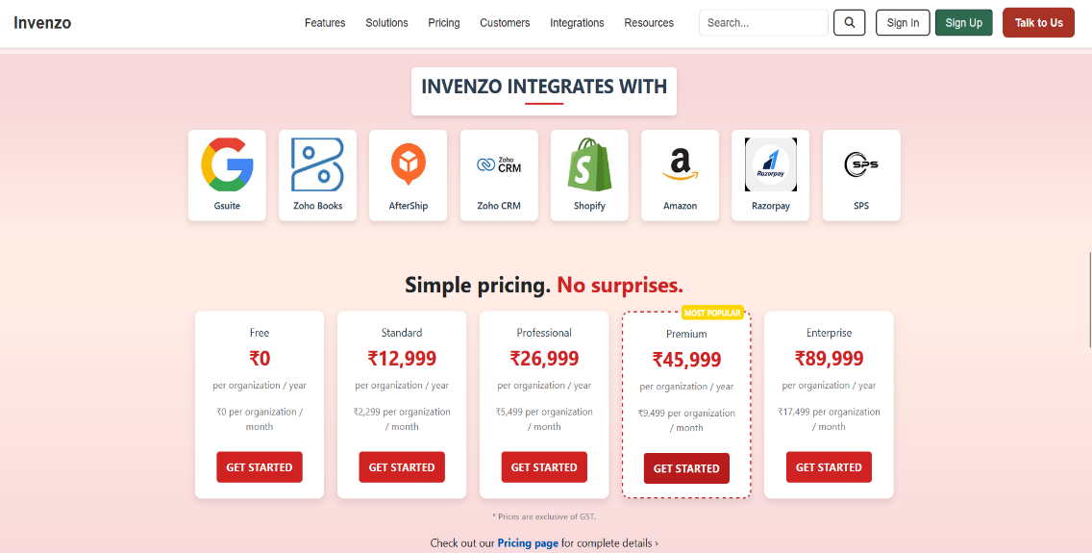

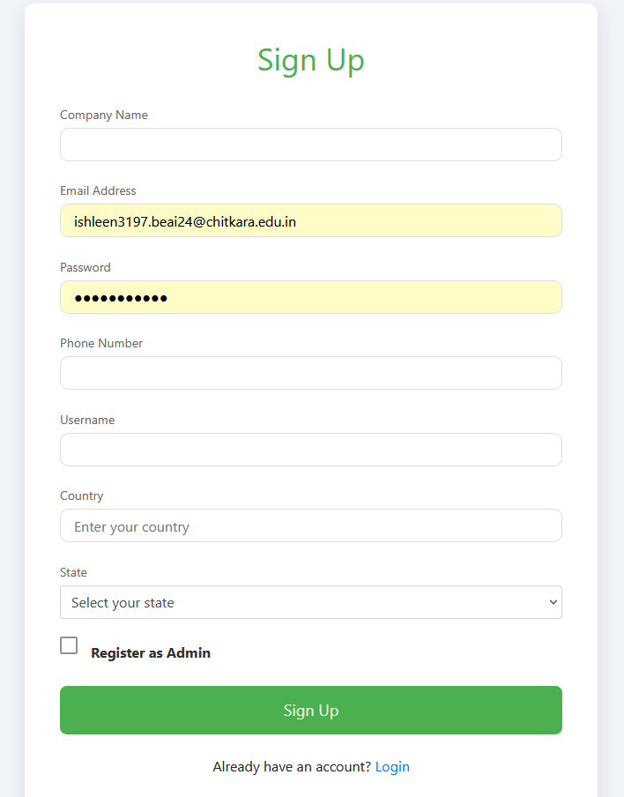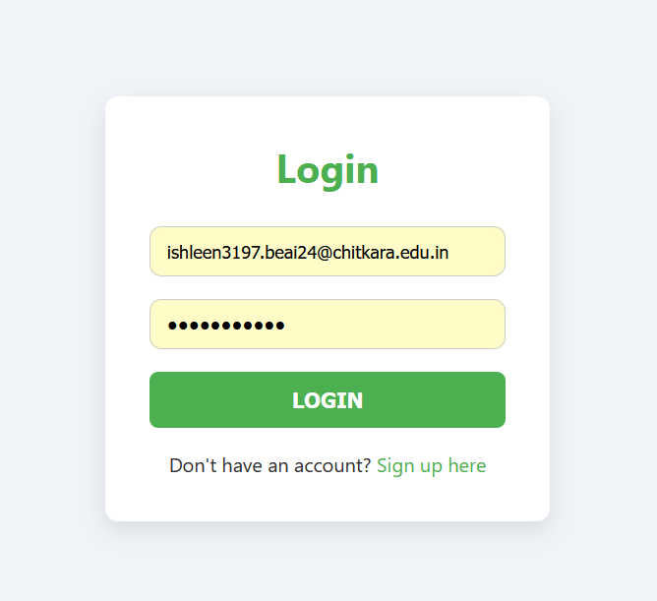

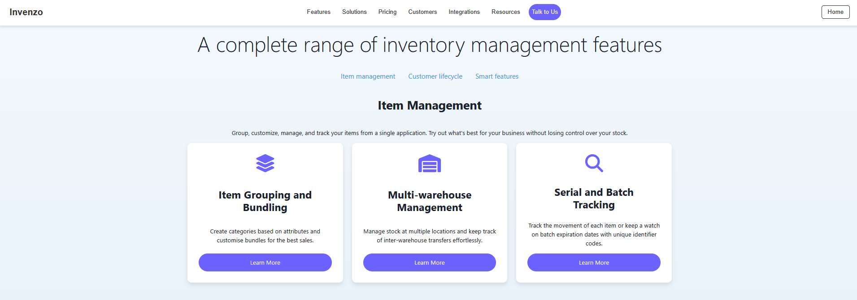

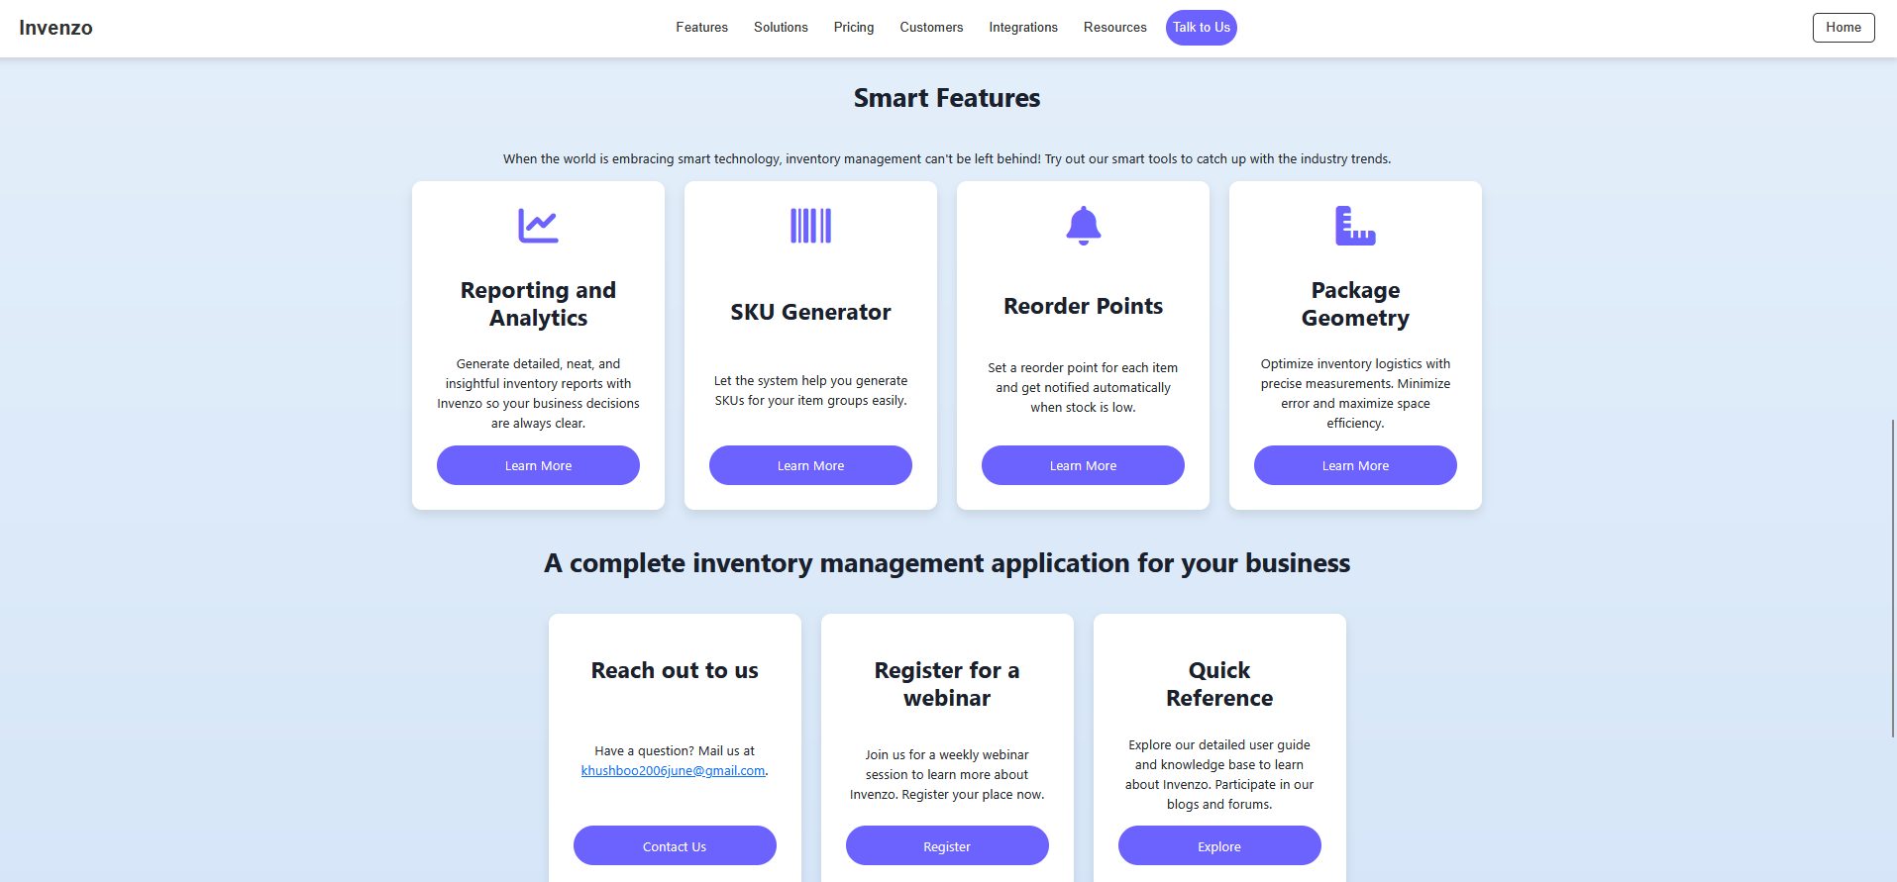

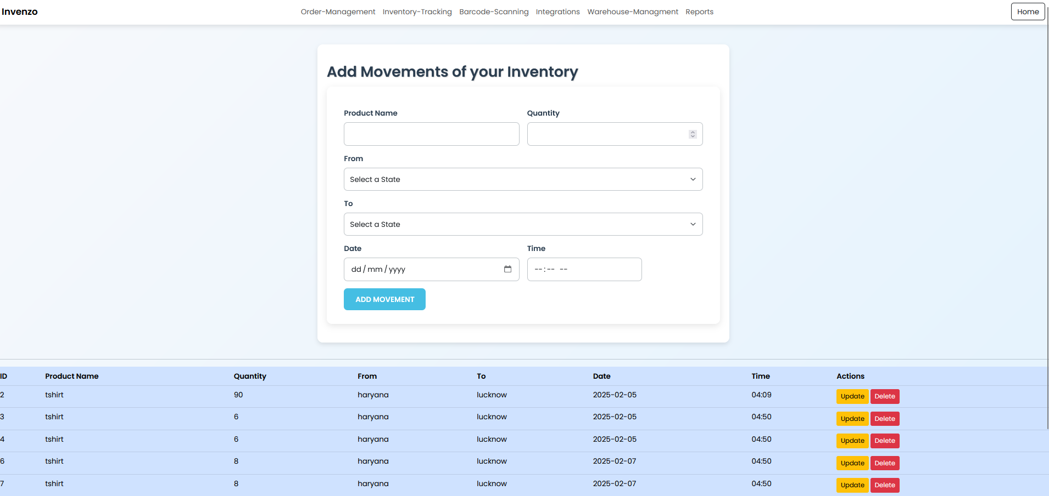

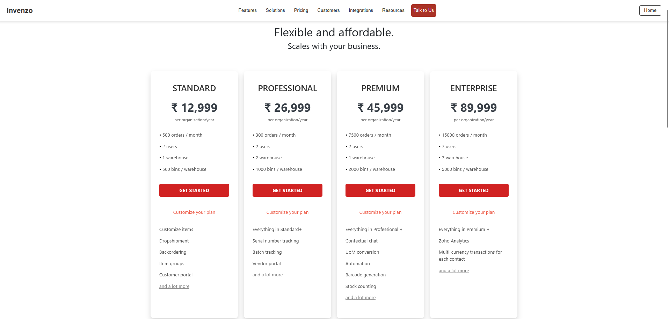 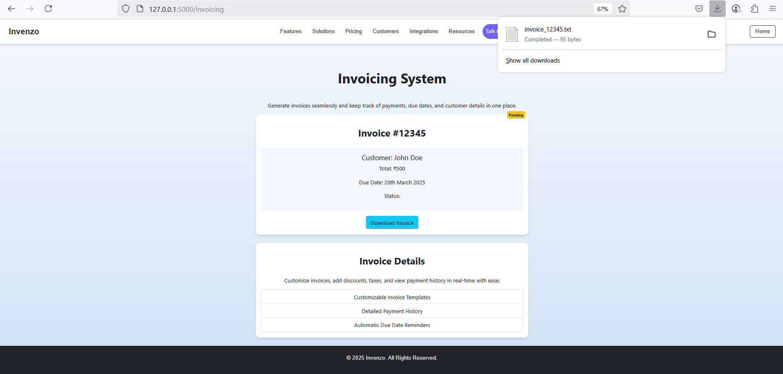

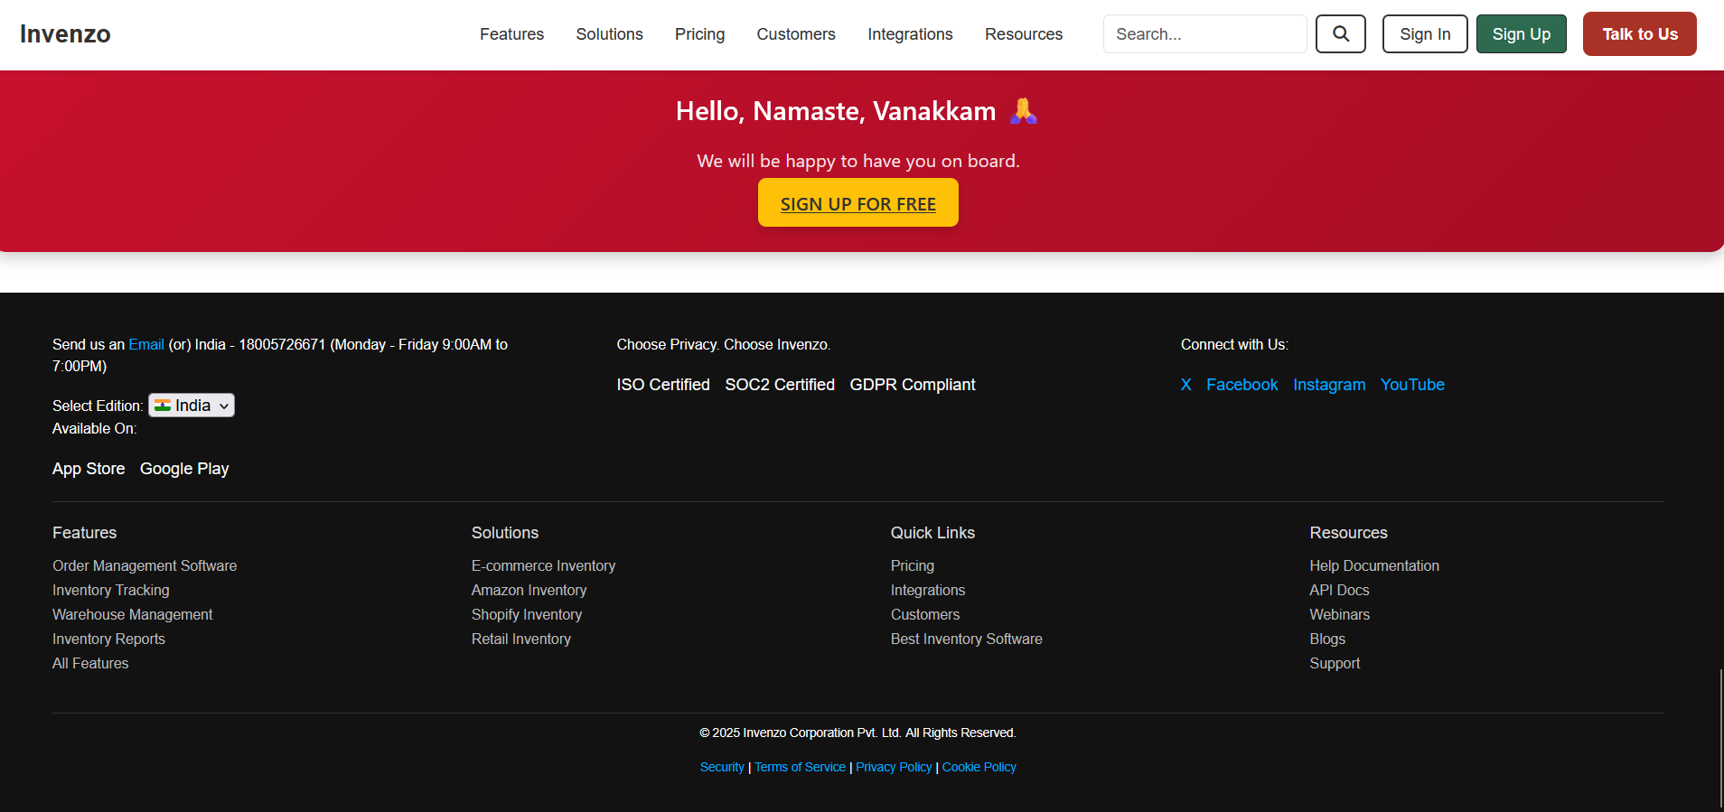

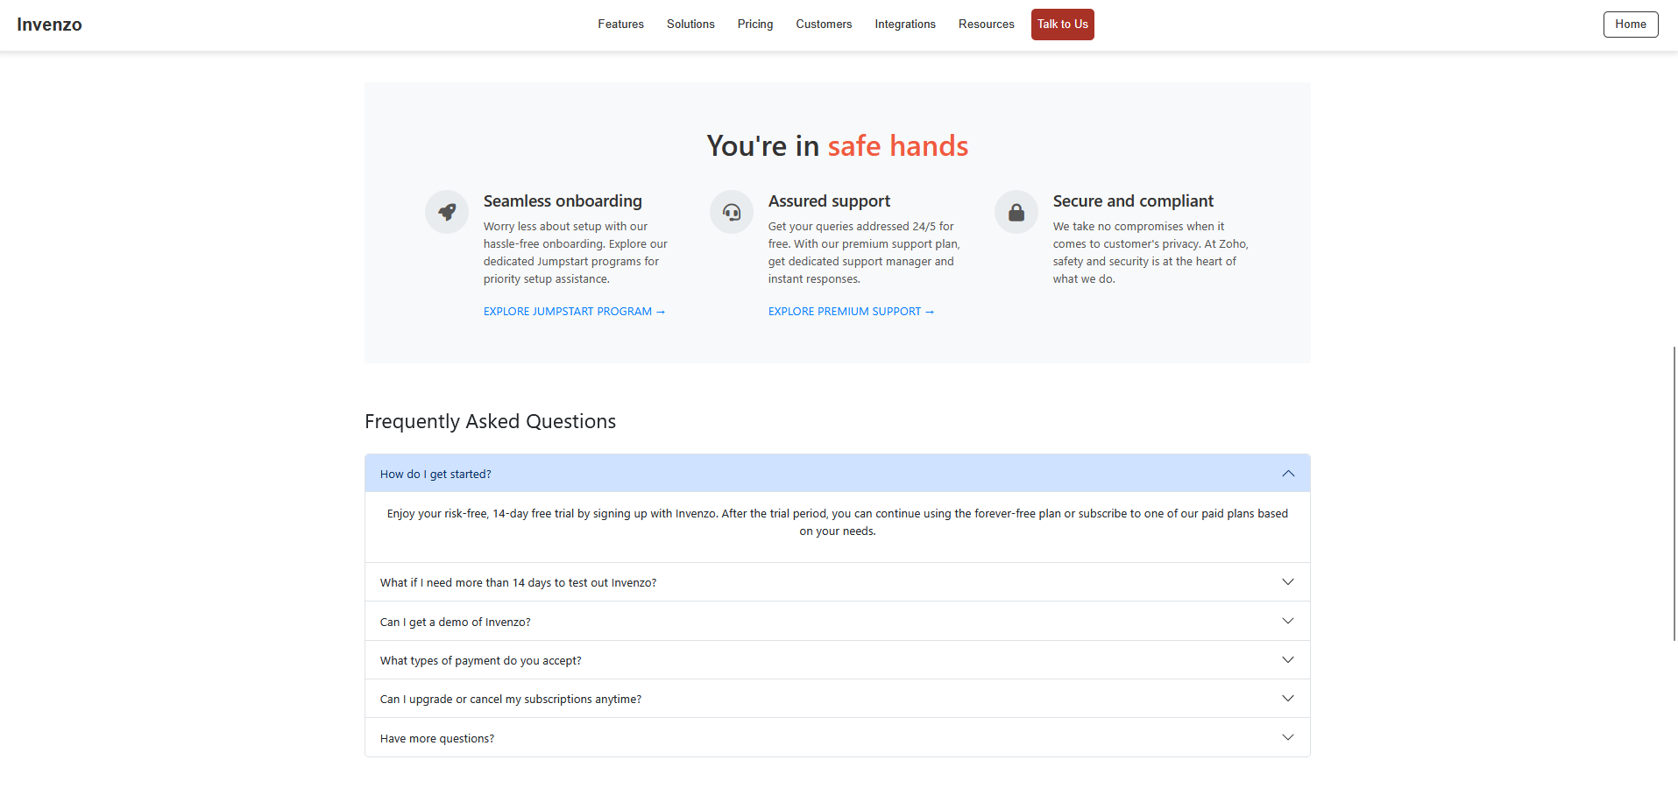

**CONCLUSION AND FUTURE SCOPE**

**6.1 Conclusion**

Here’s the conclusion of an Inventory Management System :-

* **Improves Efficiency:** Automates key tasks like stock tracking, reordering, and reporting, saving time and reducing errors.
* **Reduces Costs**: Prevents stockouts and overstocking, helping businesses minimize waste and storage costs.
* **Enhances Decision-Making**: Provides real-time data and detailed reports for informed decision-making.
* **Streamlines Operations:** Facilitates smooth inventory management across multiple locations and integrates with other business systems.
* **Boosts Customer Satisfaction:** Ensures timely product availability and accurate order fulfillment, improving customer experience.

**6.2 Future Scope**

Looking ahead, several enhancements can be integrated into the inventory management system to further improve its functionality and adaptability:

* **AI-Powered Analytics:** Implementing machine learning algorithms to analyse inventory data and provide predictive insights for better stock management.
* **Cloud Integration:** Migrating to cloud-based storage to ensure accessibility from anywhere, enabling multi-user collaboration and remote management.
* **Mobile Application Development:** Expanding the system to mobile platforms for real-time inventory monitoring and management on the go.
* **Automated Reordering:** Setting up automated purchase orders for low-stock items based on predefined thresholds to prevent stock shortages.
* **Enhanced Security Measures:** Strengthening data security with advanced encryption and authentication protocols to safeguard sensitive inventory information.

These future enhancements will further elevate the system's reliability, efficiency, and usability, making it a more robust solution for inventory management in diverse industries.

**REFERENCES\LINKS USED**

References used in the project are :-

* Sir Pavan Ambulkar’s provided course notes
* W3Schools website
* Several YouTube channels like :-

CodeWithHarry

ApnaCollege

**Appendices**

***GITHUB LINK:***

**THANK YOU**