**Comparison of Region Based on Sales**

Project 1

Description

The director of a leading organization wants to compare the sales between two regions. He has asked each region operators to record the sales data to compare by region. The upper management wants to visualize the sales data using a dashboard to understand the performance between them and suggest the necessary improvements.

**Objective:** Help the organization by creating a dashboard to visualize the sales comparison between two selected regions.

**Datasets:** Sample Superstore

**Steps to Perform:**

Select Sample Superstore as Dataset

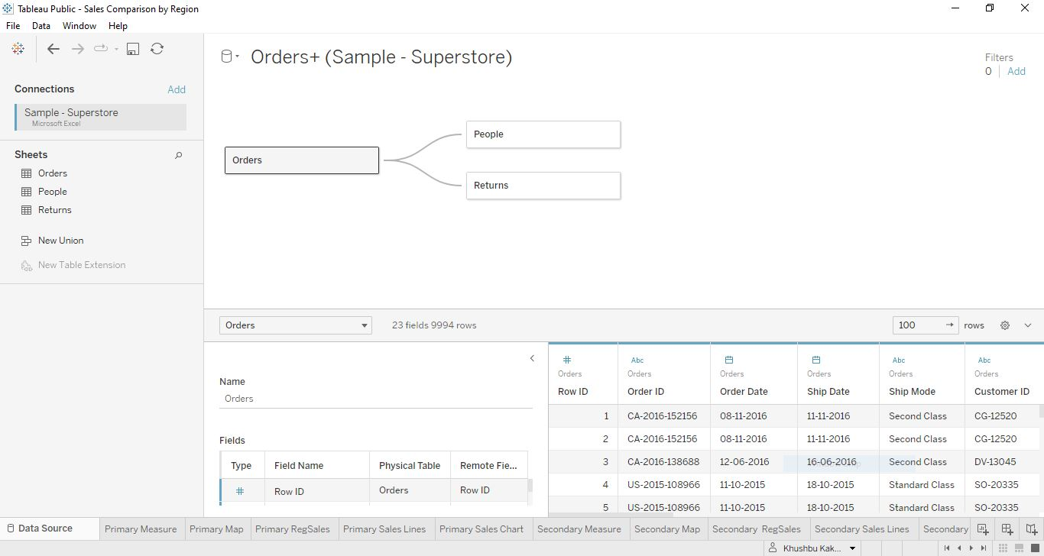

**Figure 1**

1. Use Sample Superstore Dataset
2. To select **Data**: As shown in above **Figure 1**, drag the order sheet and then build a relation with the other two sheets: people and return.
3. Now use Group by from Data Source Table on a Folder to create a folder to segregate the required data for Customer Name and Order ID to organize the data thoroughly as shown in **Figure 2**

**Figure 2**

1. To create a hierarchy called Location for the variable Country, click on the State dimension, select and drag and drop it over the country dimension, it will automatically create a hierarchy as shown in Figure 3.

**Figure 3**

Name it as **Location** and add all geographical dimensions in it chronologically as shown in Figure 4.

**Figure 4**

1. To create two parameters: Primary Region and Secondary Region with all regions listed in them. Now create Parameters for Primary Region and Secondary Region as shown in Figure 5. Select Data Type as String, available value as List and select Option ‘When workbook opens’ and Region in it for list values as shown in Figure 6 and Figure 7. Here, the primary and secondary regions are the two regions where the sales are being compared.

**Figure 5**

**Figure 6**

**Figure 7**

Now create a Calculated Field for both Primary Region and Secondary Region. Select the Primary region parameter, drop down, and select Create Calculation Field in it as shown in Figure 8.

**Figure 8**

Write the formula as shown in Figure 9 and click OK.

**Figure 9**

Repeat the same for the Secondary Region Calculation Field as shown in Figure 10.

**Figure 10**

Figure 11 is showing both Primary Region and Secondary Region parameters, also both calculated fields of both Primary Region and Secondary Region.

**Figure 11**

1. Create a First Order Date: Select Create a Calculated Field and name it as the First Order Date and write the formula as shown in Figure 12

**Figure 12**

Rename the Sheet 1 to Primary Measure and all below fields in the following order:

1. First Order Date: Select this field and drop in the Text markup field.
2. Total Sales: Select the Sales field and drop in the Text markup field.
3. Average Sales per Order: Select the Sales field and drop in the Text markup field and select measure as average.
4. No. of Customers: Select the Customer ID field and drop in the Text markup field and select measure as Count(distinct).
5. No. of Orders: Select the Order ID field and drop in the Text markup field and select measure as Count(distinct).
6. No. of Products in Sale: Select the Product ID field and drop in the Text markup field and select measure as Count(distinct).

After adding all the above fields in the sheet, put the region field in the filter as shown in Figure 13 and format the sheet accordingly as shown in Figure 14.

**Figure 13**

**Figure 14**

**Figure 15**

For Map, Select Country, and Drop on the Canvas the latitude and longitude generated measures are automatically added in row and column respectively. Then add state in detail markup and drop Sales Field in color markup. To make it for the Primary region map, add region field in the filter as shown in Figure 15, and the complete formatted version shown in Figure 16.

**Figure 16**

Primary Region Sales based on Sub-Category, tabular format is selected where total sales, minimum Sales, and Maximum Sales measure names columns are added. The matching formatting done in this sheet is also named Primary RegSales as shown in Figure 17.

Here measure name arrangement and region field are added in filter as other sheets like line chart and bar graph arrangement depend on this sheet.

**Figure 17**

**Figure 18**

In above Figure 18, the Primary Sales Lines named sheet has a sub-category field and total sales in a row and order date based on the week in the column, so by default line chart is created. Here also region filter is added to segregate Primary Region Data.

In below Figure 19, the Primary Sales Chart named sheet has a sub-category field in a row and total sales in a column and color markup, so by default bar chart is created. Here also region filter is added to segregate Primary Region Data. Make sure the sub-category field is sorted based on increasing alphabetical order.

**Figure 19**

Repeat all the above steps for Secondary Region sheets, the only difference is created by Filter.

**Figure 20**

1. Create a dashboard and align all sheets in the dashboard.
2. Partition the dashboard to display the below details of Primary Region and Secondary Region as shown in Figure 20. Also, the Tableau Dashboard link is given below:

Dashboard Link: <https://public.tableau.com/app/profile/khushbu.kakkar/viz/SalesComparisonbyRegion_17107425083260/Dashboard1?publish=yes>