BUFFER

-The Project Series Repository

**PROJECT : Smart Covid Vaccination System**

Objective of the Project:

To manage covid-19 vaccination system for both the doses, where the eligible citizen can register for vaccination and will be allotted his/her ***unique id*** and ***vaccination*** *day* according to the ***predefined priorities*** defined by the system.

Functionalities:

1. Registration of citizens for vaccination.

* Validating the registration based on aadhar card (UIDAI)
* Considering the frontline workers.
* Validating and verifying the age.
* Recording any medical history.
* Recording any family covid history.

1. Check whether he/she is eligible for vaccination.

* Checking eligibility based on parameters like age.

1. Assigned priority based on whether its his/her first/second dose, he/she is frontline worker, age, any serious medical condition and have covid history in due order.

Features:

This application correctly prioritizes citizens who should be vaccinated first and displays a list of in what sequence and on which day registered citizens would be vaccinated.

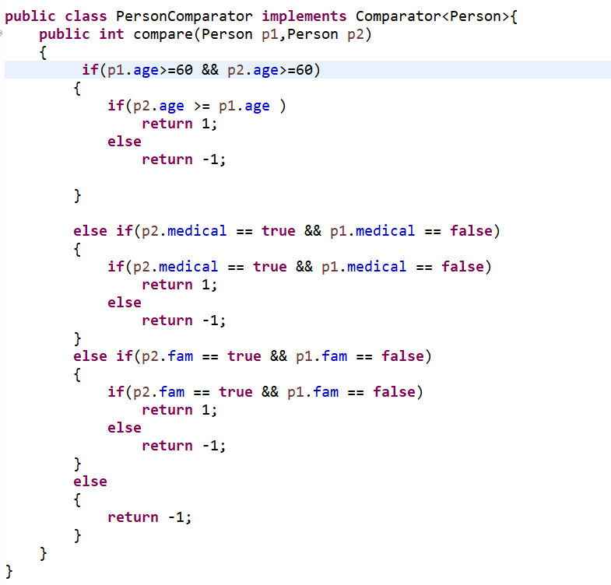

Data Structure used:

We’ve used a *priority queue implemented using a comparator*.

It is the most suitable data structure for arranging citizens in order of their priority. Also the comparator made it easy to assign priority.

Priority queue is internally implemented by heaps which is tree-based data structure and a complete binary tree.

Time Complexity Analysis:

All of our functions have a time complexity of O(logn).

Space Complexity Analysis:

O(n), where n is no. of registered citizens.

Future Scope and Scalability :

The system comprises various features built upon modular and highly scalable code. This system can be scaled for numerous immediate requirements (eg.: vaccination for age group 18 to 45) during this unprecedented time.

1. This application can be extended further to be implemented for multiple covid centres of different regions.
2. As we know, the government is modifying vaccination eligibility parameters, all changes can be implemented in this project simply playing around comparators.
3. If connected to the database module, can be applied for much larger no. of (users) citizens.
4. This module can be used in any other system where registrations are to be done on the basis of priority (e.g. hospital) just by modifying some input parameters and comparator.

Contributors:

1. Hardiki Sonchhatra
2. Khushbu Bora
3. Sudha Chintake
4. Shriharsha Dhobe

Mentor:

Rutvika Patil