**Practical - 1**

**Aim : C program to create a file and write data into file.**

**Program :**

#include <stdio.h>

main()

{

FILE *fp;

char data[1000];

fp = fopen("demo.txt", "w");

if(fp == NULL)

{

printf("Unable to create file...\n");

}

else

{

printf("File opened successfully...\n");

gets(data);

fputs("\n", fp);

fputs(data, fp);

}

printf("File created and saved successfully. :) \n");

fclose(fp);

}

**Output :**

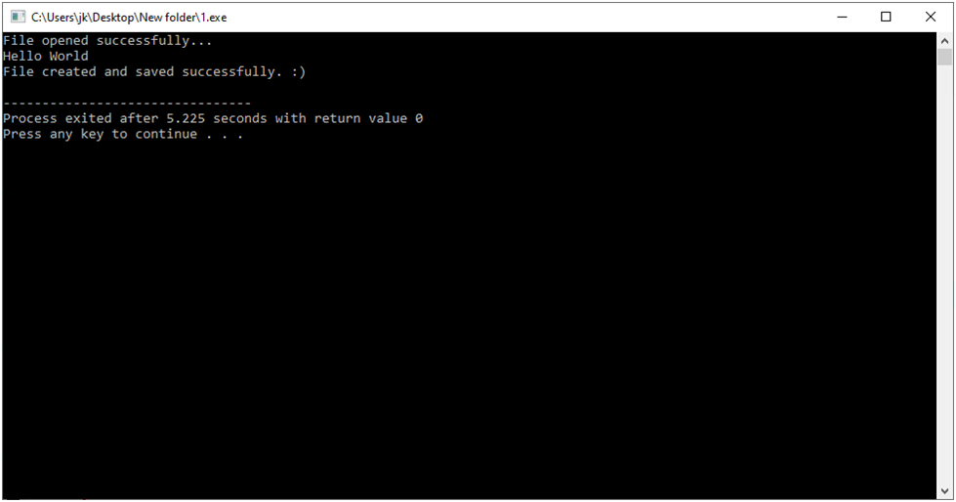

**Practical - 2**

**Aim : C program to read a file and display its contents.**

**Program :**

#include <stdio.h>

main()

{

FILE *fp;

char data[1000];

fp = fopen("demo.txt", "r");

if(fp == NULL)

{

printf("Unable to create file...\n");

}

else

{

printf("File opened successfully...\n\n");

while(fgets(data, 2, fp) != NULL)

{

printf("%s", data);

}

}

fclose(fp);

}

**Output :**

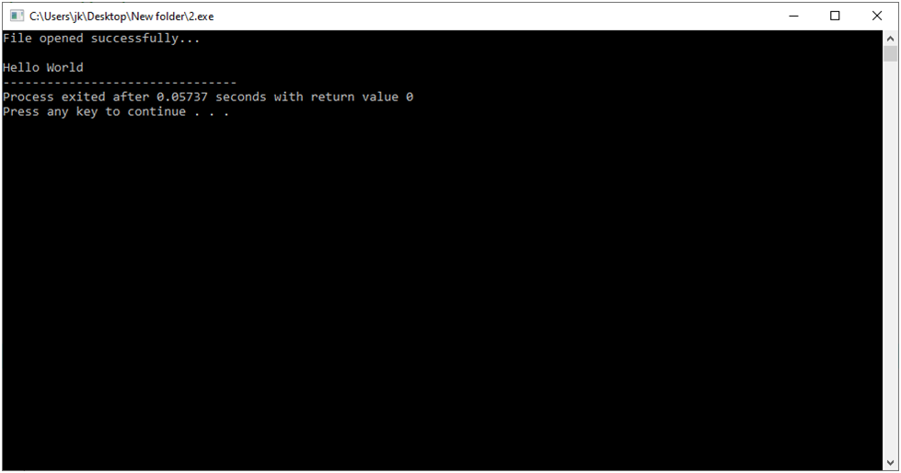

**Practical - 4**

**Aim :C program to append data into a file.**

**Program :**

#include <stdio.h>

main()

{

FILE *fp;

char data[1000];

fp = fopen("demo.txt", "a");

if(fp == NULL)

{

printf("Unable to create file...\n");

}

else

{

printf("File opened successfully...\n");

gets(data);

fputs("\n", fp);

fputs(data, fp);

}

printf("File created and saved successfully. :) \n");

fclose(fp);

}

**Output :**

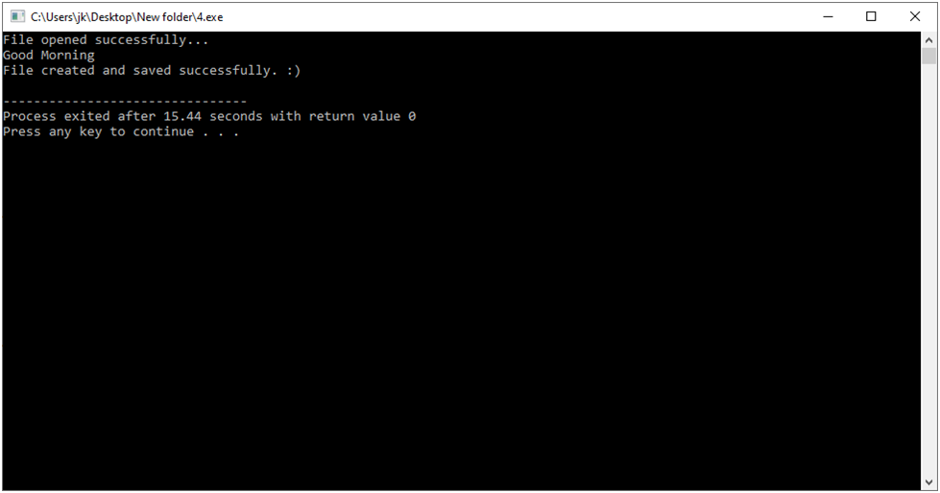

**Practical - 5**

**Aim :C program to copy contents from one file to another.**

**Program :**

#include <stdio.h>

main()

{

FILE *fp1, *fp2;

char data[1000];

fp1 = fopen("file1.txt", "r");

fp2 = fopen("file2.txt", "w");

while(fgets(data, 3, fp1) != NULL)

{

fputs(data, fp2);

}

printf("File copied successfully...");

fclose(fp1);

fclose(fp2);

}

**Output :**

