**Practical : 1**

**Aim**: Write C Program to print below design using printf function with help of \t & \n escape sequence(please check below image in attachment section).

**Program(I):**

#include<stdio.h>

#include<conio.h>

main()

{

clrscr();

printf("\t *\t *\t\n");

printf("\t*\t*\n\n");

printf(" *\t * \n\n");

printf("\t*\t*\n\n");

printf("\t *\t *\n\n");

getch();

}

**Output :**

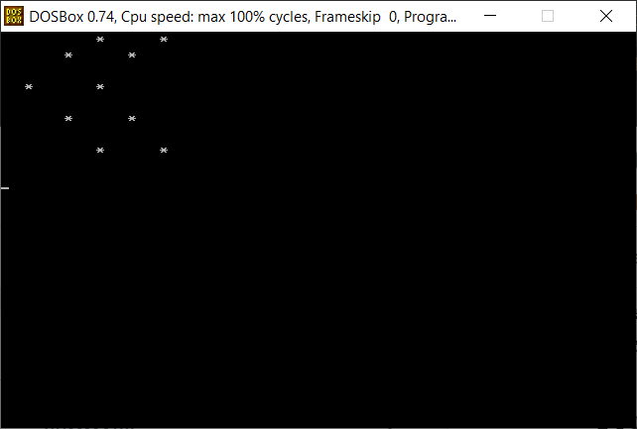

**Program(II)**:

#include<stdio.h>

#include<conio.h>

main()

{

clrscr();

printf("\t * * * * * * *\n\n");

printf("\t* * * * * * * *\n");

printf("\t* * *\n");

printf("\t* * * * * *\n");

printf("\t* * * * *\n");

printf("\t* * * * * * * *\n");

getch();

}

**Output :**

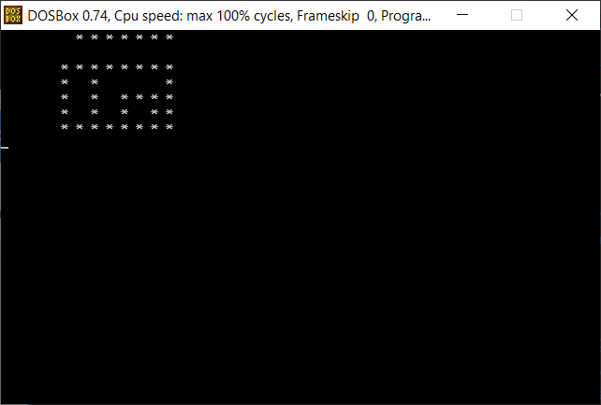

**Practical : 2**

**Aim**:Write C Program to perform a swapping of two variables.

**Program:**

#include<stdio.h>

#include<conio.h>

main()

{

int a,b;

clrscr();

printf("enter value of a and b respectively :");

scanf("%d %d",&a,&b);

a = a+b;

b = a-b;

a = a-b;

printf("after swapping value a = %d,b= %d",a,b);

getch();

}

**Output :**

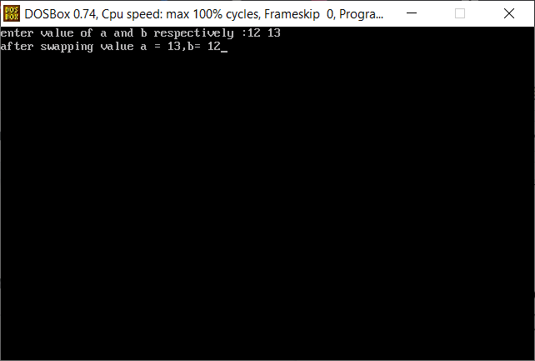

**Practical : 3**

**Aim**: Write C program to convert temperature from degree Celsius to Fahrenheit.

Use this formula

(Your Degree celcius temperature x 1.8) + 32

**Program**:

#include<stdio.h>

#include<conio.h>

main()

{

int c,f;

clrscr();

printf(" enter celsius of temprature: \n");

scanf("%d",&c);

f = (1.8 * c)+32;

printf("\n celsius of fahrenhit = %d",f);

getch();

}

**Output :**

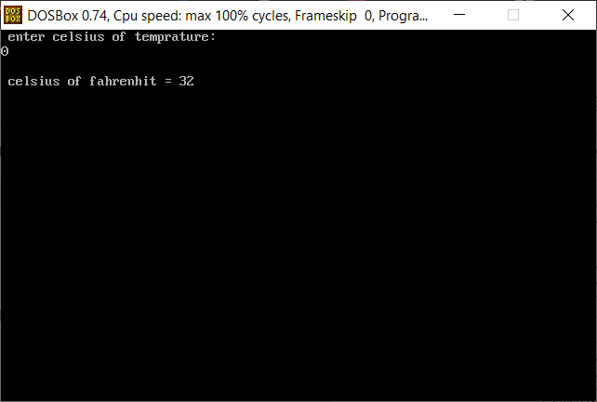

**Practical : 4**

**Aim**: Write C Program to find gross salary.

Ex. Base Salary: 100 RS, HRA=10%, DA=5%, TA=8%.

Ans = 123 RS

**Program**:

#include<stdio.h>

#include<conio.h>

main()

{

int base_salary ,hra,da,ta,gross_salary;

clrscr();

printf("\nenter value of base salary :");

scanf("%d",&base_salary);

hra = (base_salary*10)/100;

da = (base_salary*5)/100;

ta = (base_salary*8)/100;

gross_salary = base_salary+hra+da+ta;

printf("gross salary = %d",gross_salary);

getch();

}

**Output :**

