**Practical** **: 1**

**Aim :** Write C program to check a number is even or odd using ternary operator.

**Program :**

#include<stdio.h>

#include<conio.h>

main()

{

int n;

clrscr();

printf("enter value of a:");

scanf("%d",&n);

n%2 == 0 ? printf("%d is even number\n") : printf("%d is odd number\n");

getch();

}

**Output :**

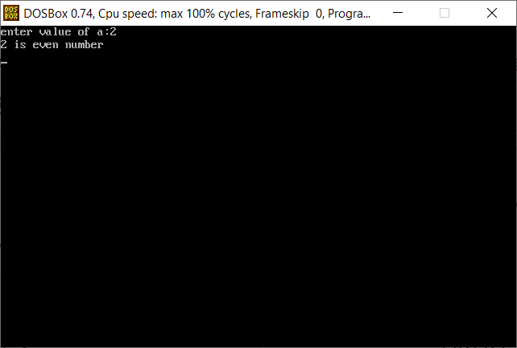

**Practical** **: 2**

**Aim :** Write C program to find out max from 4 numbers using nested if.

**Program :**

#include<stdio.h>

#include<conio.h>

main()

{

int a,b,c,d;

clrscr();

printf("enter value of a,b,c and c respectively :");

scanf("%d%d%d%d",&a,&b,&c,&d);

if(a==b && b==c && c==d)

{

printf("all values are same....");

}

else

{

if(a>b)

{

if(a>c)

{

if(a>d)

printf("a is maximum number");

else

printf("d is maximum number");

}

else

{

if(c>d)

printf("c is maximum number");

else

printf("d is maximum number");

}

}

else

{

if(b>c)

{

if(b>d)

printf("b is maximum number");

else

printf("d is maximum number");

}

else

{

if(c>d)

printf("c is maximum number");

else

printf("d is maximum number");

}

}

}

getch();

}

**Output :**

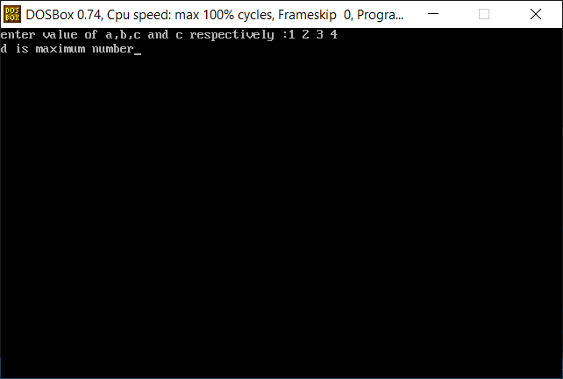

**Practical** **: 3**

**Aim :** Write C program use switch statement. Display Monday to Sunday.

Ex. User Input: M

Output: Monday

**Program :**

#include<stdio.h>

#include<conio.h>

main()

{

char ch;

clrscr();

printf("press M \n");

printf("press T \n");

printf("press W \n");

printf("press F \n");

printf("press S \n");

printf("enter any choice :");

scanf("%c", &ch);

switch(ch)

{

case 'M' :

printf("Monday");

break;

case 'T' :

printf("Tuesday or Thursday");

break;

case 'W' :

printf("Wednesday");

break;

case 'F' :

printf("Friday");

break;

case 'S' :

printf("Saturday or Sunday");

break;

default :

printf("invalid choice");

}

getch();

}

**Output :**

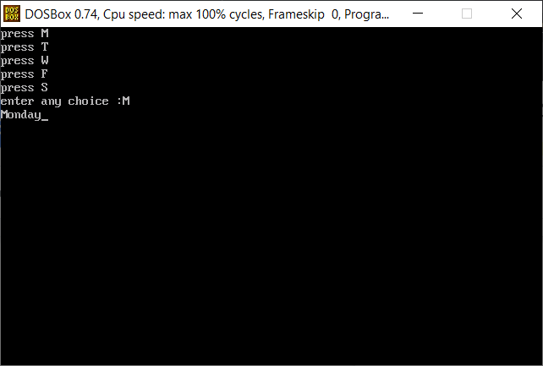

**Practical** **: 4**

**Aim :** Write a C program to input electricity unit charges and calculate total electricity bill according to the given condition:

For first 50 units Rs. 0.50/unit

For next 100 units Rs. 0.75/unit

For next 100 units Rs. 1.20/unit

For unit above 250 Rs. 1.50/unit

An additional surcharge of 20% is added to the bill.

**Program :**

#include<stdio.h>

#include<conio.h>

main()

{

int unit;

float amt,servicecharge,total_amount;

clrscr();

printf("enter total elecricity charge :");

scanf("%d", &unit);

if(unit <= 50)

{

amt = unit * 0.50;

}

else if(unit <= 50)

{

amt = unit * 0.50;

}

else if(unit <= 150)

{

amt = 25 + ((unit-50)* 0.75);

}

else if(unit <= 250)

{

amt = 100 + ((unit-150)* 1.20);

}

else

{

amt = 220 + ((unit-150)* 1.50);

}

servicecharge = amt * 0.20;

total_amount = servicecharge + amt;

printf("Bill = %f",total_amount);

getch();

}

**Output :**

