**Program : 1**

**Aim** **:** Write C program to print all alphabets from a to z. using do while loop

**Program** **:**

#include<stdio.h>

#include<conio.h>

main()

{

char ch='A';

clrscr();

do{

printf("%c\t",ch);

ch++;

}while(ch<='Z');

getch();

}

**Output :**

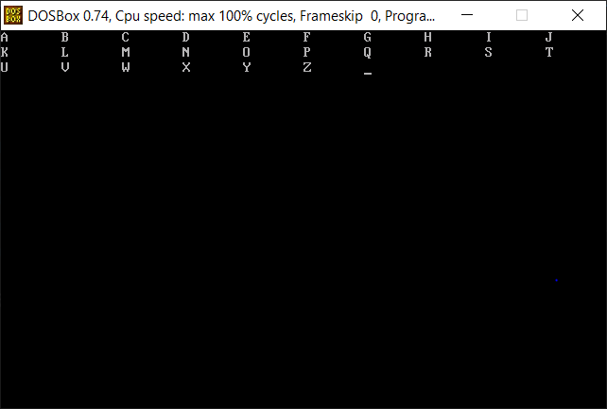

**Program : 2**

**Aim** **:** Write C program to print multiplication table of any number.

**Program** **:**

#include<stdio.h>

#include<conio.h>

main()

{

int i,n;

clrscr();

printf("enter ant number : \n");

scanf("%d",&n);

for(i=1;i<=10;i++)

{

printf("%d * %d = %d\n",n,i,n*i);

}

getch();

}

**Output :**

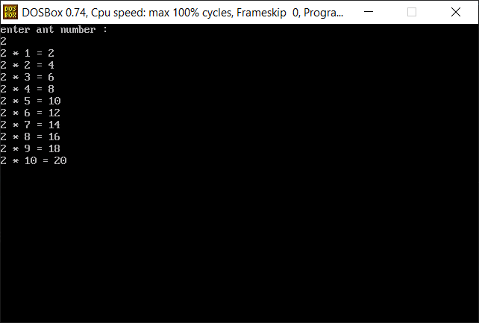

**Program : 4**

**Aim** **:** Write C program to find sum of first and last digit of a number.

**Program** **:**

#include<stdio.h>

#include<conio.h>

main()

{

int n,ans=0,a,b;

clrscr();

printf("enter any number :");

scanf("%d",&n);

b = n%10;

while(n>=10)

{

n = n/10;

}

a = n;

ans = b + a;

printf("number of last digit = %d",ans);

getch();

}

**Output :**

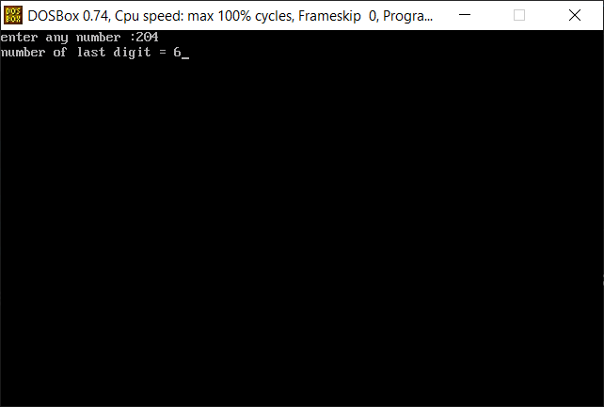

**Program : 5**

**Aim** **:** Write C program to enter a number and print its reverse & check weather num is palindrome or not?

**Program** **:**

#include<stdio.h>

#include<conio.h>

main()

{

int n,rev=0,rem,a;

clrscr();

printf("enter any number :");

scanf("%d",&n);

a=n;

while(n>0)

{

rem = n%10;

rev = rev *10+rem;

n = n/10;

}

if(a=rev)

{

printf("numver is palindrom number");

}

else{

printf("number is palindrom number");

}

getch();

}

**Output :**

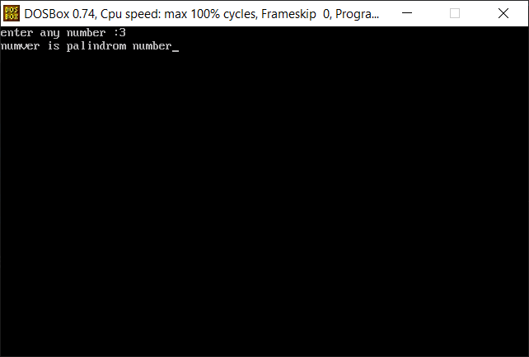

**Program : 6**

**Aim** **:** Write C program to calculate factorial of a number.

**Program** **:**

#include<stdio.h>

#include<conio.h>

main()

{

int n,i=1,fact=1;

clrscr();

printf("enter any number :");

scanf("%d",&n);

while(i<=n)

{

fact = fact *i;

i++;

}

printf("factorial %d is : %d ", n,fact);

getch();

}

**Output :**

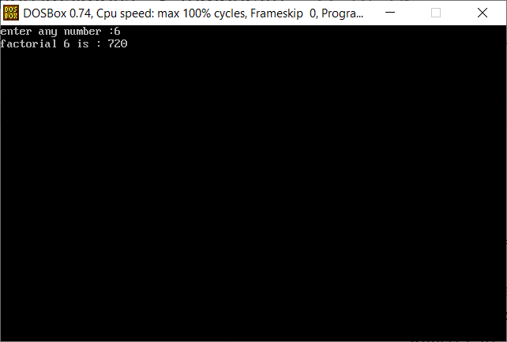

**Program : 7**

**Aim :** Write C program print out Fibonacci series. (0,1,1,2,3,5,8…)

**Program :**

#include<stdio.h>

#include<conio.h>

main()

{

int n1=0,n2=1,ans=0,n;

clrscr();

printf("enter any number :");

scanf("%d",&n);

printf("\nfibonacci series is :%d,%d,",n1,n2);

ans = n1 +n2;

while(ans<=n)

{

printf("%d,",ans);

n1=n2;

n2=ans;

ans = n1+n2;

}

getch();

}

**Output :**

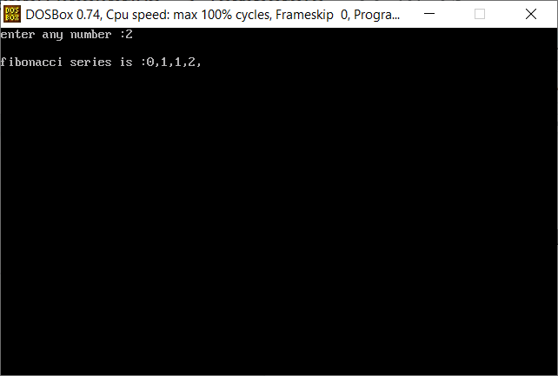

**Program : 8**

**Aim :** Program Check weather num is prime or not.

**Program :**

#include<stdio.h>

#include<conio.h>

main()

{

int n,i,a=0,flag=0;

clrscr();

printf("enter any number :");

scanf("%d",&n);

a = n/2;

for(i=2;i<=a;i++)

{

if(n%i==0)

{

printf("\n number is not prime number");

flag = 1;

break;

}

}

if(flag ==0)

printf("\n number is prime number");

getch();

}

**Output :**

