**Practical : 1**

**Aim :**Write C program to print all negative elements in an array.

**Program :**

#include<stdio.h>

#include<conio.h>

int main()

{

int i,n,arr[1000];

clrscr();

printf("\n enter size of array : ");

scanf("%d",&n);

printf(" enter elements of array :");

for(i = 0;i<n ; i++)

{

scanf("%d",&arr[i]);

}

printf("\n all negative elements in array :");

for(i = 0;i<n ; i++)

{

if(arr[i] < 0 )

{

printf("arr[%d] = %d \n",i,arr[i]);

}

}

getch();

}

**Output :**

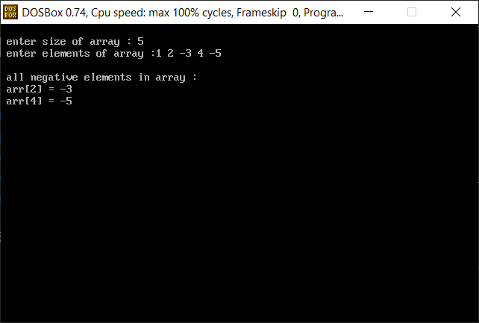

**Practical : 2**

**Aim :**Write C program to find second largest number in array.

**Program :**

#include<stdio.h>

#include<conio.h>

int main()

{

int i,n,arr[1000],secondmax,max;

clrscr();

printf("\n enter size of array : ");

scanf("%d",&n);

printf(" enter elements of array :");

for(i = 0;i<n ; i++)

{

scanf("%d",&arr[i]);

}

for(i = 0;i<n ; i++)

{

if(arr[i] > 0 )

{

secondmax = max;

max = arr[i];

}

else if(arr[i] < max && arr[i]>secondmax)

{

secondmax = arr[i];

}

}

printf("second largest number is %d",secondmax);

getch();

}

**Output :**

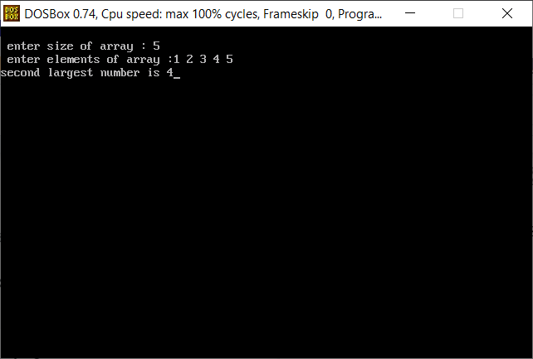

**Practical : 3**

**Aim :** Write C program to count frequency of each element in an array.

**Program :**

#include<stdio.h>

#include<conio.h>

int main()

{

int i,n,arr[1000],fre[1000],j,count;

clrscr();

printf("\n enter size of array : ");

scanf("%d",&n);

printf(" enter elements of array :");

for(i = 0;i<n ; i++)

{

scanf("%d",&arr[i]);

fre[i] = -1;

}

for(i = 0;i<n ; i++)

{

count = 1;

for(j = i+1;j<n;j++)

{

if(arr[i] == arr[j])

{

count++;

fre[j] = 0;

}

}

if(fre[i]!=0)

{

fre[i] = count;

}

}

printf("frequency of each elements :\n");

for(i=0;i<n;i++)

{

if(fre[i] != 0)

printf("%d is %d times \n",arr[i],fre[i]);

}

getch();

}

**Output :**

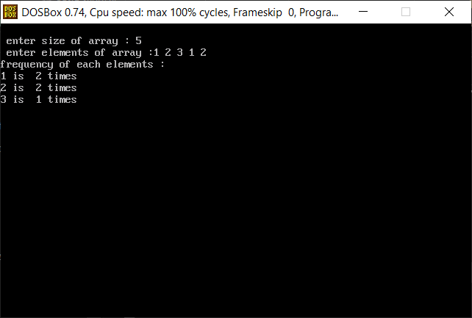

**Practical : 4**

**Aim :** Write C program to Insert & Update operations the element into array.

**Program :**

#include<stdio.h>

#include<conio.h>

main()

{

int a[1000],i,n,k,ch,loc,size,j;

clrscr();

printf("menu\n");

printf("=====\n");

printf("1.insert\n");

printf("2.update\n");

printf("\n enter your choice ...");

scanf("%d",&ch);

switch(ch)

{

case 1 :

printf("\n enter size of an array :");

scanf("%d",&n);

printf("\n enter %d array elements :",n);

for(i=0;i<n;i++)

{

scanf("%d",&a[i]);

}

printf("\n before insetion :");

for(i=0;i<n;i++)

{

printf("\n a[%d]= %d",i,a[i]);

}

printf("\n enter an element to insert: ");

scanf("%d",&k);

printf("\n enter a position to insert an element %d :",k);

scanf("%d",&loc);

loc--;

for(i=n-1;i>=loc;i--)

{

a[i+1] = a[i];

}

a[loc] = k;

printf("\n after insertion...");

for(i=0;i<n+1;i++)

{

printf("\n a[%d] = %d",i,a[i]);

}

break;

case 2 :

printf("\n enter the size of an array :");

scanf("%d",&n);

printf("\n enter array an elements :");

for(i=0;i<n;i++)

{

scanf("%d",&a[i]);

}

printf("\n list before update :");

for(i=0;i<n;i++)

{

printf("\n a[%d] = %d",i,a[i]);

}

printf("\n enter the position to update : ");

scanf("%d",&k);

printf("\n enter the value to be update :");

scanf("%d",&loc);

for(i=0;i<n;i++)

{

if(i==k)

{

a[i]=loc;

}

}

printf("\n after updated values ");

for(i=0;i<n;i++)

{

printf("\n a[%d]=%d",i,a[i]);

}

break;

default :

printf("your choice is invalid");

break;

}

getch();

}

**Output :**

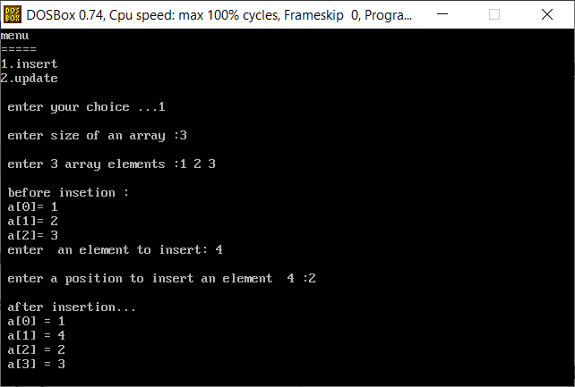

**Practical : 5**

**Aim :** Write C program to addition of two matrices

**Program :**

#include<stdio.h>

#include<conio.h>

int main()

{

int r,c,a[100][100],b[100][100],sum[100][100],i,j;

clrscr();

printf("\n enter number of rows: ");

scanf("%d",&r);

printf(" enter number of columns :");

scanf("%d",&c);

printf("\n enter elements of 1st matrix ");

for(i = 0;i<r ; ++i)

{

for(j=0;j<c;++j)

{

printf("\n enter elements [%d][%d] :",i+1,j+1);

scanf("%d",&a[i][j]);

}

}

printf(" \n enter elements of 2nd matrix ");

for(i = 0;i<r ; ++i)

{

for(j=0;j<c;++j)

{

printf(" \n enter elements b [%d][%d] :",i+1,j+1);

scanf("%d",&b[i][j]);

}

}

for(i = 0;i<r ; ++i)

{

for(j=0;j<c;++j)

{

sum[i][j] = a[i][j] + b[i][j];

}

}

printf(" \n addition of two matrix :\n");

for(i = 0;i<r ; ++i)

{

for(j=0;j<c;++j)

{

printf("%d ",sum[i][j]);

if(j==c-1)

printf("\n\n");

}

}

getch();

}

**Output :**

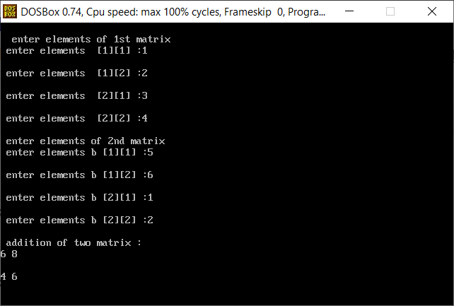

**Practical : 6**

**Aim :** Write C program matrix convert into transpose matrix.

**Program :**

#include<stdio.h>

#include<conio.h>

int main()

{

int i,n,m,matrix[10][10],transpose[10][10],j;

clrscr();

printf("\n enter rows and columns : ");

scanf("%d%d",&m,&n);

printf(" enter elements of the matrix : \n ");

for(i = 0;i<m ; i++)

{

for(j = 0;j<n;j++)

{

scanf("%d",&matrix[i][j]);

}

}

for(i = 0;i<m ; i++)

{

for(j = 0;j<n;j++)

transpose[j][i] = matrix[i][j];

}

printf("transpose of the matrix :\n");

for(i = 0;i<n ; i++)

{

for(j = 0;j<m;j++)

printf("%d\t",transpose[i][j]);

printf("\n");

}

getch();

}

**Output :**

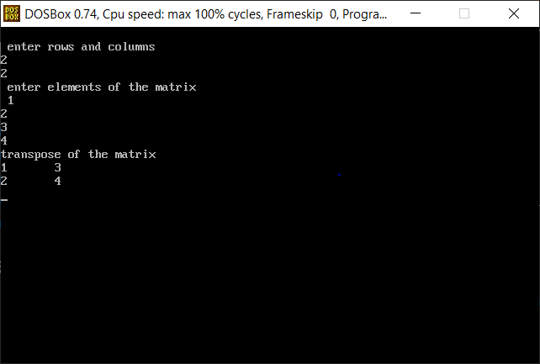

**Practical : 7**

**Aim :** Write C program to find sum of diagonal elements of a matrix.

**Program :**

#include<stdio.h>

#include<conio.h>

main()

{

int m,n,matrix[10][10],sum=0,j,i;

clrscr();

printf("\n enter rows and columns : ");

scanf("%d%d",&m,&n);

printf(" enter elements of the matrix : \n ");

for(i = 0;i<m ; i++)

{

for(j = 0;j<n;j++)

{

scanf("%d",&matrix[i][j]);

}

}

printf("the matrix ...\n");

for(i = 0;i<m ; i++)

{

for(j = 0;j<n;j++)

{

printf("%d\t",matrix[i][j]);

}

printf("\n");

}

printf("add diagonal elements....\n");

for(i = 0;i<m ; i++)

{

for(j = 0;j<n;j++)

{

if(i==j)

{

sum = sum + matrix[i][j];

}

}

}

printf("sum of diagonal elements of a matrix = %d\n",sum);

getch();

}

**Output :**

