**Program : 1**

**Aim :** Write C program to count frequency of each character in a string.

**Program :**

#include <stdio.h>

#include <string.h>

int main()

{

char a[100];

int c = 0, count[26] = {0}, x;

printf("Enter a string\n");

gets(a);

while (a[c] != '\0') {

if (a[c] >= 'a' && a[c] <= 'z') {

x = a[c] - 'a';

count[x]++;

}

c++;

}

for (c = 0; c < 26; c++)

printf("%c occurs %d times in the string.\n", c + 'a', count[c]);

return 0;

}

**Output :**

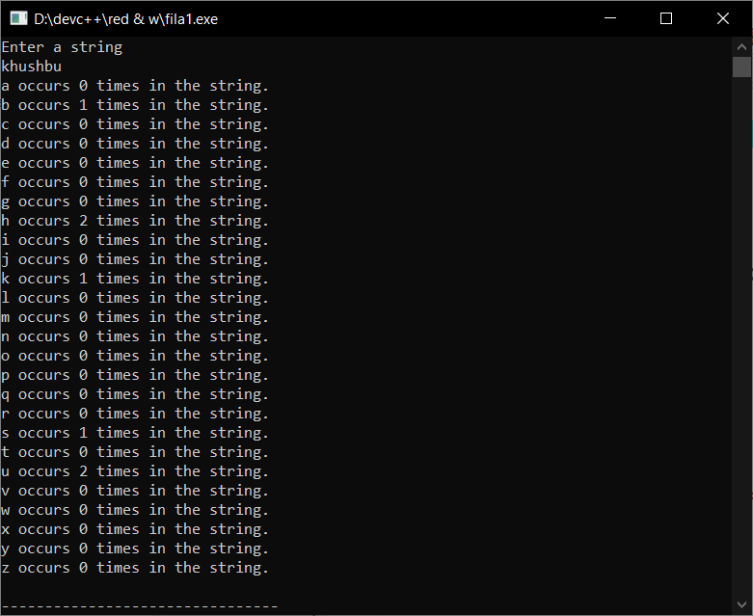

**Program : 2**

**Aim :** Write C program to check whether a string is palindrome or not.

**Program :**

#include <stdio.h>

#include <string.h>

int main()

{

char str[100];

int i, len, flag;

flag = 0;

printf("\n Please Enter any String : ");

gets(str);

len = strlen(str);

for(i = 0; i < len; i++)

{

if(str[i] != str[len - i - 1])

{

flag = 1;

break;

}

}

if(flag == 0)

{

printf("\n %s is a Palindrome String", str);

}

else

{

printf("\n %s is Not a Palindrome String", str);

}

return 0;

}

**Output :**

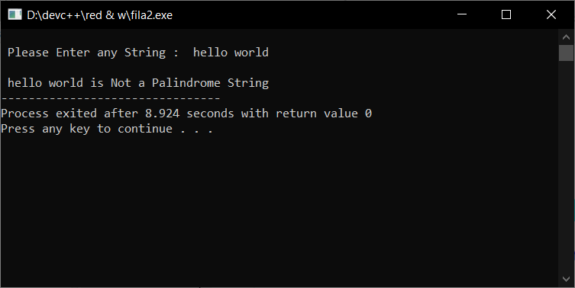

**Program : 3**

**Aim :** Write C program to remove spaces, blanks from a string.

**Program :**

#include<string.h>

#include<stdio.h>

main()

{

char s[1000];

int i,k=0;

printf("Enter the string : ");

gets(s);

for(i=0;s[i];i++)

{

s[i]=s[i+k];

if(s[i]==' '|| s[i]=='\t')

{

k++;

i--;

}

}

printf("string after removing all blank spaces:");

printf("%s",s);

return 0;

}

**Output :**

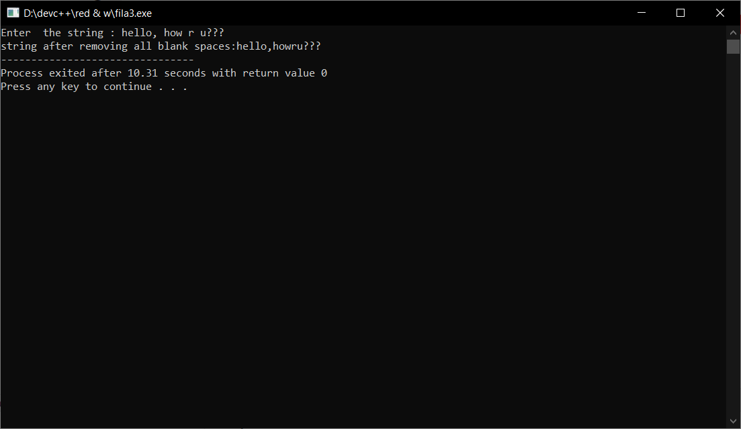

**Program : 4**

**Aim :** Write C program to remove all repeated characters in a string.

**Program :**

#include <stdio.h>

#include <string.h>

int main()

{

char str[100];

int i, j, k;

printf("\n Please Enter any String : ");

gets(str);

for(i = 0; i < strlen(str); i++)

{

for(j = i + 1; str[j] != '\0'; j++)

{

if(str[j] == str[i])

{

for(k = j; str[k] != '\0'; k++)

{

str[k] = str[k + 1];

}

}

}

}

printf("\n The Final String after Removing All Duplicates : %s ", str);

return 0;

}

**Output :**

