**Program : 1**

**Aim :** C program to find factorial of number using recursion.

**Program :**

#include<stdio.h>

int fact(int n)

{

if(n<=1)

{

return 1;

}

else

{

return n * fact (n-1);

}

}

void main()

{

int n;

printf("Enter a positive integer: ");

scanf("%d",&n);

printf("Factorial of %d = %d", n, fact(n));

}

**Output :**

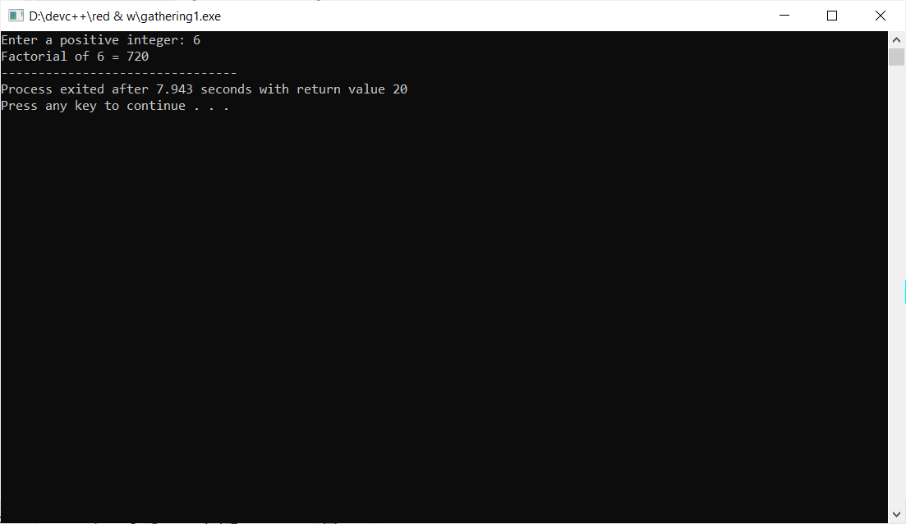

**Program : 2**

**Aim :** C program to find Sum of all Array Elements by passing array as an argument using User Define Functions.

**Program :**

include<stdio.h>

int sumofarray(int a[],int n)

{

int i,sum=0;

for(i=0; i<n; i++)

{

sum+=a[i];

}

return sum;

}

int main()

{

int a[1000],i,n,sum;

printf("Enter size of the array : ");

scanf("%d", &n);

printf("Enter elements in array : ");

for(i=0; i<n; i++)

{

scanf("%d",&a[i]);

}

sum=sumofarray(a,n);

printf("sum of array is :%d",sum);

}

**Output :**

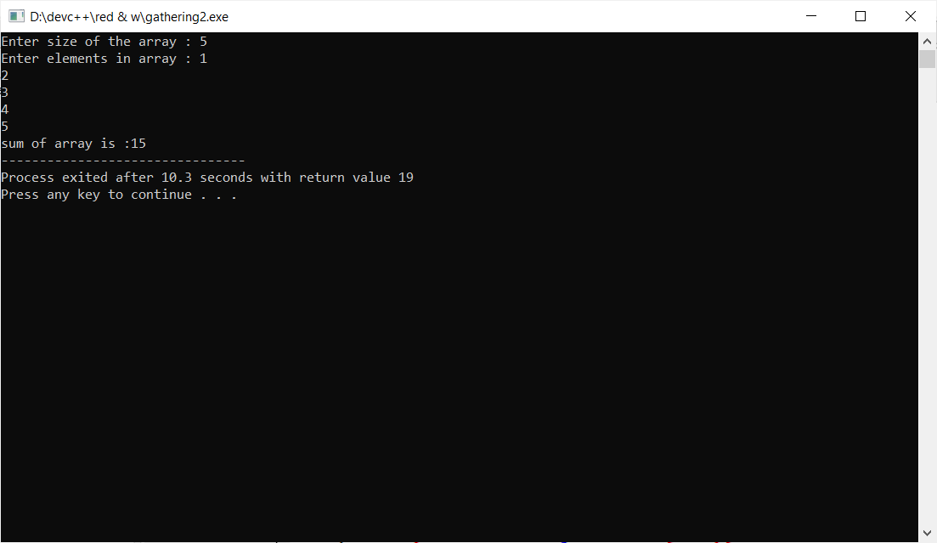

**Program : 3**

**Aim :** C program to find Length of the String by passing String/ Character Array as an Argument using User Define Functions.

**Program :**

#include<stdio.h>

int Length(char str[]) {

int len = 0;

while (str[len] != '\0')

len++;

return (len);

}

int main() {

char str[100];

int length;

printf("\nEnter the String : ");

gets(str);

length = Length(str);

printf("\nLength of the String is : %d", length);

}

**Output :**

