**Program : 1**

**Aim :** C program to swap two numbers using pointers

**Program :**

#include <stdio.h>

int main()

{

int x, y, *a, *b, temp;

printf("Enter the value of x and y\n");

scanf("%d%d", &x, &y);

printf("Before Swapping\nx = %d\ny = %d\n", x, y);

a = &x;

b = &y;

temp = *b;

*b = *a;

*a = temp;

printf("After Swapping\nx = %d\ny = %d\n", x, y);

return 0;

}

**Output :**

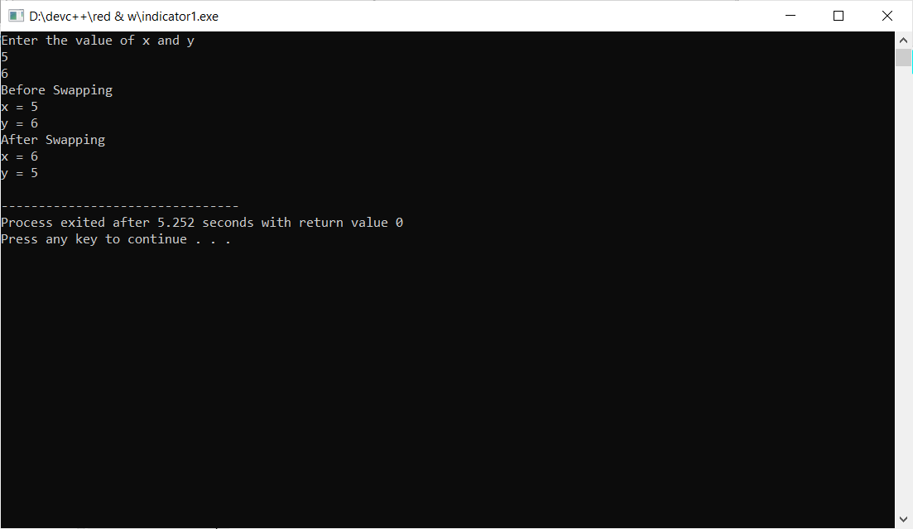

**Program : 2**

**Aim :** C program to input and print array elements using pointers

**Program :**

#include <stdio.h>

int main()

{

int arr[1000];

int N, i,* ptr = arr;

printf("Enter size of array: ");

scanf("%d", &N);

printf("Enter elements in array:\n");

for (i = 0; i < N; i++)

{

scanf("%d", (ptr + i));

}

printf("Array elements: ");

for (i = 0; i < N; i++)

{

printf("%d, ", *(ptr + i));

}

return 0;

}

**Output :**

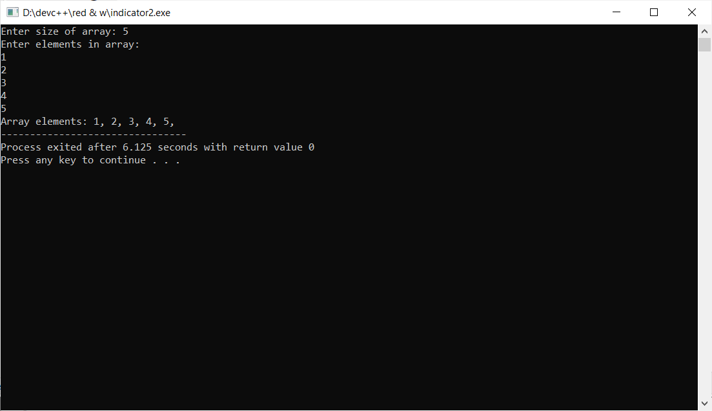

**Program : 3**

**Aim :** C program to reverse an array using pointers

**Program :**

#include<stdio.h>

int main()

{

int a[1000], i, *ptr,n;

printf("Enter size of array: ");

scanf("%d", &n);

printf("Enter %d integer numbers\n", n);

for(i = 0; i < n; i++)

scanf("%d", &a[i]);

ptr = &a[n - 1];

printf("\nElements of array in reverse order ...\n");

for(i = 0; i < n; i++)

printf("%d\n", *ptr--);

return 0;

}

**Output :**

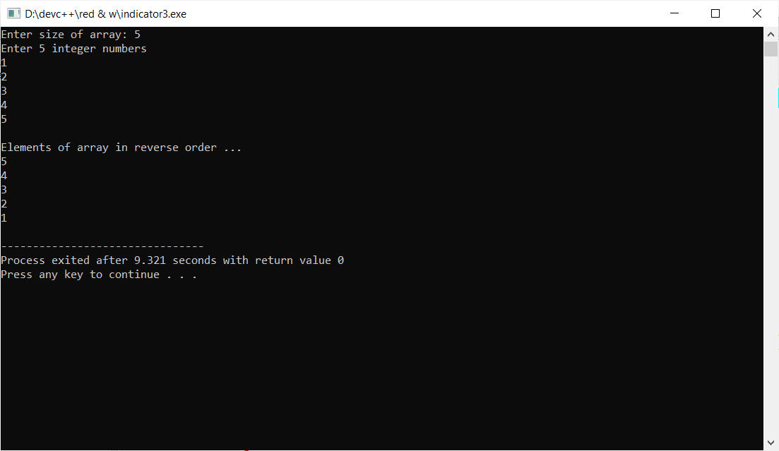

**Program : 4**

**Aim :** Program to find length of string using pointer

**Program :**

#include<stdio.h>

int main()

{

char str[1000];

char *ptr=str;

int count=0;

printf("Enter the string:\n");

gets(str);

while(*ptr!='\0')

{

count++;

ptr++;

}

printf("Length of string = %d",count);

return 0;

}

**Output :**

