**Program : 1**

**Aim :** Write a program to add two distances in inch-feet using structure. The values of the distances is to be taken from the user.

**Program :**

#include <stdio.h>

struct Distance {

int feet;

float inch;

} d1, d2, ans;

int main() {

printf("Enter 1st distance\n");

printf("Enter feet: ");

scanf("%d", &d1.feet);

printf("Enter inch: ");

scanf("%f", &d1.inch);

printf("\nEnter 2nd distance\n");

printf("Enter feet: ");

scanf("%d", &d2.feet);

printf("Enter inch: ");

scanf("%f", &d2.inch);

ans.feet = d1.feet + d2.feet;

ans.inch = d1.inch + d2.inch;

while (ans.inch >= 12.0) {

ans.inch = ans.inch - 12.0;

ans.feet++;

}

printf("\nSum of distances = %d\'-%.1f\"", ans.feet, ans.inch);

return 0;

}

**Output :**

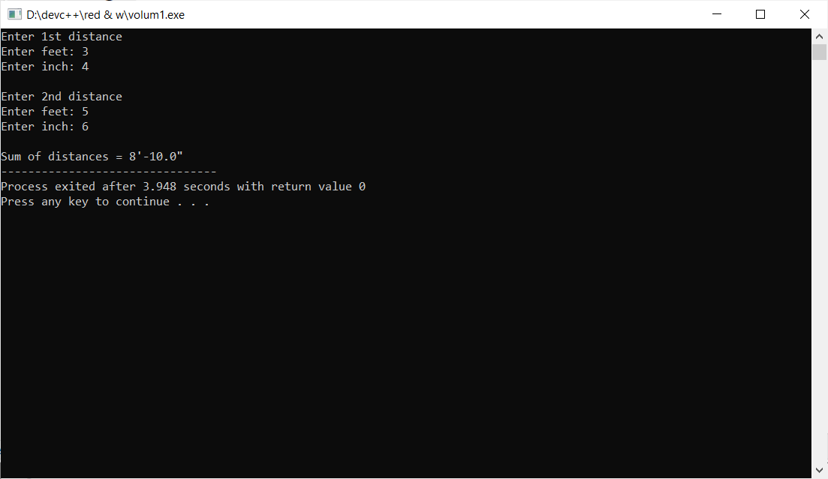

**Program : 2**

**Aim :**  Enter the marks of 5 students in Chemistry, Mathematics and Physics (each out of 100) using a Union named Marks having elements roll no., name, chem_marks, maths_marks and phy_marks and then display the percentage of each student.

Program :

#include <stdio.h>

union Marks {

int roll_no;

char name[30];

float chem_marks, maths_marks, phy_marks;

};

int main() {

union Marks marks[5];

int i;

float percentage;

for(i=0; i<5; i++){

printf("\n Student %d\n ",i+1);

printf("\n Enter roll no. :");

scanf("%d", &marks[i].roll_no);

printf("\n Enter name :");

scanf("%s",&marks[i].name);

printf("\n Enter Chemistry marks :");

scanf("%f", &marks[i].chem_marks);

printf("\n Enter Maths marks :");

scanf("%f", &marks[i].maths_marks);

printf("\n Enter Physics marks :");

scanf("%f", &marks[i].phy_marks);

}

for( i=0; i<5; i++)

{

printf("Student %d\n",i+1);

printf("=================\n\n",i+1);

percentage = (marks[i].chem_marks + marks[i].maths_marks + marks[i].phy_marks)/300.0*100;

printf("Percentage : %f\n", percentage);

}

return 0;

}

**Output :**

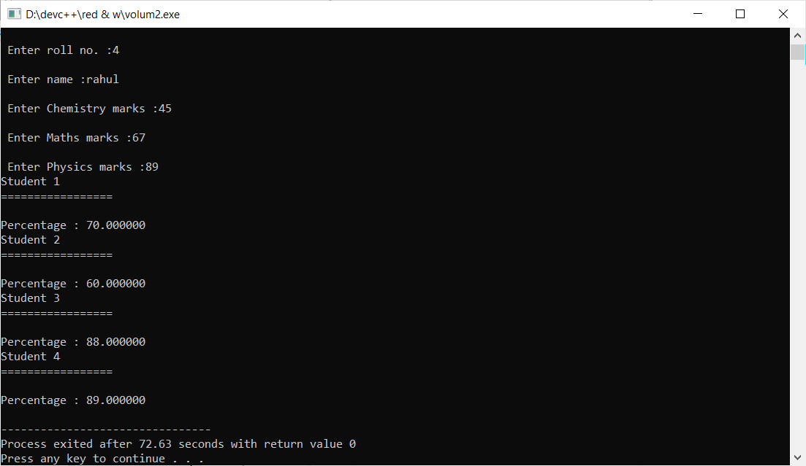

**Program : 3**

**Aim :** Write a program to print integer value of day of week using enum.

**Program :**

enum Day

{

Sunday = 1,Monday = 2,Tuesday= 3,Wednesday = 4,Thursday = 5,Friday = 6,Saturday =

};

int main() {

int i;

for(i=Sunday;i<=Saturday;i++)

{

printf("%d - ",i);

}

return 0;

}

**Output :**

