**Program : 1**

**Aim :** WAP to check given string is numeric or not.

**Program :**

#include<iostream>

using namespace std;

int main()

{

char ch[1000];

cout << "Enter any string : ";

gets(a);

if(ch[i]>= '0' && ch[i] <= '9')

{

cout << "Input is numeric";

}

else

{

cout << "Input is not numeric";

}

return 0;

}

**Output :**

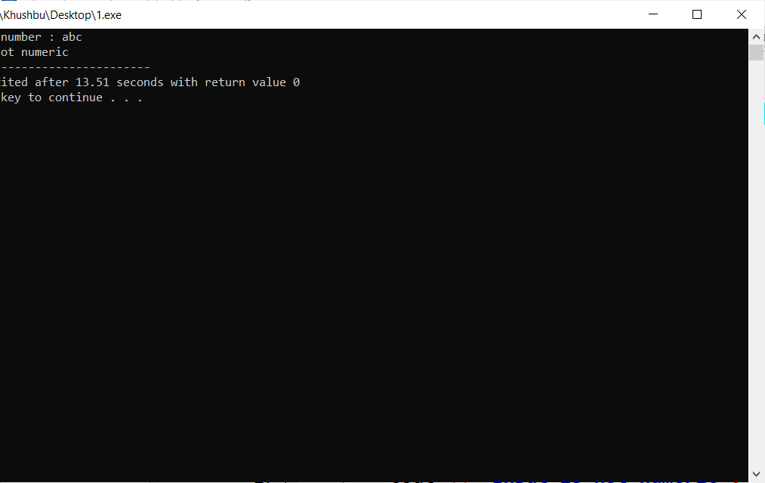

**Program : 2**

**Aim :**  WAP to find leap years from 2000 to 3000.

**Program** :

#include<iostream>

using namespace std;

int main()

{

int i;

cout << "Leap years between 2000 to 3000 :\n " ;

for(i = 2000 ; i <= 3000 ; i++)

{

if(i % 4 == 0)

cout << i << "\t";

}

return 0;

}

**Output :**

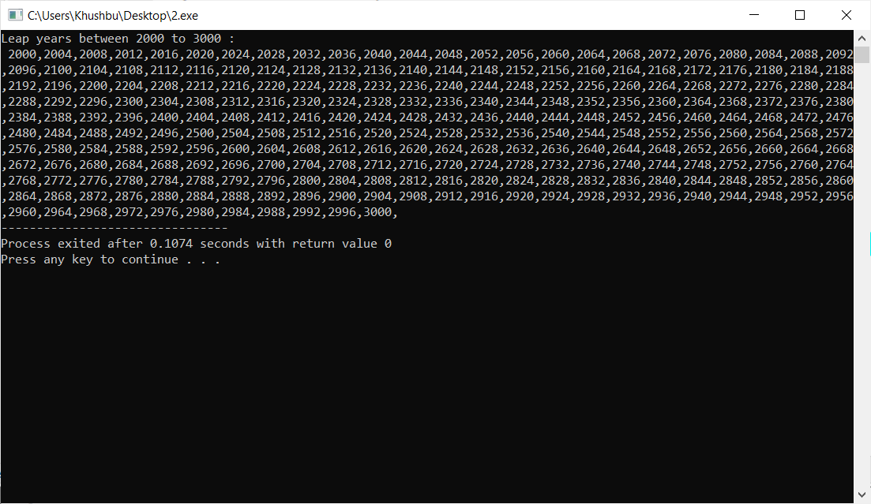

**Program : 3**

**Aim :** WAP to convert given string into toggle case.

**Program :**

#include<iostream>

using namespace std;

int main()

{

int i;

char a[1000];

cout << "Enter the string : ";

gets(a);

for(i = 0 ; a[i] ; i++)

{

if(a[i] >= 97 && a[i] <= 122)

{

a[i] = a[i] - 32;

}

else if(a[i] >= 65 && a[i] <= 90)

{

a[i] = a[i] + 32;

}

}

puts(a);

return 0;

}

**Output :**

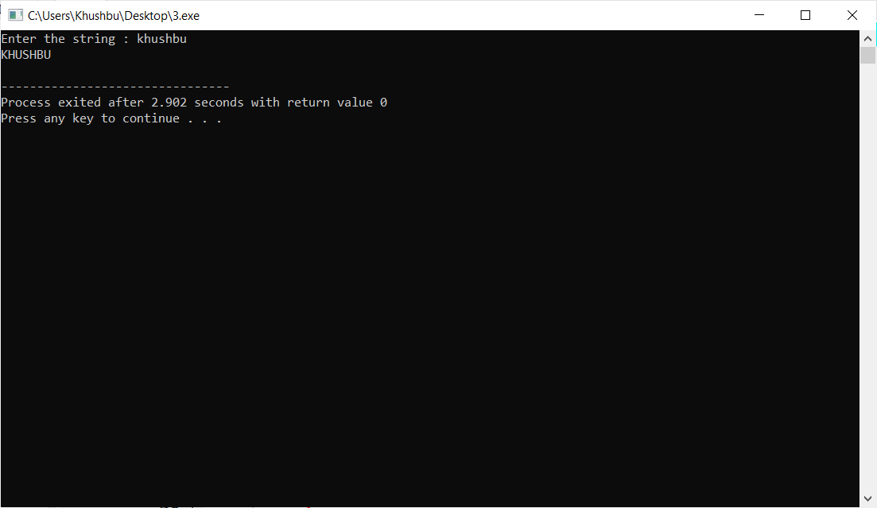

**Program : 4**

**Aim :** WAP to check if a given character is vowel or consonant.

**Program :**

#include<iostream>

using namespace std;

int main()

{

char ch;

cout << "Enter any character : ";

cin >> ch;

if(ch == 'a' || ch == 'e' || ch == 'i' || ch=='o' || ch =='u' || ch == 'A' || ch == 'E' || ch =='I' || ch=='O' || ch == 'U')

{

cout << "character is vowel";

}

else

{

cout << "character is consonant";

}

return 0;

}

**Output :**

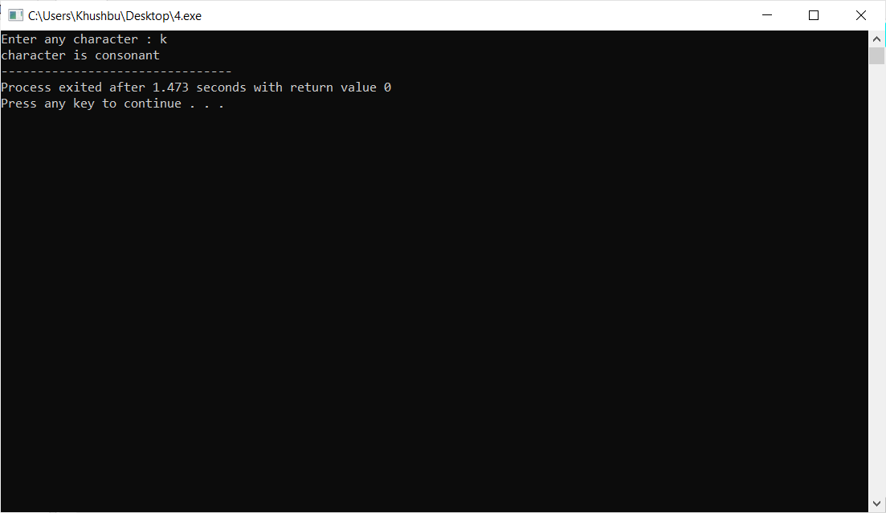

**Program : 5**

**Aim :**  WAP to find square root of given numbers from array elements.

**Program :**

#include<iostream>

#include<math>

using namespace std;

int main()

{

int a[1000], n, i;

cout << "Please enter of an Array : ";

cin >> n;

for(i = 0 ; i < n ; i++)

{

cin >> a[i];

}

cout << "Square root of elements are : " << endl;

for(i = 0 ; i < n ; i++)

{

cout << sqrt(a[i]) << endl;

}

return 0;

}

**Output :**

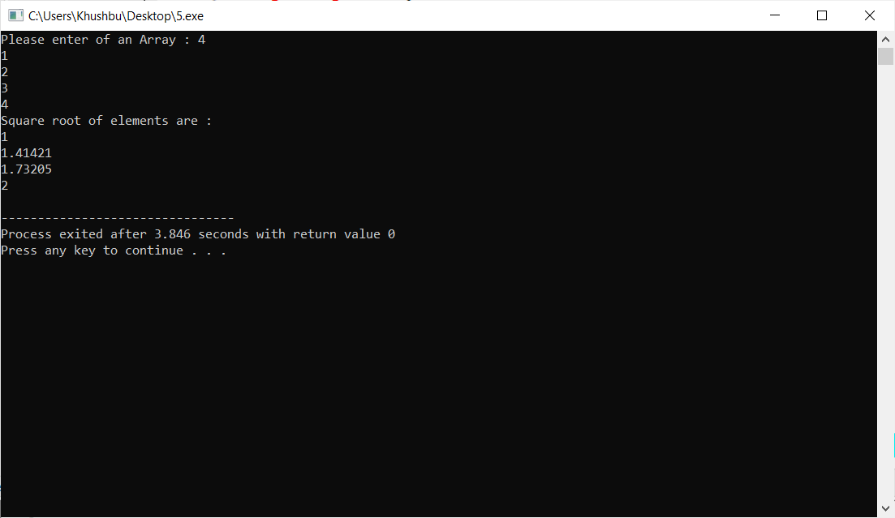

**Program : 6**

**Aim :** WAP to generate cube of given 5 numbers and make an array of that generated cubes

**Program :**

#include<iostream>

using namespace std;

int main()

{

int a[100], i;

cout << "Enter 5 elements of an Array : " << endl;

for(i = 0 ; i < 5 ; i++)

{

cin >> a[i];

}

for(i = 0 ; i < 5 ; i++)

{

a[i] = a[i] * a[i] * a[i];

}

cout << "Cube of array is : " << endl;

for(i = 0 ; i < 5 ; i++)

{

cout << a[i] << endl;

}

return 0;

}

**Output :**

