**Practical : 1**

**Aim :** WAP to pass function as an argument to a function.

**Program :**

#include <iostream>

using namespace std;

int fun_1(int , int );

int fun_2(int);

int main()

{

int i=5 , j=6;

fun_2(fun_1(i,j));

}

int fun_1(int a , int b)

{

return (a+b);

}

int fun_2(int temp)

{

cout<<"\nThe value of temp is :"<<temp;

}

**Output :**

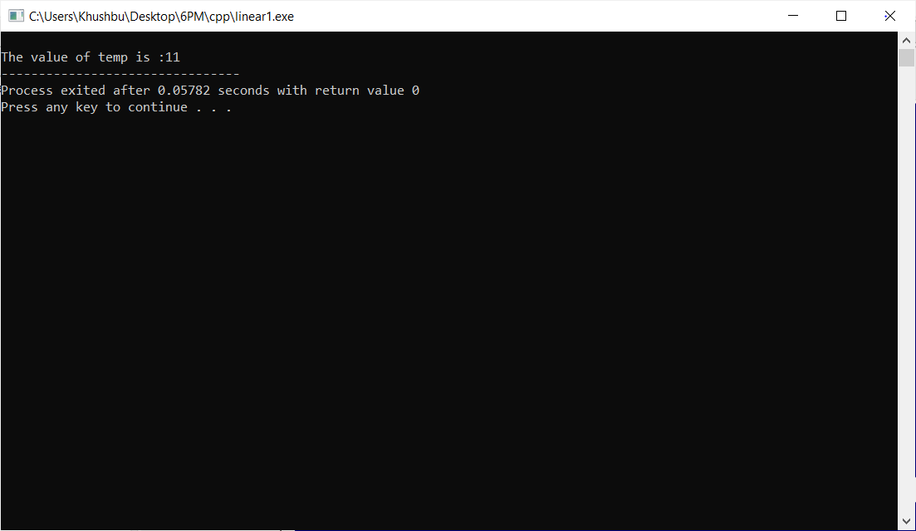

**Practical : 2**

**Aim :** WAP to swap elements of two integer arrays using user define function.

**Program :**

#include<iostream>

using namespace std;

void swap();

int main() {

swap();

}

void swap()

{

int a[10],b[10],c[10],i;

cout<<"Enter First array :";

for (i=0;i<10;i++)

cin>>a[i];

cout<<"\nEnter Second array :";

for (i=0;i<10;i++)

cin>>b[i];

cout<<"Arrays before swapping";

cout<<"\nFirst array :";

for (i=0;i<10;i++) {

cout<<a[i]<<",";

}

cout<<"\nSecond array :";

for (i=0;i<10;i++) {

cout<<b[i]<<",";

}

for (i=0;i<10;i++) {

c[i]=a[i];

a[i]=b[i];

b[i]=c[i];

}

cout<<"\nArrays after swapping";

cout<<"\nFirst array :";

for (i=0;i<10;i++) {

cout<<a[i]<<",";

}

cout<<"\nSecond array :";

for (i=0;i<10;i++) {

cout<<b[i]<<",";

}

}

**Output :**

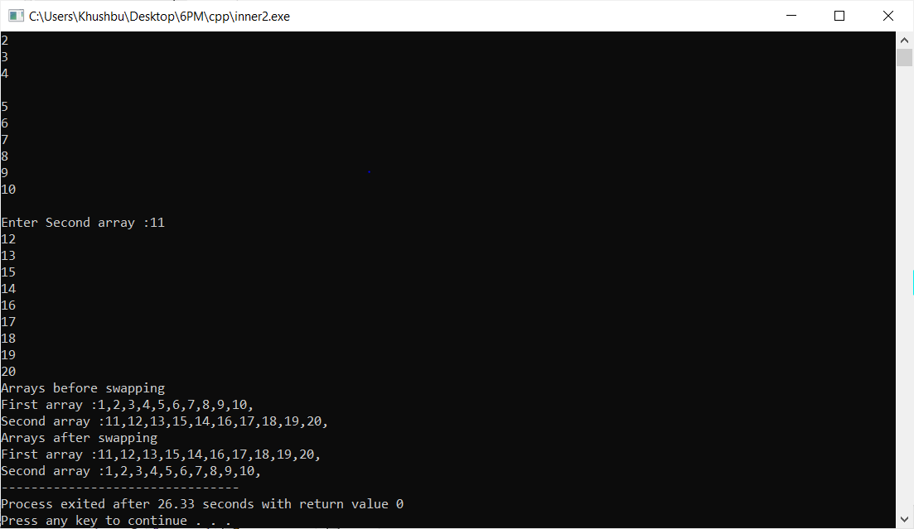

**Practical :3**

**Aim :** WAP to find factorial using recursion.

**Program :**

#include<iostream>

using namespace std;

int fact(int);

int main()

{

int n, f;

cout << "Enter any positive number : ";

cin >> n;

f = fact(n);

cout << "Factorial of "<< n << " is : " << f;

}

int fact(int n)

{

if(n <= 1)

return 1;

else

return n * fact(n - 1);

}

**Output :**

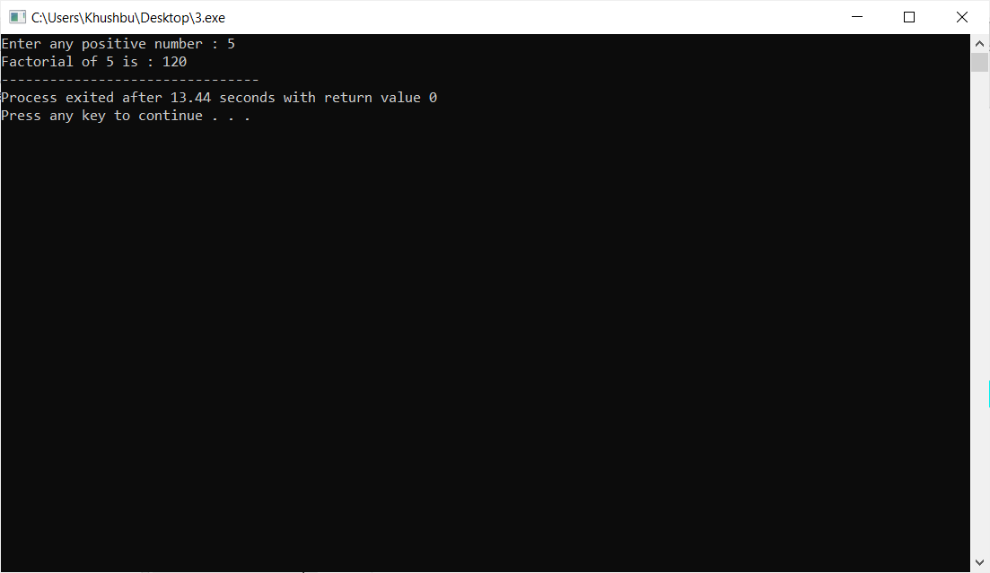

**Practical : 4**

**Aim :** WAP to illustrate the use of inline function by creating a function which prints a multiplication table of given number.

**Program :**

#include <iostream>

using namespace std;

int cube();

int main()

{

cube();

return 0;

}

inline int cube()

{

int n,i;

cout<<"enter any number :";

cin>>n;

for(i=1;i<=10;i++)

{

cout<<endl<<n<<"*"<<i<<"="<<n*i;

}

}

**Output :**

