**Program : 1**

**Aim :** WAP to create a class to read and add two distance. (e.g. 8 feet 16 inch + 4 feet 14 inch = 14 feet 6 inch)

**Program :**

#include <iostream>

using namespace std;

class Distance {

public :

int feet;

float inch;

};

int main() {

Distance d1 , d2,ans;

cout << "Enter 1st distance" << endl;

cout << "Enter feet: ";

cin >> d1.feet;

cout << "Enter inch: ";

cin >> d1.inch;

cout << "\nEnter information for 2nd distance" << endl;

cout << "Enter feet: ";

cin >> d2.feet;

cout << "Enter inch: ";

cin >> d2.inch;

ans.feet = d1.feet+d2.feet;

ans.inch = d1.inch+d2.inch;

while(ans.inch >= 12.0) {

ans.inch = ans.inch - 12.0;

ans.feet ++;

}

cout << endl << "Sum of distances = " << ans.feet << " feet " << ans.inch << " inches";

return 0;

}

**Output :**

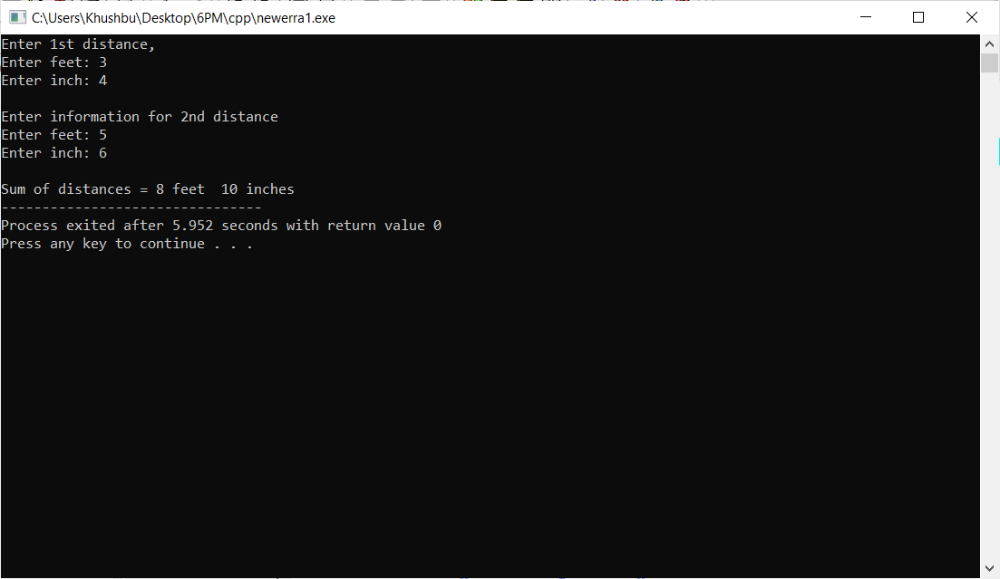

**Program : 2**

**Aim :** WAP to create a class to read and add two times.

**Program :**

#include<iostream>

using namespace std;

class Time{

public :

int hour,minute,second;

};

int main()

{

Time h1,h2,h3,m1,m2,m3,s1,s2,s3;

cout<<"***Enter first time***"<<endl;

cout<<"Hours: ";

cin>>h1.hour;

cout<<"Minutes: ";

cin>>m1.minute;

cout<<"Seconds: ";

cin>>s1.second;

cout<<"***Enter second time***"<<endl;

cout<<"Hours: ";

cin>>h2.hour;

cout<<"Minutes: ";

cin>>m2.minute;

cout<<"Seconds: ";

cin>>s2.second;

s3.second=s1.second+s2.second;

m3.minute=m1.minute+m2.minute+(s3.second/60);

h3.hour=h1.hour+h2.hour+(m3.minute/60);

m3.minute=m3.minute%60;

s3.second=s3.second%60;

cout<<"Total Time is: "<<h3.hour<<" hours "<<m3.minute<<" minutes "<<s3.second<< " seconds";

return 0;

}

**Output :**

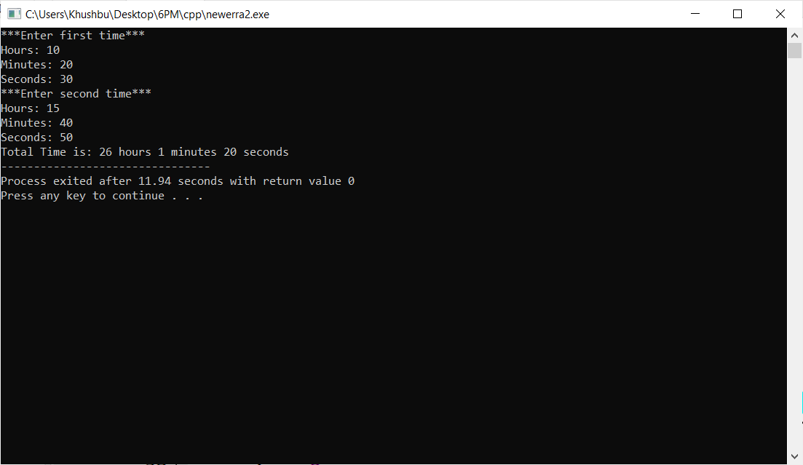

**Program : 3**

**Aim :** WAP to create class to read time in seconds and convert into time in (HH:MM:SS) format.

**Program :**

#include<iostream>

using namespace std;

class Second{

public :

int time,hour,minutes,second;

};

int main()

{

Second t,h,m,s;

cout<<"\t Changing Time Format "<<endl;

cout<<"\n";

cout<<"Enter time (in Seconds) "<<endl;

cin>>t.time;

h.hour =t.time/3600;

t.time=t.time%3600;

m.minutes=t.time/60;

t.time=t.time%60;

s.second=t.time;

cout<<"\n";

cout<<"Time in HH:MM:SS is "<<h.hour<<":"<<m.minutes<<":"<<s.second<<endl;

return 0;

}

**Output :**

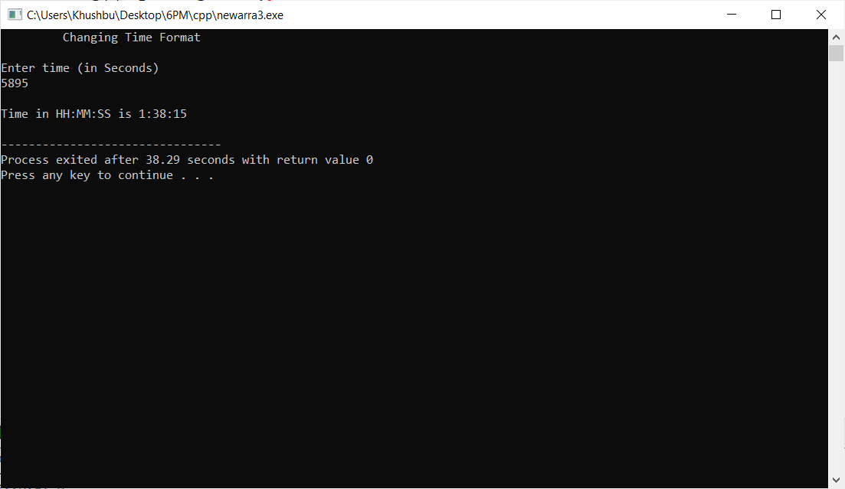

**Program : 4**

**Aim :** WAP to create a class which Read and Print House details along with Room details.

**Program :**

#include<iostream>

using namespace std;

class House {

public :

char name[100];

char address[100];

};

class Room {

public :

int length;

int breath;

int height;

};

int main()

{

int i,n;

House h[100];

Room r[100];

cout<<endl<<"how many house details enter u want to enter...";

cin>>n;

for(i=0;i<n;i++)

{

cout<<endl<<"house and room details...";

cout<<i+1<< endl;

cout<<endl<<"name :";

cin>>h[i].name;

cout<<endl<<"address :";

cin>>h[i].address;

cout<<endl<<"length :";

cin>>r[i].length;

cout<<"breath :";

cin>>r[i].breath;

cout<<endl<<"height: ";

cin>>r[i].height;

}

for(i = 0 ; i < n ; i++)

{

cout << endl << "house and room details... ";

cout << i+1 << endl;

cout << "name : ";

cout << h[i].name <<endl;

cout << "address: ";

cout << h[i].address <<endl;

cout << "length : ";

cout << r[i].length <<endl;

cout << "breath : ";

cout << r[i].breath <<endl;

cout << "height : ";

cout << r[i].height<<endl;

}

return 0;

}

**Output :**

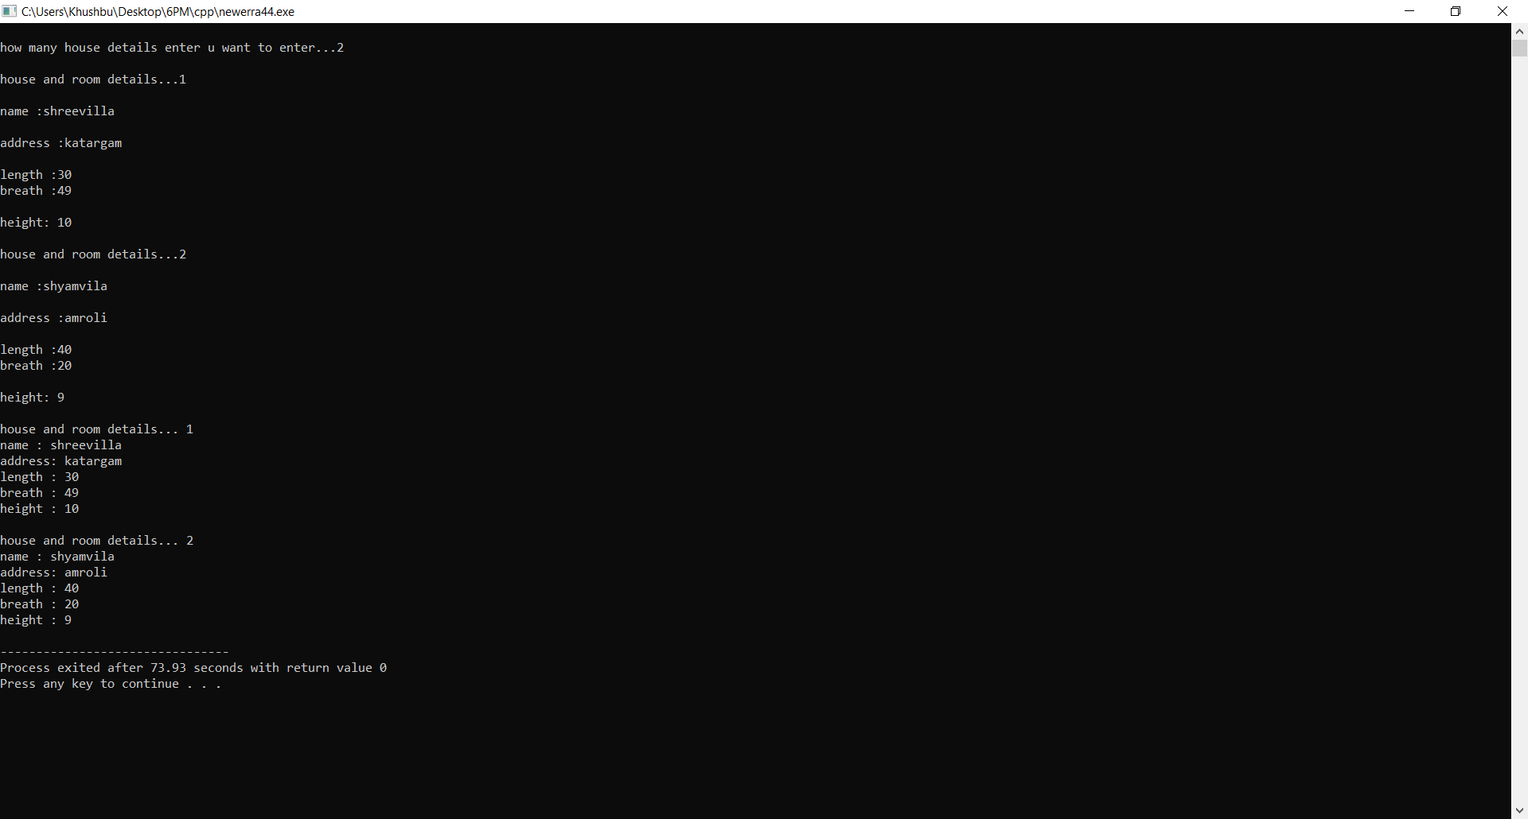

**Program : 5**

**Aim :** WAP which illustrates the use of public and private access modifiers**.**

**Program :**

#include<iostream>

using namespace std;

class Modifiers

{

private:

int height;

public:

int weight;

};

int main()

{

Modifiers m;

cout<<"height is not accsseible because it is private data member of modifier class..."<<endl;

cout<<"**********"<<endl;

cout<<"weight is accessible because it a public data member of modifier class...."<<endl;

cout<<"enter any number:";

cin>>m.weight;

cout<<endl<<"weight is :"<<m.weight;

return 0;

}

**Output :**

